TW: CP, CENSORED AND CROPPED PORN, RACISM AND SH.

My History with Gui (and why he’s kinda bad.):
Me and Gui had become friends around 2022, his old account was banned (from 2022) and because of this, no screenshots can be grabbed. (which sucks, but there is still a lot more proof).

Back on topic, at one point, he added me to his gc, where stuff between me and him went downhill, at the time I was pretty new to baldi, and this was the first gc with baldi people i had ever been added to. Within a few months I had left twice due to several people saying the n word.

The people I remember in the GC were Jad, Gui, Weodobo and bisque. (This is not implying bisque or weo had said the n word however.) Even though i don’t remember who said the n word, (apart from gui, i mean), gui promised me people would stop being racist.

The next drama was when Notfurnace being added (I wont go into details about notfurnace, his drama is old and has been untouched ever since the middle 2023 iirc, this is just here so i can provide a more cohesive timeline). afterward, he was kicked.

A few months later Zawru, (now Jamdope) was added to the gc, and while (at the time) he add his own issues, we had recently forgiven him for it. But BEFORE we did, gui kept trying to get me to forgive jamdope and pressuring me, he did this to bisque also. We did eventually forgive him in our own time, but this isn’t the point.

A month later gui tried to “expose” Bisque by using out-of -context photos of her jokingly saying kys and stuff like that when they were friends. Around that was when I had finally left his gc.

A few months prior I had made a joke image from when i was still fine with notfurnace. it was made with no malicious intent.

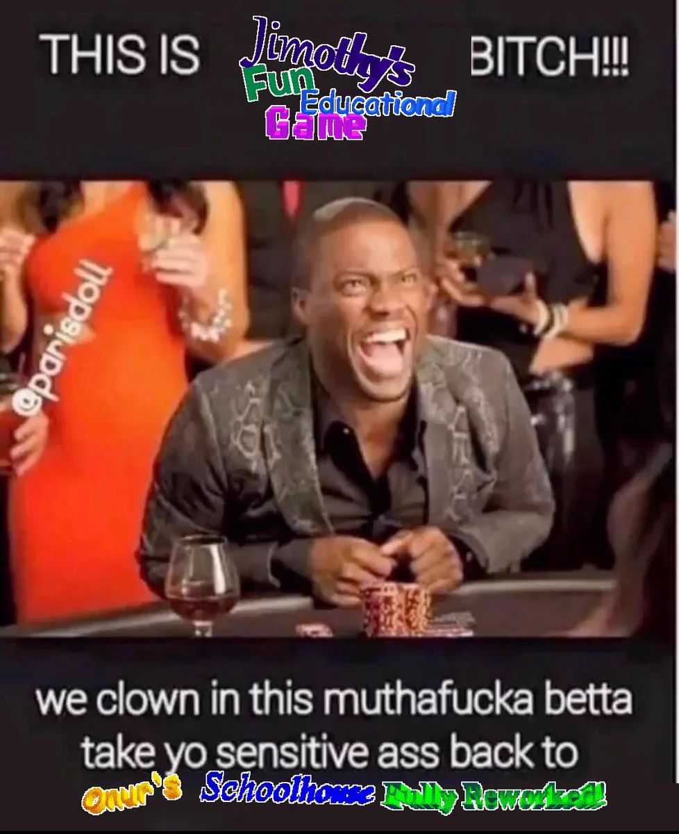
Zorphix later on made a tweet just kinda making fun of me, but what really mattered to me was seeing people who I thought were my friends liking it, making me kinda get trust issues.

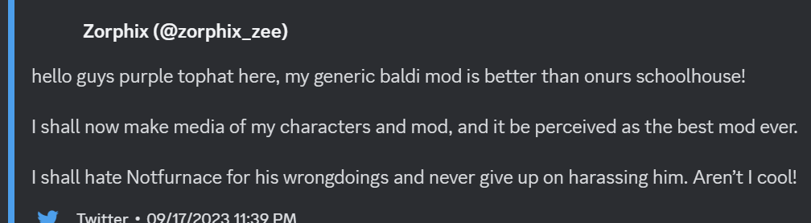

Small Update: gui asked zalgo who he would rather groom, check thread comments for proof.

He then made a denyathon cover (yes really) with jimothy, bisque and some other people WITH zorphix. https://www.youtube.com/watch?v=6Ffi0u23cz4 (the cover)

This was REQUESTED to be taken down several times, but it wasn’t. And still isn’t down to this day.

After I asked him to stop doing this kind of stuff, we had a back and forth argument for months, I do admit with one message I went a bit too far. However this does not change how even after the removal of the cover from youtube he started charting it with zorphix, it also doesn’t excuse their actions towards any of us.

Zorphix then, for some reason, tried remaking my characters model, out of spite, for some reason, here is proof:

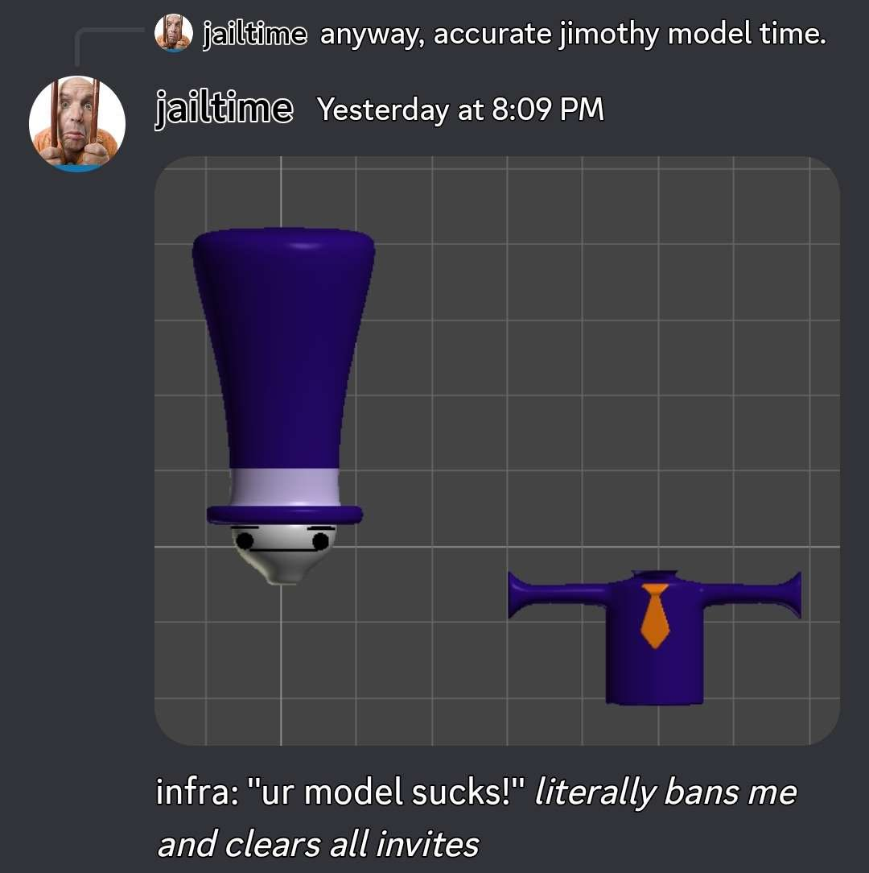
(image from the making of the inaccurate model)
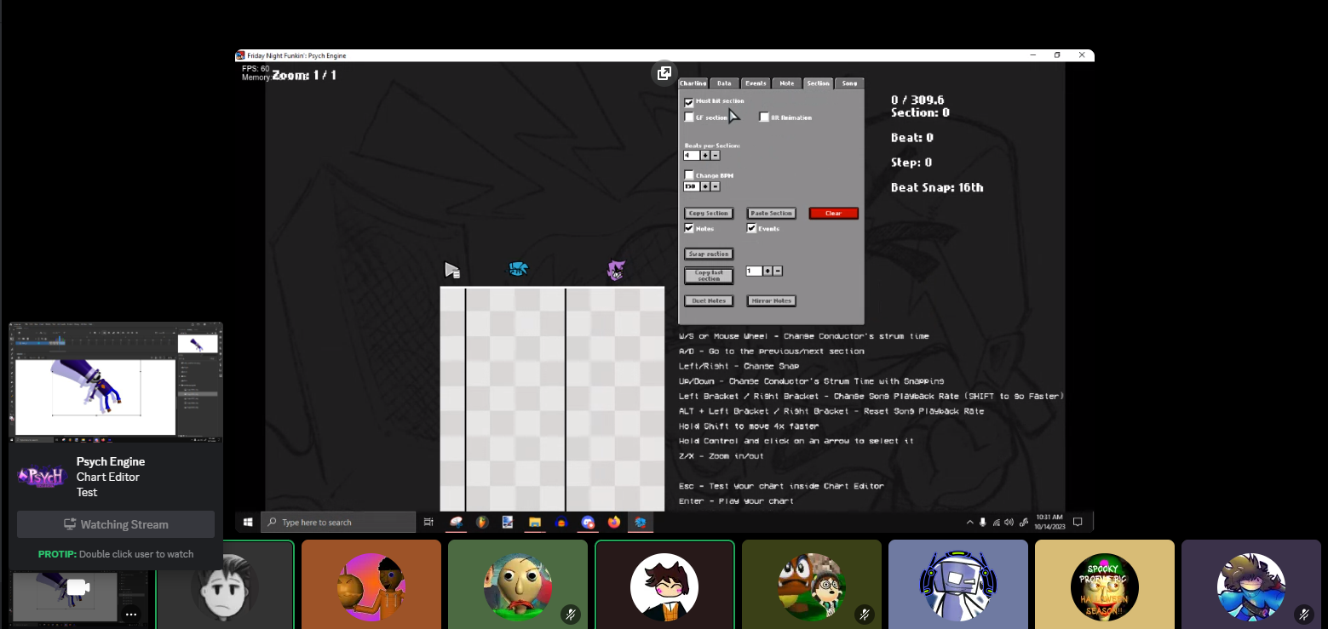
(image of the cover making)

Eventually this all blew over, but that doesn’t mean its okay, during the big argument i wasnt really sure what to do (i was really stressing) and ended up reporting guis account after he had told me to kill myself.

Before that however i was arguing with gui in my friends gc, eventually leaving it.

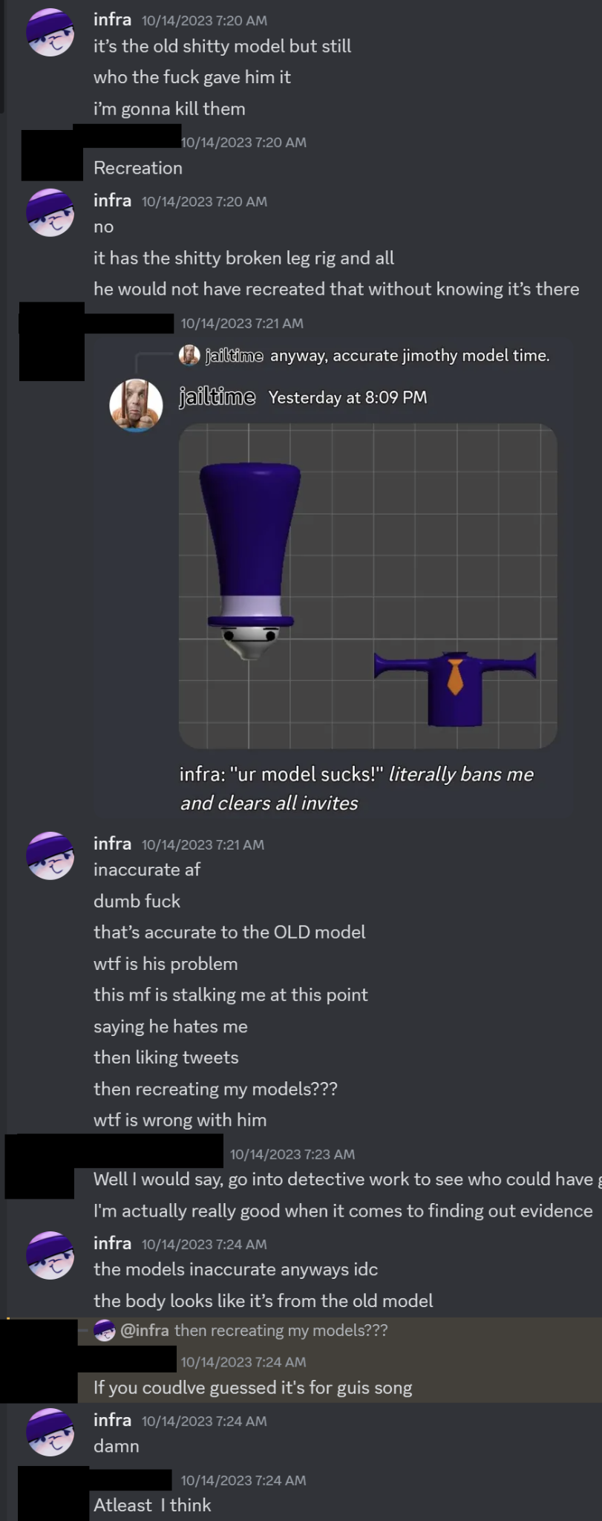
The conversation before hand (censored for privacy)
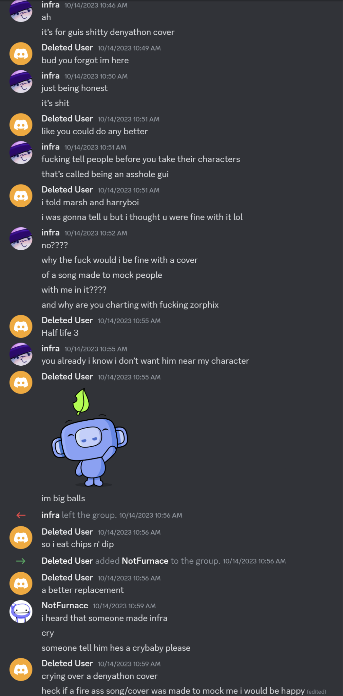
Me leaving the gc then notfurnace being added afterwards, only to then literally mock me

After that I didn't really do much about gui for a while. Before eventually kyra had dmed me asking about making a full doc.
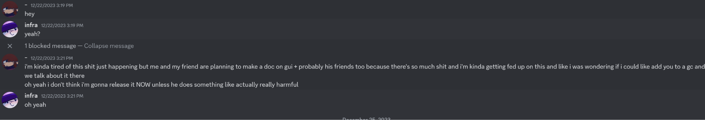

While making the gc I had told kyra about reporting gui, although I did not mention him telling my to kys

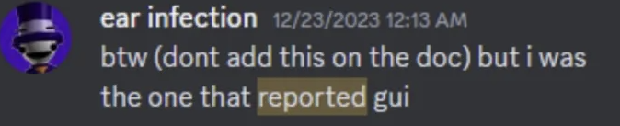

I also unintentionally accidentally pressured kyra into releasing the doc
https://docs.google.com/document/d/1aE6uI1AkLrDpvwCxldLUQ0wThL-R50a_sf0AAciSQu8/view#heading=h.wj2dcnjjqcwa (the old doc) its privated. After a few hours of the doc being up, kyra suddenly took it down, telling me that he made up with gui. A few more hours later. I was dmed about kyra telling gui about me reporting him. I freaked out and immediately blocked him. Im not the best at trusting people after zorphix and gui. So this more or less validated everything in my mind
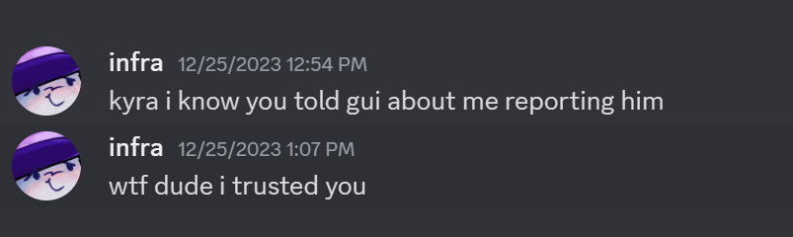
After a while nothing really happened with gui, however after a while on february 1st. 2 people had dmed me about gui having leaked my face in a gc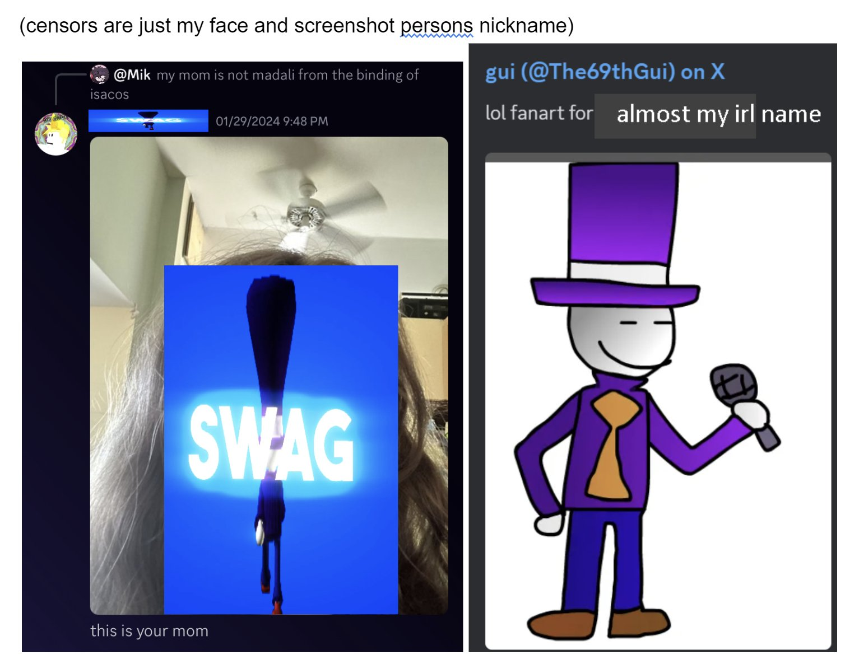
He later tried to use the excuse of “i didnt know whose face it was” however you can see that he knowingly did this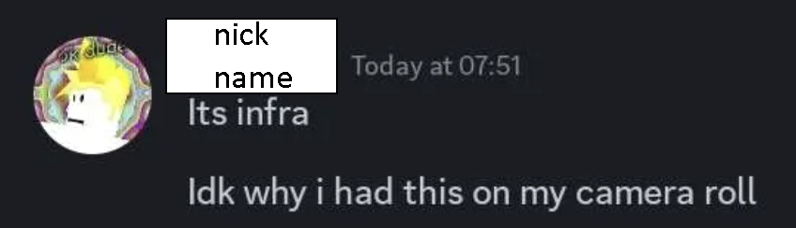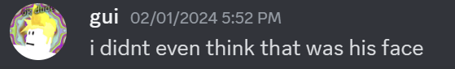
This led too a post, basically just telling people to block him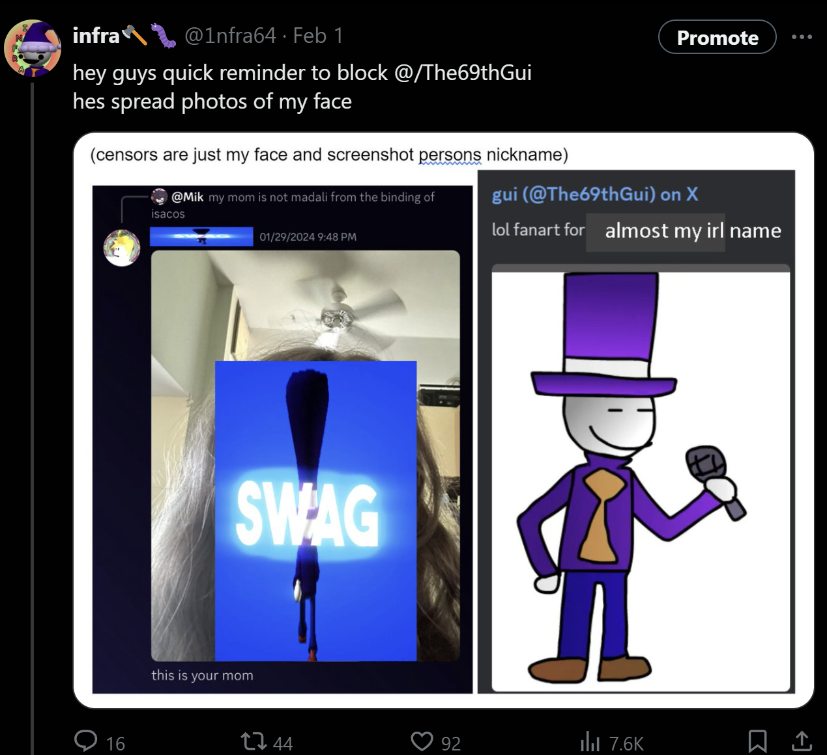

Gui later found out about this post. Basically making an apology.

Aswell as then for some reason, stalking me on an alt, (he stalked me and bisque btw, for more clarification) AFTER i had blocked him. (this has happened several times.)

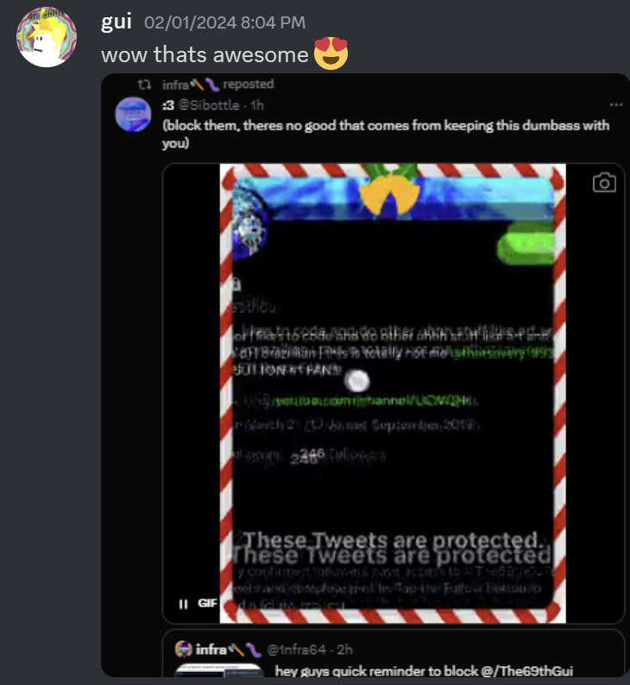
The Apology: 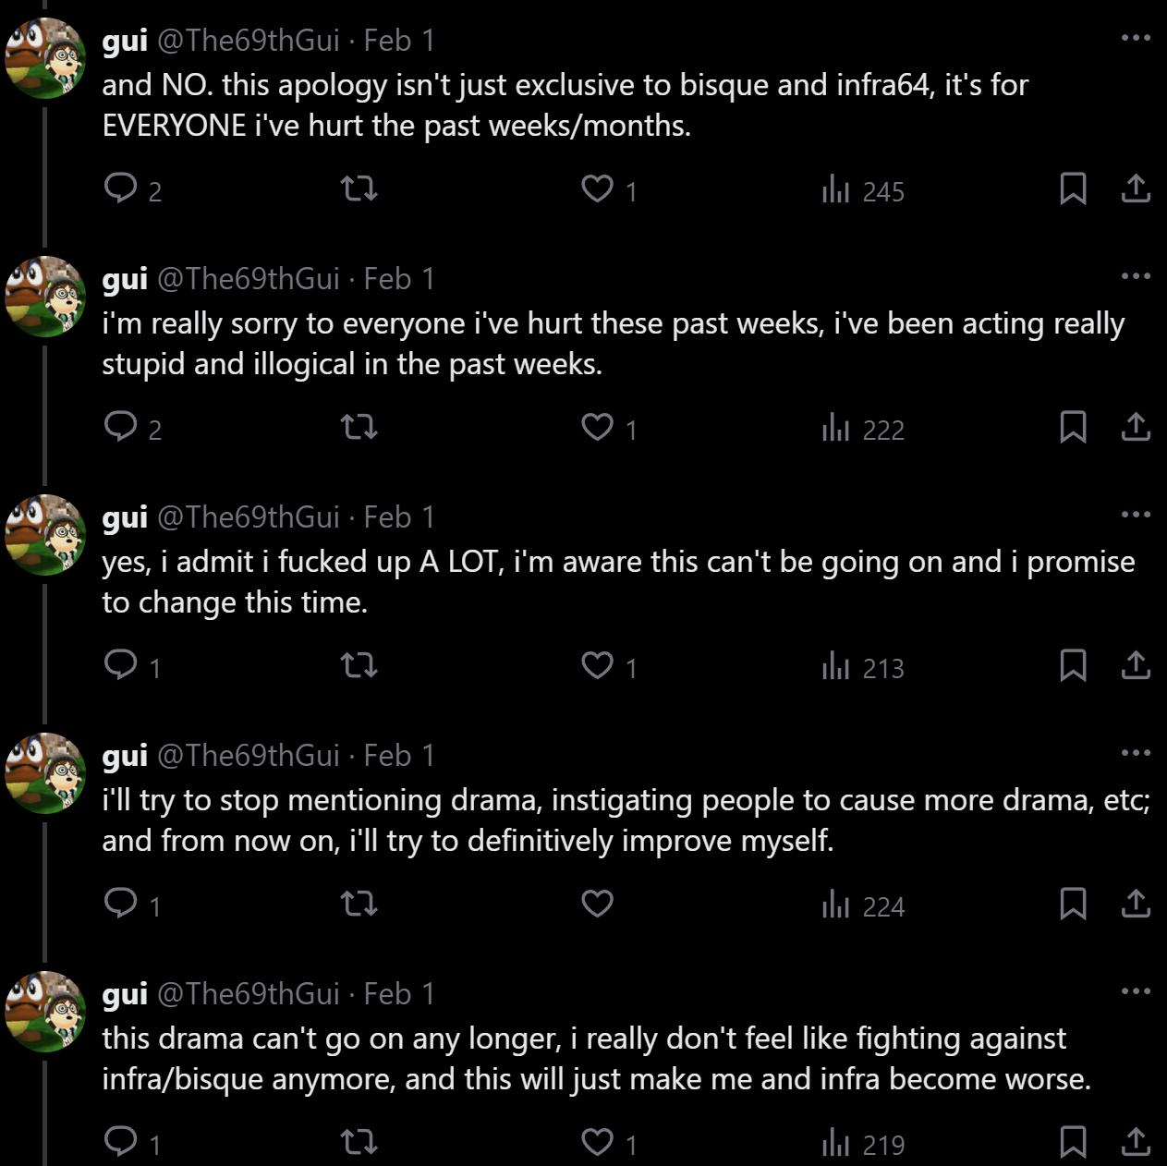
This isn’t really an apology from him though, its just more or less him just saying “sorry guys, my bad” and learning really nothing. Afterwards me and kyra basically got into a fight of “doc on infra” “response” for about 3 or 4 docs. However the main issue with it was that in the final kyra doc he added actually sh, although censored with no warning, trying to use it as an excuse on why i'm a bad person.

Moving on, i’m going to talk about the more modern stuff, which is probably the worst of it in all complete honesty, like, really really bad.

Gui supporting child porn artists and groomers.

A while ago. An artist called zalgo. (twitter user @/zalgoisreal) made nsfw art of several baldi modders. The first of which was bisque, who is 14 years old. Then aria, and then ironically zalgo drew it of gui.

Later on gui kept making jokes about it, even making it a sticker on his own server. Although gui no longer is friends with zalgo, he still actively supported him knowing what he did. It still took him HALF A MONTH because he was begged too do it, not because he actually WANTED to, i think its already really weird as is gui was friends with these people, but for him to make fun of people right after is just… even worse.

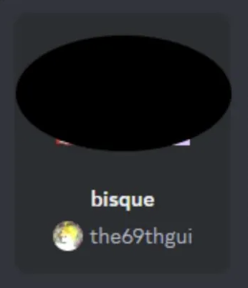
The Sticker
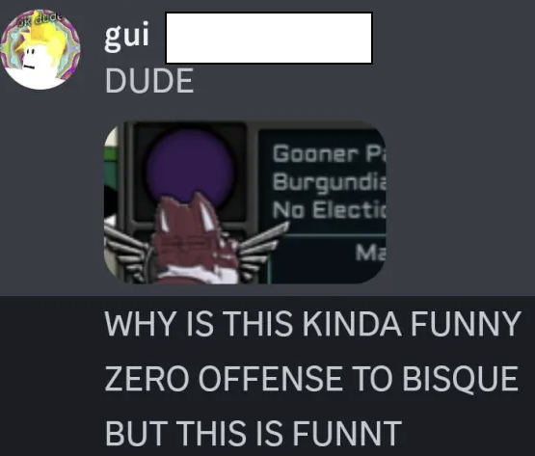
A Photo of him laughing at it.

Although zalgo was kicked after he drew nsfw of GUI, (which is, kinda fucked up considering he didn’t do this to begin with, until it affected him specifically.) later on, Gui added another person, nezthorn, they also drew nsfw of bisque AND bestboy,
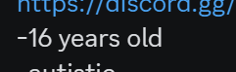
(Nezthorns age)

(For context, bisque is 14.)
(Bestboy is also sixteen.)

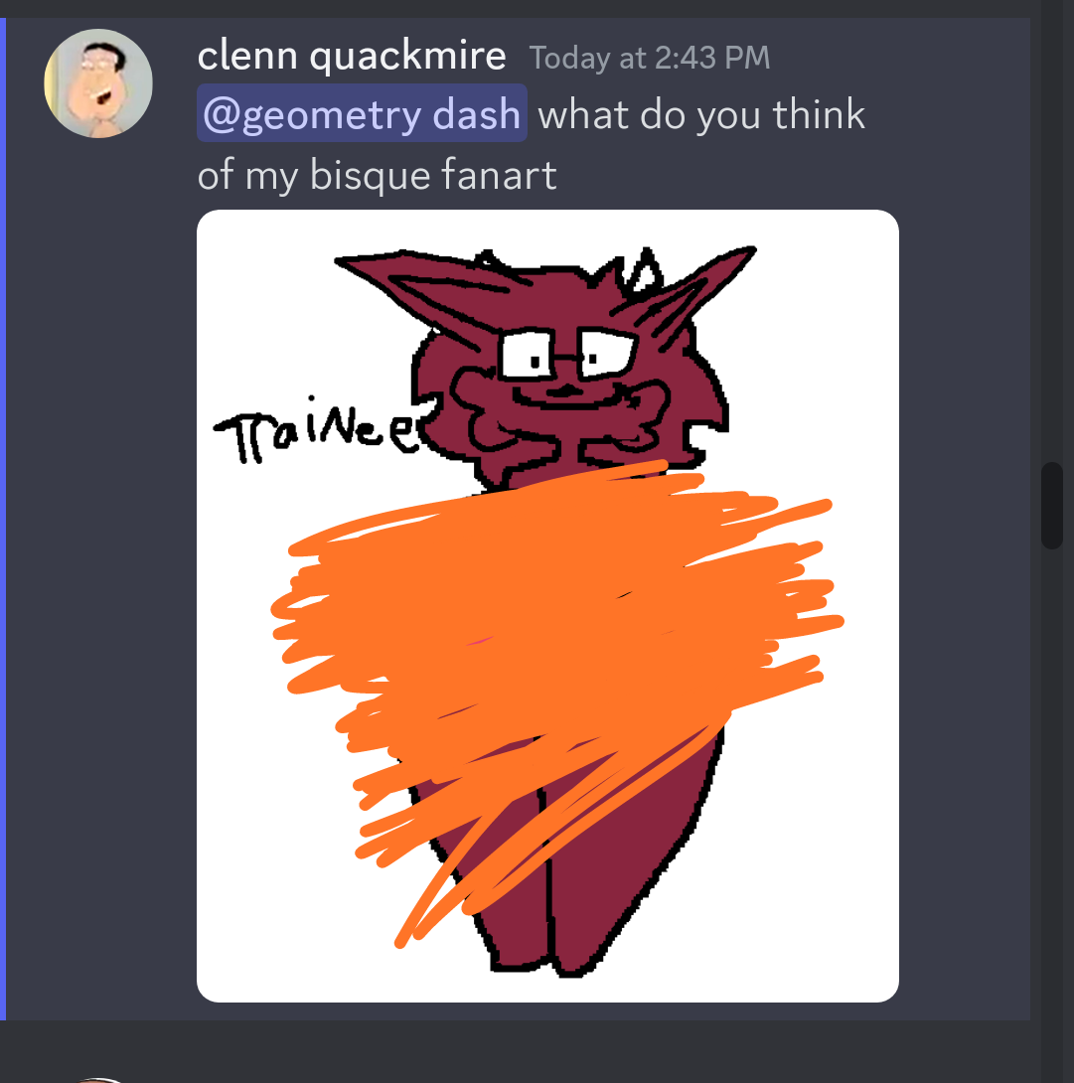
Him drawing porn of bisque
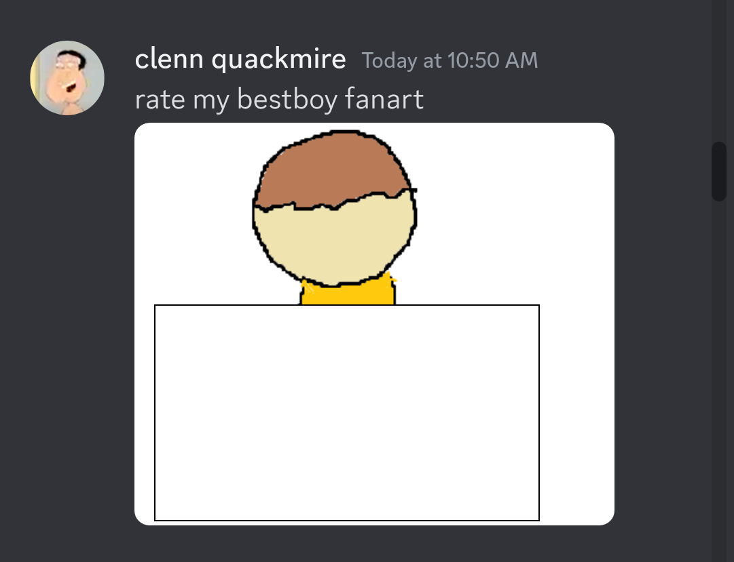
And bestboy.

Nezthorn is also a mod for the baldi’s basics modding section on gamebanana, which is very scary considering his actions towards people. Someone should, legit do something about this in the future.
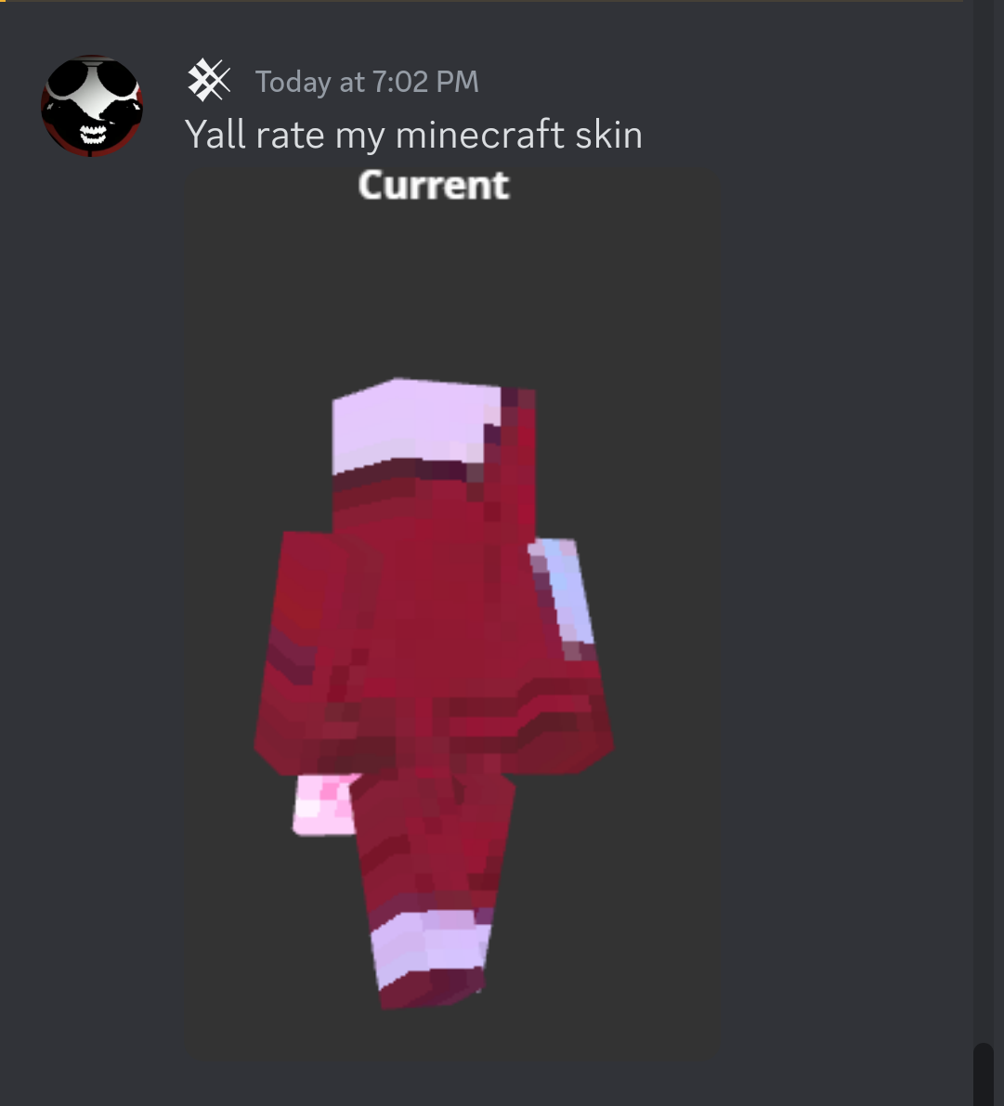
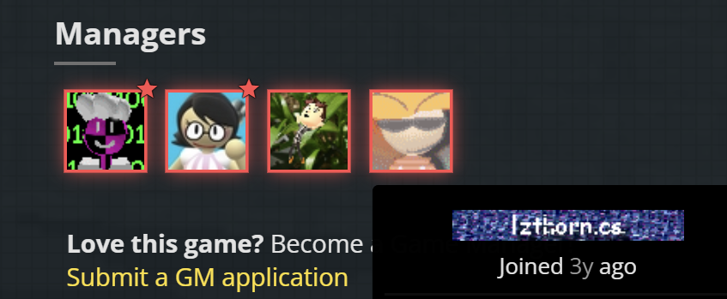 Along with guis and his friends weird obsession with bisque, we have bulb.

(For context, this is not snowball, this is bulb pretending to be snowball.)

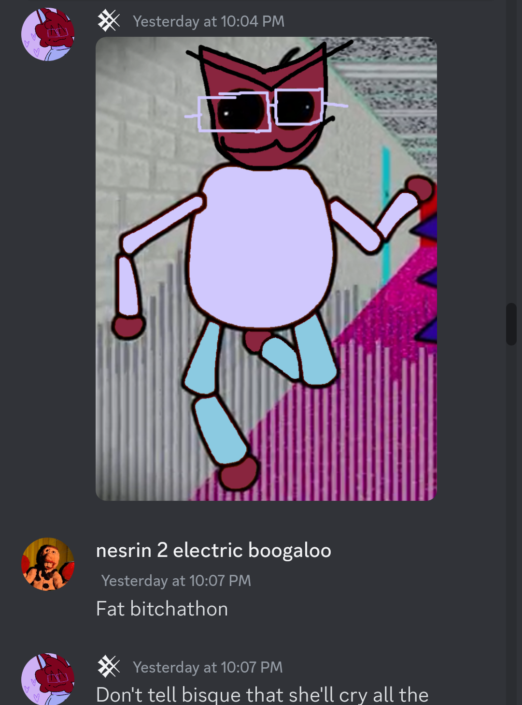
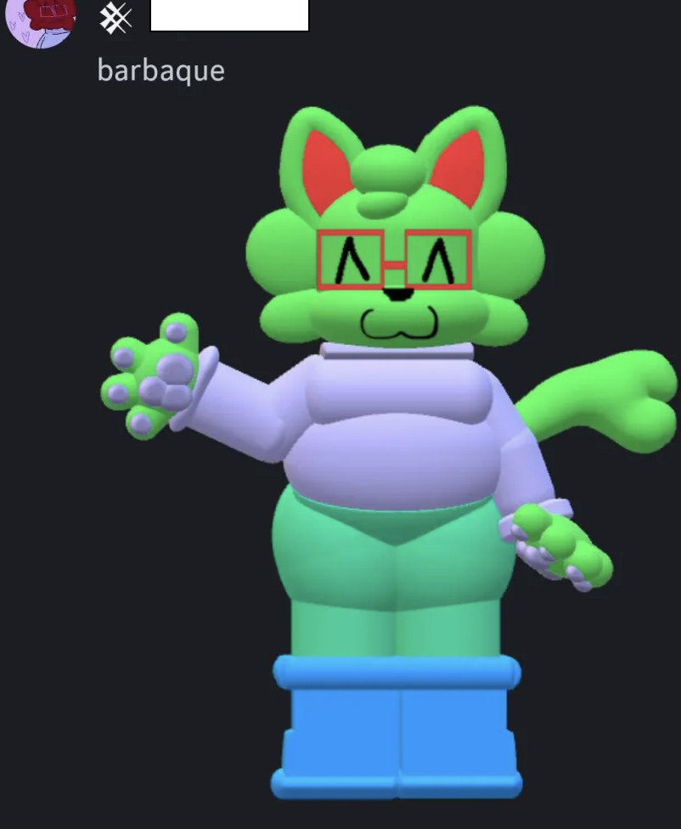

The okaysock story
A few months ago gui made a garrett parody baldi mod, called oksock. The character of oksock was based on fixns and his old username opensock. Fixns was okay with it atfirst. But after a while he didn't want the mods up anymore. But gui would refuse to get the mod taken down. Even making a sequel to the mod. To the point of trying to own him because fixn started just using a private account. Making gui say he owned him now (he didn't). Aswell as gui posting screenshots of fixns and guis dms. As Well as not taking them down when asked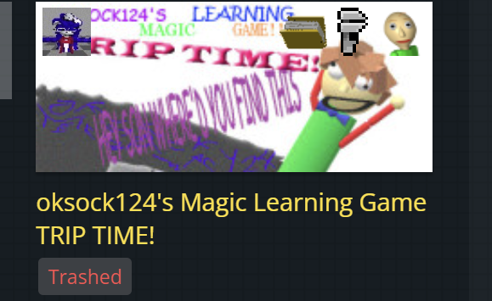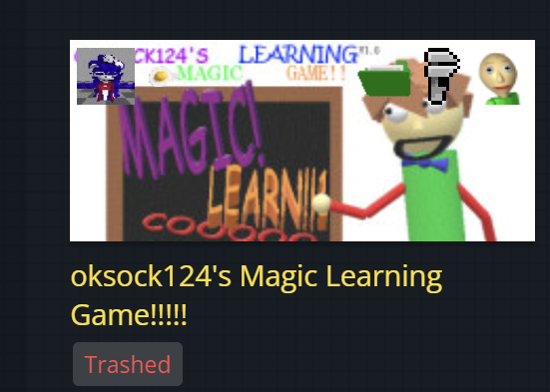

For the last section, i’d like to show off gui playing condo roblox games, while he was presumably younger than 12,

I’m gonna blank out the rest of this page, so if you’d like to stop reading, this is probably the place to stop, please also consider blocking gui. But please do NOT harass any of the people mentioned. Thank you.
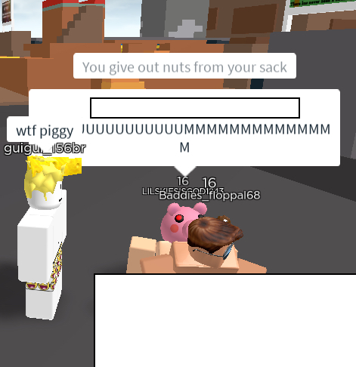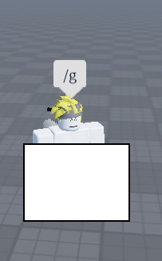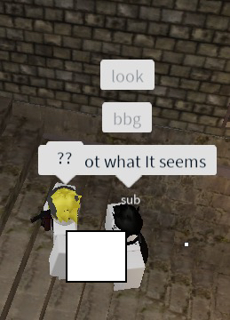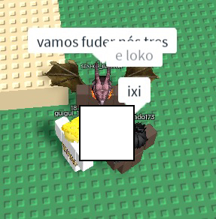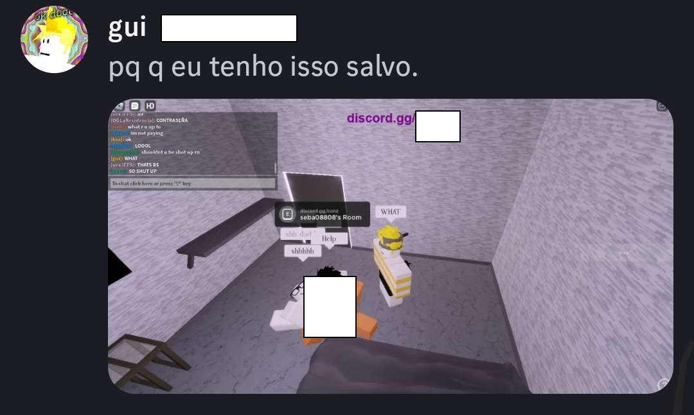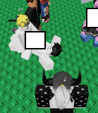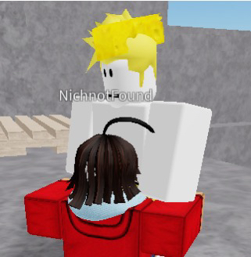

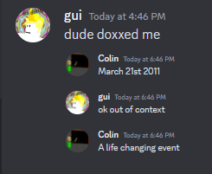
Finally gui turned 13 ONE DAY before the release of this doc.

Thank you for reading. Please do not harass or attack gui, just simply block and move on from him.

deadass

