Hi, this is a document about Care (L1ttleCare) on Twitter!! This will be short but if anyone wants to add anything please feel free to dm me!
This is going to be unorganized btw idgaf

- Supporting proshippers. Proshippers are genuinely horrible people, if you don’t know what a Proshipper is: 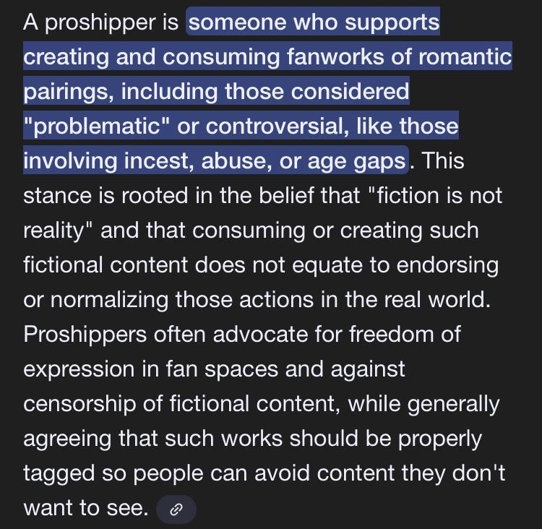Care has been seen reposting proshippers onto her account.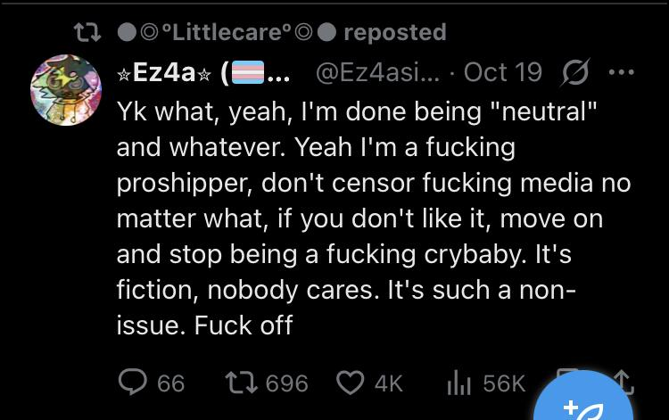
- Calling June a minor despite June being 18 (Young Adult age)
Care seems to heavily hate June in general, harassing them and such.
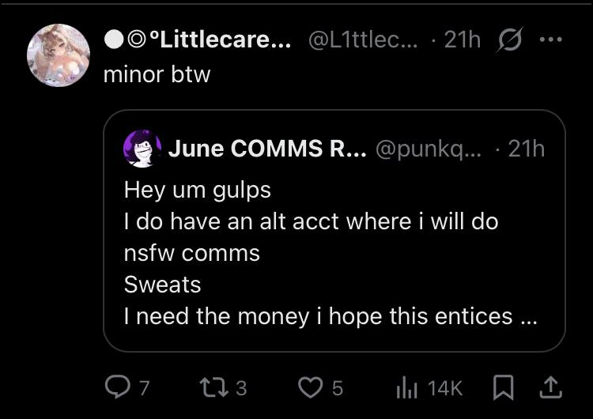
June is trying to get money and Care is harassing June about having a NSFW alt. Mind you June can control who follows and doesn’t follow this alt, so no minors can access it.
- Care actively REPOSTING NSFW for minors to see on her own page.
While not being actual NSFW, it’s very NSFW heavy, and due to the fact that Care is starting shitty useless drama, minors will be looking at her page.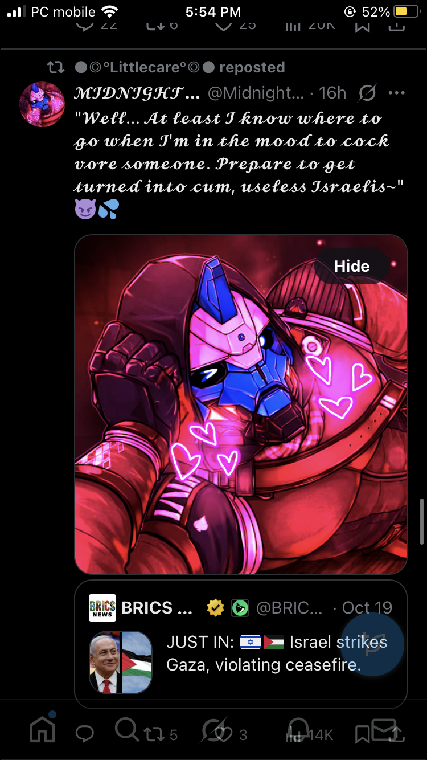
No minor should be reading or looking at this, especially on a profile of someone who is really “against” NSFW exposed to minors herself.
- (Allegedly) Supporting Charlie Kirk.
Care has been seen reposting Charlie Kirk memorial art from someone she knows. Charlie Kirk was a horrible man, being heavily anti-LGBTQ, very heavy on gun violence and mass deportations.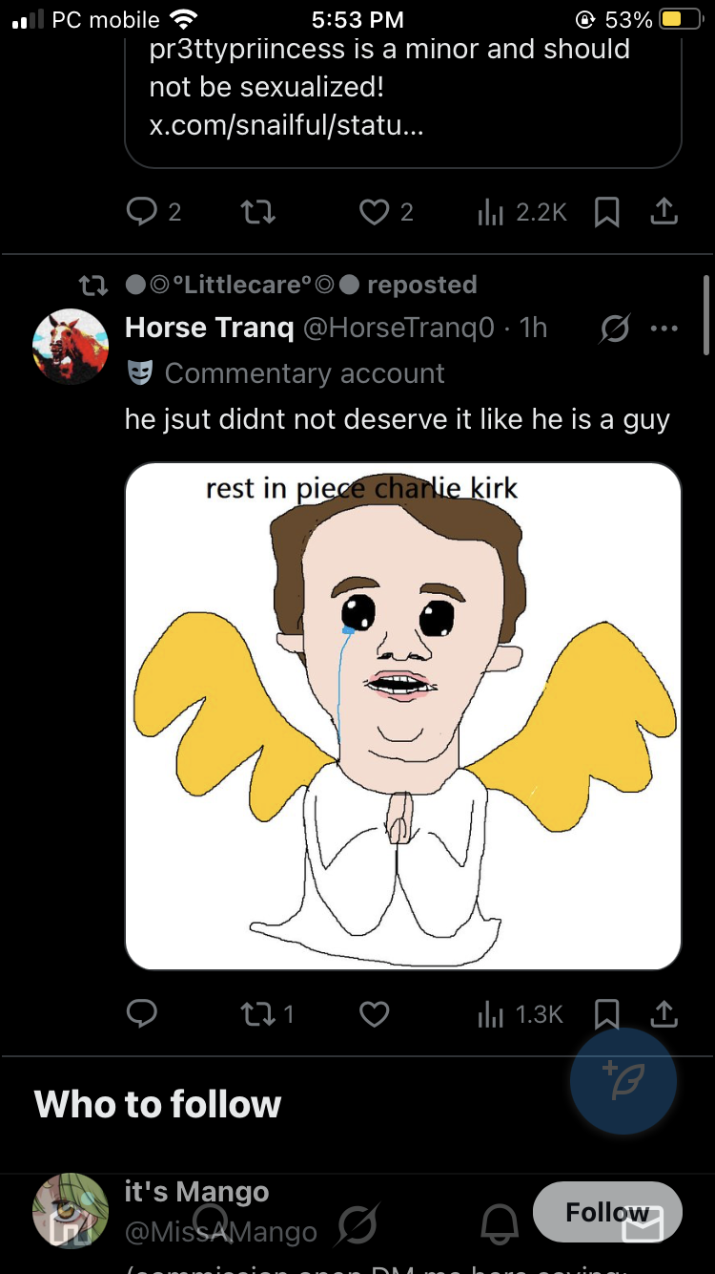This is all I have right now, again if someone would like to add more please dm me on Twitter (Phantomish).
Please don’t let this become June’s only reason of becoming popular due to a stupid document, go support them <3

