Embroila
Complete Weirdo

This document contains NSFW content, discretion is advised.
Please do not harass anyone present in this document.

Sections:
Context
Evidence
Analysis

Context
Embroila is a 17 year old artist who goes by the username embroila on the platforms of Discord, Steam, Spotify, and Twitter, as well as horrorplayer47 on Roblox. She joined Discord in May of 2023 (new account) / May of 2021 (old account), Steam in May of 2022, Roblox in May of 2018, and Twitter in July of 2023.
Twitter:
https://twitter.com/EmbroilaS
Discord Profile:
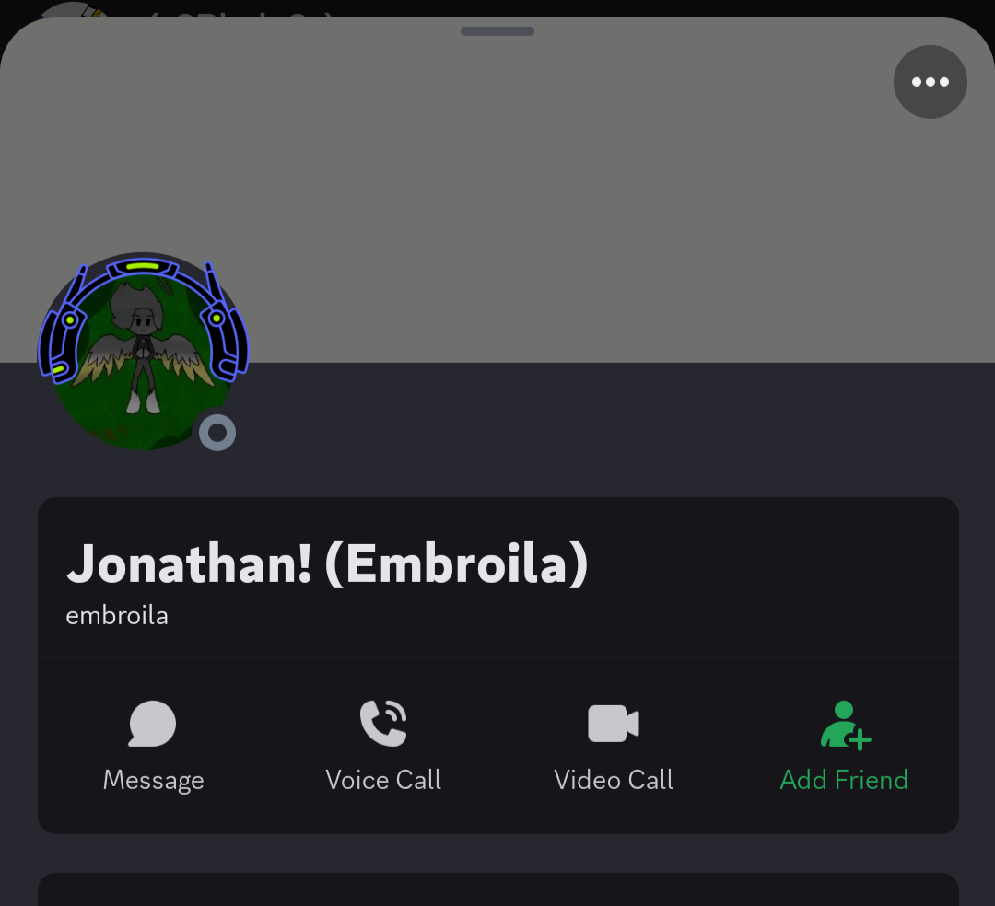
User ID: 1106376027212632084

Evidence
In March of 2024, it was revealed that Embroila had been drawing NSFW/Suggestive content (mostly porn) of characters created by minors, whilst being a minor. It was also revealed that Embroila had been ERPing (Erotic Roleplay) in VCs, including moaning and sexual comments.

Drawings
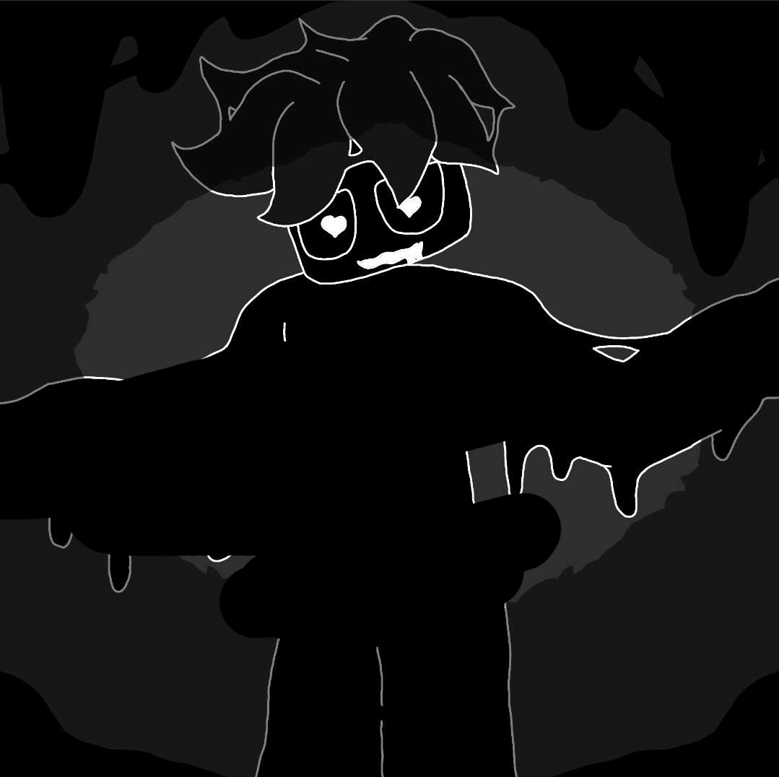

Battery Acid Yin (Still a minor’s OC, even when an AU by Embroila)
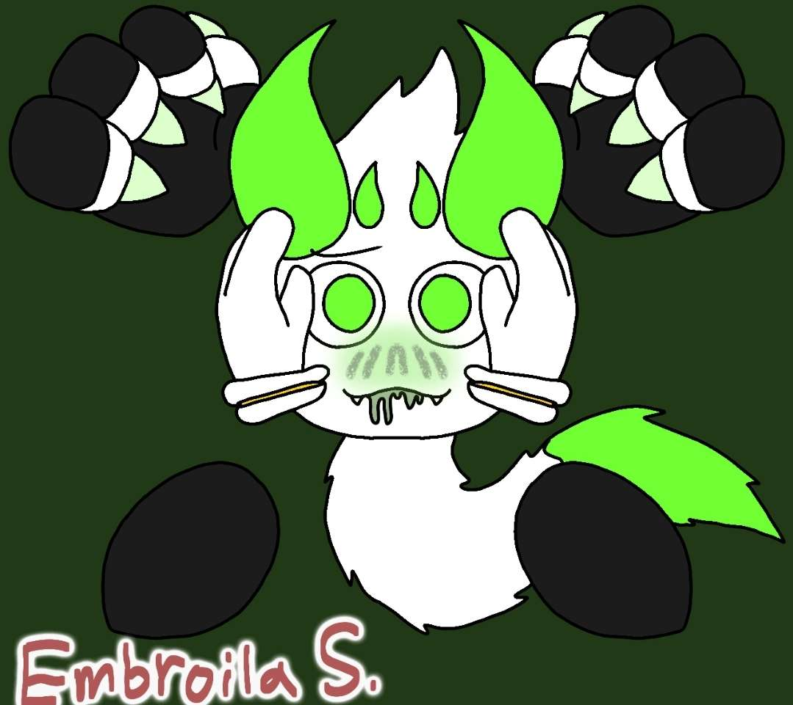

Yin (yinlol’s OC)
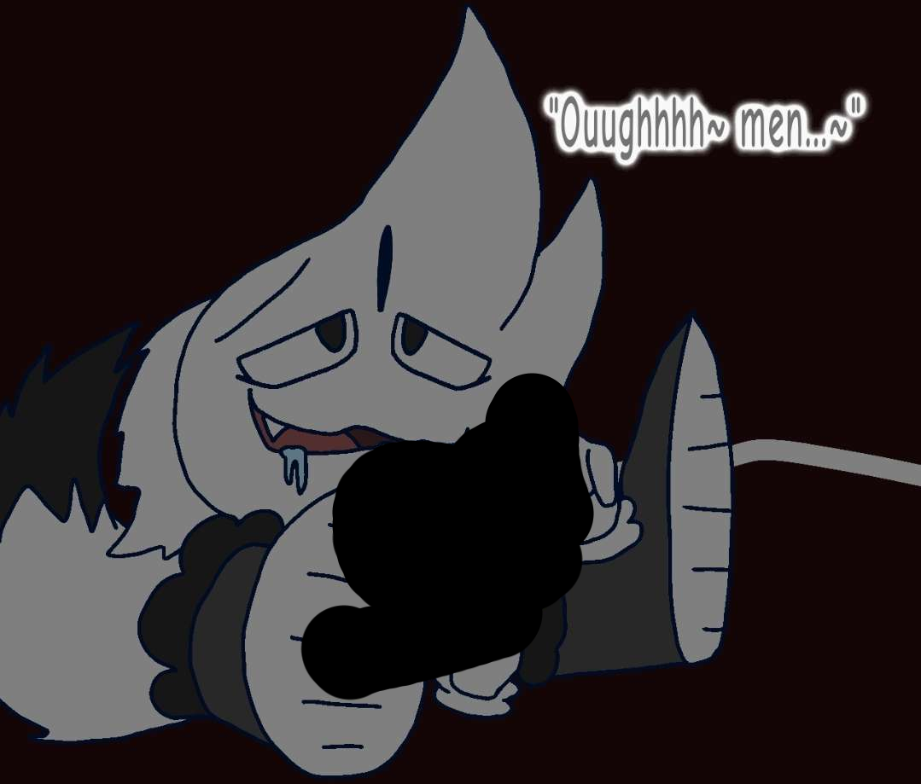

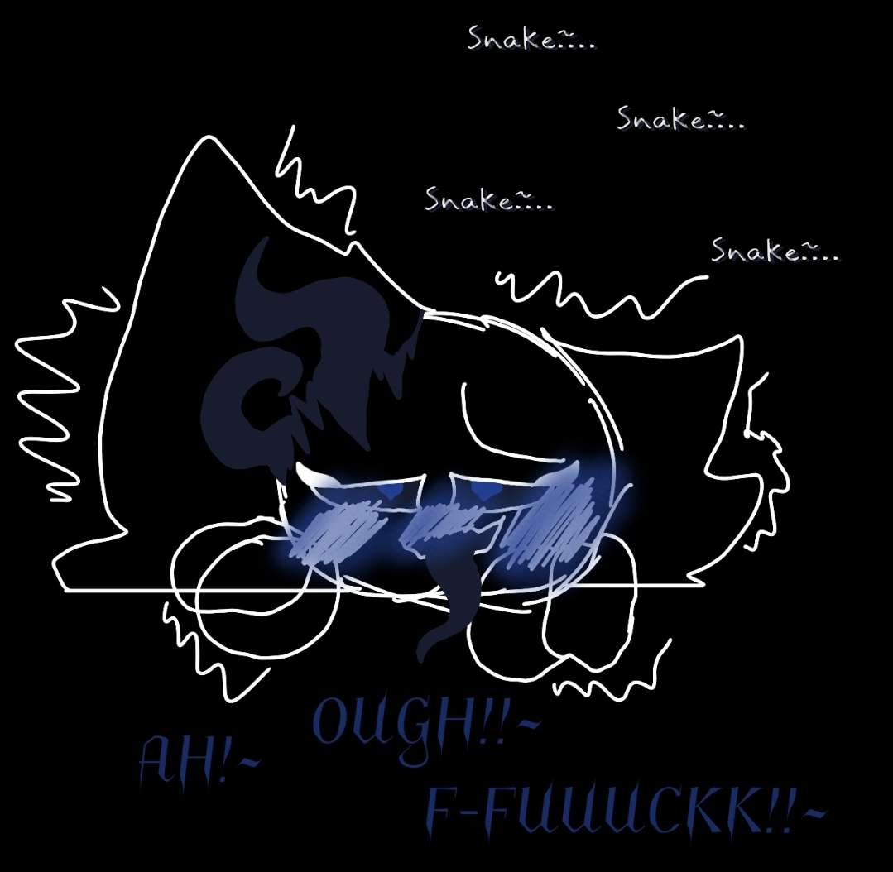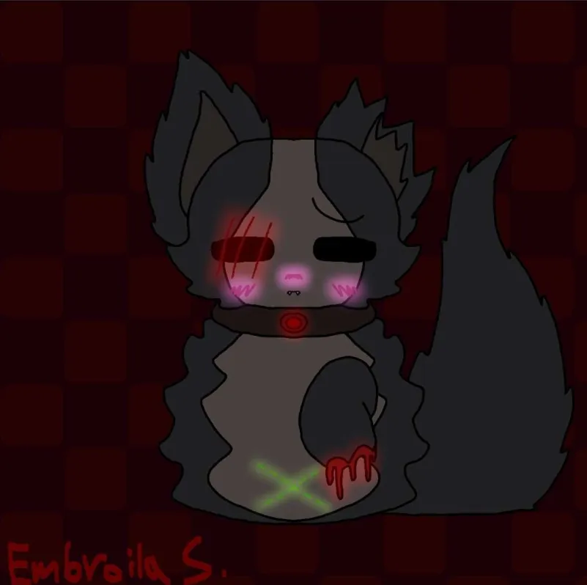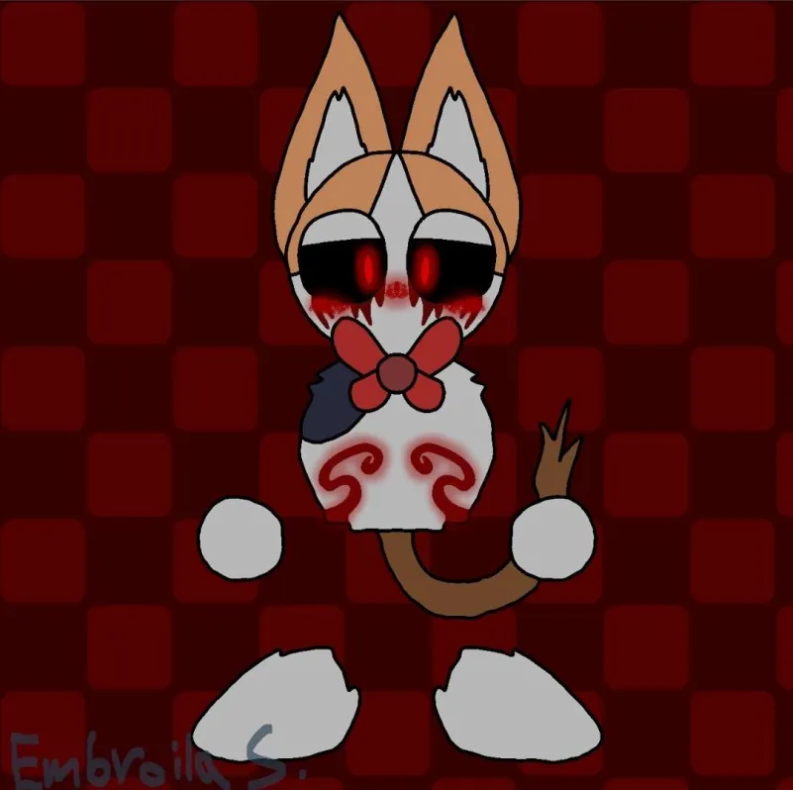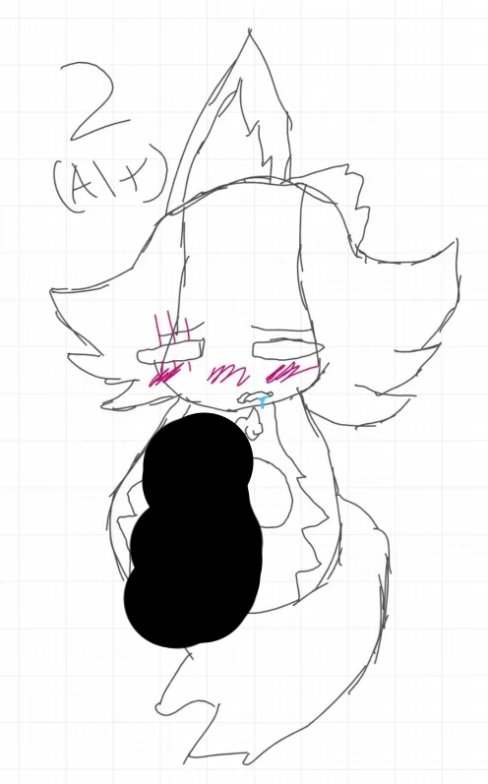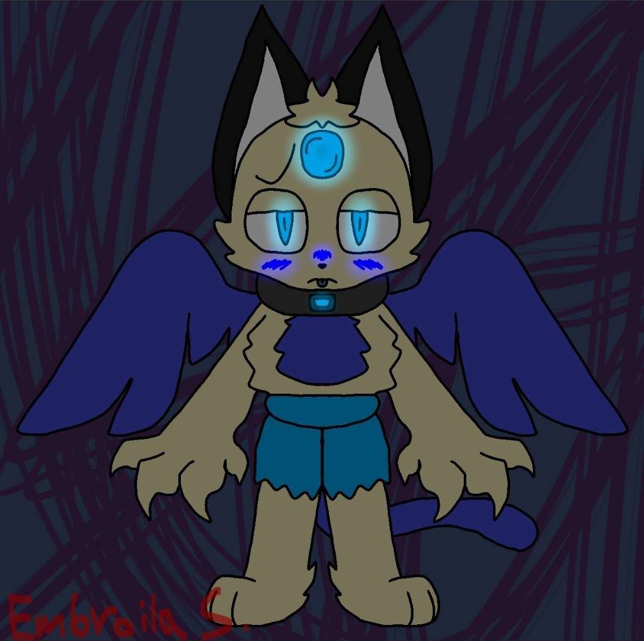
(This drawing was before Mikey was 18 years old)
(Hello, Mikey here. I wanna say that I gave her permission to draw my OC like this because we were dating until I found out what happened, now I regret letting her do this.)

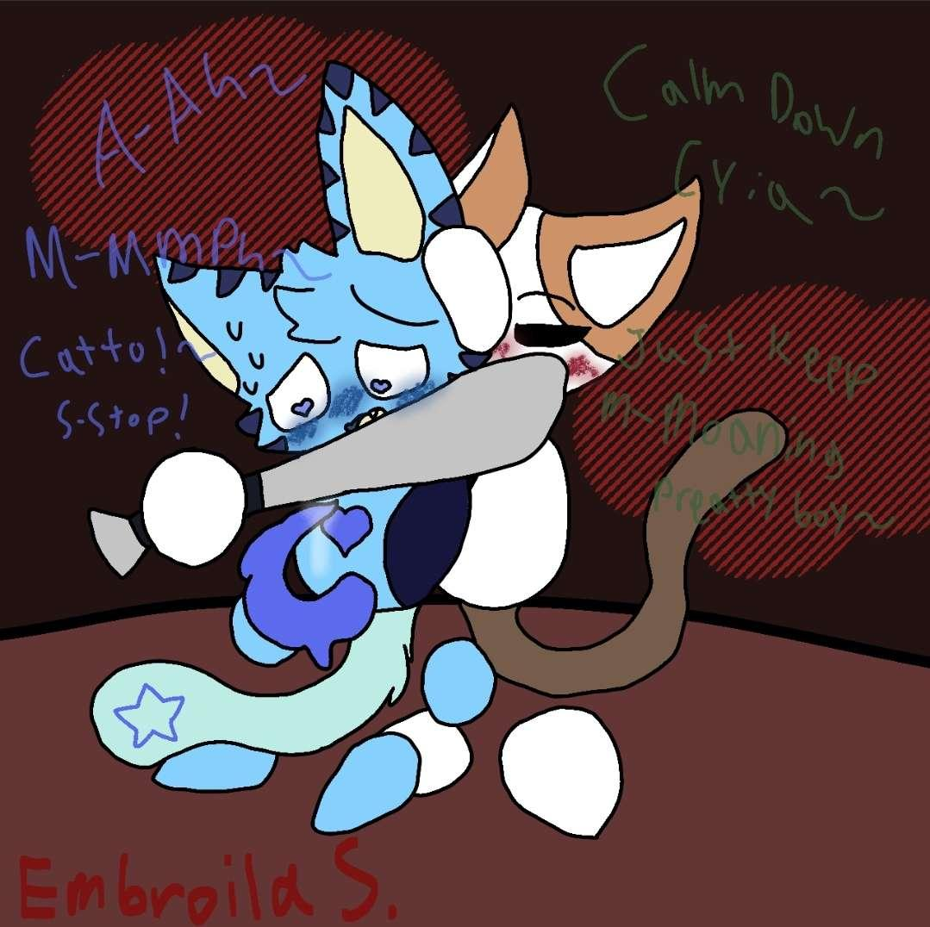

Embroila also drew Phelo’s OC named Eepy:
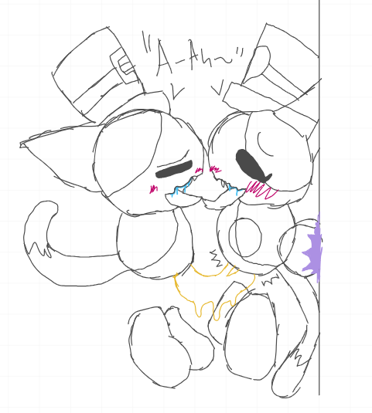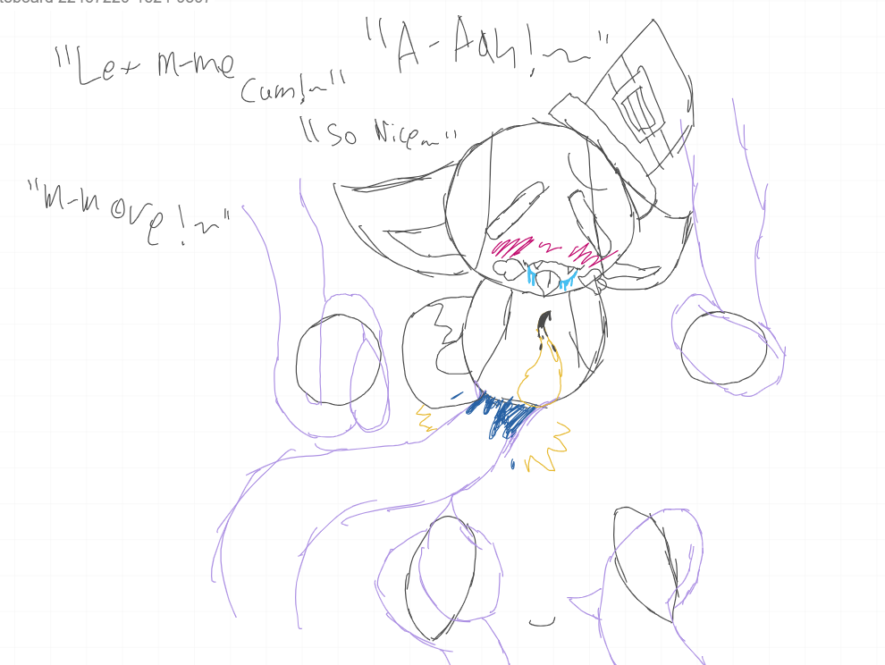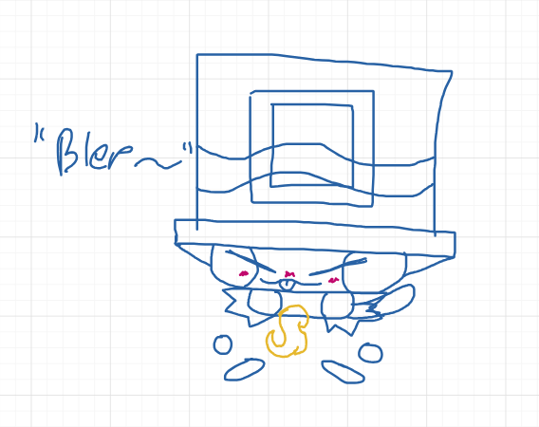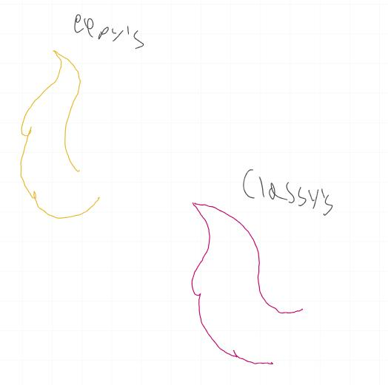
The creator of Eepy (Phelo) is 14, while Embroila is 17.

Videos
(Videos contain ERP and Moaning)
https://drive.google.com/file/d/1RFUa1nm8V_Ud1LwwAMLS_Ze-1Du7CLk-/view?usp=drive_link

https://drive.google.com/file/d/1S5AJD_7dTrVjQtKS-d2F9YRF-oMuHAxG/view?usp=sharing

https://drive.google.com/file/d/11wT5Z6JktV8uBYfiHYny73bfBNmY_272/view?usp=drivesdk

https://drive.google.com/file/d/1xAwm8lBYowxCJtnSpoPAd6dScurCFUa2/view?usp=drivesdk
(Thanks to Phelo for the proof and evidence and Bloxifilms too for most of the evidence)

Lying
Embroila also has also gaslit a lot of people about Phelo. That caused Phelos' friends to not be friends with them and make a document on him.
Screenshots:
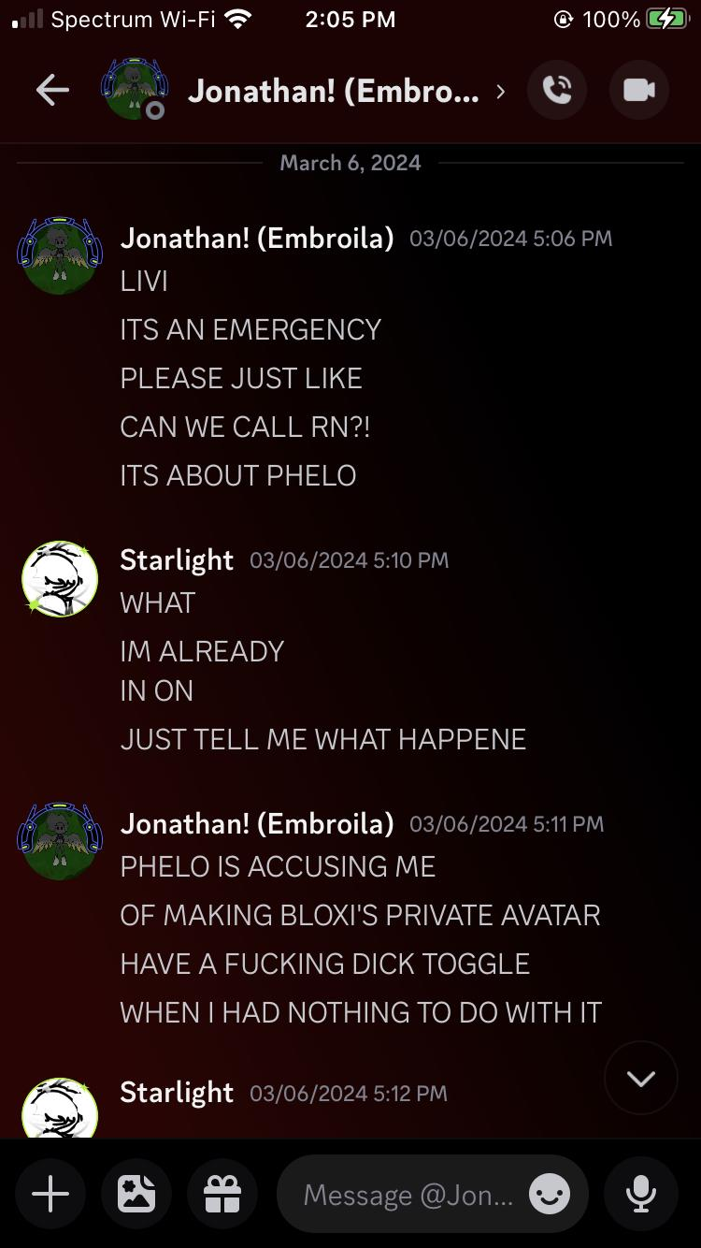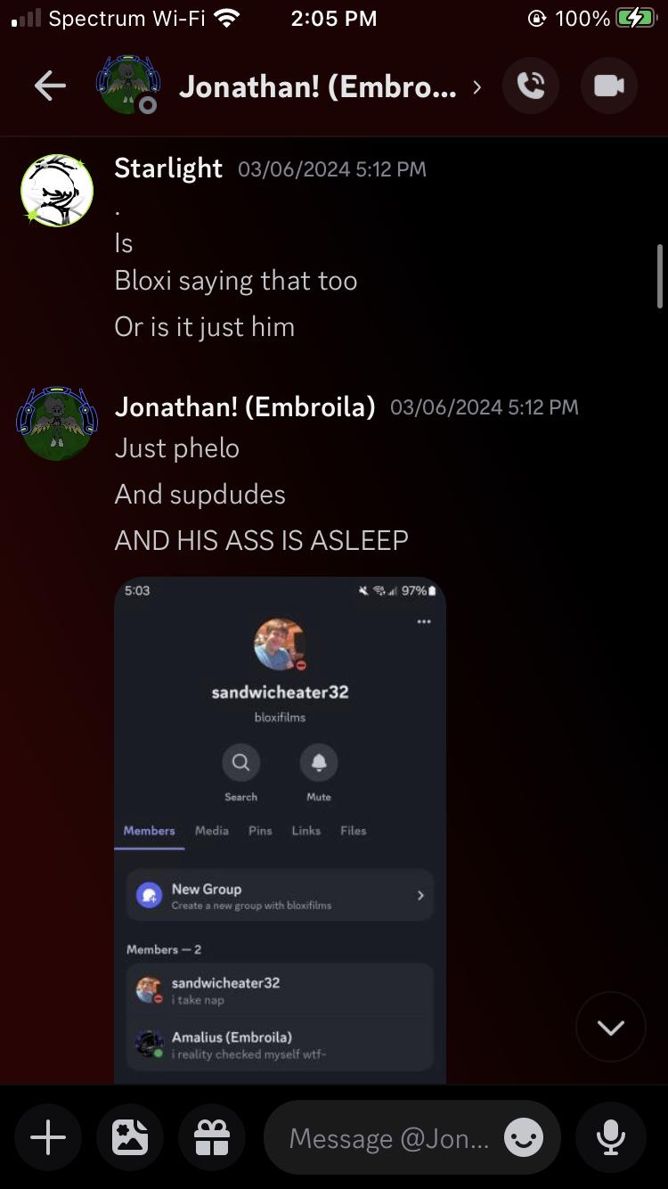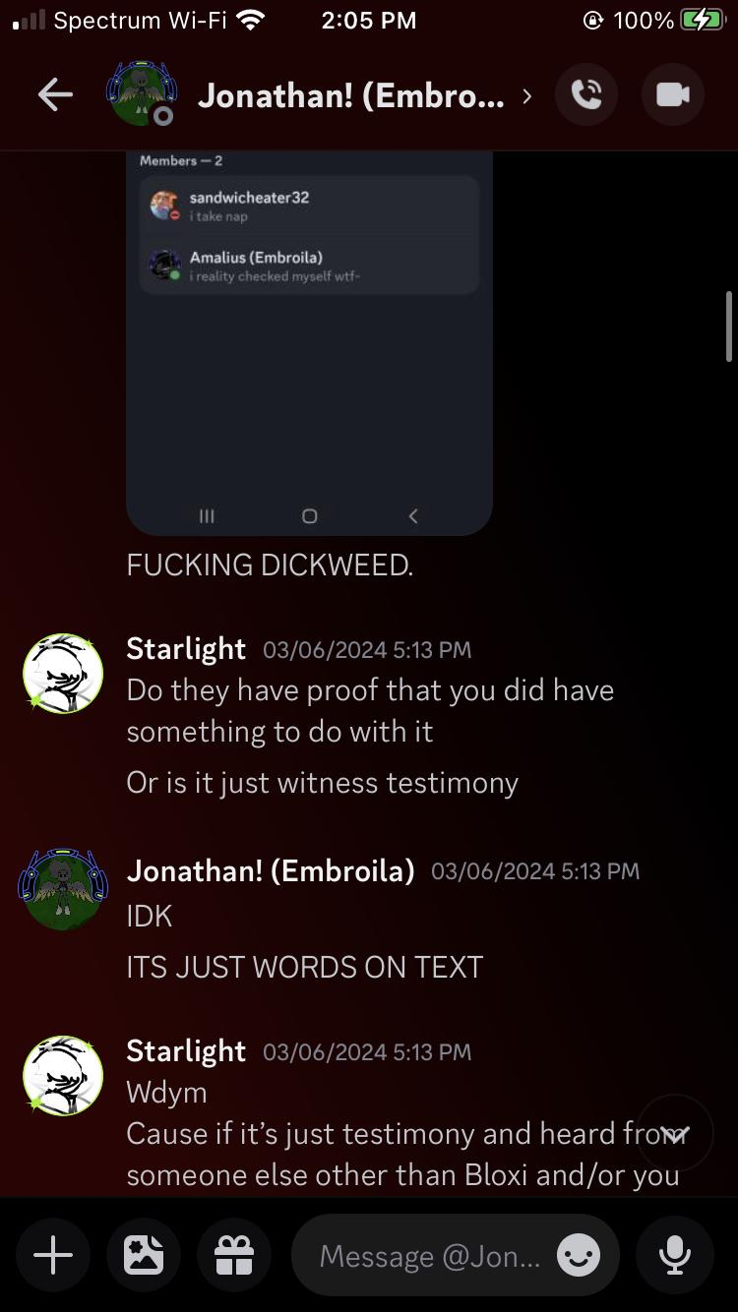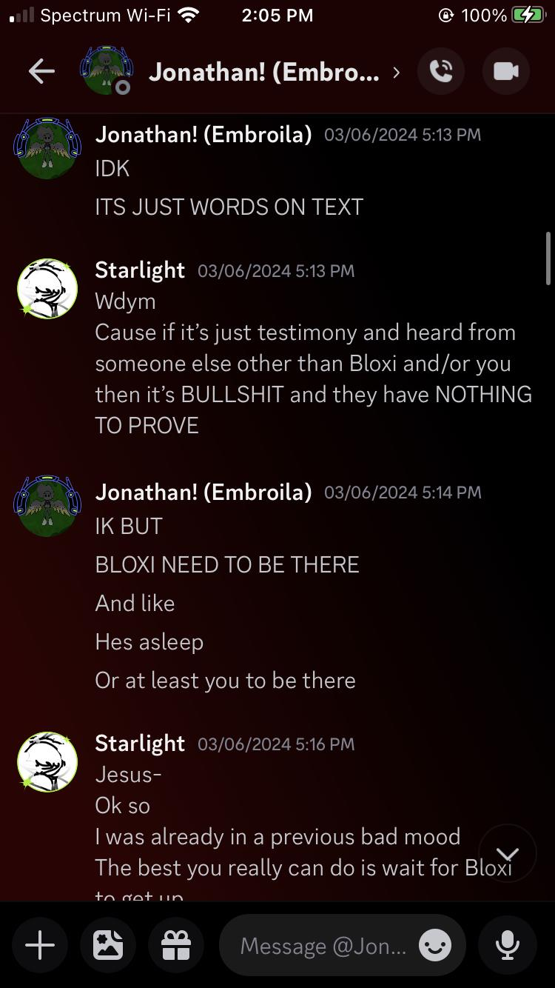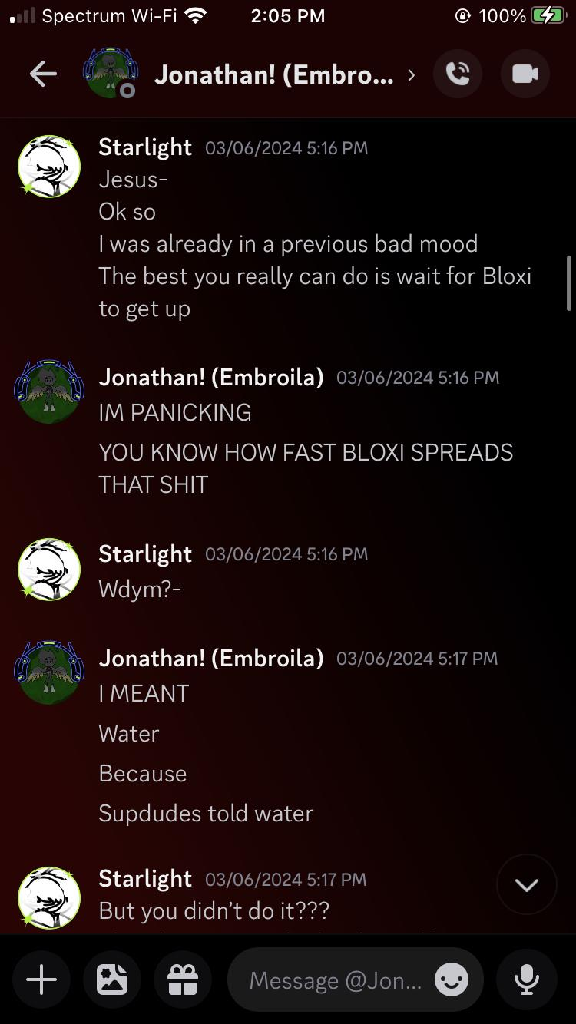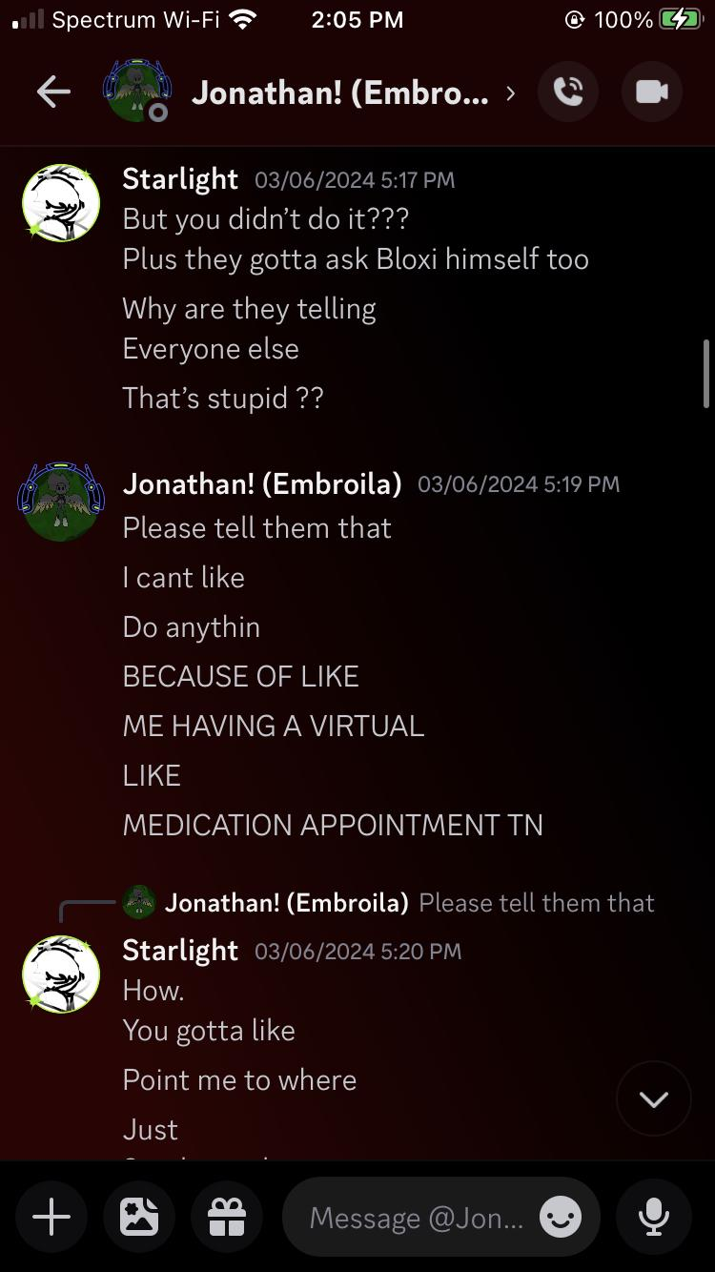

Trauma baiting
When Embroila was confronted with all of the evidence and her trying to take down evidence from Water. She made a group chat involving other people who didn’t know the full extent, or was added for no reason.
She proceeded to trauma bait and break down in a call in said group chat, before leaving for a bit to go on a walk with her mother.
After she came back, she tried to trauma bait again until her mother came on the phone.
These are recordings of said call. Recorded by Starlight
https://youtu.be/TMv_N0fqmFE?si=B-pmzwLlBYTLLqSL
https://youtu.be/3Euwoub3Hsw?si=wFe-9In-_B4GVruL

Analysis

9Phelo9’s Response:
Embroila I genuinely can't believe you will do this types of shit on me. We've been friends feels like 1 year and 1 YEAR. I honestly thought we were good friends. I trusted you, I cared about you. But no you had to groom me and manipulated me into being your partner and made me into a porn addict. I'm genuinely upset at you.. I trusted you.. take a break from the Internet.. and think about what you have done. Don't ever get near me and talk to me ever again…oh! Try to apologize to me. (Not) if you even fucking can. fucking groomer…
Goodbye embroila…
Bloxifilms’s Response:
I kinda thought of embroila as a good friend most of the time before we all connected the dots and pieces. The shit we found out made me realize the shit she did.
Your dms and your words are your worst enemy embroila.

Starlight/TheMushroomLady/Livi’s Response:
“ Im not very happy with you, embroila. Not only did you LIE to me about a lot of shit that you done. You also twisted things to make others seem like the bad guy. I trusted and believed you because you were my friend, and I thought you were hurt. But as it turned out, you were the one that hurt others.
Despite us being friends ever since around, what, 2018? You lied to me about everything and tried to make everyone else seem like the bad guy. You even got me to take down EVIDENCE because you convinced me it was something illegal.
For anyone who reads this. Please do not harass Embroila/Horror or anyone else. Just please show support to the victims of this whole thing. They didn’t deserve this. WE didn’t deserve this.
Embroila, if you’re reading this. This is something that was a long time coming. And you know it. “
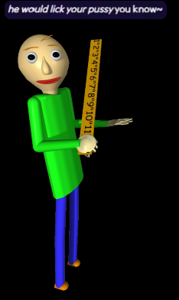

Mikey Boi’s Response:
Embroila, what the fuck is wrong with you? This whole situation is reminding of a drama I got into because I was threatened and manipulated by a 16 year old. (14 at the time.) You might’ve not threatened anyone, unless I need to check again but you did manipulate Phelo. I trusted you. I loved you. Even after all this time of me trying to talk to you and hang out with you, you ignore me because your friend group on Roblox is more important than me. Even when I sent you memes so I could get you to laugh, you mute my DM’s without telling me you were under stress. That’s when I decided to say I’m done with you. You did this to yourself. I hope you’re happy. And I bet cheating on me with a 14 year old was the best thing you’ve ever done. Fuck you, Embroila. I will ruin your life by spreading this shit. Goodbye.

Artificer’s Response:
Embroila, I fucking trusted you and it seems all you fucking do is ruin everything for everyone else. You constantly drag others into fucking drama and you are just a nuisance to everyone that was your friend. I will never unblock you, I will never talk to you again, Because I fucking hate you, Goodbye.

Yin’s Response:
"ok i'm gonna like keep this short and simple since i really don’t like you and stuff but
fuck you!!! good riddance you’re gone honestly like jesus christ man, after finding all this out too???
i already told nice about this and he agreed that what your ass did is disgusting, don’t show ya damn face around here again"

