Hello. I am sorry to have had to make this document, but as a fandom mom I truly cannot let this stand any longer

This document is about @punkquency on twitter/X
All I ask is for accountability to be taken.

(document is grey for any neurospicy friends who get eyestrain!!)

TW; RACISM , NECROPHILIA, SWEARING, MANIPULATION, GROOMING, PEDOPHILIA

CASE 1: NECROPHILIA
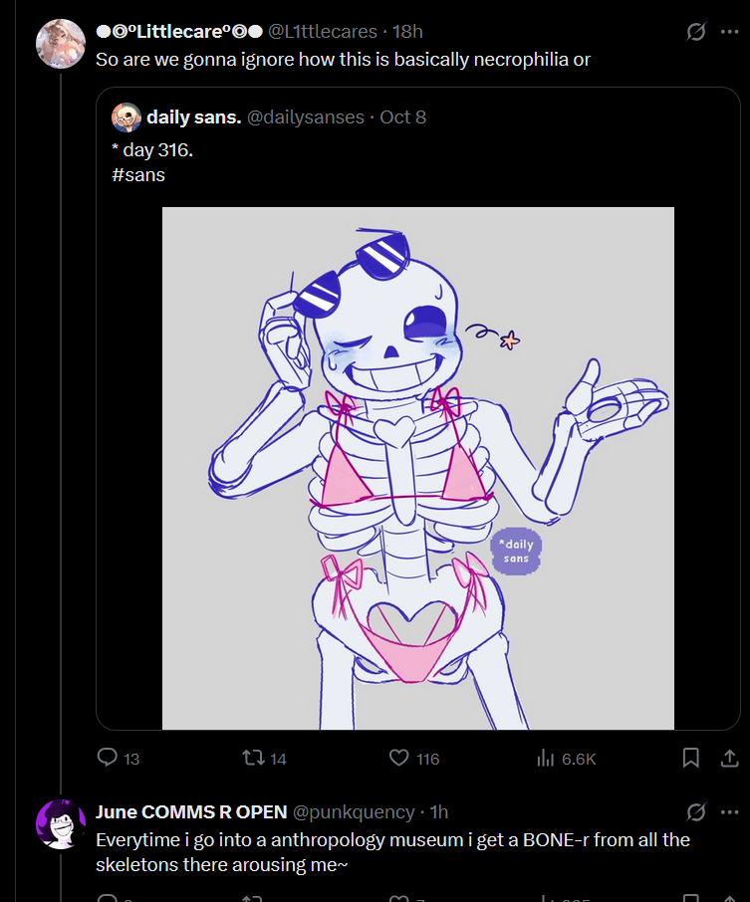This is pretty straight forward. Getting aroused by skeletons.

CASE 2: PEDOPHILIA
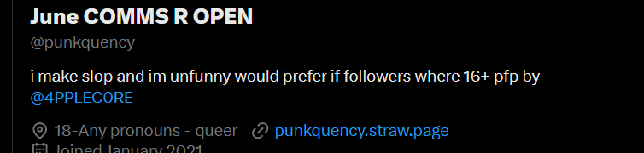
NOT an 18+ account, this borders on pedophilia because we already know this user is a necro, and there are dead minors out there. June is preying on minors and the dead.
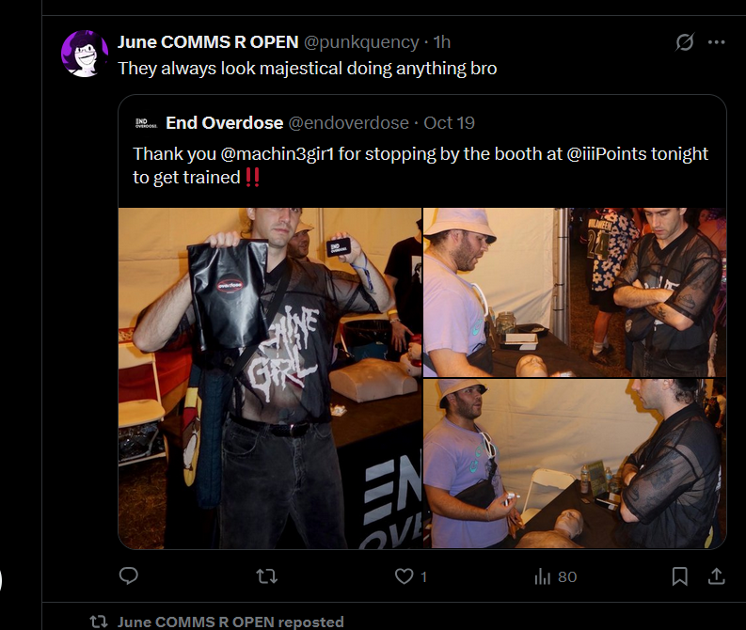
Calling a minor majestical..?
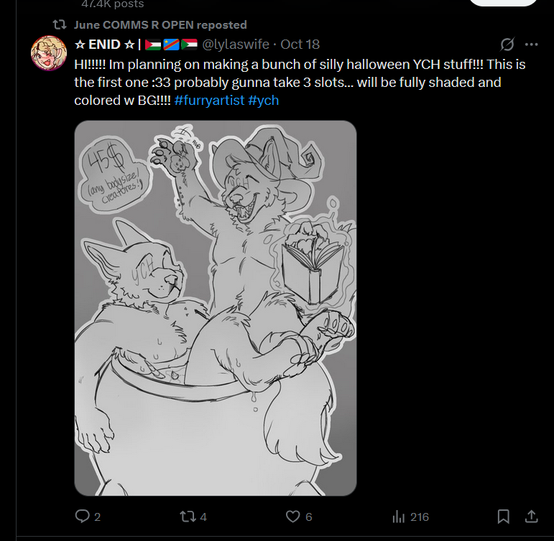POSTING FETISH ART. ON A 16+ ACCOUNT.
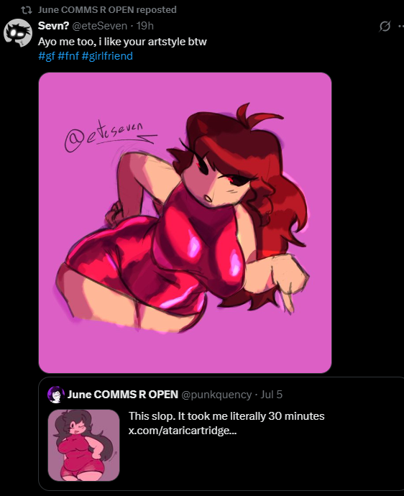sa

Same here and also, fnf art? Do we remember that its made by a pedo?? Also this art sexualizes women and uses ableist language. This might be the worst one yet
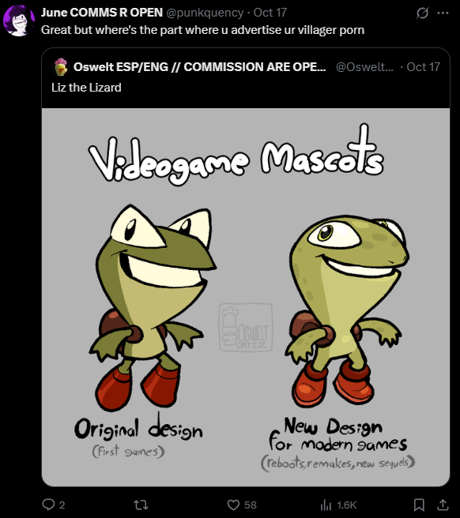
Again, advertising porn to minors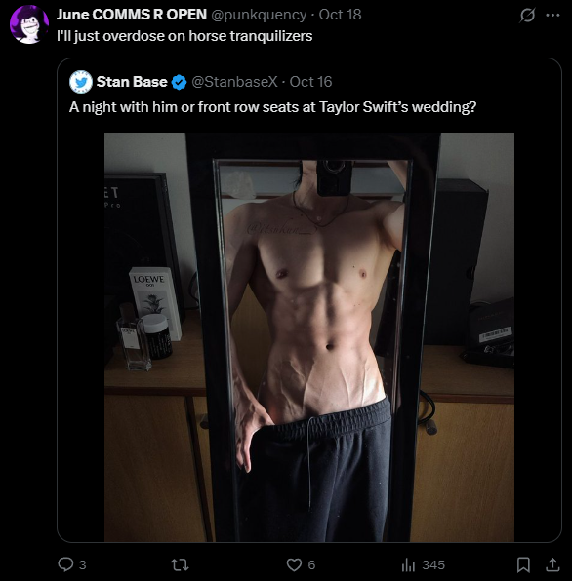
Whatever this is
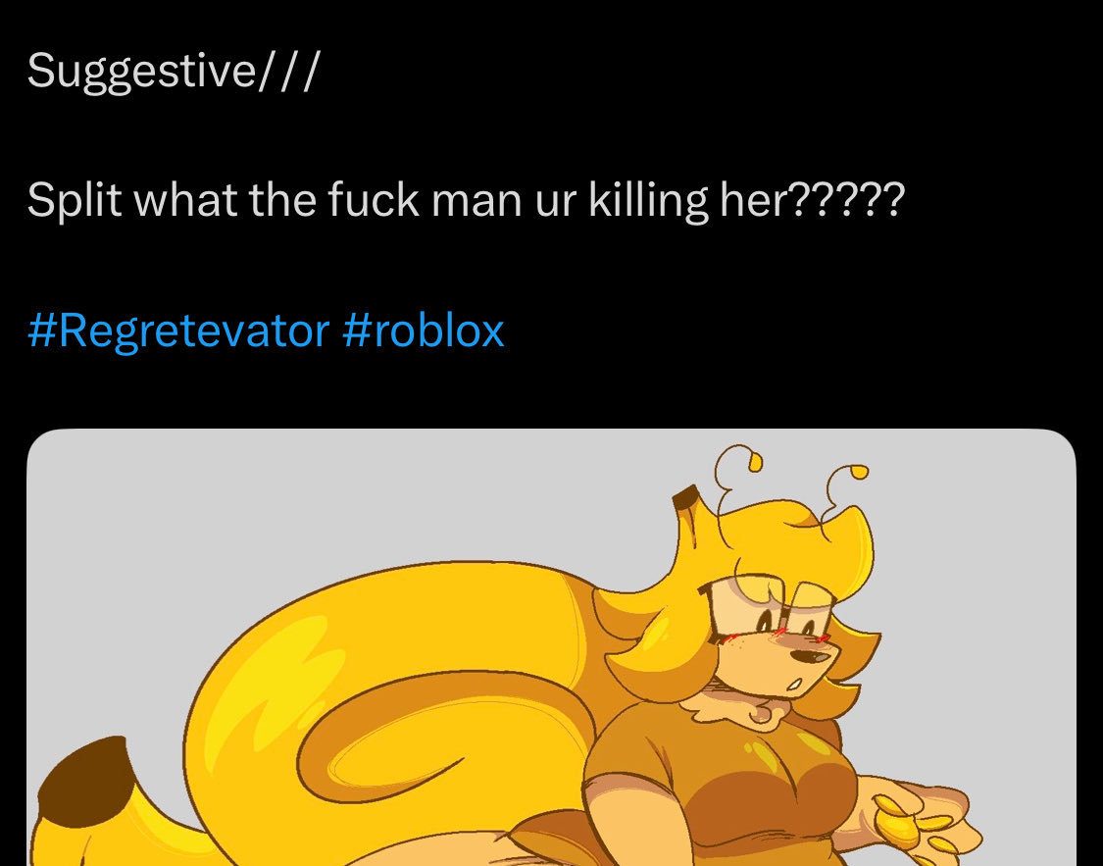
Posting suggestive art which again, doesnt belong on a 16+ account, the creator of this character said not to make nsfw, AND sexualizing women.
Side note, this is fatphobic, because she is crushing someone with her weight..come on, do better

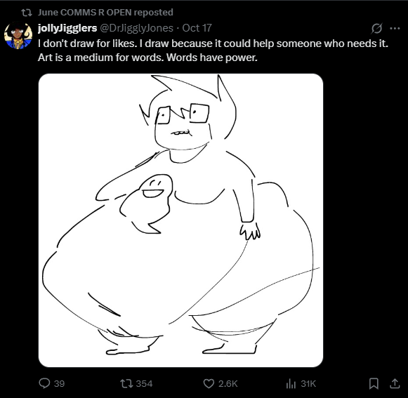
FAT FETISH ART OF A MINOR CHARACTER.

NOTE
I know 16 year olds and up are more mature, but they are still minors and it is messed up to include them in your fetish. If June is a minor, then they need to get off of twitter! The only expedition to this is if they are older in body and are an agere. But this still does not excuse their other actions.

CASE 3: GUILT TRIPPING/MANIPULATION
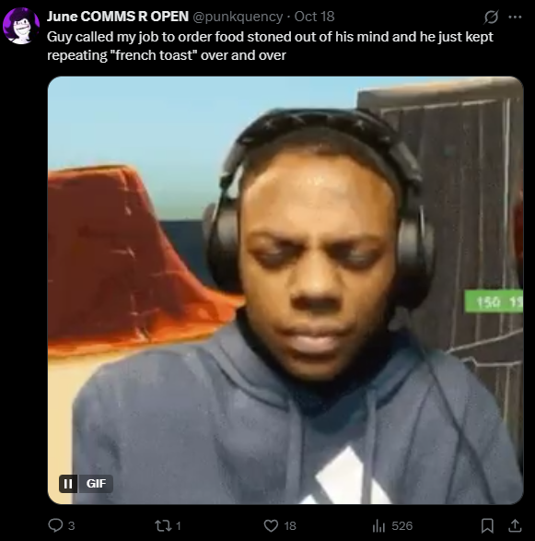
Watched someone die of weed overdose and just laughed?? You’re fucking disgusting

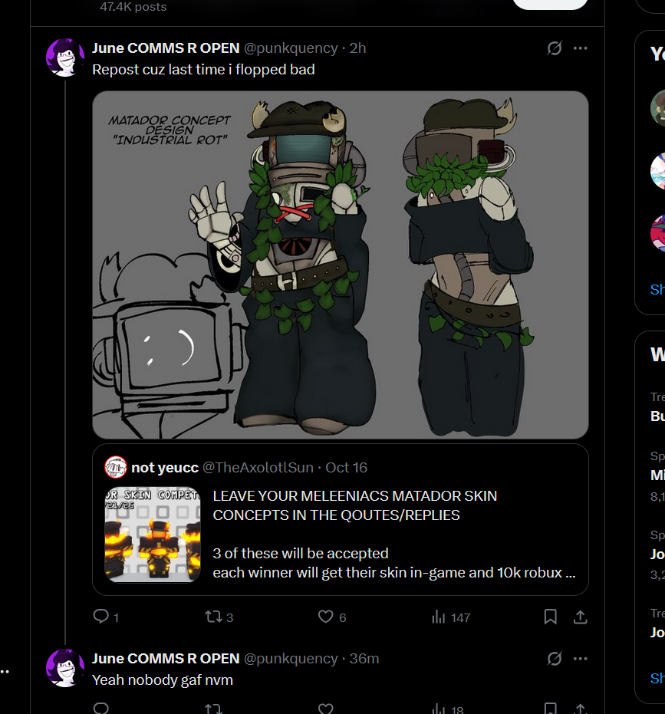
Begging for interaction via guilt tripping minors, as it is an 16+ account and not 18+
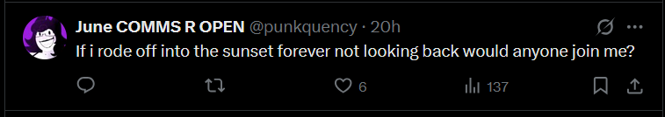same here

CASE 4:RACISM
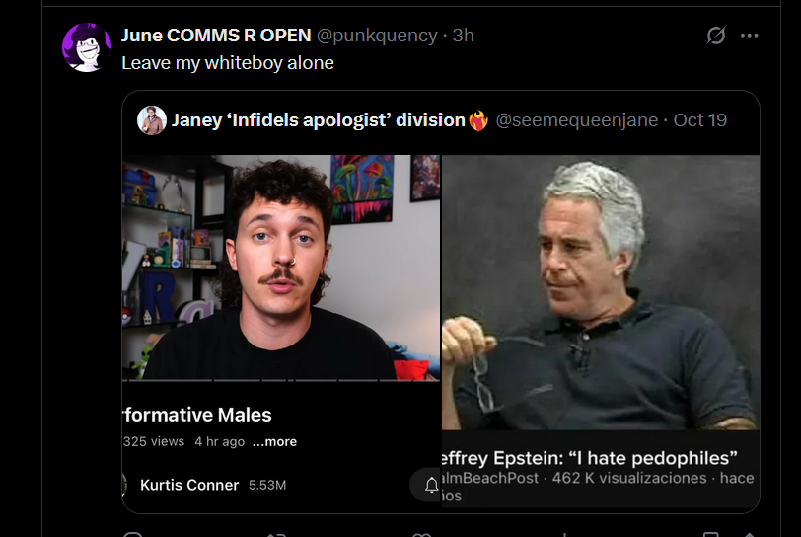
Thinks cishet white men can do no wrong? Ok..
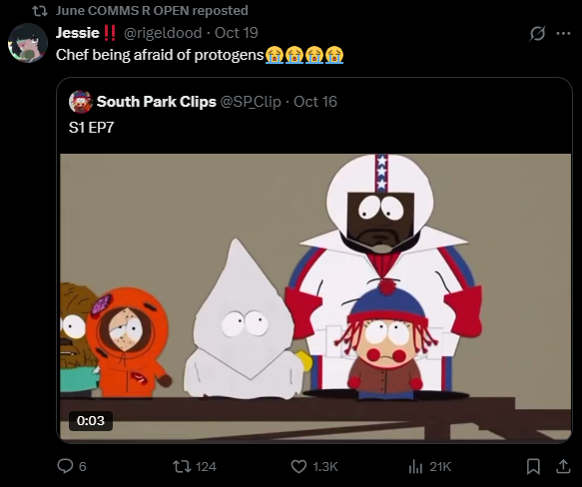
Reposted someone in a kkk outfit
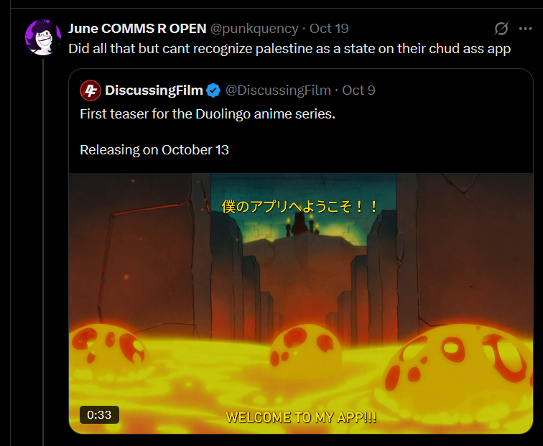
Against learning new languages. Ignorant white

CASE 5: SEXISM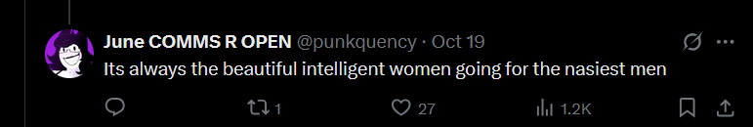
Misandry IS harmful. Come on, we can do better.

MY STATEMENT
I have talked personally to June, and iv been hurt by their words in the past. They are truly a revolting individual and I think they need to be deplatformed for the sake of respecting the dead, and the saftey of minors.
As well as this, their friends defend them and all need to also be removed. Here is proof of them defending June’s necrophilia.
