DOCUMENT
RAINX & PB LOOMER EXPOSAL DOCUMENT
Written since: 28/01/2025 (dd/mm/yyyy);
Date published: 02/02/2025 (dd/mm/yyyy).

NOTES:
- This document serves as a source of information. The primary purpose of this document is to inform bystanders on the various aspects of the situation between Rainx and Alex, and it’s not meant to slander anyone involved with the situation.
- The writers of this document will try their best to provide evidence on almost every claim on the Google document.
- The situation that this Google document is talking about will likely be documented retrospectively, but the document will try explaining everything chronologically.
- This document will tackle manipulation and relationship issues in a very confusing issue; please refrain from reading this document if you aren’t comfortable with such subjects.
- Engaging in any behavior that could be perceived as harassing or condoning harassment is not allowed, regardless whether the actions of the person being harassed are deemed morally reprehensible or not.
- In the Google document, there are numerous paragraphs that contain a mix of testimonials provided by Rainx's ex-partner Alex and Rainx himself. This document will try to take all sides of the story. Full objectivity isn’t guaranteed due to the fact that Rainx doesn’t have contact with the writers of this document.
- For the claims that do not have proper evidence or are just hearsay, the reader will be notified of the content of such—in other words, take them with a grain of salt and approach them with skepticism.
- Similarly, noteworthy people, aspects, and terms in the document will have their names emboldened only once.
- Additional footnotes will be added to some pages to clear up any potential confusion that might arise from the text. Most of them will be used to add emphasis to statements or to provide elaboration on a person or the story in order to ensure minimal confusion to the reader. They will be located at the bottom of each page.
- As stated before, this document likely isn’t 100% substantiated or correct, and the writers will try to update the document regularly if new details or evidence arise in the future.

PART I

Before the entire event, Rainx and Alex met as acquaintances during a voice chat session in June, during summer 2024. For her birthday, Alex was gifted Nitro by Rainx, which led them to get along and begin knowing each other well. Alex has vaguely described him as being “very nice” to her while also telling her that he loved her; at the time, Alex thought it was purely platonic on his part, so she went along with it until he confessed his love to her while she was still thinking whether she was bisexual or lesbian. She said she'd think about his offer, and at the end of July, they officially got together.

For context, Rainx is the owner of a Pretty Blood fan series called Pretty Blood Loomer (almost always shortened to “PB Loomer”), which is a series about Gerald Henderson, a vigilante turtle malino who hunts down, tortures, and murders Pretty Blood members and people alike under the false disguise of an independent jazz musician. The fan series bears a strong similarity with a commissioned Pretty Blood series, Just A Neighbor, which was commissioned by Klingard Bieckle (shortened to Kling; his OC bears the same name). Coincidentally, he is Rainx’s former friend and Alex’s current one.

There are theories that Gerald from Pretty Blood Loomer is just a self-insert of Rainx. There is no vital evidence to support this; however, if it is true, it could be considered concerning due to Gerald’s moral philosophy.

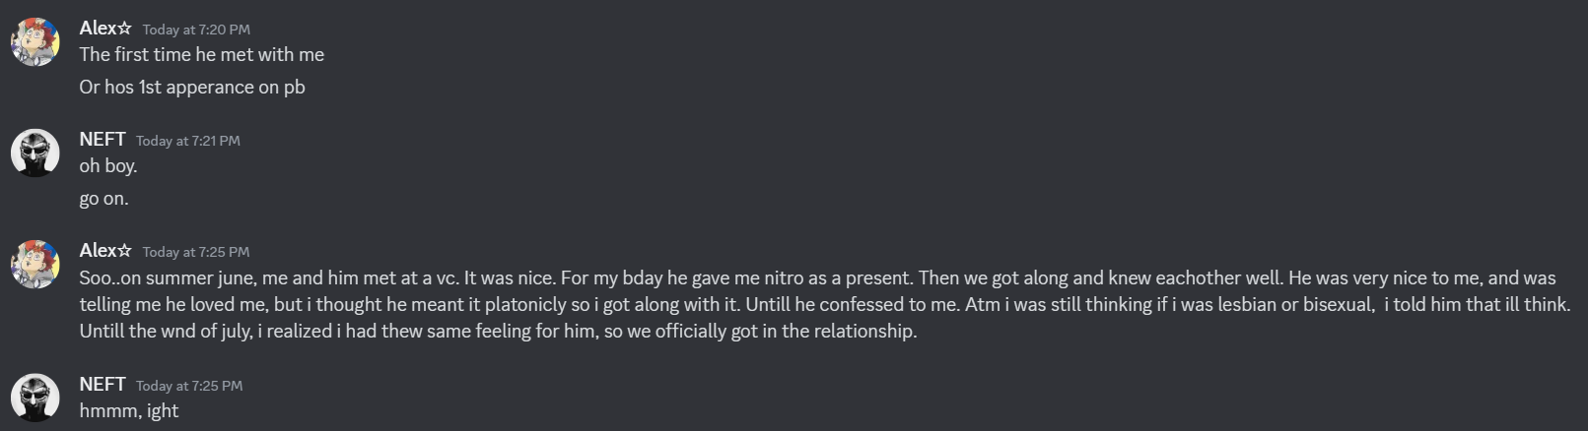
As for Alex, she is the creator of a PB OC and persona, Sara, a friend of Kling who aids him in killing Pretty Blood members in the Just a Neighbor series. As stated before, she has connections with Kling, who was Rainx’s friend (at that time; in other words, not anymore).

During the end of August 2024, Rainx suddenly began ghosting Alex all of a sudden. Due to the fact that Alex herself has confirmed—or, at least, implied—that she has attachment issues (while Rainx has anger issues), this intensely worried and stressed her out. It would later be revealed that the reason Rainx has ghosted and ignored her is because she managed to piss him off when she supposedly made fun of him for having an outburst on a voice call and spamming soundboards, after which she would apologize to him profusely.

(Note: Alex’s messages are written weirdly due to the fact that she was in a rush.)
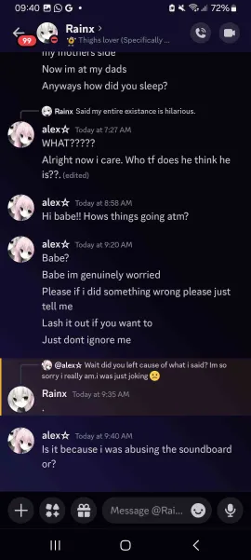
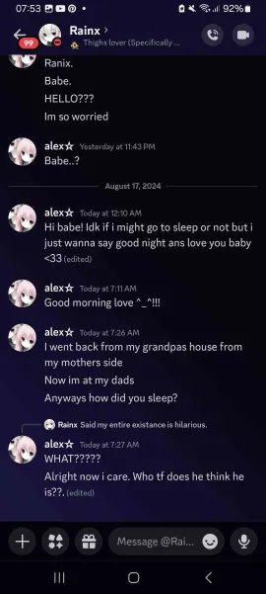
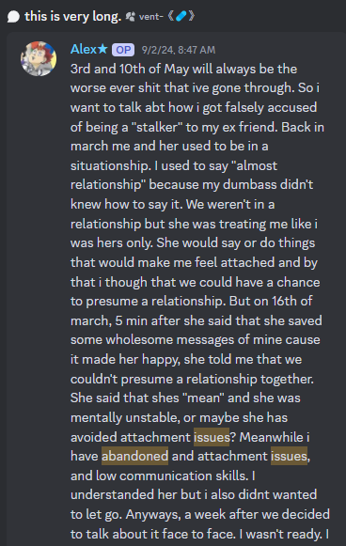
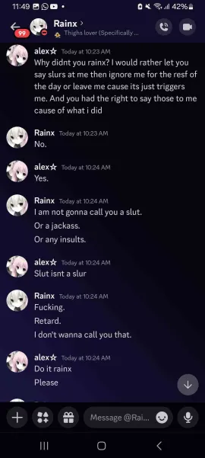

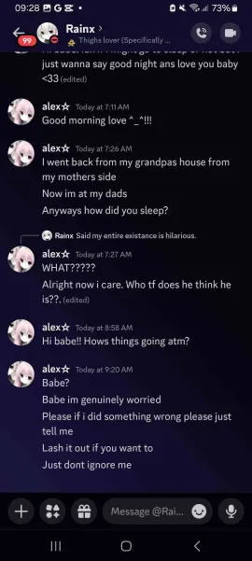
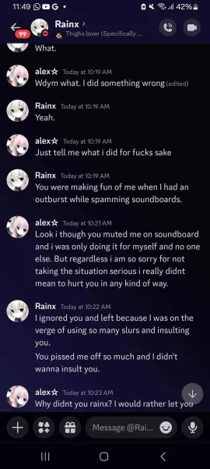

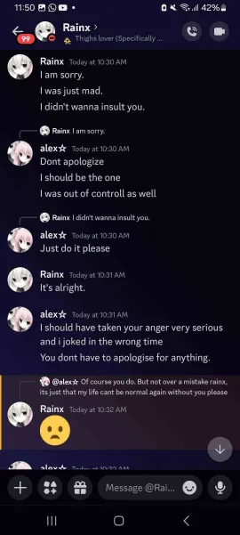
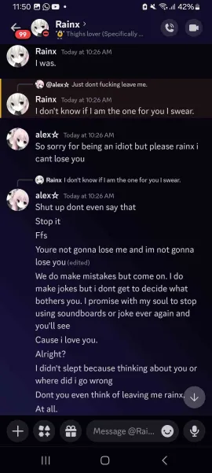
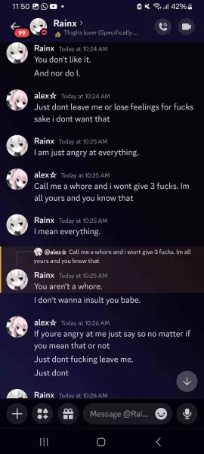

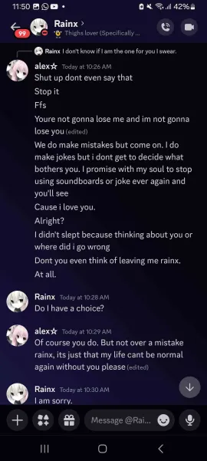

Eventually, Rainx started doing more of the things that Alex defined as “silent treatments” (i.e., Rainx’s tendency to ghost Alex for a few days in a row). When Alex chose to vent in public (in other words, when she chose to vent in the Pretty Blood Silly Friends Server), it made some people (especially Ubo and Roz) criticize Rainx for his actions, which caused him to become even less talkative and more negative.

“From the very start, everything seemed fine, but over time, he started acting distant—barely texting me, giving dry responses, and making me feel like I was the only one putting in effort. When I vented about it because I was genuinely hurt and confused, he got mad at me, acting like I was talking badly about him instead of realizing I was just trying to express how I felt. Then, people started calling him a ‘bad person’ or a 'red flag’, which made him withdraw even more, but instead of actually communicating with me about how he felt, he started making me feel like I was the one hurting him. Eventually, he gave me the silent treatment, completely ignoring me for days, leaving me anxious, scared, and desperate for any kind of response. I didn't know what to do, so I leaked messages looking for help, but instead of understanding why I did it, he made me feel like I was a terrible person for it. [...]” (A bit from Alex’s paragraph)

From Rainx’s perspective, he might have felt “betrayed” when Alex was trying to reach out, which resulted in him shutting her out, even after she apologized and “did everything she could to regain his trust,” as she’s stated. Rainx isolated and distanced himself more, and it all bubbled up until Rainx decided to end the relationship completely, which, as Alex states, broke her.

“[...] He saw it as betrayal, even though I was just trying to reach out because he was shutting me out. Even after I apologized and did everything I could to regain his trust, he still held it over my head, making me feel guilty, like I was the one who destroyed everything when in reality, he was the one who abandoned me first. Then he unfriended people, isolated himself, and kept acting distant, like I was the one who needed to prove my worth to him. He broke up with me on a Friday, and it destroyed me, but after some time, he came back with an apology, acting like maybe we could get back together in a few weeks or months. And when we did, things got even worse. He started isolating me from my friends, calling it a ‘boundary,’ but in reality, it was just control. [...]” (The second bit from Alex’s paragraph)

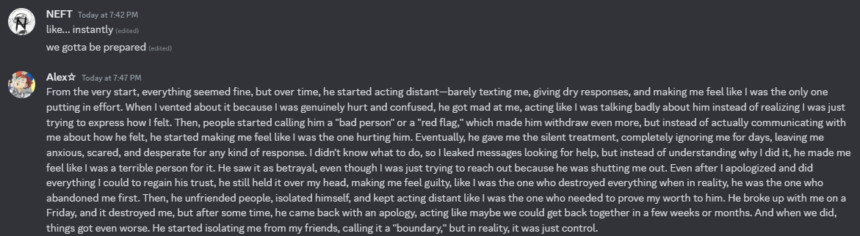

Here is where Rainx’s controlling behavior starts: He told Alex to leave every Pretty Blood server, which she did, as she states. He didn’t want her talking to people who supported her, and due to the fact that she and her friends were close, she lied about blocking them, which led Rainx to find out and gaslight Alex later by convincing her that she supposedly “betrayed” him.

“He told me to leave each PB servers [sic], which I did. He didn’t want me talking to the people who actually supported me, and I was scared of losing them, so I lied about blocking them. I didn’t want to cut them off because they were the only ones helping me through everything, but he made it seem like I was betraying him just by keeping my friends. This happened around five times[;] [h]e would try to break up with me, [and] block me, and every time, I was so desperate that I made new TikTok accounts just to text him, begging him to come back. And every time, I thought we could fix things, but the cycle just kept repeating. He manipulated me into thinking everything was my fault, that I was the problem, that I had to change to make things work, when in reality, he was the one constantly hurting me. [...]” (The third bit from Alex’s paragraph)

According to Alex, Rainx has gaslighted her to a long extent into doubting her feelings and making her think that she was overreacting for being upset at the way Rainx was treating her. He would even call Alex a “whore” and a “lying sack of shit” one time. Their relationship would end shortly after with a short message: She says that she has been gaslighted, controlled, and emotionally manipulated by Rainx while not being able to meet his standards herself and having to deal with the fact that Rainx was victimizing herself.

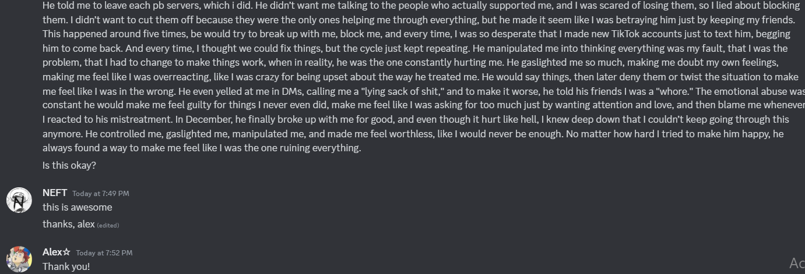
“[...] He gaslighted me so much, making me doubt my own feelings, [and] making me feel like I was overreacting, like I was crazy for being upset about the way he treated me. He would say things, then later deny them or twist the situation to make me feel like I was in the wrong. He even yelled at me in DMs, calling me a ‘lying sack of shit’, and to make it worse, he told his friends I was a ‘whore’. The emotional abuse was constant[;] he would make me feel guilty for things I never even did, make me feel like I was asking for too much just by wanting attention and love, and then blame me whenever I reacted to his mistreatment. In December, he finally broke up with me for good, and even though it hurt like hell, I knew deep down that I couldn’t keep going through this anymore. He controlled me, gaslighted me, manipulated me, and made me feel worthless, like I would never be enough. No matter how hard I tried to make him happy, he always found a way to make me feel like I was the one ruining everything.” (The fourth bit from Alex’s paragraph)
Here are the screenshots proving the earlier statements.

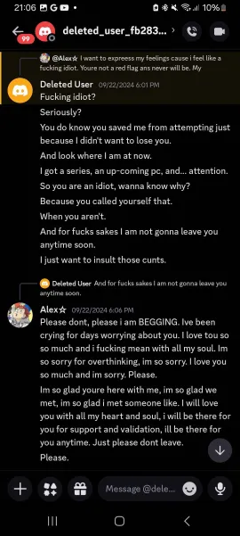
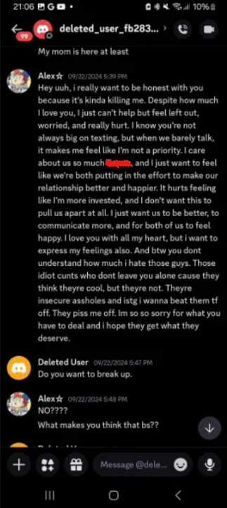
From a logical perspective, this could be seen as the perpetrator guilt-tripping someone into continuing to be in a relationship with them. Rainx also knows that Alex is sympathetic and has attachment issues, which would make his actions scummy. However, if, by some off chance, Rainx didn’t mean to be manipulative, it could be argued that he handled the situation extremely poorly. Rainx has also claimed that he was “holding back the urge” to doxx Ubo and Roz.
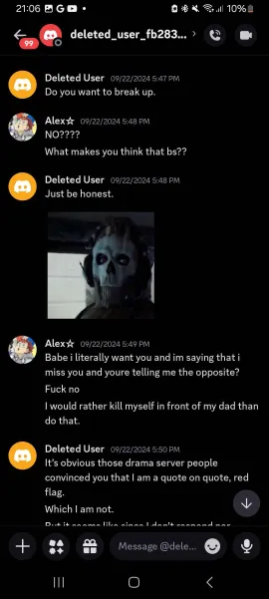
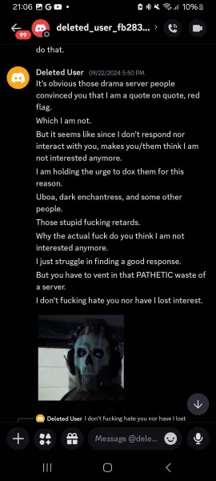
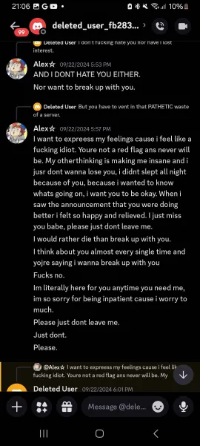

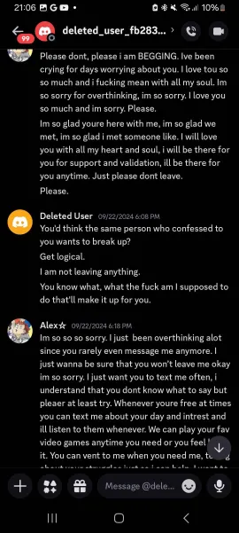

Rainx has also accused Alex of trying to pressure him by venting and getting some, quote unquote, “stupid ass people to say things about me that aren’t true.” Given the circumstances, it can be said that Rainx is just trying to project his issues onto Alex.

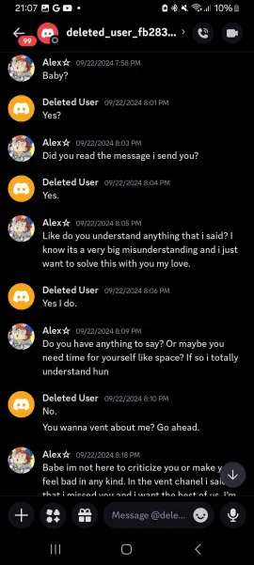
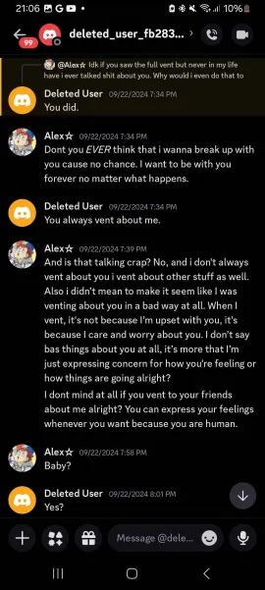

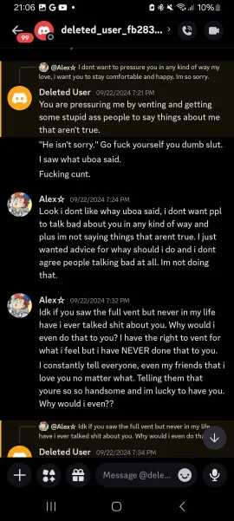

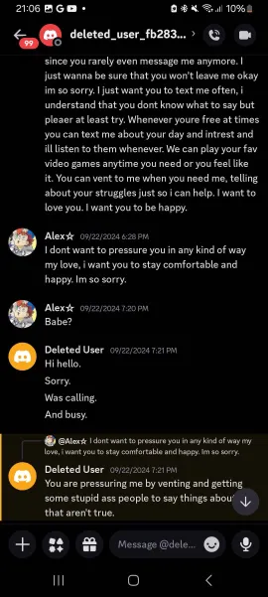

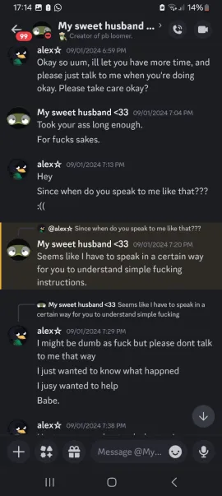
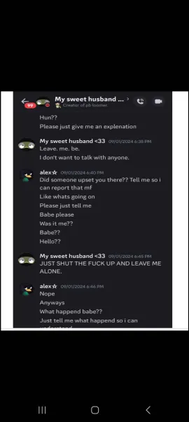

Rainx would say that this sort of thing happened four times beforehand in a way to justify his actions. Even with that statement, it could be agreed upon that he handled the situation in a very poor manner, as he usually does with other relationship-related issues.

While it's true that anger issues can influence a person's behavior, they don't necessarily excuse harmful actions. Understanding the reasons behind someone's anger can help in managing it, but it doesn't mean that harmful behavior is acceptable or without consequence. Everyone is responsible for their actions, regardless of underlying emotional or psychological challenges.

During circa November 2024, both Alex and Rainx have “settled stuff” in November, which inevitably ended next month, during December.
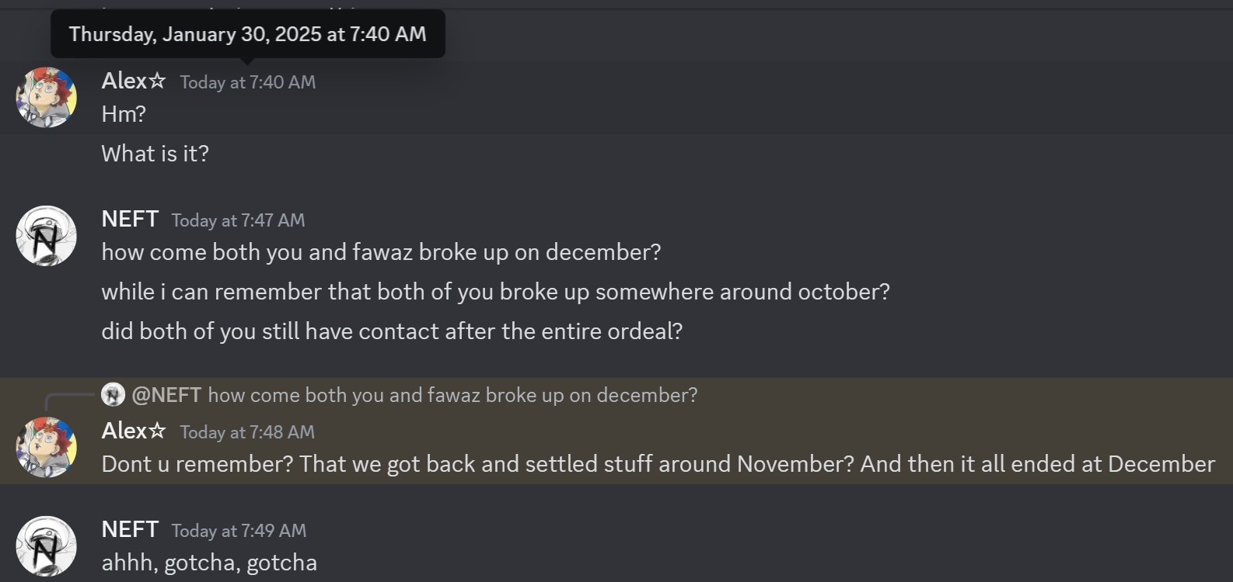
During this time, Rainx was more desperate than anything. He attempted to contact Alex, which was successful, and he managed to talk to her from mid-November to the other half of December. Without Alex’s permission or consent, Alex’s vents on the PB Drama server were leaked to Rainx by a person named TheEnjoyer.

Rainx supposedly freaked out and told the leaker that Alex needed to unblock her. Alex was very reluctant and wanted to be left alone; even so, Rainx was eager and he begged to “help her” while suffering from an outburst midway talking to her. He also allegedly attempted suicide by shooting himself in the chest during this time—though no proof of this was ever shown, neither to Alex nor to the public.

During the conversation, Rainx implied that he had cut himself and bled out, which caused Alex to become worried sick for him, even attempting to call a few times while spamming his name in his DMs.

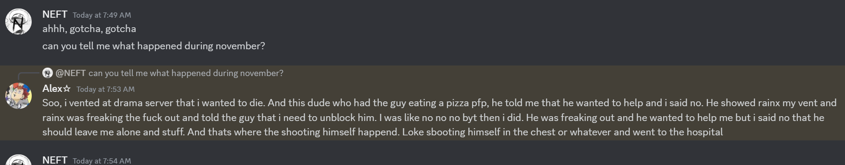
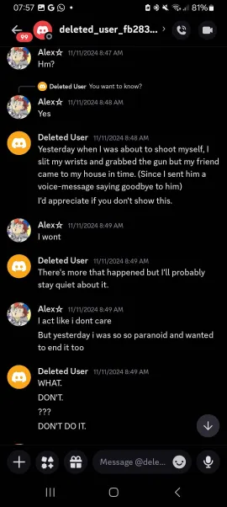
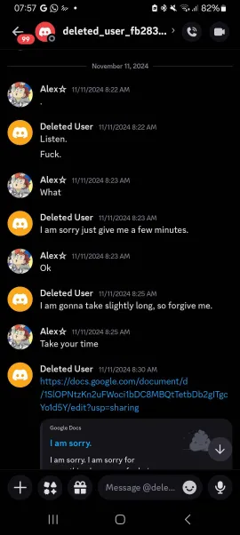
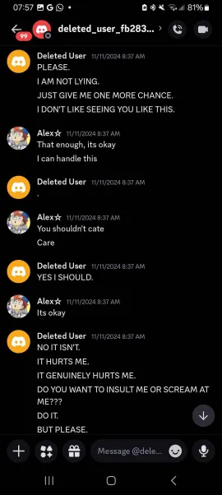
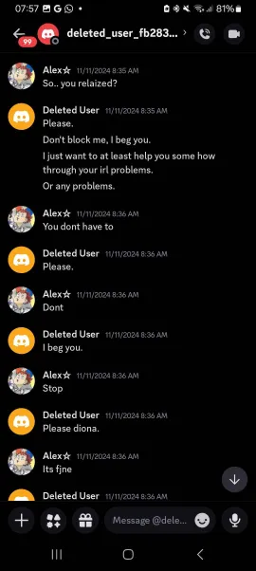
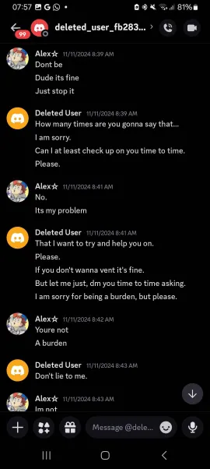
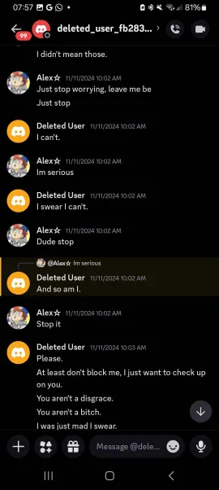
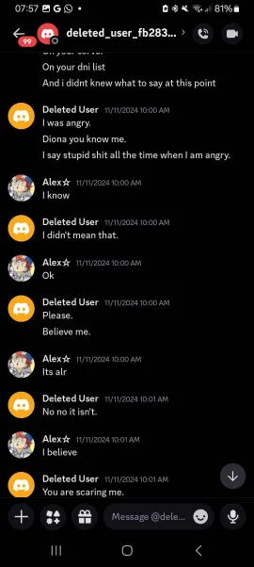
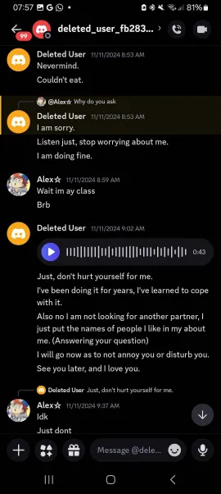
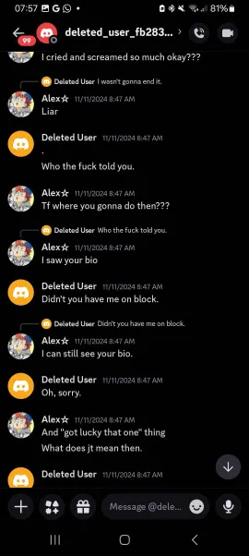
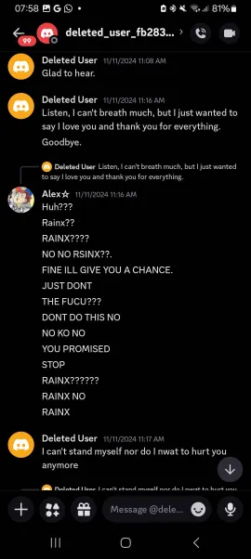
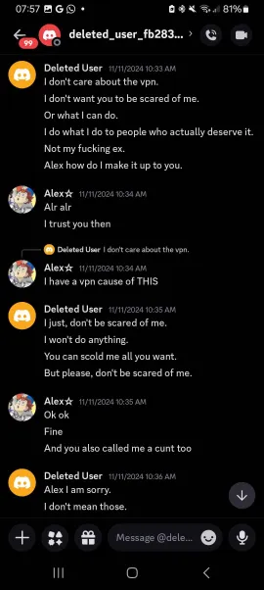
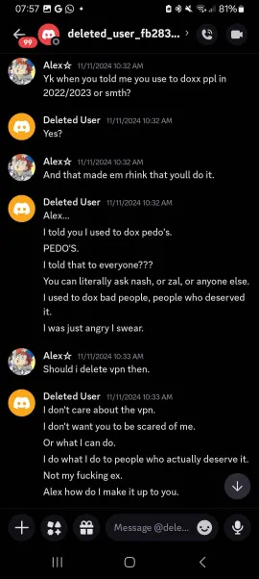
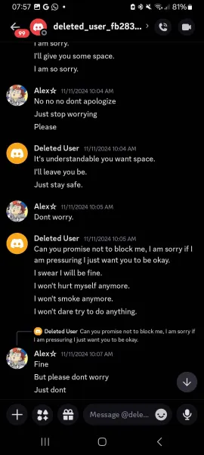
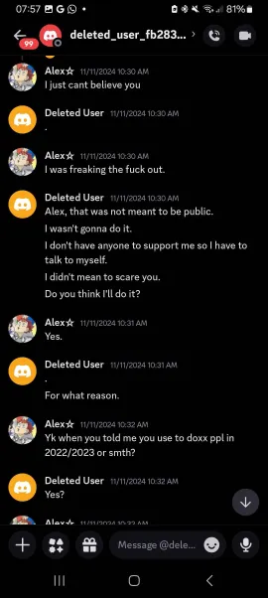
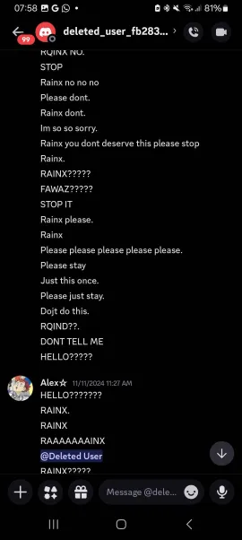
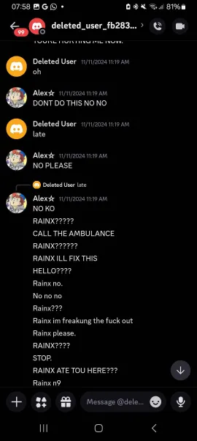
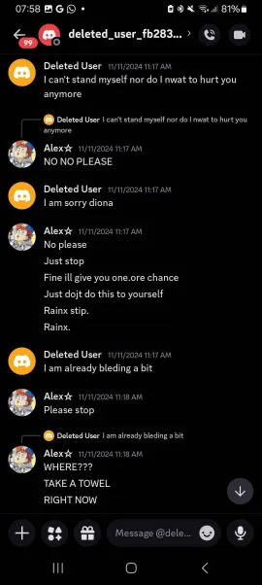
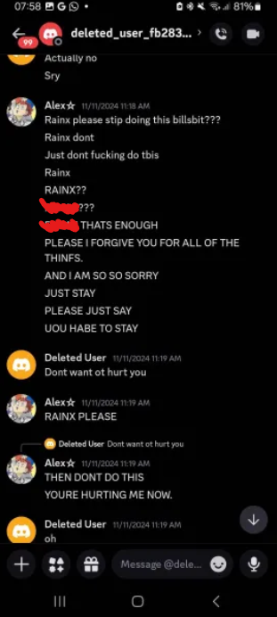
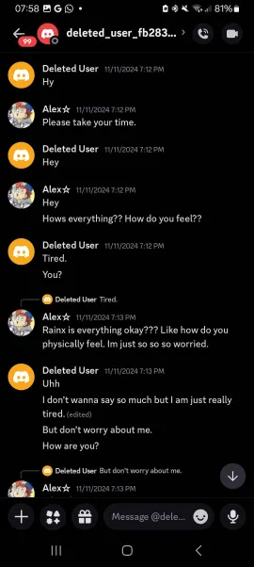
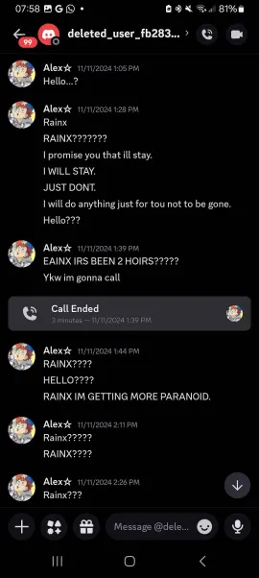
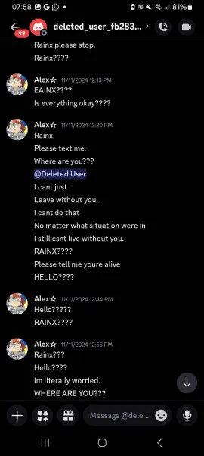
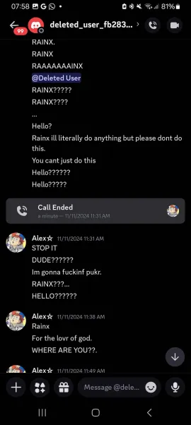
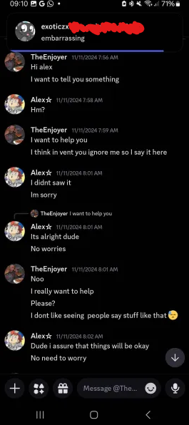
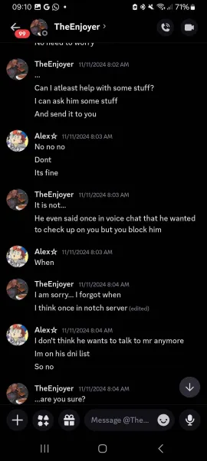
The following screenshots will also show the discourse between TheEnjoyer and Alex. The Notch Server that TheEnjoyer is talking about is a server created by one of Rainx’s former friends, Zalaxis (shortened to Zal).
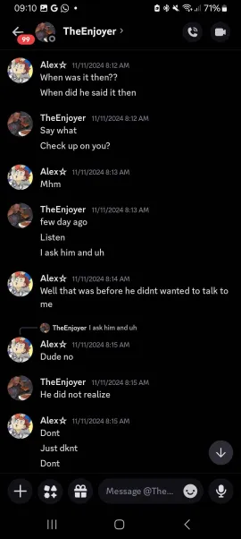
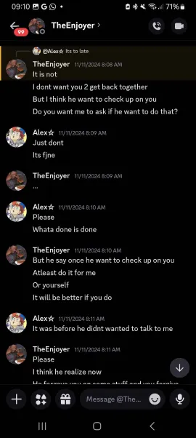
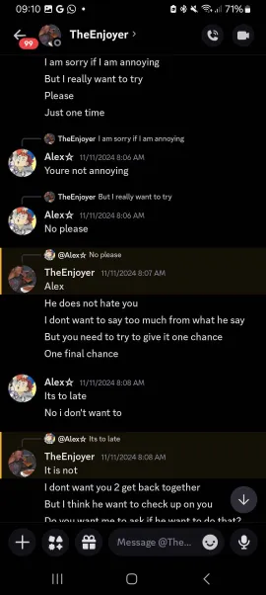
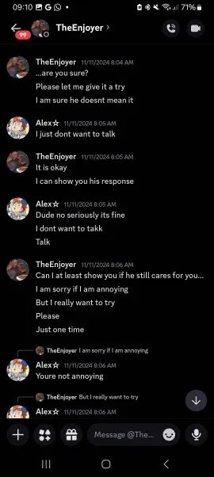

Note: A few screenshots have censored words because Alex refers to Rainx by his real first name.
All of these screenshots were sent by Alex and elaborated on by her.

There was one point when Ubo and Roz chose to directly confront Rainx on his issues. However, during the length of the discourse, Rainx wasn’t taking any of their advice and complaints seriously.

One of Ubo’s arguments involved the claim of Rainx using Alex as a scapegoat to vent all of his anger and frustration to her without dealing with them in a healthy way like a normal couple does. Rainx’s response to this was that he didn’t need to tell her everything that happens bad in his life, which completely misrepresented the original point of Ubo’s argument. One of Roz’s suggestions was to improve himself before starting a relationship, which would be the most logical option for Rainx. However, he completely brushed off the suggestion and dismissed it.

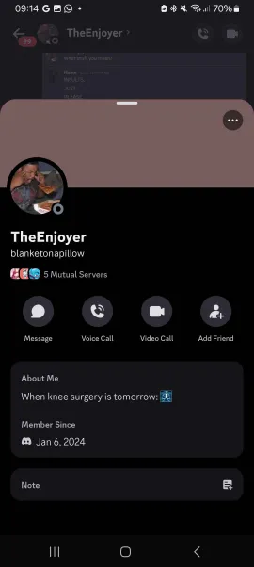
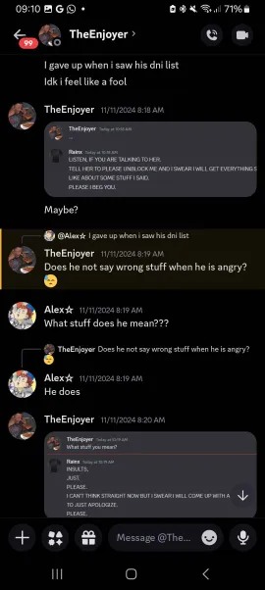
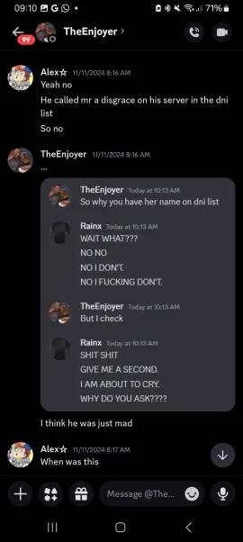
One time, Rainx threatened to shoot down a school and kill some students while he was talking with Alex, which obviously stressed her out to a very high degree and resulted in her desperately urging Rainx to not go through with his plans. Rainx reveals that he can’t trust Alex anymore due to the fact that just because he ghosted her, the screenshots of the conversations between him and her.

While it’s normal to experience intrusive thoughts—especially the ones that Rainx experiences—Rainx has phrased his plans in a way that made him seem like he was genuinely going to go ahead and do the things he said he was going to do, which either comes off as manipulative, stupid, or both. As for the thing about Alex leaking the messages, Rainx was trying to downplay everything that has happened in the relationship as her “leaking everything just because he ghosted her.”

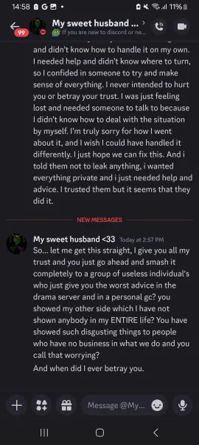
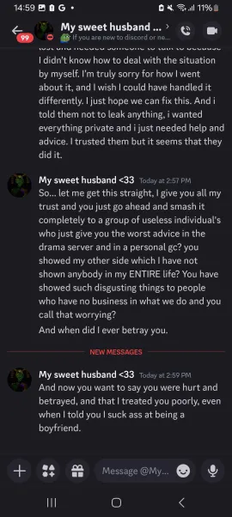
Of course, Rainx would have a point if he knew what he was actually talking about and the things that he was doing were more than ghosting; he has, as Ubo’s stated, used her as a scapegoat to vent to her about his mostly volatile emotions, ignoring her for periods of time without notifying her, and gaslighting her.
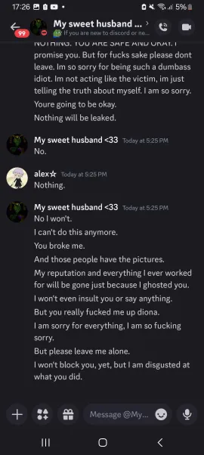
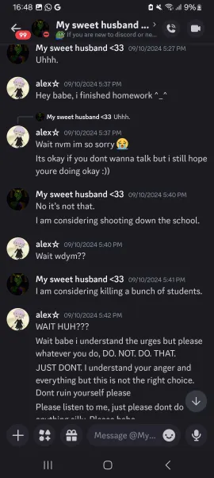
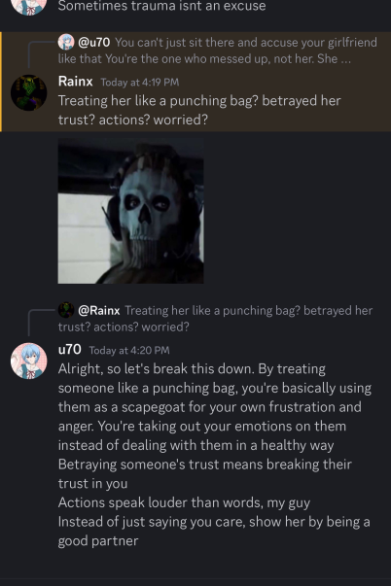
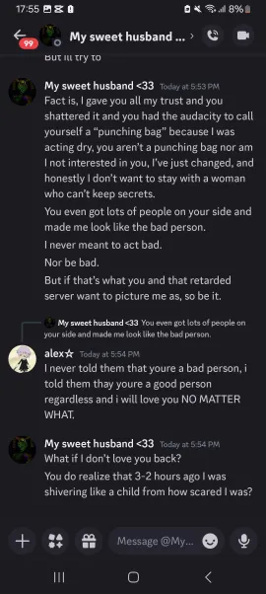
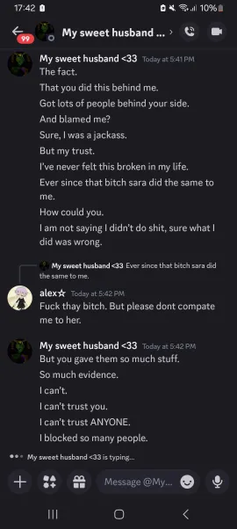
Rainx also recounted one of the similar experiences he had with Sara, who won’t be elaborated on in the document due to the fact that there’s not much information about her. He has implied that she has betrayed him in a similar way, but nothing much is explained after that statement. After some time, both of them will have a heated argument, which would end up in them ending things again. The story behind the other screenshots are obvious and therefore won’t be clarified.
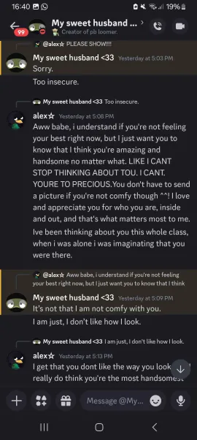
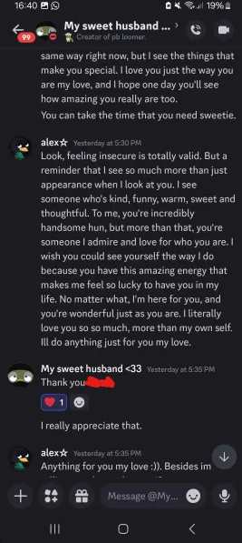
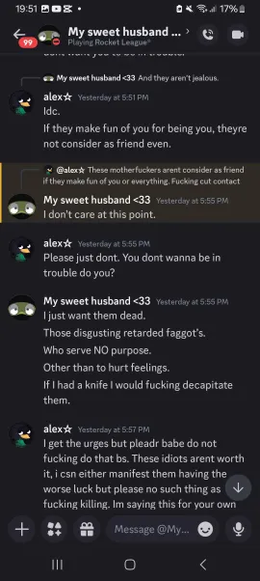
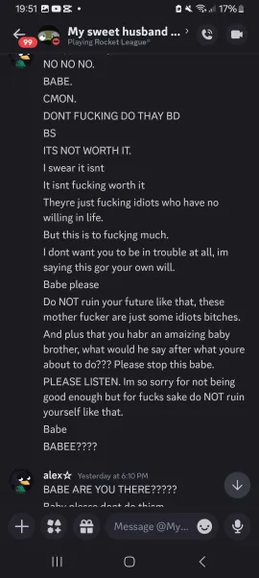
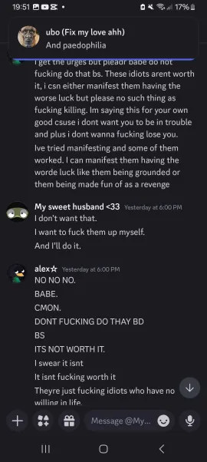
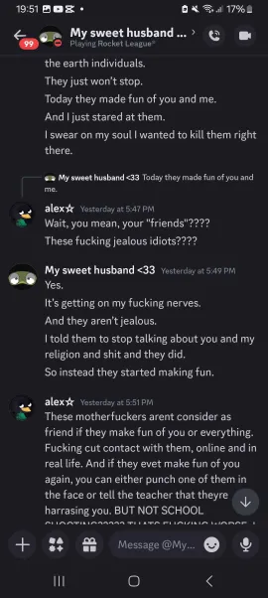
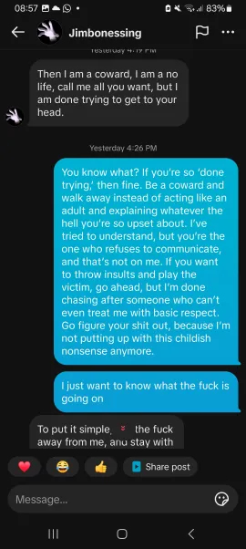
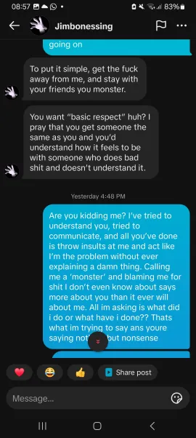
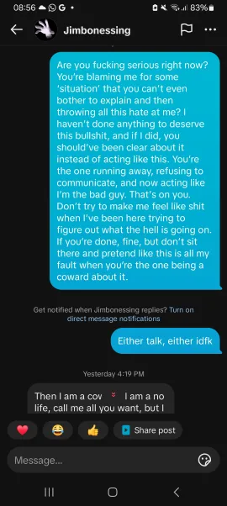
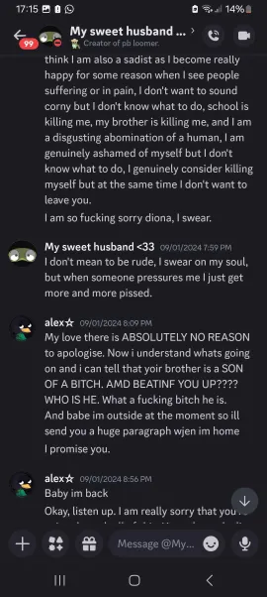
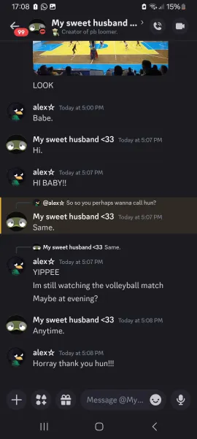
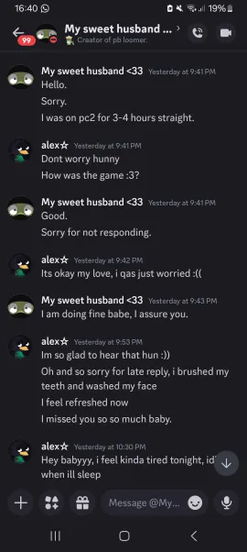
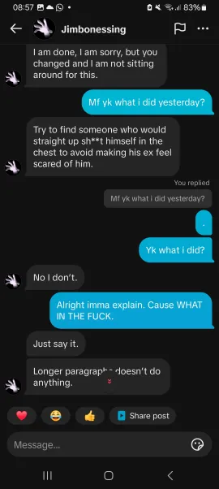
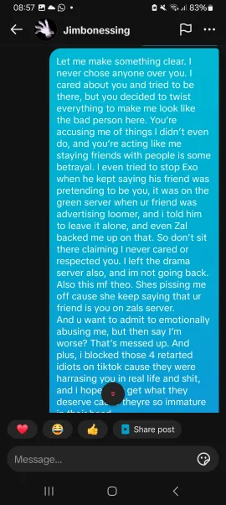
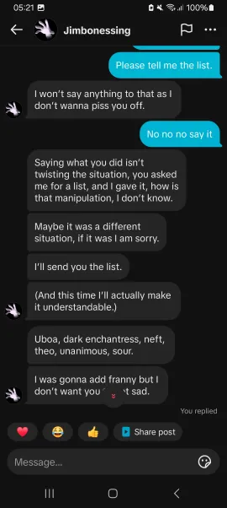
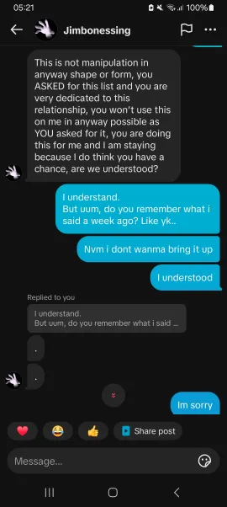
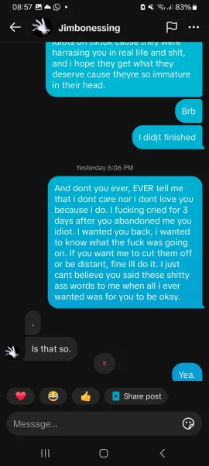
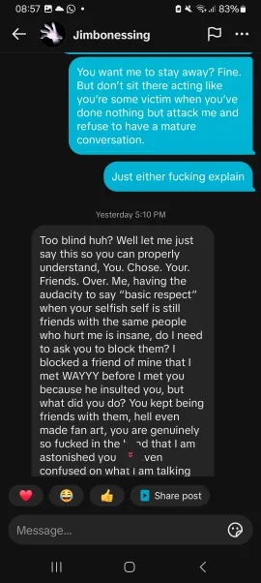
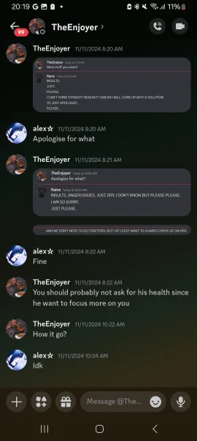
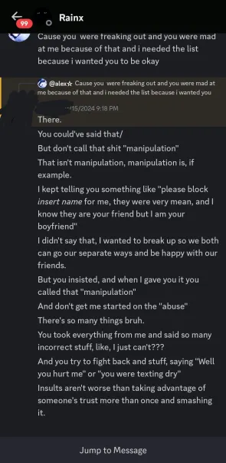
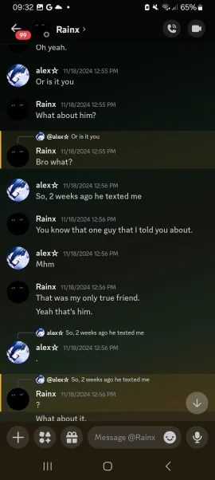
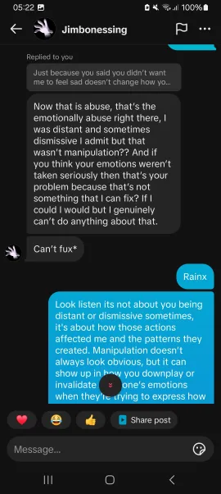
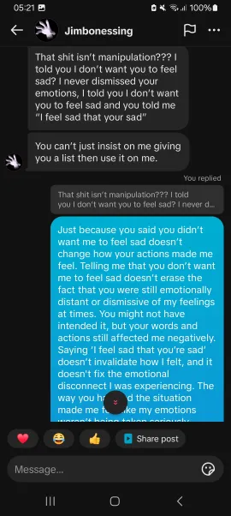
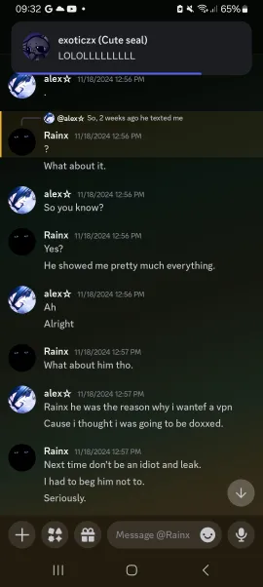
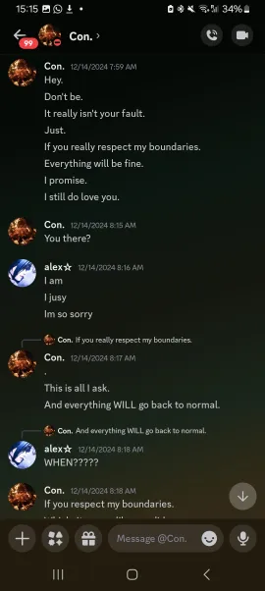
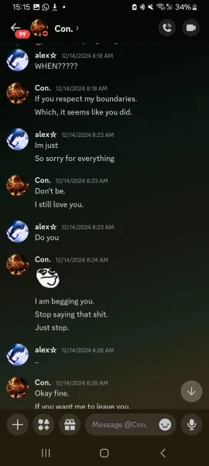
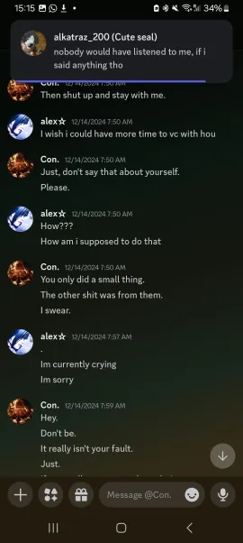
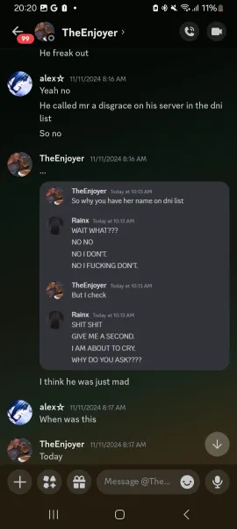
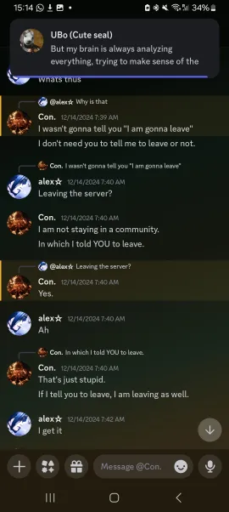
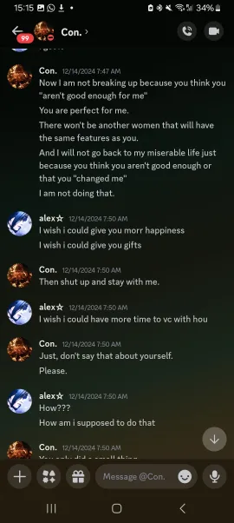
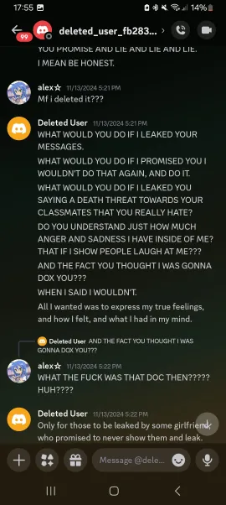
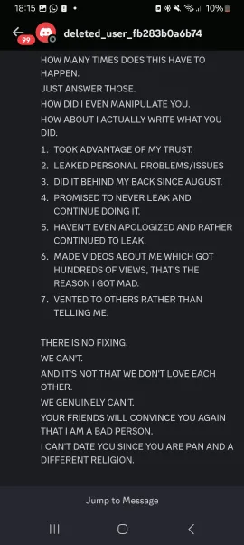
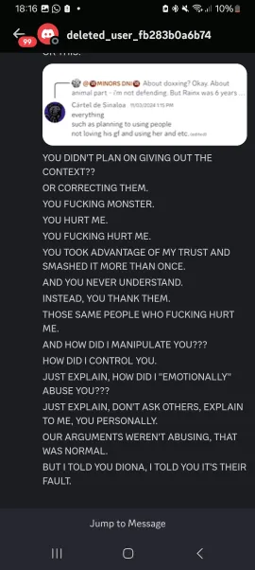
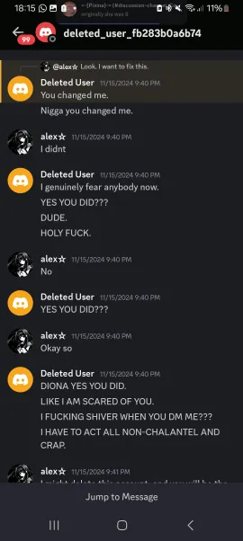
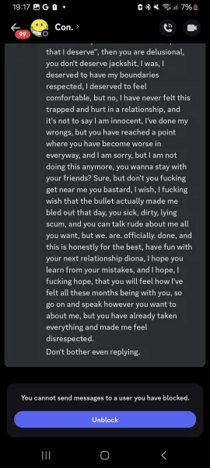
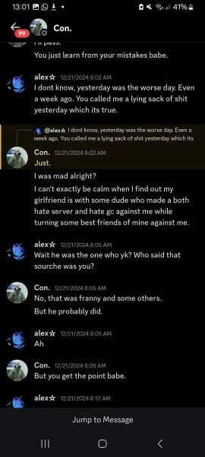
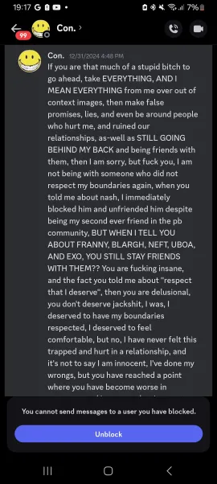
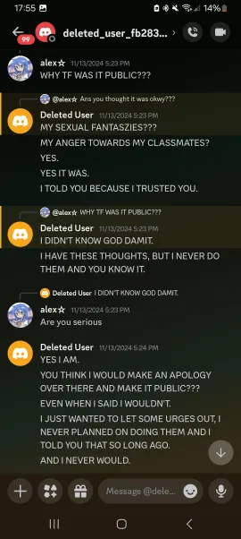
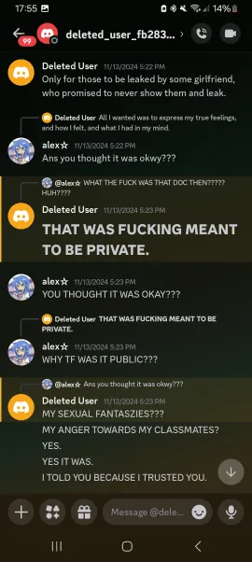
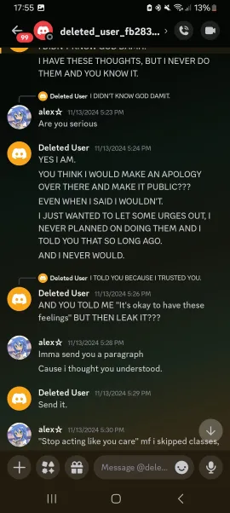

Refer to the next page of this document for explanations on the people that Rainx has mentioned.

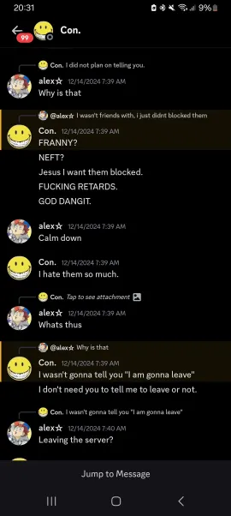
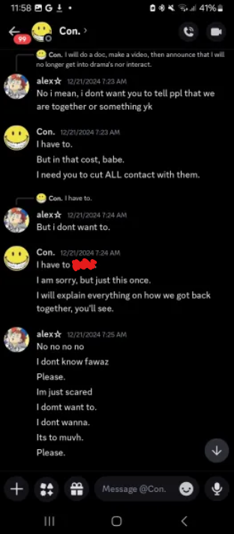
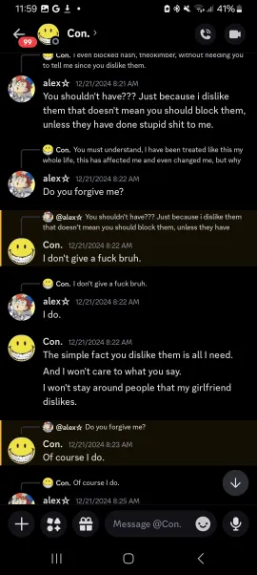
At this time (during the end of January), Rainx’s major enemies (excluding Alex) are listed as follows: Ubo, Roz, Neft, Franny, Alkatraz, Blargh, Kling, Quantum, Cyan, and Exo. Their actions against Rainx are listed below:

- Ubo: Ubo was one of the first people who raised concerns about Rainx while Alex was venting about her struggle with the relationship in the Pretty Blood Drama Server. She directly talked to Alex, gave her advice, became her support system, and began criticizing Rainx in a group chat with him, Alex, and Roz. She assisted Alex in giving her advice and safety and even facilitated evidence (i.e., chat logs and text conversations between Rainx and Alex) with others. She was also one of the three people who informed Kling about Rainx’s actions, which caused Kling’s opinion of Rainx to sour rapidly due to his good friendship with Alex.
- Roz: Roz was also one of the first people who criticized Rainx for his actions, and as mentioned previously, her and Ubo confronted Rainx about this with Alex. Roz is currently uninvolved as of now.
- Neft: Neft has created a hate server and a hate group chat against Rainx, which were actually used as spots for documenting Rainx’s actions and facilitating evidence. Aside from that, Neft—alongside Ubo—revealed everything to Kling while Alex confirmed to him about Rainx’s actions. After that, Neft and Quantum relentlessly mocked Rainx on the Pretty Blood Community Server, which made him hate both of them. When he became the owner of PBTV, he immediately deleted the PB Loomer comic off of the website with Alkatraz, which caused Rainx to relocate.
- Franny: Franny utilized her reputation and popularity to help with the heated conflict while getting involved in the situation itself. She also responded to Rainx on X (or rather, Twitter) by calling him an abuser while he chastised her for being a former NSFW artist and for nuking the Pretty Blood Community because of the fact that its owner (JohnDiz) has defended a pedophile (SirBearsALot) who worked for the server’s staff at that time. She also raised concerns in the official Pretty Blood server about Rainx while other admins were discussing Rainx.
- Alkatraz: Even though Alkatraz isn’t mentioned much, he has done his fair share of things. As mentioned before, he removed Rainx’s PB Loomer comic from the PBTV website (which was formerly owned by Zalaxis). He also aggressively ended contact with Rainx. He is not currently involved.
- Blargh: Similarly with Alkatraz, Blargh isn’t that important in the drama in the grand scheme of things. He has simply badmouthed Rainx while acting nice to him. When Rainx found out about this, he ended contact with him. He is not currently involved.
- Kling: As stated before, Kling was a former friend of Rainx, and both of them were good friends too until Kling found out about Rainx’s actions thanks to Ubo, Neft, and Alex. Immediately after finding out, Kling began to detest Rainx and the loss of Kling’s support for him was a huge blow to the PB Loomer series due to the fact that Kling is an incredibly influential member in the PB community because of his commissioned Just A Neighbor series. He is not currently involved.
- Quantum: Although not really involved in the drama itself, he has shown his hatred for Rainx before. Both he and Neft persistently insulted Rainx’s fanseries in front of him, which caused Rainx to lose his temper. Because of his good friendship with Neft, Ubo, and Alkatraz, he managed to be in the GCs and servers that Neft made.
- Cyan: Cyan has always disliked Rainx ever since the drama, but he has started getting involved since he started informing Rainx’s crew of his actions (the people in the crew will be elaborated later on).
- Exo: While he hasn’t done much, he has insulted Rainx for his actions and is affiliated with people like Ubo, Neft, Franny, and Cya, which likely means he is working with them in order to get rid of Rainx.

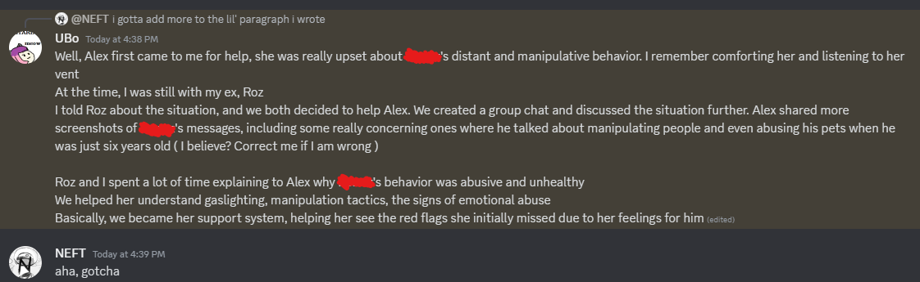

Note: Some parts of the screenshot are censored due to the fact that Ubo usually refers to Rainx by his real first name.

PART II

It’s important to note that Rainx’s “crew” isn’t that much involved with his drama; in fact, they usually prefer to stay away from it while being employed to work for his series, PB Loomer. The team includes people like Gibb, Gachadonut, DreamTerror Joesell, Cat (formerly), Shriggy (formerly), and Sourche (formerly and allegedly).

Both Gachadonut and Joesell are commissioned artists of the series, with Joesell being more of a concept artist for the series while Gachadonut is an actual one for the comic. Gibb (or Gibberson) is a moderator in the PB Loomer server while also being the one who created a render of Gerald Henderson, Rainx’s previously mentioned OC on his fanseries.

As for Cat and Shriggy, they left the team. However—according to Rainx—they didn’t leave because of the drama; both of them left because they had their own personal issues to deal with.

However, as for DreamTerror (who is a TikTok user whose account largely centers around Pretty Blood edits), things start to become a bit concerning. This will be elaborated on in the future.

During one of Rainx’s episodes, he has mentioned random people like Gwen, Lyla, and Sharcto in his bio and implied that he was close with them. However, he has never elaborated on them, and his bios that mentioned them were never archived.

“[...] And about Shriggy and Cat, I don’t even know myself[;] they just announced they were leaving because they had their own personal issues, and you say[,] ‘I feel like Loomer wouldn’t have needed to be cancelled if you legit weren’t like this[,]’ but what do you know about me? This series wasn’t finish [sic] not due to drama, but because Gacha has her own stuff going on. [...]”—Rainx.

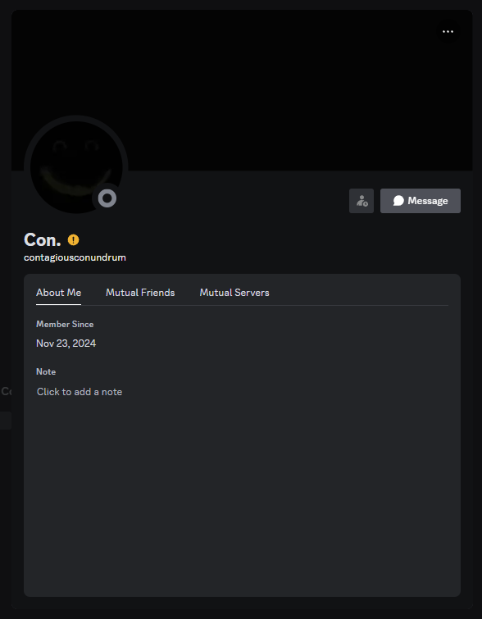
Sourche took over the PB Loomer server while Rainx was gone. For the most part, the server was peaceful, and the people who were banned got unbanned. Soon after, Rainx would come back, but he would publicly rebrand to someone who he is known as today—ContagiousConundrum (Conuns or Con for short).

However, something odd would happen. Rumors would surface that claimed that Sourche was actually Rainx’s alt account, which made Gibb question both Rainx and Sourche on this as time went on. Rainx freaked out and tried his best to prove that he wasn’t Rainx, which soured the friendship between him and Sourche.
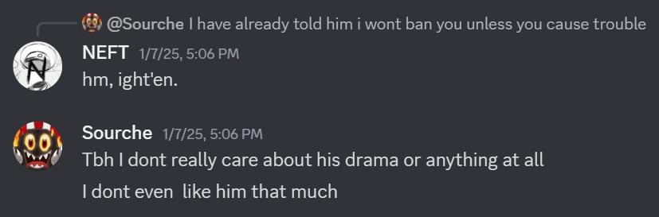
As for Alex, she would get DM’d by a Regenerator at one point, a supposed friend of Rainx who decided to confront Alex after allegedly receiving a picture of Rainx’s blood (which likely alludes to Rainx’s self-harm and suicidal tendencies). The screenshots are censored due to the fact that Regenerator has mentioned Rainx by his real first name.

He would curse Alex out while showing what Rainx has sent him—he would forward a voice message (which was likely Rainx’s, meaning that it would have his real voice) and send a screenshot of their DMs to Alex.

Unsurprisingly, Regenerator is rumored to be an alt of Rainx due to how some of his behavior parallels Rainx’s and how both of them share the same viewpoint on the matter. Whether this is Rainx’s alt account or not, this could definitely be considered a triangulation if it was purely intentional on Regenerator’s (or Rainx’s) part.
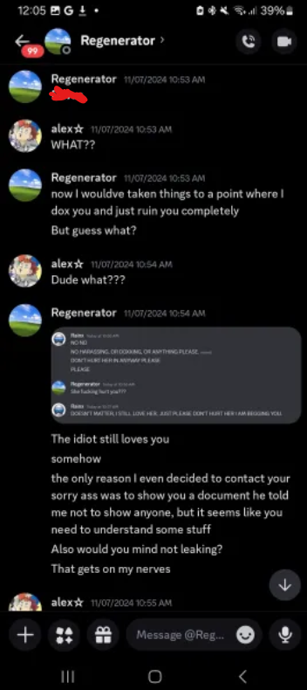
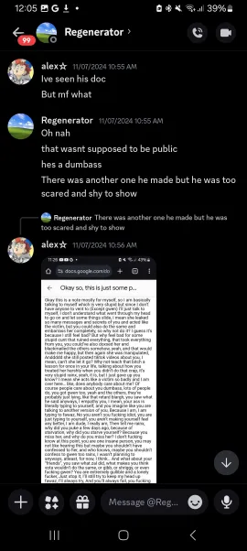
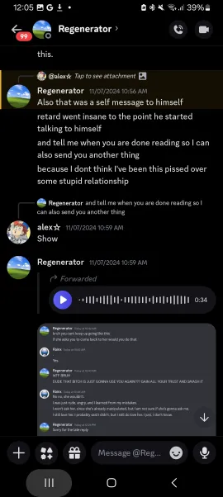
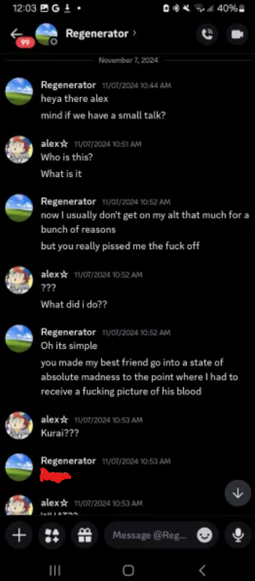
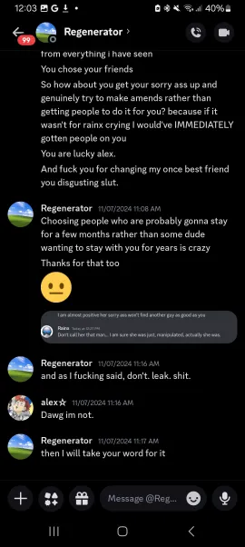
Back to the topic at hand, people’s suspicions of Sourche were growing, especially considering the fact that Sourche was able to immediately take leadership of the project and the fact that they use the same emojis, talk with the same mannerisms, share the same interests, and they have even done the same trivial stuff like say that Gibb is lazy. Two images will be shown below for comparison.

At first, Gibb liked Sourche and even said that he was chiller compared to Rainx, but as time went on, Gibb became more suspicious about things.

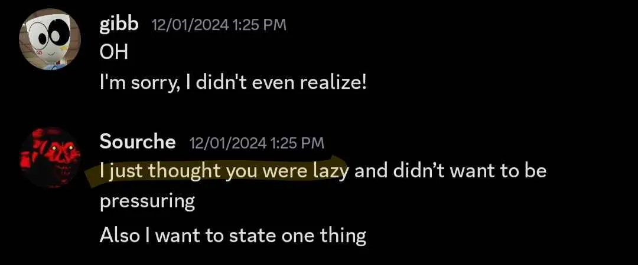
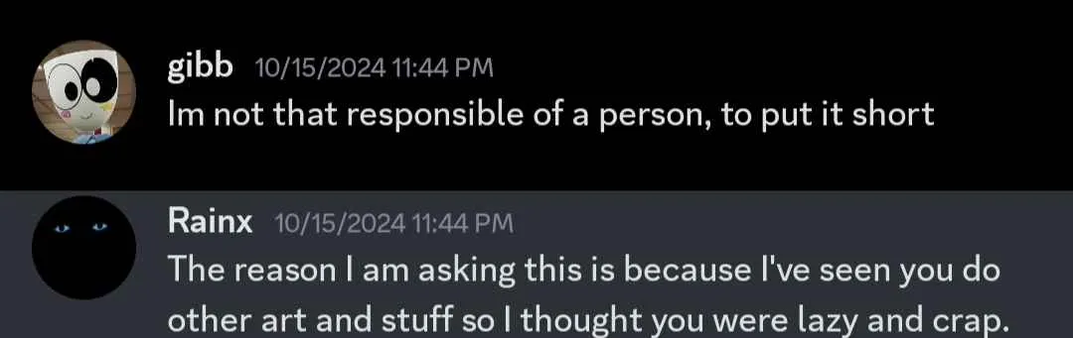
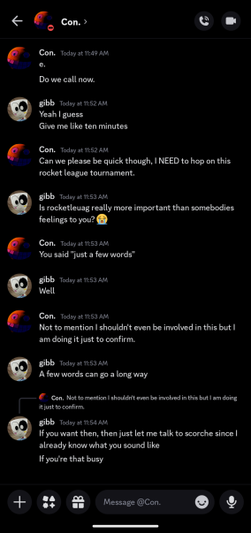
The fact that Sourche also typically brought up Alex when Rainx was mentioned and the fact that Rainx typically lashed out at Gibb when he was accused by him of being Sourche didn’t help. Long story short, when Rainx attempted to prove that both he and Sourche were two separate people by sending Sourche’s voice message to Zalaxis, he cussed him out afterwards.
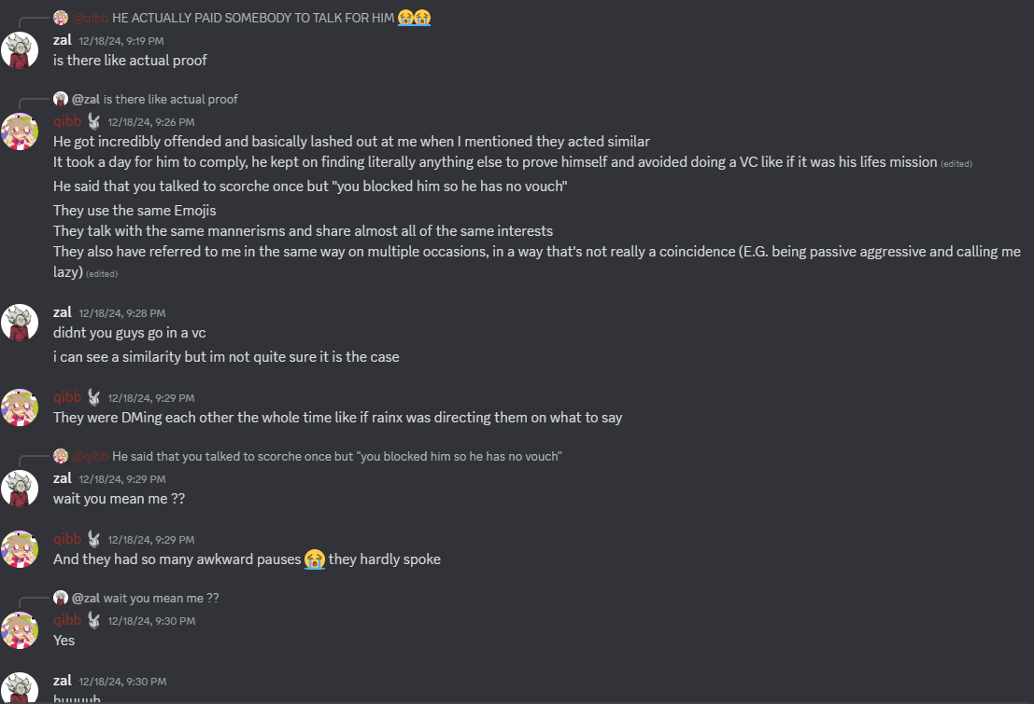
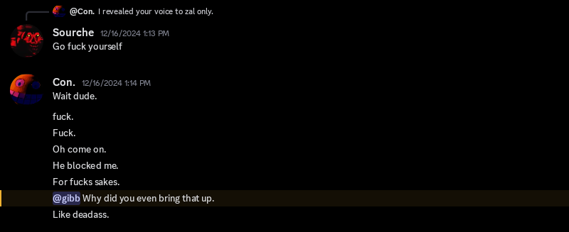
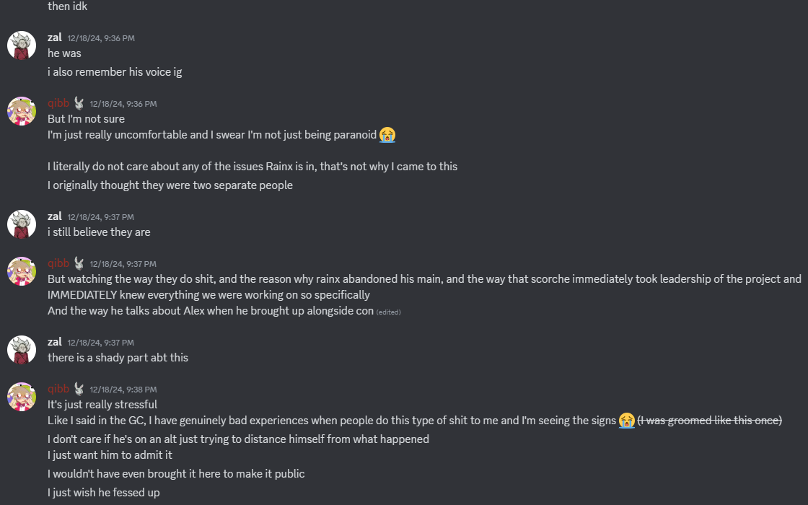
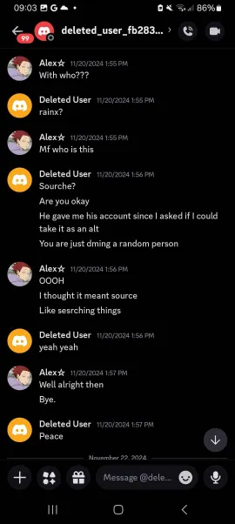
Sourche has also interacted with Alex on some certain occasions, during a time when Rainx knew that he was accused of being Sourche. The reason why Sourche acted so aggressively towards Alex is because he was apparently told everything by Rainx about her.
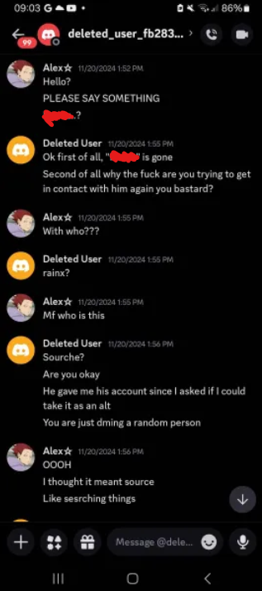
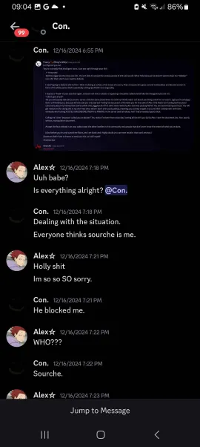
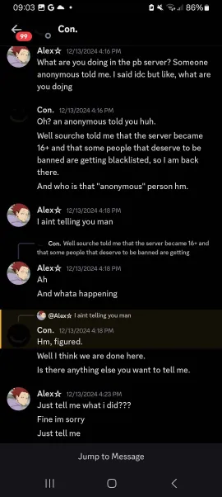
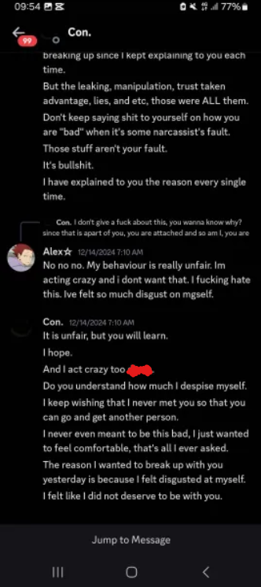
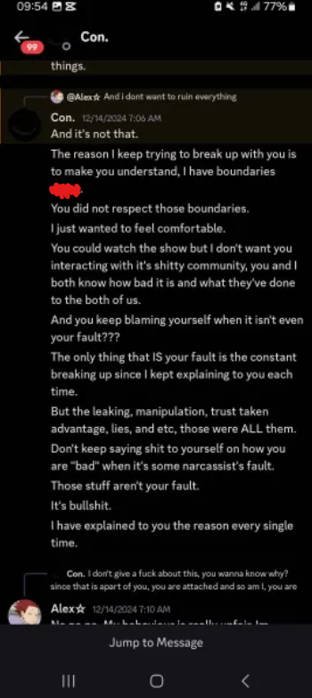
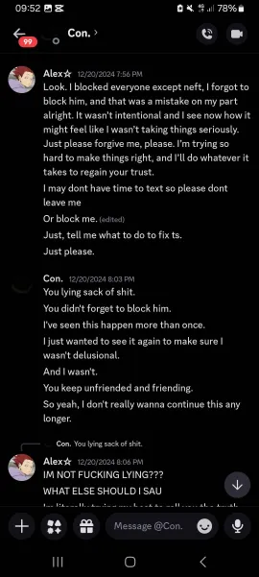
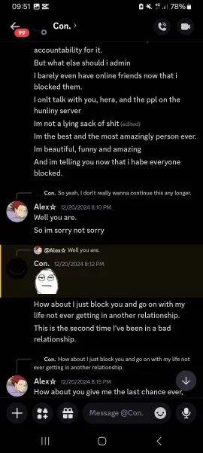
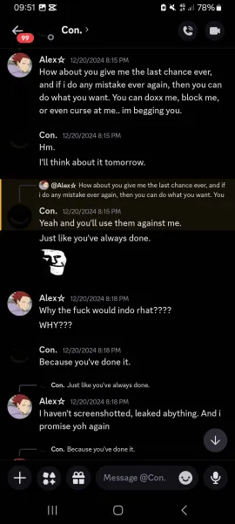
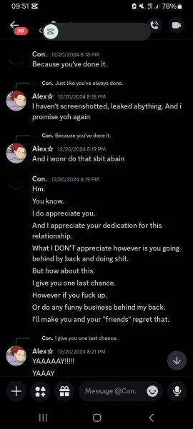
‘

During roughly mid-December, Rainx spoke in a more threatening tone, stating that if Alex chose to do some “funny business” behind his back, he'd make sure to make her and her friends regret it. It’s important to note that Alex’s sense of self-worth was evidently low, as seen in the message where she told Rainx that he could doxx her if she screws up.

Similarly enough, Rainx hated himself during his period and stated himself that he felt that he, quote unquote, “did not deserve to be with [Alex].” Rainx’s paranoia also began to surface, which made him doubtful of anyone around his social circle on Discord.

This was one of the moments when he called Alex a “lying sack of shit” when she said that she has blocked everyone on Discord except for Neft. This time, he has stated that Alex has broken his boundaries; however, it’s unknown if he genuinely thought the standards he imposed on Alex were actually boundaries or if it was a way for him to control Alex.

As mentioned before, Alex and Rainx officially ended things near the end of December (i.e., close to New Year’s Eve), which finally gave Alex the possibility to interact with the people (Ubo, Franny, Neft, Exoticzx, et al.) she has unfriended because of Rainx

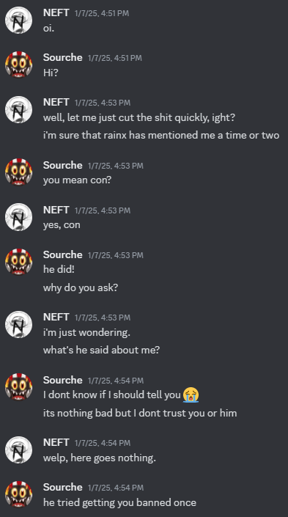
Continuing on Sourche’s ownership on the PB Loomer server, controversial members were banned while people who were previously banned (especially Cyan and Neft). When Neft would contact Sourche, he would confirm that Rainx attempted to ban Neft (and maybe Cyan due to the fact that Rainx knows he knows about his actions).

As for Alex, during the beginning of January, she began venting privately to her friend group about her circumstances with Rainx. She reveals that Rainx wanted her to block the people he didn’t like while also wanting her to leave and abandon every PB-related server she was in—even Kling’s server due to the previously explained reasons—while emphasizing the fact that she didn’t leave because of the fandom; she did it because of him.

If Rainx saw Alex being friends with people she was supposed to block, he’d just break up with her and block her afterwards, which motivated Alex into creating several TikTok accounts just so that she could keep in contact with him. Alex recounted that this has happened roughly five times. She was pressured into cutting ties with her friends and felt as if she had to do it because he was her boyfriend.

Alex also referenced an interaction between Rainx and Quantum that has occurred at some point, which led to Ubo insulting Rainx personally with the help of Quantum. Alex also claims that Rainx was friends with someone (who is actually Regenerator) who threatened to doxx her, which motivated her into starting to use a VPN solely because of the threats. She didn’t tell Rainx that he should cut him off, but she did express her concerns, which made Rainx respond in a dismissive tone and say that she should just stop leaking the DMs and the chatlogs between him and her. Regenerator and Rainx were both friends in real life, so there was nothing much she could do about it. Not to mention, this relationship ruined Alex to the point that she became super attached and would harm herself if he threatened to break up with her, which, as Alex implies, was constantly done by Rainx.
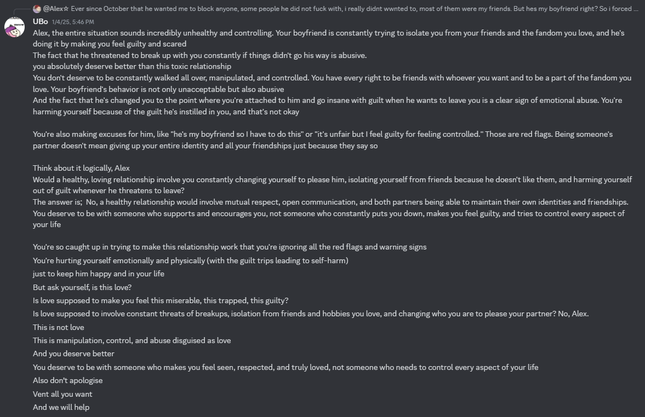
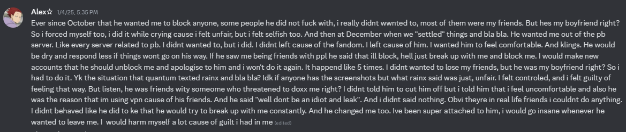
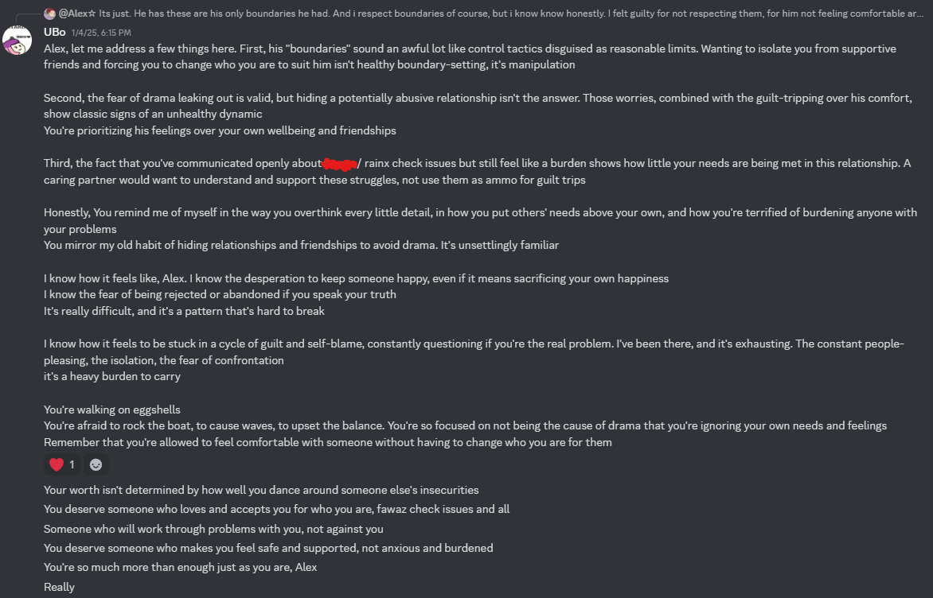
Ubo would comfort and sympathize with Alex afterwards by saying that a healthy relationship is obviously not focused around infatuation, changing and isolating yourself to meet the other person’s standards, and harming yourself when your partner threatens to leave the conversation.

She would also make observations such as Rainx’s boundaries awfully resembling control tactics, which are disguised as, in Ubo’s words, “reasonable limits,” such as Rainx attempting to make Alex block, unfriend, and isolate herself from her friends. She also claims that Alex’s needs were never met properly in the relationship and that she was prioritizing her ex’s feelings rather than her wellbeing and friendships, which are valid points.
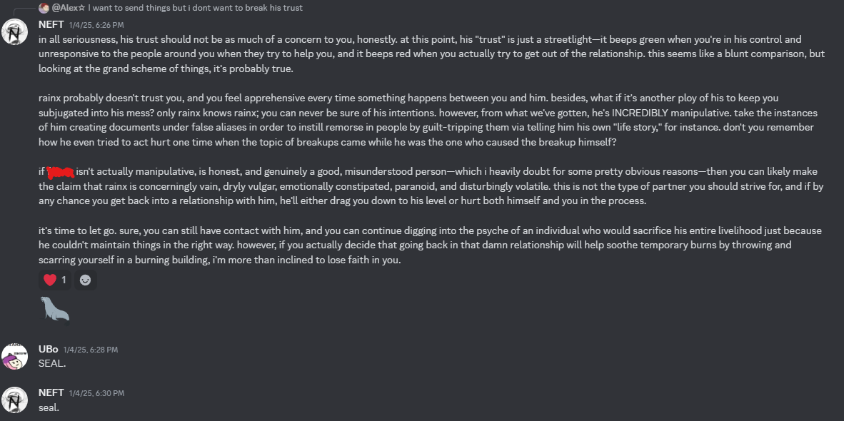
Neft, alongside Ubo, would also try shaking some sense into Alex by stating Rainx was definitely not a good partner to be around, which is true, and he also pointed out how even if Rainx, by some off chance, wasn’t manipulative as he was made out to be, he is still a violent person to be around—those outbursts are typically categorized as something that are caused by his paranoia and anger issues, which isn’t really an excuse for his actions, as explained previously.

From this point onward, this document will delve into more serious topics.

PART III

It’s likely important to note that Alex likely loathes Rainx from here on out. It might also be important to mention that NASHqp, a former musician of Little Deadly Thing’s Red Snow 2 sub-series who was exposed for showing NSFW to minors on a VC in the Pretty Blood Official Server and trauma-dumping about sexual assault on Shishi, who is a thirteen-year-old.

After Rainx (now rebranded as Con) took over the PB Loomer server and removed Sourche from the server, Neft and Cyan were banned from the server all of a sudden due to obvious reasons. This has led to Cyan being able to successfully contact some members of Rainx’s team and to Neft organizing the evidence against Rainx with others like Ubo and Alex. This will be brought up later in the document after things get more elaborated on.

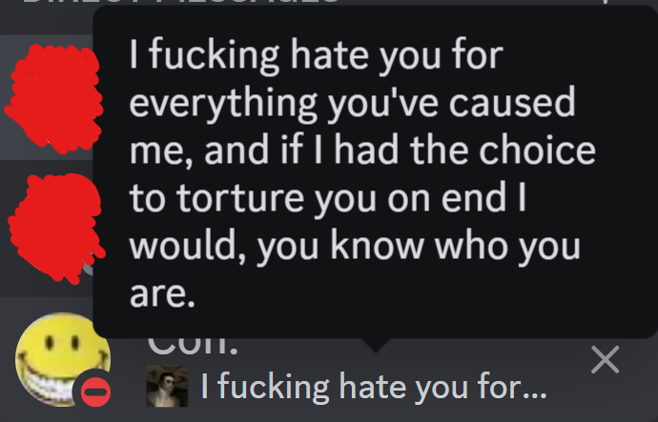
Rainx started displaying more concerning behavior in public. For example, he has publicly shared his aspirations of physically torturing someone that he hates with his wrath being set on display. It’s theorized that he was talking about Alex; however, it isn’t proven, but it’s very likely considering the circumstances surrounding him and the eventual break-up of his relationship. Keep in mind that this screenshot was taken during the last week of January, which makes this recent.

“I fucking hate you for everything you’ve caused me, and if I had the choice to torture you on end[,] I would[;] you know who you are.”—Rainx.

At one moment, Rainx exhibited his explosive anger and troubling behavior when he asserted that he was teetering on the brink of committing a violent crime, fueled by his alleged disdain for this planet—which essentially was his contempt for society as a whole.

In one of the statuses he had (which was unfortunately not archived), he said he was plotting a massacre, which might’ve been centered around his earlier claims of causing mass school shootings.

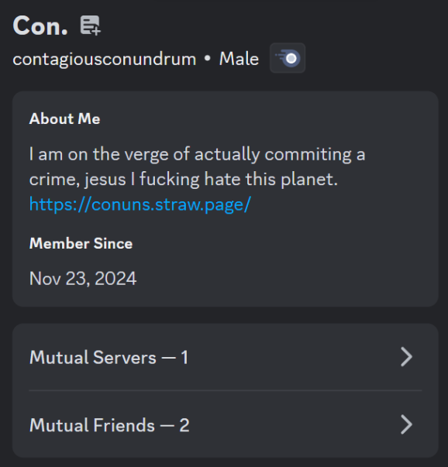
Rainx’s declining mental state is also shown on his own strawpage, where he writes notes on an inconsistent basis. The most concerning note will be quoted below:

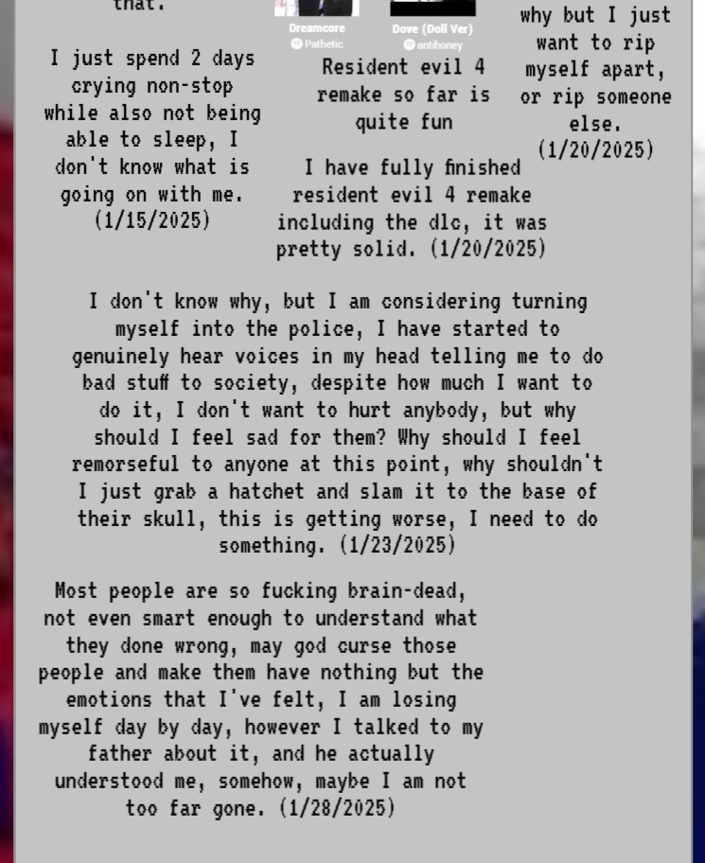
“I don't know why, but I am considering turning myself to the police. I have started to genuinely hear voices in my head telling me to do bad stuff to society, despite how much I want to do it. I don't want to hurt anybody, but why should I feel sad for them? Why should I feel remorseful toward anyone at this point? Why shouldn't I just grab a hatchet and slam it to the base of their skull? This is getting worse; I need to do something.”—Rainx’s note on his strawpage (conuns.straw.page), grammatically rewritten, 23/01/2025 (in the European date format).
Horribly enough, Rainx’s degenerancy and mental decline could even be traced back before the entire drama, such as the moment when he admitted to being a sadist, torturing and killing his pets, and manipulating others at the time he was only six.

The message below—where Alex states that she has done the same thing—shouldn’t be taken out of context. Alex was referring to one point in her childhood where she accidentally stepped on a bird while she was running around.

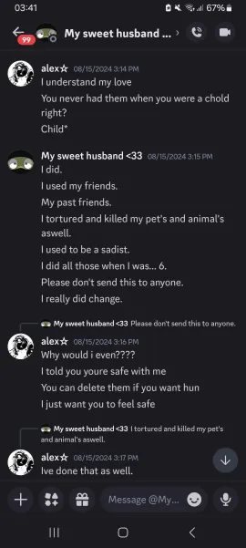
Considering that this page is currently talking about old screenshots, the next few pages of this document will show different screenshots that are a few months old in order to emphasize this claim before it comes back to its focal point of this part, which is about Rainx’s concerning behavior and Cyan’s measures with Neft.

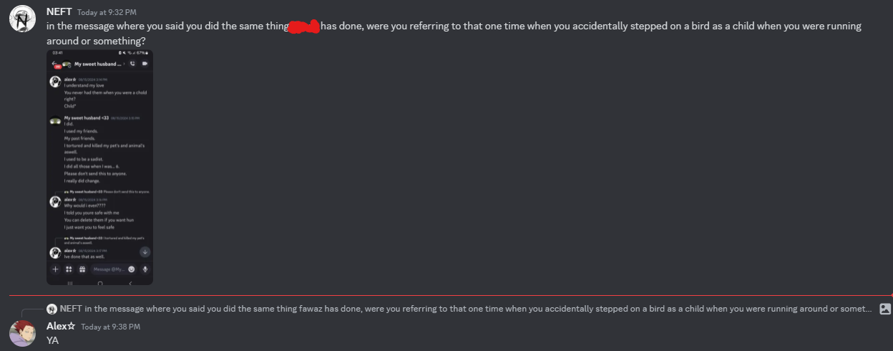
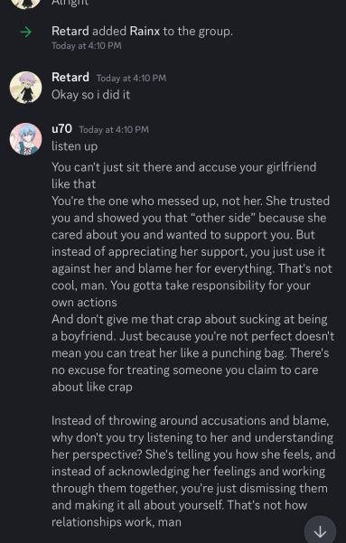
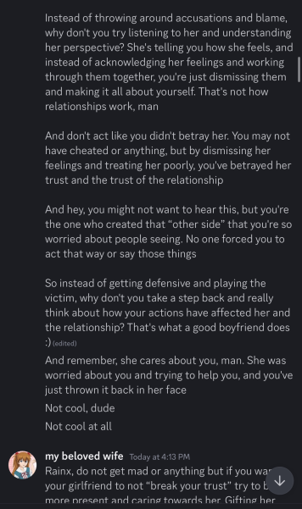
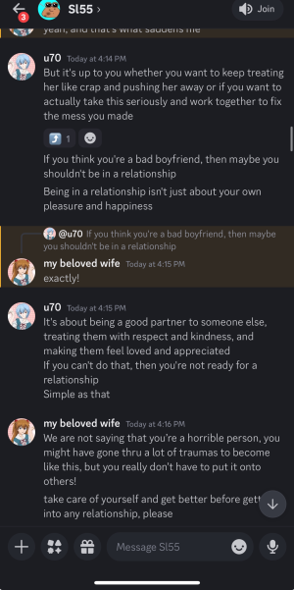
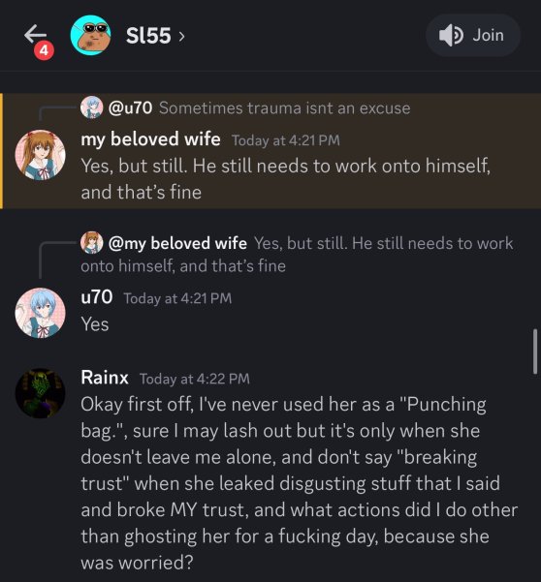
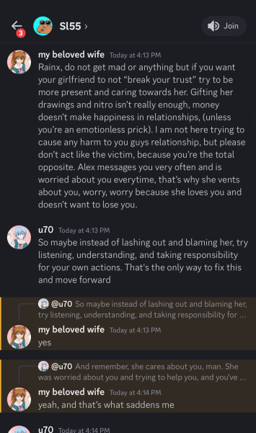
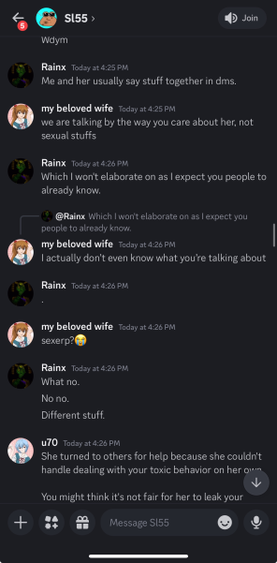
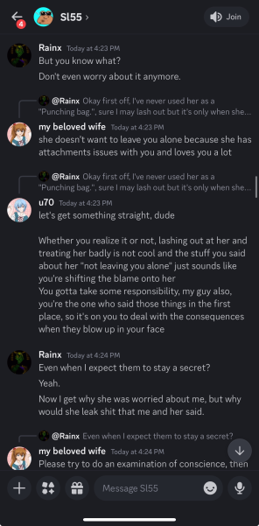
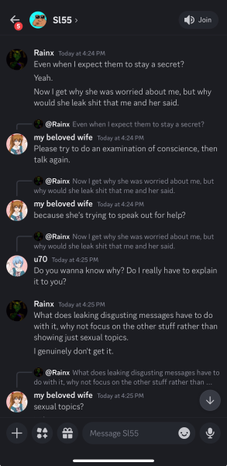
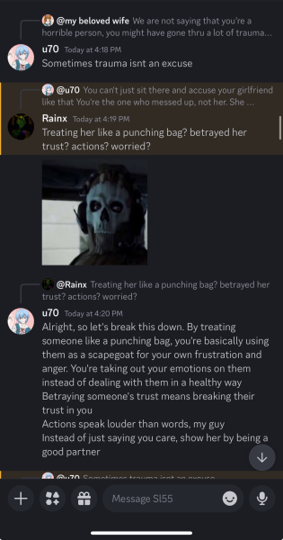
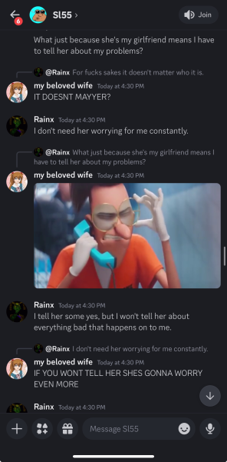
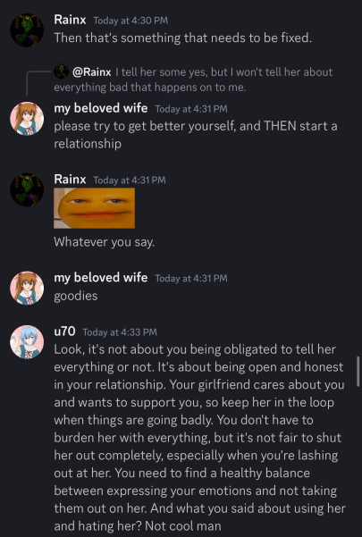
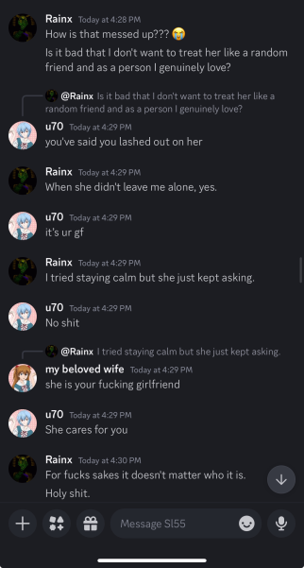
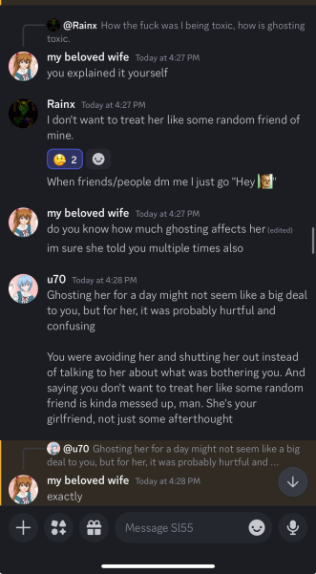
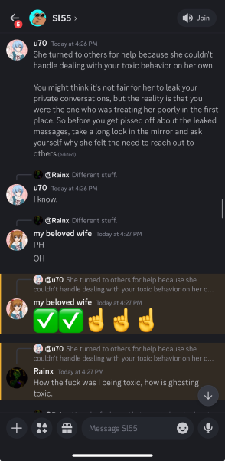
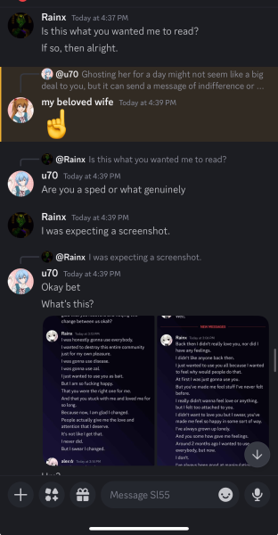
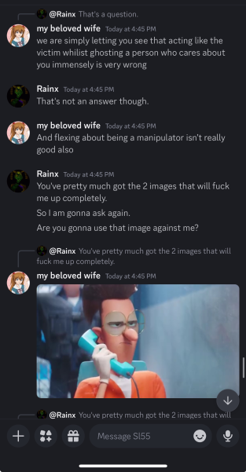
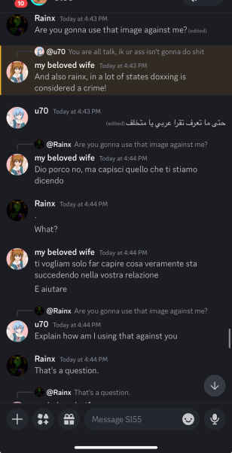
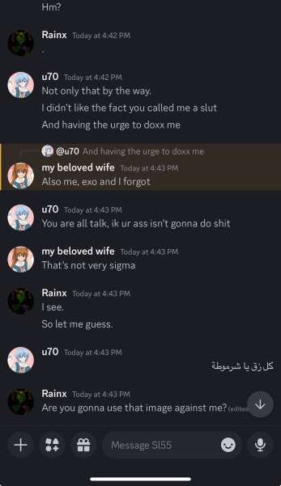
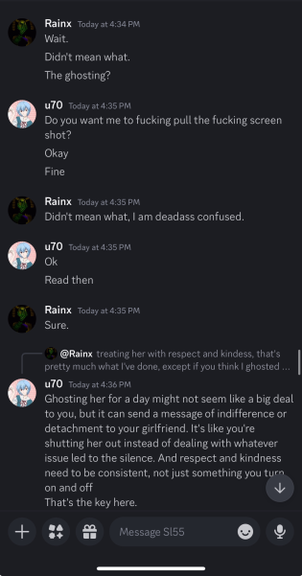
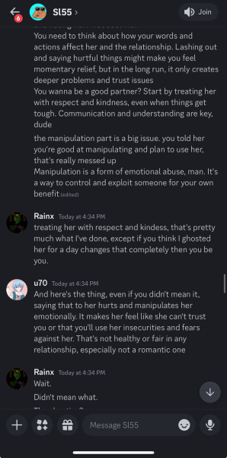
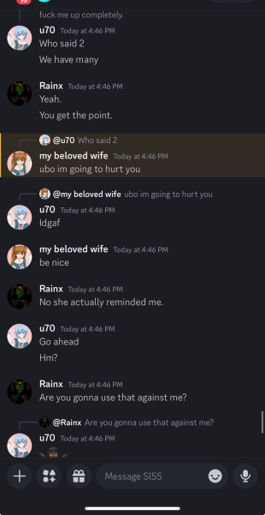
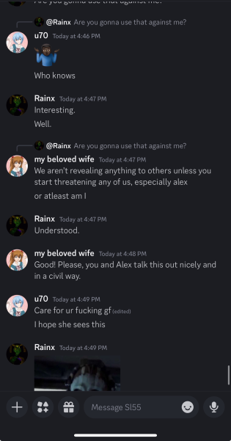
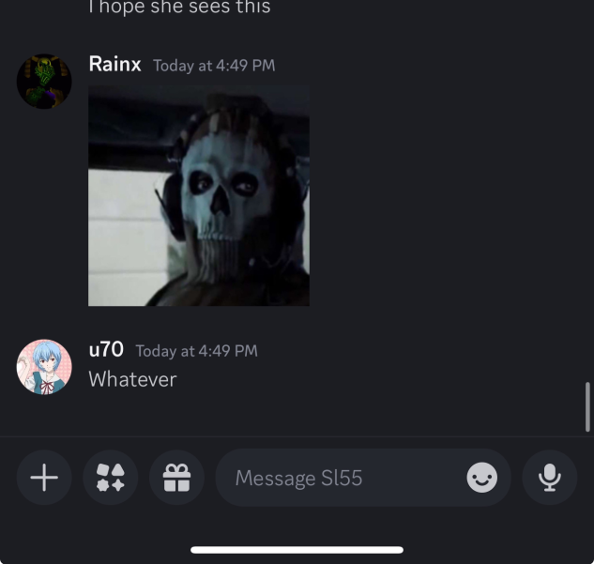
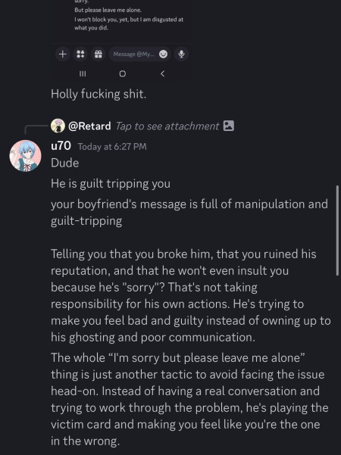
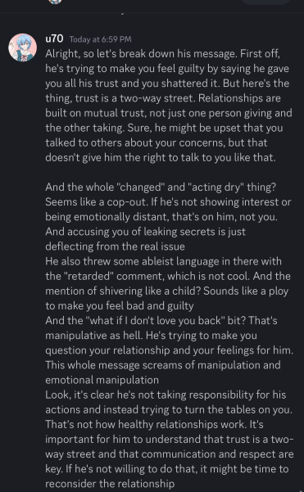
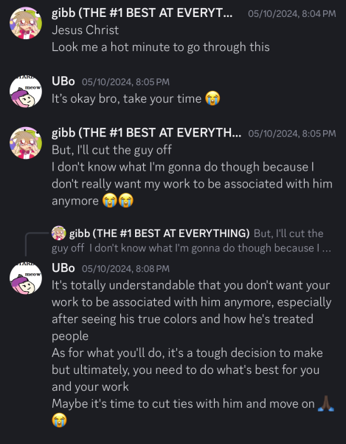
Most of Ubo’s quoted paragraphs below stem from October 2024. It mostly involves her exposing Rainx’s hypocrisy, behavior (both during the time he was in the GC with Ubo and Roz and his general behavior towards Alex).

“I will explain what happened from the beginning Alex was concerned about her boyfriend, Rainx, because he had been acting distant and dry, talking to other people instead of her, and basically ghosting her. This had been happening multiple times, and it was understandably worrying her So as her best friend, I decided to comfort and support her in any way I could I advised her to talk to him about how this behavior was bothering her and affecting her So Alex did talk to Rainx about it and he revealed his “true colors.”"
Alex’s boyfriend, Rainx, admitted that he planned to manipulate and use people [Zal, Disease, et al.] in the community, including his girlfriend. He was bragging about being good at manipulating, which hurt Alex deeply However, Rainx also claimed that he had changed, which is clearly bullshit because his behavior was still toxic and manipulative. It's absolutely wrong and unacceptable for him to act that way, especially towards his own girlfriend. Claiming that he changed is just a way to deflect responsibility and avoid accountability for his actions.
Her boyfriend is a total creep. He’s being sexually inappropriate with her while at the same time pretending to dislike sexual things. It’s hypocritical and totally messed up. She deserves much better than that kind of treatment. She was honest enough to admit that her boyfriend is actually quite sexual, despite his claims otherwise. This shows that he is NOT only a hypocrite but also deceptive and untrustworthy. He’s basically trying to fool her into thinking he’s something he’s not. Her boyfriend is such a drama queen. He got into a stupid fight with Exo because Exo made some sexual jokes, even though he himself is super sexual. Like, come on, dude, get a grip.”

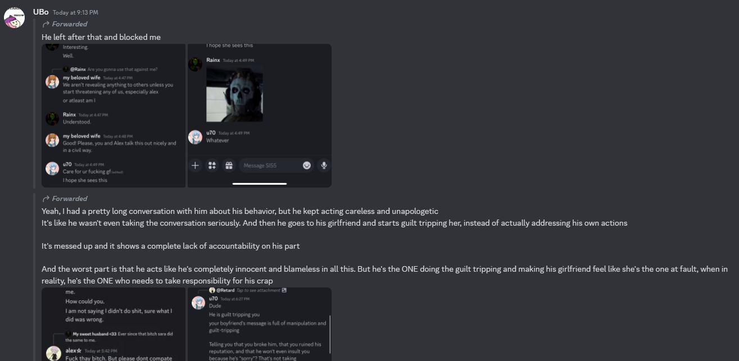

“Alex and her boyfriend agreed to write each other a paragraph about their love for one another. Alex wrote a heartfelt and sincere message expressing her deep feelings for him. However, her boyfriend, Rainx, responded with something completely different, completely missing the point of the exercise. It showed a lack of emotional depth and sincerity on his part. [...]”

“[...] It's absolutely absurd and hypocritical that he claims he doesn't like sexual jokes when he's acting so obnoxiously sexual himself Seriously, it's beyond messed up and shows that he's just a huge hypocrite Like Dude, first of all, being a teenager is no excuse for acting that way. And his response shows a complete lack of maturity and understanding. He says he loves those parts of a person’s body, which is fine. But then he says that other people have to act “normal” because they don’t have the same interests That’s a pretty damn judgmental attitude and shows a lack of respect for other people’s boundaries. It’s not cool to guilt-trip others for not sharing his same views.”

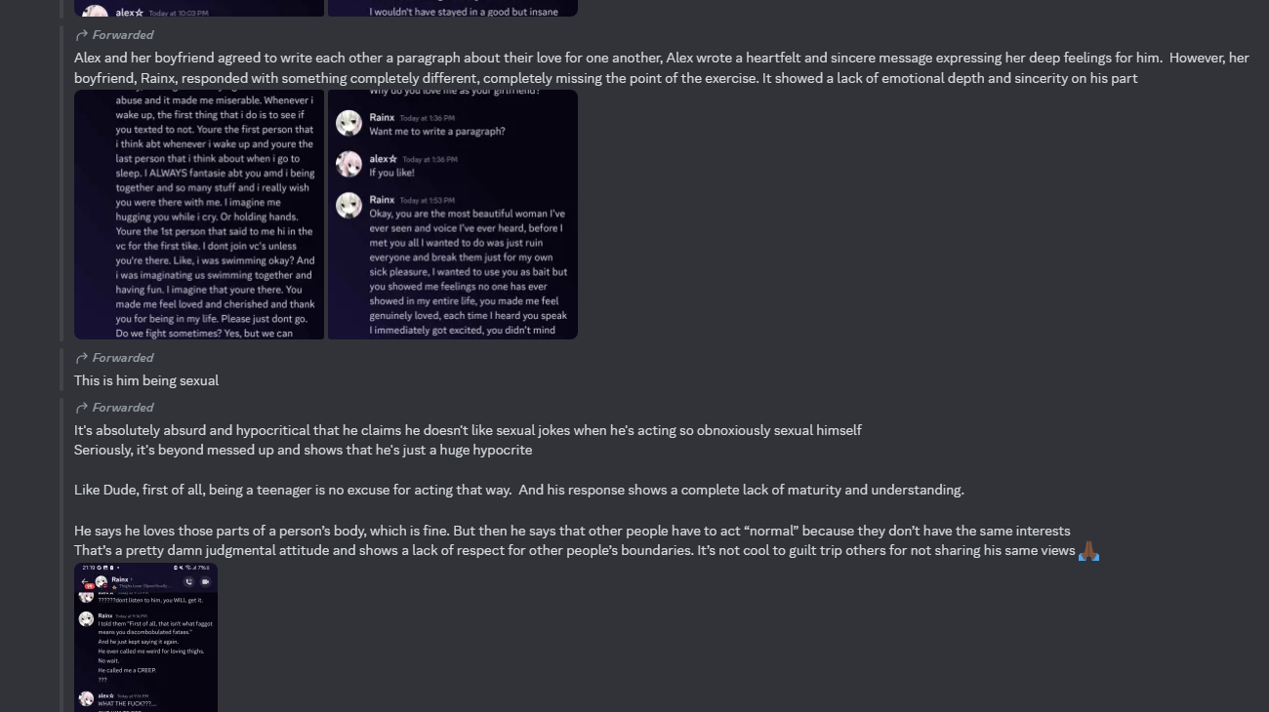

“Yeah, I had a pretty long conversation with him about his behavior, but he kept acting careless and unapologetic It's like he wasn't even taking the conversation seriously. And then he goes to his girlfriend and starts guilt-tripping her instead of actually addressing his own actions It's messed up and it shows a complete lack of accountability on his part And the worst part is that he acts like he's completely innocent and blameless in all this. But he's the ONE doing the guilt-tripping and making his girlfriend feel like she's the one at fault, when in reality, he's the ONE who needs to take responsibility for his crap.”
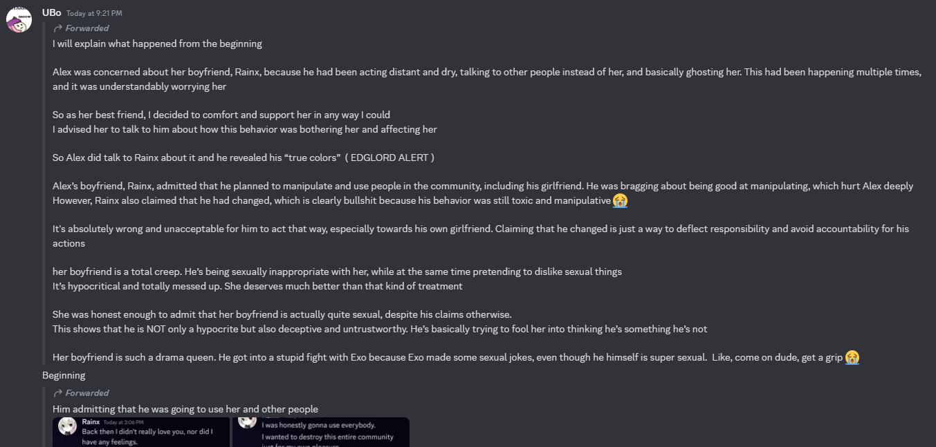
Here are the screenshots that were sent alongside the forwarded messages, where he admits to other erroneous stuff:
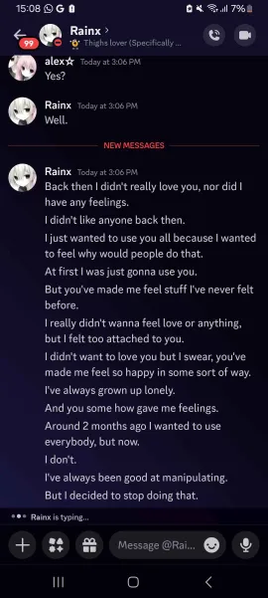
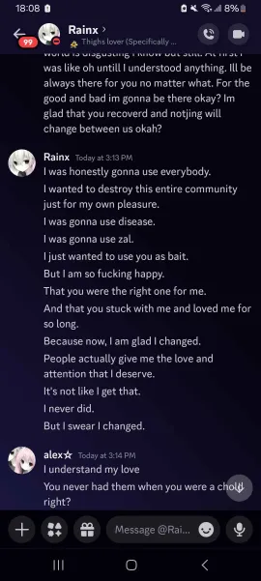
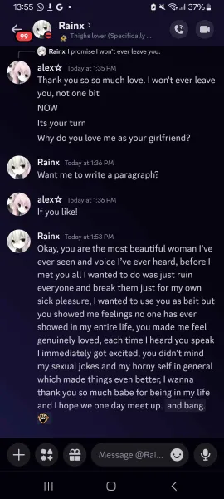
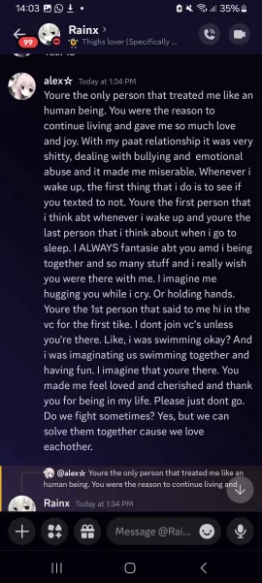
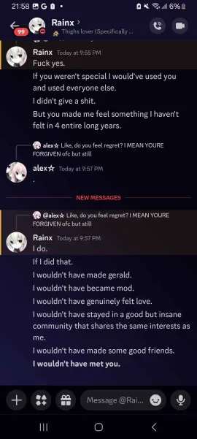
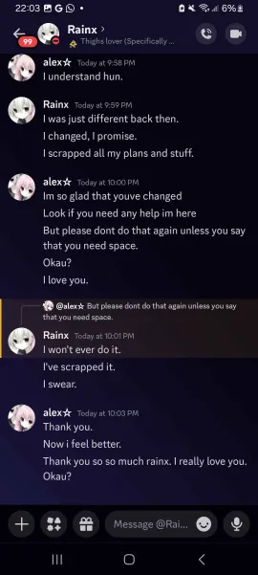
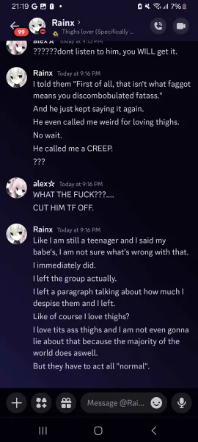
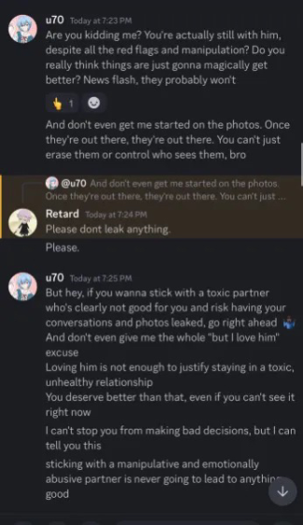
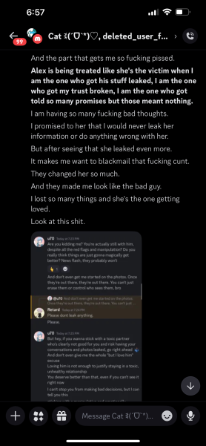
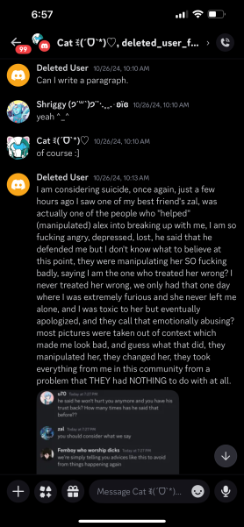
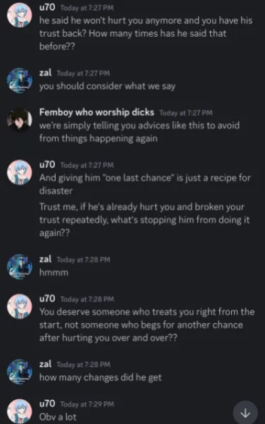
Rainx would also vent to Cat and Shriggy about this. It’s not known whether he was trying to rope them into drama or if he just wanted to tell them how he felt, but it’s definitely a part of the reason why both of them have left the PB Loomer team.
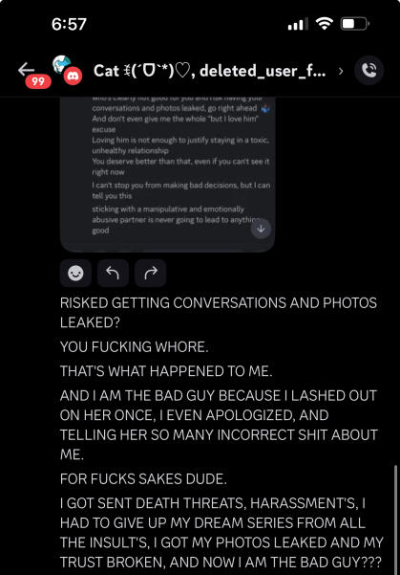

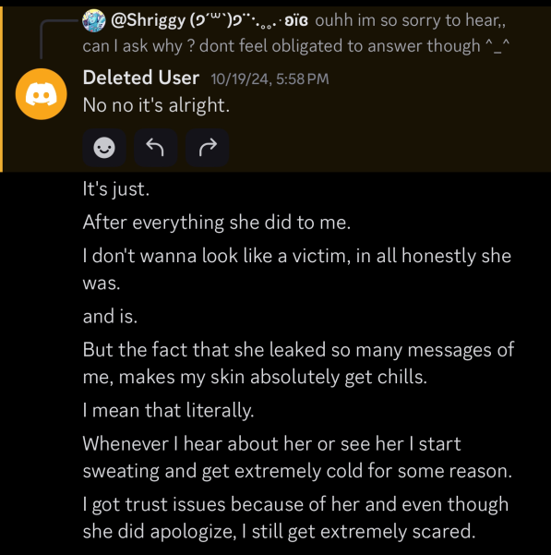
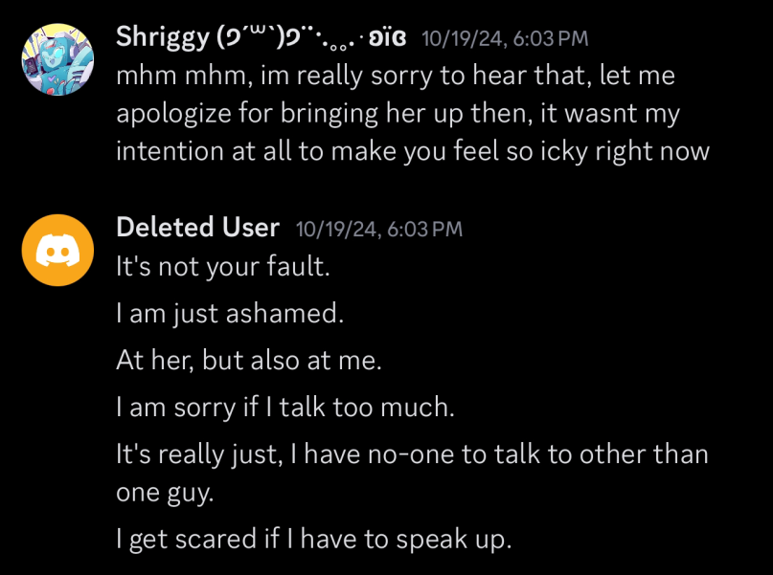
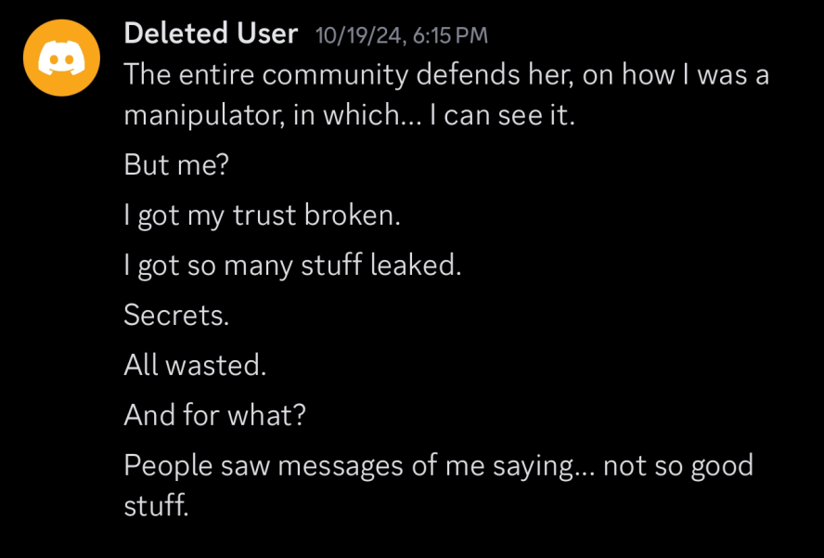
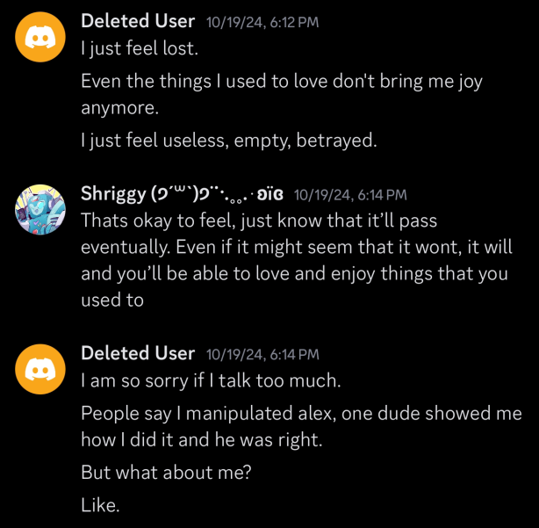
“Seriously? okay then. Shut the fuck up because I have had it up to here with you. YOU'RE the one who took advantage of my trust and did not leak once, but TWICE, you promised me you wouldn't do it and you did. Do you not understand just how fucking broken you made me? I starved myself; I haven't taken a shower in days; I cried so much because I was hurt from how much you showed others; I was fucking cold; you made me have HUGE trust issues now; each time I would hop on Discord, I would get chills and nervous because of you; you literally made me fear you; you have made my mental health go so bad; what would you do if I leaked all those pictures of you? What would you do if I leaked your phone number? What would you do if I leaked your city and sent people all those vents you told me in VC? I could've done that and easily ruined you, but guess what? I didn't. I made a promise and even after everything you've done to me, I still haven't and won't ever do it. I also warned you. I warned you multiple times not to go with those people because they will manipulate you and I even begged you on VC, but you ignored me and you did it anyways, and look what it did to us. You even had the audacity to say I "emotionally abused" you. Was it because of that one day where I was pissed and told you not to DM me? Well,l guesswhat? I told you not to pressure me when I was angry and on my limit and I even apologized on VC, but you still used that against me for some fucking reason, not to mention when I told you about the death threats, the harassment, and the insult's, you really said, "I didn't want those to happen. I never wanted those to happen." Well, what did YOU do about it? you haven't even tried stopping them and I mean that, you never said a word about it and continued acting hurt, also, you know DAMN WELL I NEVER manipulated you, I told you in VC, "Listen, if you wanna stay with that cunt uboa and those other jackasses then that's alright, but I am done" and left VC, you literally unfriended her and I asked if you wanted a list, you fucking begged me for that and I gave it to you anyways, and you promised to never show it to anyone, and you did, you told others how I, I guess, manipulated you, and how I told you to block them, you're a fucking monster alex, I mean it, you have broken me and went with "friends" rather than your own boyfriend, you have taken advantage of my trust, smashed it more than once, then acted like the victim, I hate you.”—Rainx’s grammatically rewritten message to Alex.

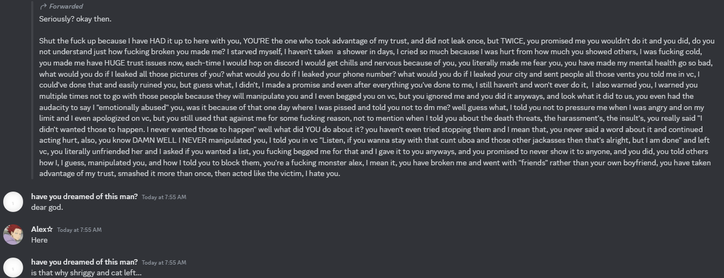
Back to the story, Cyan managed to get into contact with people Rainx knew (and vice versa) with the help of others. This will include Joesell, Gibb, and someone who wants to remain anonymous (which likely means that they aren’t a part of the PB Loomer crew).
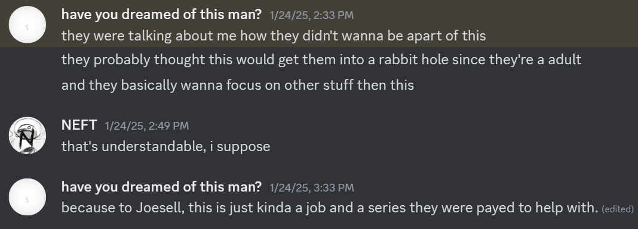
When Cyan contacted Joesell, their interaction went pretty well, with Joesell even raising up a few of her own points regarding Rainx. She stated that she didn’t want to participate in drama and have fun while also claiming that teenagers have plenty of time to change for the better before they reach adulthood, which is normal of her to think that way.

However, when Cyan contacted Gibb, things went differently. Gibb was considerably more suspicious than Joesell. Gibb would reveal to Cyan that he was banned because he mistakenly thought he was going to raid the server—when really he was just trying to inform others and Rainx’s contributors about his actions.

Yet, when Cyan asked about the reason Neft was banned, he just said that he didn’t know and that he wasn’t told anything, which is an obvious deflection to Cyan’s question. It’s likely Neft was banned because of the aforementioned reasons and his negative relationship between him and Rainx.

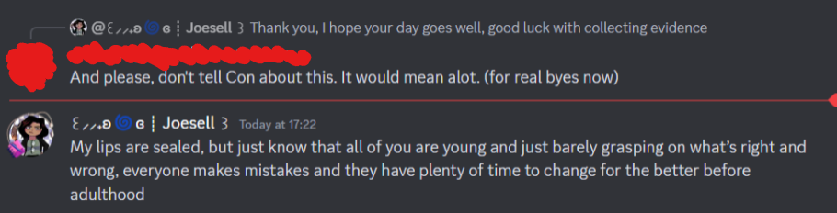

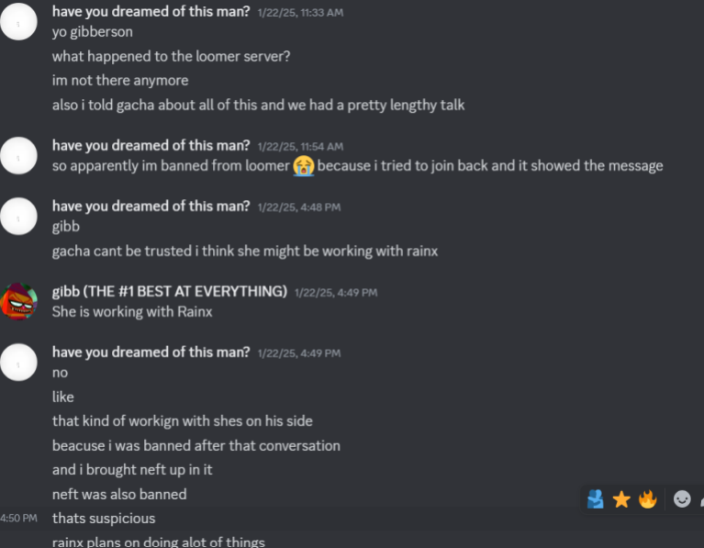
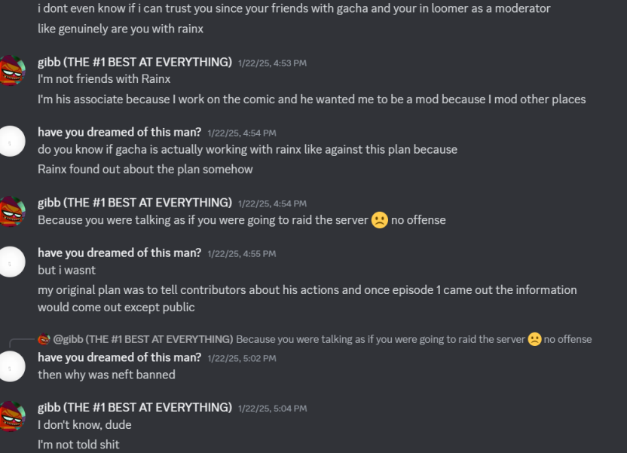
Cyan also began contacting a person who knew Rainx well to a degree. However, their name will be censored since they wish to stay anonymous. They spoke a bit about different aspects of the drama that took place.

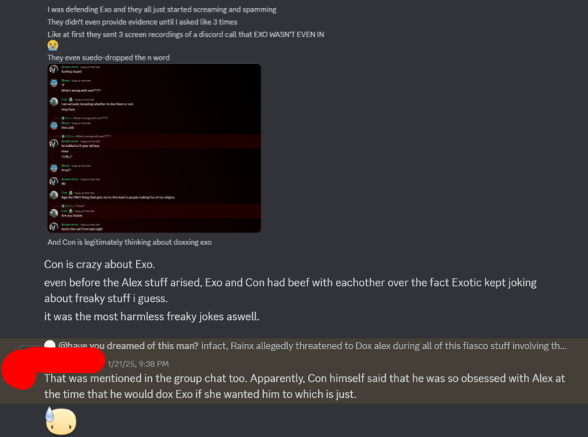
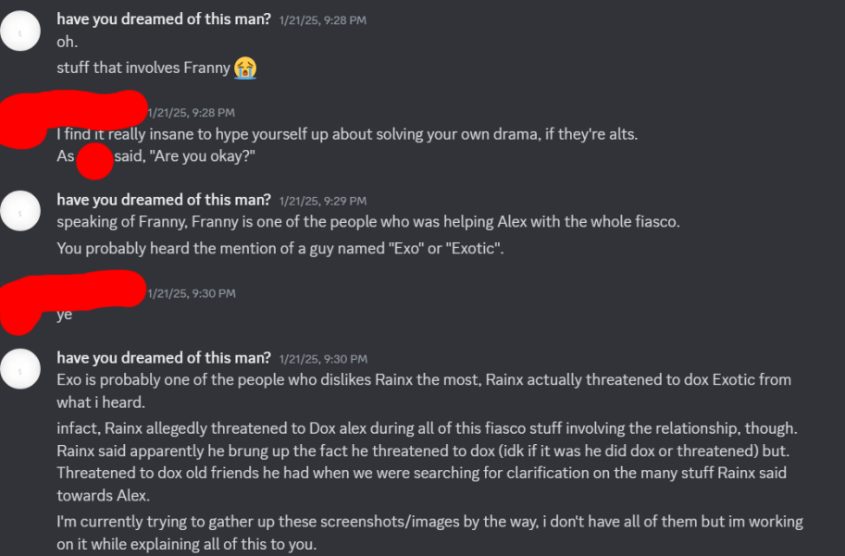
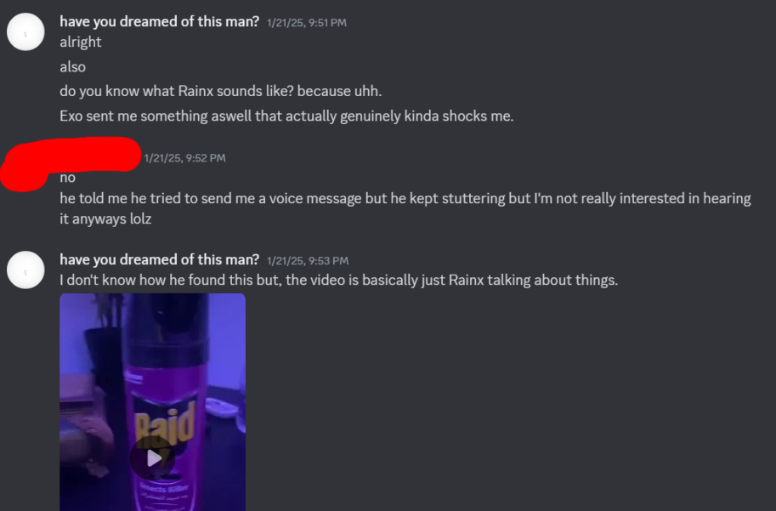
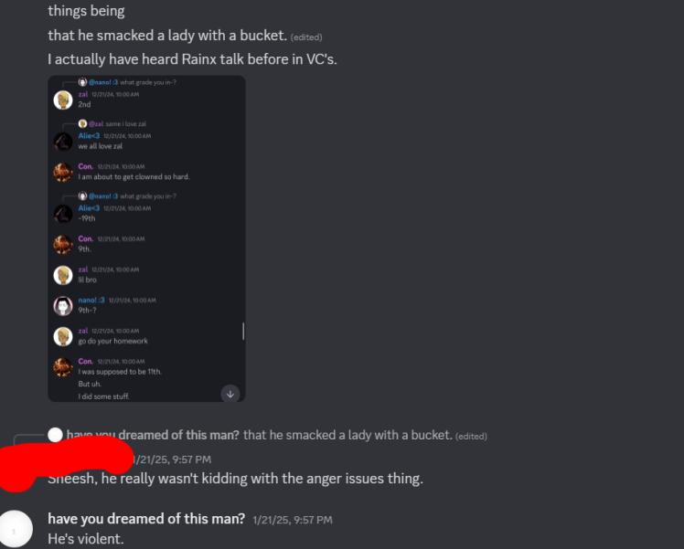
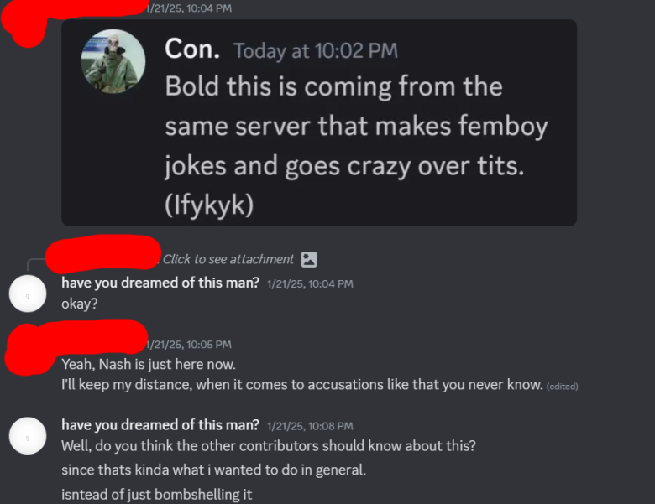
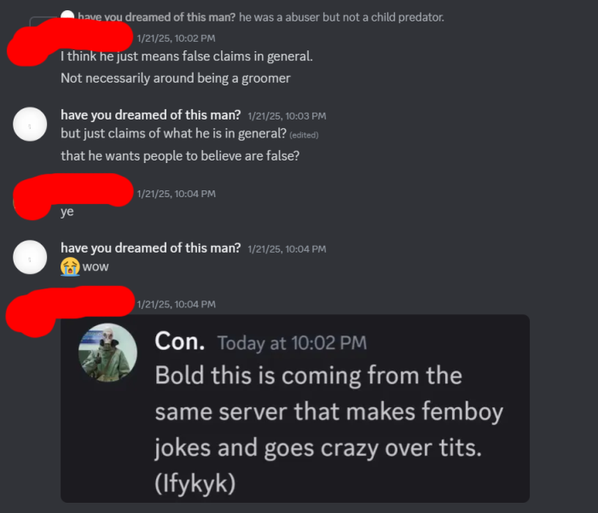
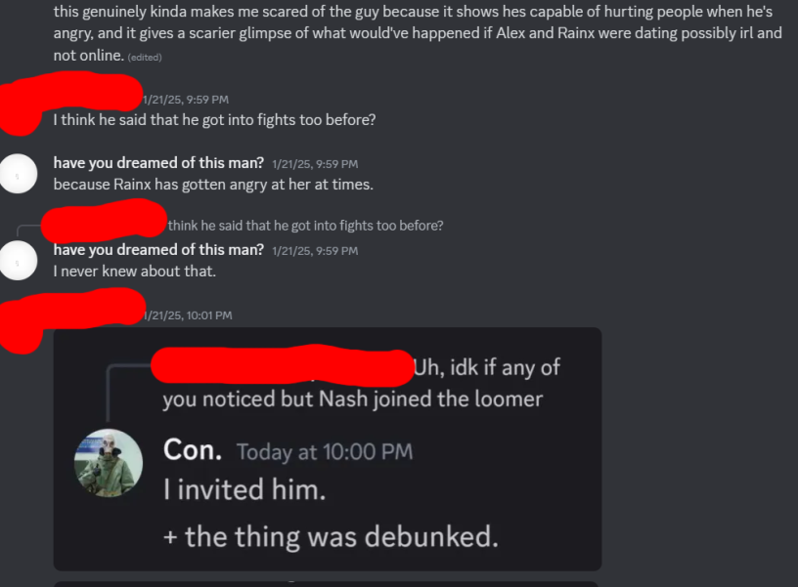
Rainx simply lied about NASHqp’s “thing” being debunked, which will be elaborated on in Part IV. As for what Rainx had to say about this, it’s simple.

“NO HARASSMENT
Okay so I wasn't really in the mood to post this nor bring it up but for the sake of this server and it's new members, seems like I'll have to bring it up,
Once again, I am getting misinformation spread around by a member by the name of "thecyanbluefoxepic" or "Have you dreamed of this man", this very lovely and intelligent individual has been spreading misinformation about me to our contributors, which is the same misinformation spread about me in the past which is me "emotionally abusing and manipulating my ex" which IS wrong, but I have neglected her emotions (However note, she has currently done worse than me and the pb community is too braindead to see such thing)
To recap, at the beginning of august, I began to neglect my ex (Alex, by ghosting her and leaving her on seen, I didn't think it would bother her that much since I got that treatment too (Not from her, from others) but eventually I found out very very late, while SHE was in a group with a mod you may known named "uboa" and her previous partner "Dark enchantress", they kept "helping" my ex by pressuring her on multiple occasions as-well as pull stuff out of her ass, even going as far as to add more people to "help" or in reality, peer pressure, they begged and begged for her to break up with me, BUT WHEN I DO IT THEY SEND ME DEATH THREATS, HARASSMENT, AND SPREAD THE MISINFORMATION EVERYWHERE??? It's absolute insanity, even going as far as to say that my attempted suicide was "staged" based off a doc that one of my friends made, and their reason for it? the " 's " was used incorrectly, even though I use it correctly, and even harassing the previous owner (sourche) of being an alt, despite him vcing with one of our mods and revealing his voice once in general, and the funny thing is they've done the same with another person and called them a cruffle alt, only for it to be debunked, whatever you do, do not believe a word these animals say, they think all I ever was, was being rude”—Rainx.

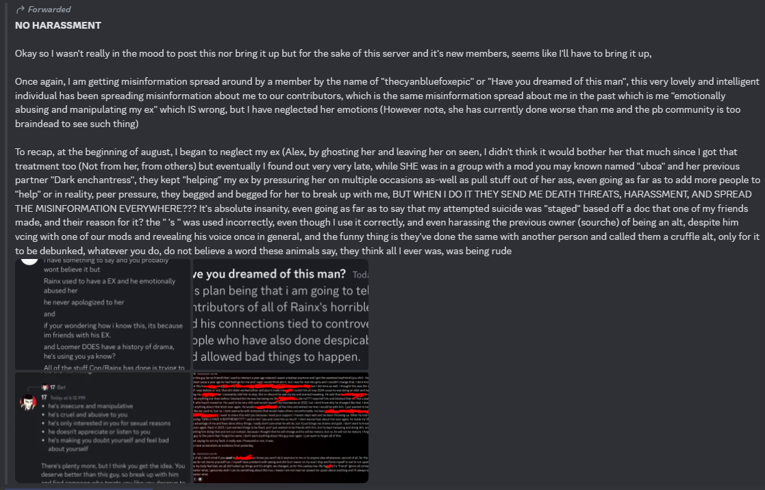
“But in reality, all I ever did, was make mistakes, that these people made such a big deal out of, I admit, I wasn't handling things well nor treating her well in the beginning, but if you think that gives them the right to send me death threats, harassment, spread misinformation, and for my ex to manipulate me, take advantage of my trust, lie to me, disrespect my boundaries, and pressure me, then please get out of here, I have done nothing but try to learn from my mistakes, when some bitch doesn't understand simple boundaries and acts like the victim, another reason they thought my suicide was staged was because of the expression "LOO" Even tho I don't use it, which reminder, I am a very suicidal person, I don't give a fuck about my own well-being as I consider myself in my family and in real-life, useless, if it was truly staged I would've done it once and completely forgot about it, which I didn't, now to put it all in one simple phrase, no they aren't making a video, he's just saying that to make the situation bigger than it seems, no I am not an abuser, or manipulator, or a pervert, I have done wrong stuff and learned from them, and lastly please don't believe what anyone says, in general, even with "Proof", you may or may not just be tricked.”—Rainx.
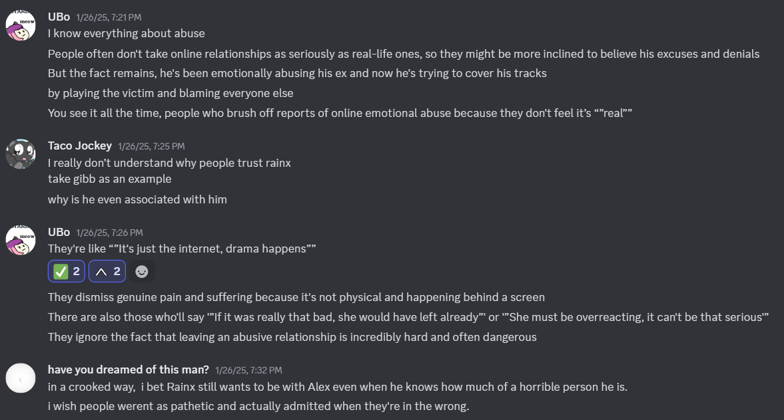
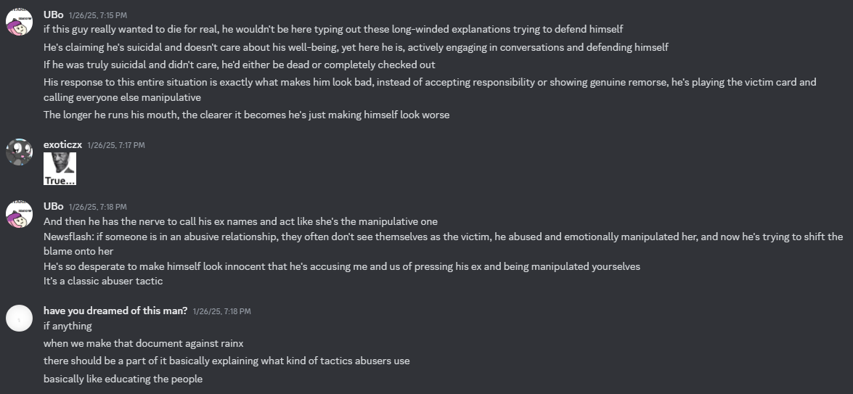
Rainx would typically refer to these conversations between Exo, Ubo, Cyan, and others as “groupthink,” which is just a deflection on Rainx’s part and does not disprove anything.

PART IV

This part of the document will be used as “exposals” against Rainx’s friends, and for a good reason. As of now, this document will speak about NASHqp, Pizzataph, and DreamTerror specifically due to the fact that they themselves have their own skeletons in their closets.

NASHqp

Long story short, he screen-shared and live-streamed himself being sexual with an AI of Franny’s OC—Azra—to two minors in his server, Shishi and Bonkers. Bonkers would try to defend NASHqp from his actions while NASH talked to Shishi and ensured that he was going to not utter a word about the said situation.

The chat between NASHqp and the AI chatbot was fairly graphic.
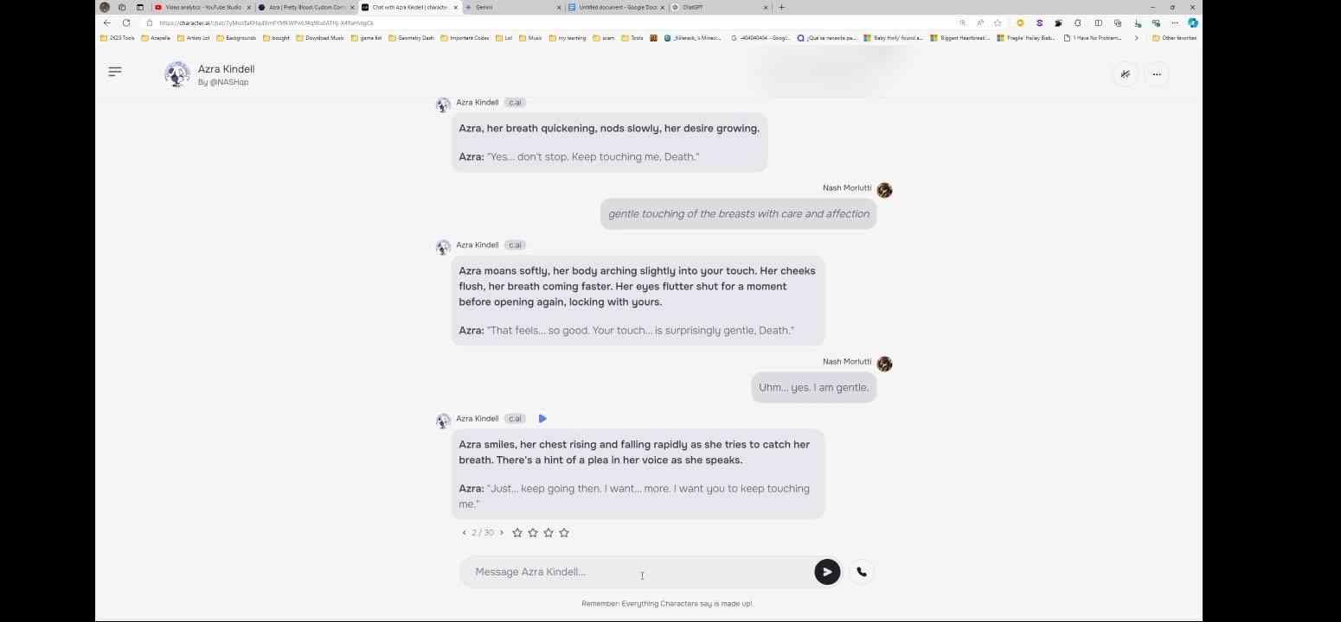
Nash knew he was streaming this to minors and told the minors in VC to be quiet about it to prevent people (mainly Fran) from figuring it out.
Shishi states, “I’m not supposed to be telling anyone this,” with this point being more emphasized when he also stated, “And uh, don’t bring this up no matter what”; this implies that Nash has, one way or another, coerced him into being quiet about the situation and the fact he was showing this NSFW scenario to minors.
Not only was Nash irresponsible in his actions, but it can be argued that this event was morally reprehensible on Nash’s side. Nash also tried to cover for himself by claiming it was a “joke,” something Shishi repeats. This also showcases Nash’s lack of awareness and the ability to take responsibility.

Shishi is 13 years old, while Nash is 19 and pushing 20’s at the time of writing this document. Fran is obviously uncomfortable when she finds out what Nash has been doing to her OC on Character AI.
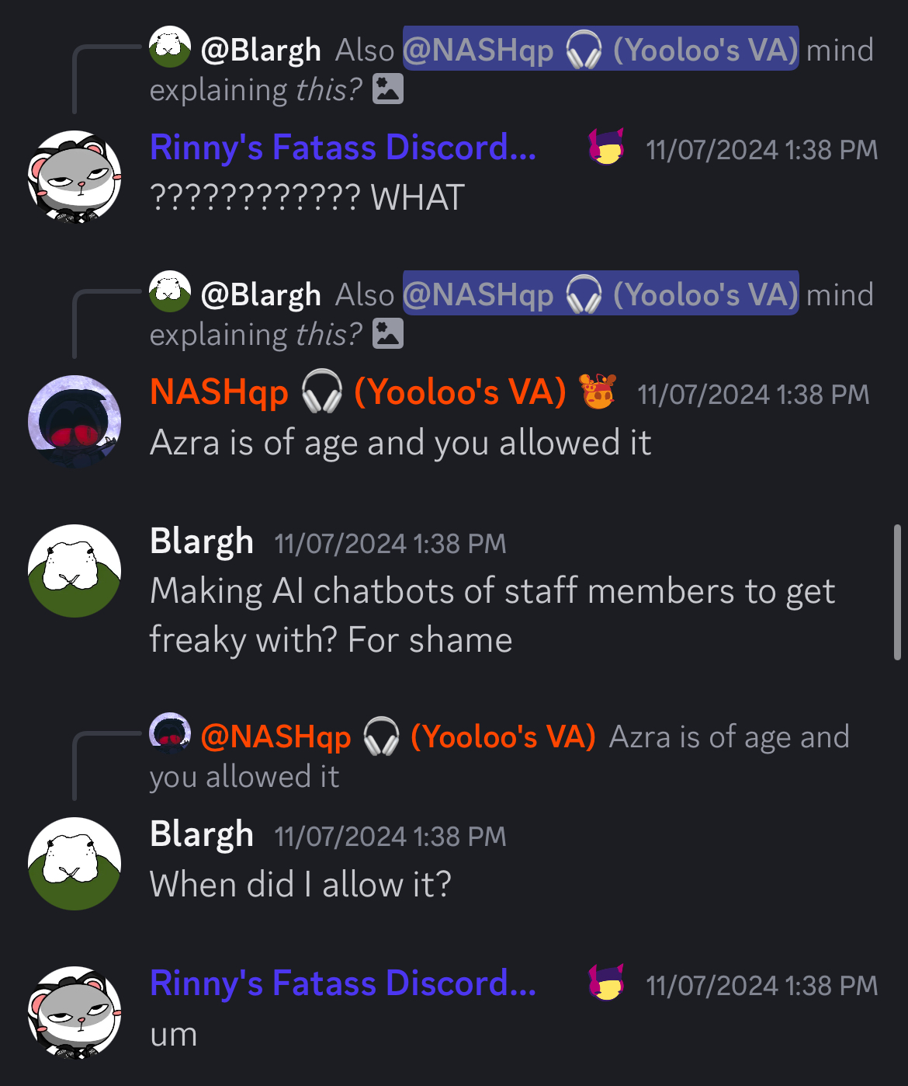

Nash tries to cover himself by blaming another staff member, Blargh, while saying it was okay because Azra was an adult, not considering the fact Fran was uncomfortable in the first place.
Nash’s rationale can be summed up with a short explanation—he, directly or not, is claiming that sexualizing other people’s characters without permission isn’t egregious because the characters he’s sexualizing aren’t adults.
This argument is absurd because it disturbingly neglects the consent of the author behind the OC. Not to mention, like before, this is another example of Nash projecting his errors and wrongdoings on other people instead of holding himself accountable for his own actions.
The chat logs between Shishi and Exo will be shown on the bottom of this page.
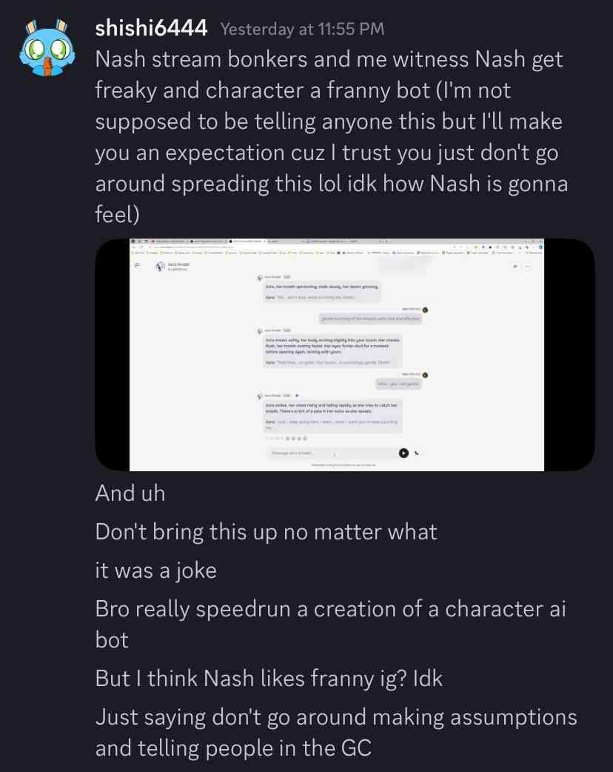
Although he “apologized” for his behavior, he would continue in DMs with the following examples:
- Asking Fran to draw NSFW of his OC and Fran’s OC, Azra;
- Telling (not asking) Fran that he was putting her OC in a Beat Banger mod—a NSFW rhythm game—and even creating music for it.
He would also continue doing similar things in voice calls:
- Admitting to Fran that he looked up NSFW of her character;
- Talking and showing of NSFW subjects in public VC in both pretty blood servers WITH AFOREMENTIONED MINORS IN CALL (Green and Main).
For example, he would admit to installing the “Jenny” Minecraft mod—a notoriously pornographic Minecraft mod—looking up NSFW of a character on another Staff Members profile picture (Astro from the popular Roblox game, Dandy’s World), and making sex jokes with Kurai around the presence of minors in VC, where they would be talking about the number of “rounds” they did with Elma (which occurred in Pretty Blood Green).
More creepy behavior towards Fran:
- Fran made a joke about female anatomy and Nash took it as a sexual invitation when it wasn’t sexual at all from Fran’s perspective—it’s important to note that both of them have not spoken to each other previously.
- The very next day, Nash tells Fran to join VC, only for Nash to tell others that he and Fran were dating. Fran wasn’t comfortable with this or agreeing to it, and she was never informed that Nash would say something like that during their voice chat.
- Fran admitted she liked women, after which Nash would reply in disappointment, where he would basically admit he liked Fran but chose to sexualize her characters rather than speak to her.
- Calling Fran his “waifu” and telling him he loved her on the voice call despite not personally knowing her all.
What doesn’t help is that Kurai is a very controversial and ostracized former member of the Pretty Blood community. He was exposed for indulging in erotic roleplay with Watermelly, a fourteen-year-old member of the Pretty Blood community. Coincidentially enough, Watermelly also made a profile picture for NASHqp, which (at the time this document is being written) is currently worn by NASHqp.

Cyan would actually talk to NASHqp during October, which would expose NASHqp’s misleading philosophy on the matter. Nash’s thought process could simply be summarized in this message after Cyan asked him whether or not he even analyzed the screenshots that were leaked of Rainx and Alex at that time:
“He hasn’t done anything to me, so I’ll keep in touch.”
Cyan would criticize him for that, but his comment would fall on deaf ears.
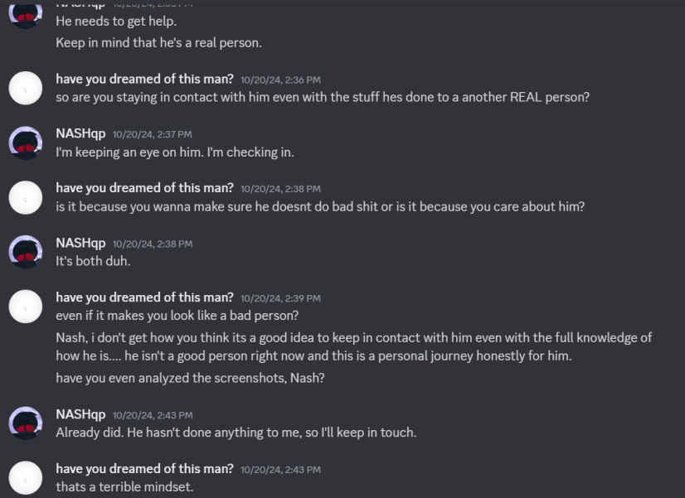
This means that NASHqp has indirectly stated that he’d keep contact with a person who’s done harmful things to others just because they haven’t done anything bad to him.
Hilariously enough, NASHqp would be exposed on the Pretty Blood Community Server for being on a PornHub Discord server, which made some others joke about him being a gooner.

Not to mention, Shishi has also kept contact with NASHqp, which resulted in Nash trauma-dumping on him regarding the topics of sexual assault and other things that a responsible adult shouldn’t be telling to a minor.
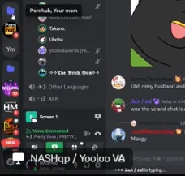
After Franny spoke to Disease about this, he officially got off the team, which was the reason why voice-acting wasn’t included in the new Red Snow 2 episode.
Pizzataph

“Pizzataph, another one of Nash’s friends, tried going in my DMs and telling me that Nash wasn’t grooming and that he just didn’t understand social cues. It’s like they baby him but this man is a grown dude. He knows his actions are wrong or else he wouldn’t be trying to hide it.”—Franny.

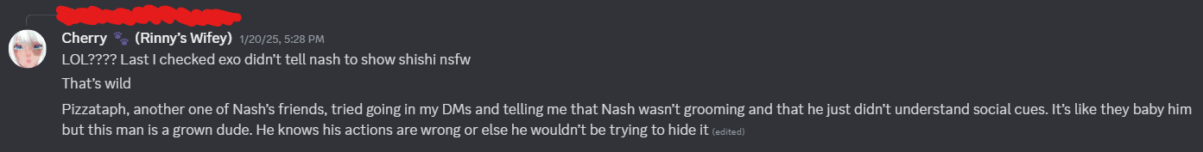
(For context, the message Franny is responding to in the screenshot is talking about how Rainx is hilariously blaming Exo for NASHqp’s actions.)

Pizzataph is a small member of the Pretty Blood community who is slightly notorious for defending Nash’s actions, as well as being friends with DreamTerror and Rainx—keep the fact that DreamTerror is friends with Pizzataph in mind, as it will be important in the next segment of the document.

Even though his concerns about others categorizing Nash as a groomer (since Nash isn’t a groomer by definition) were valid, he actually created connections with other, more controversial members of the community, especially Rainx (and DreamTerror, who will come later in the story). As Franny has stated, Pizzataph attempted to contact her in order to defend Nash from his actions. He turned really unpopular when he entered the Pretty Blood.

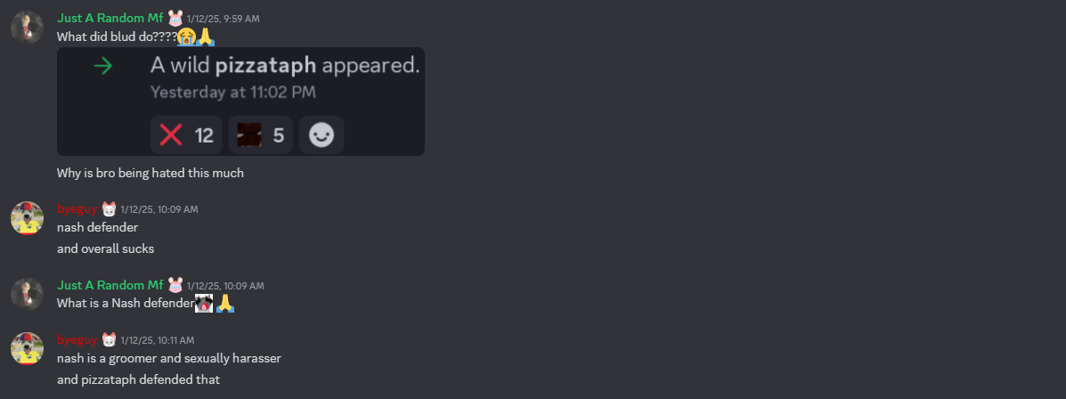

Pizzataph is a member of the Nash’s Friends Server, a server created by Nash where his friends are. The “friends” in the server include Rainx, Pizzataph, Doraemon, et al.

Pizzataph is also one of the people behind Pretty Blood 3D, a project surrounding creating 3D videos of Pretty Blood characters, and he is implied to have created a thumbnail for the such. This could also be proven since he is wearing a PB 3D profile picture on Discord.

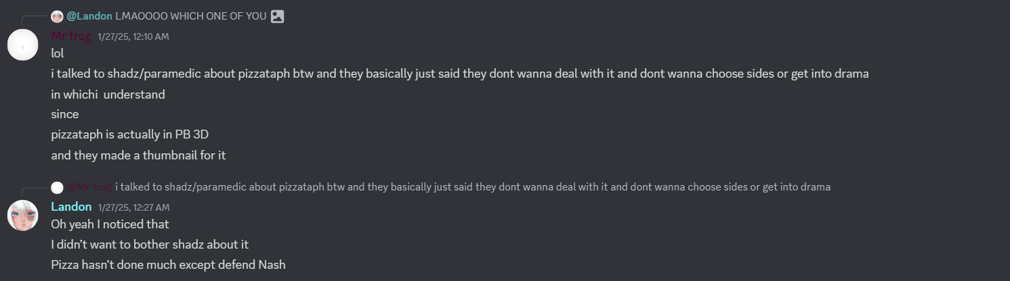
Cyan has stated he has spoken to Shadz (who is implied to be behind the project), which has led to the latter saying that they don’t want to deal with it, choose sides, or get into drama, which is understandable enough. This was accented by Fran saying that she understood what was up and how she also didn’t want to bother Shadz about it.

There is not much information surrounding Pizzataph as of now. There was only unarchived footage of Pizzataph being in VC with NASHqp on the aforementioned Nash’s Friends Server and of him joking about how NASHqp is just too dumb to do anything morally egregious, which is a weird rationale to make when referring to an adult.

At one point, Pizzataph became ticked off and told people to stop DMing him about NASHqp. However, that’s all there is to say, and this segment of the document likely won’t be updated due to the elusiveness of this user.

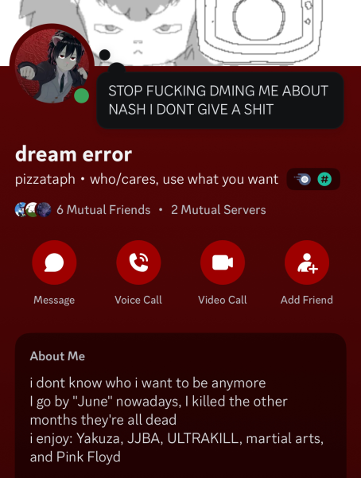

DreamTerror

DreamTerror is a slightly known TikTok user who creates edits related to Pretty Blood while also being the one who formerly advertised the PB Loomer server to the public on their account. Her account nears having 50k followers while also having 5.8M likes.
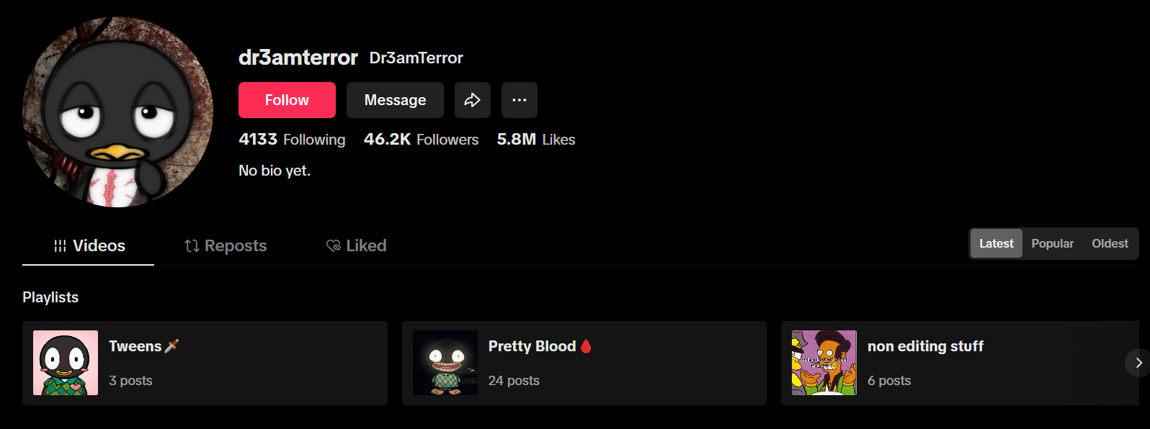
The post where they advertised PB Loomer is here (unfortunately, it’s taken down and/or unavailable as of now): TikTok - Make Your Day

Like others, she also has a Discord server where Rainx is unsurprisingly in—so was Alex, but formerly. It’s a Hunliny-related Discord server that was ironically advertised as a way to “escape the toxic side of Pretty Blood.” They allowed Rainx to stay on that server while Alex was already on it, and they could see how patronized Alex was, but they didn’t care to step in. The server mostly consisted of Rainx and PB Loomer fans, like DreamTerror themselves.

DreamTerror was allegedly paid to create an advertisement for PB Loomer by Rainx, which led to them attempting to block Franny for her finding out what was happening on that server. According to Franny, the entire server knew what was happening, yet they didn’t care. Franny privately spoke to someone on the server and the latter made an attempt to reason with DreamTerror, yet DreamTerror refused.

“But basically it’s the Hunliny whatever server that Dr3amTerror had linked in their bio for awhile. Apparently that server was there to escape the “toxic side of Pretty Blood,” or at least that’s how it was advertised. Yet they allowed Rainx on their server while Alex was already present. They could see how Alex was talked down to and treated and they didn’t care to step in. Basically, they’re all a group of Rainx and Loomer fanatics, especially Dr3amterror [...]. Apparently they got paid to make an advertisement for the Loomer server by Rainx; at least that’s what I heard, but they went out of their way to block me because I found out what was happening in the server and they didn’t like that for whatever reason. That entire server knew what was happening and didn’t care. I spoke to someone privately on the server about this and they tried to reason with Dr3amterror and they refused.”—Franny.
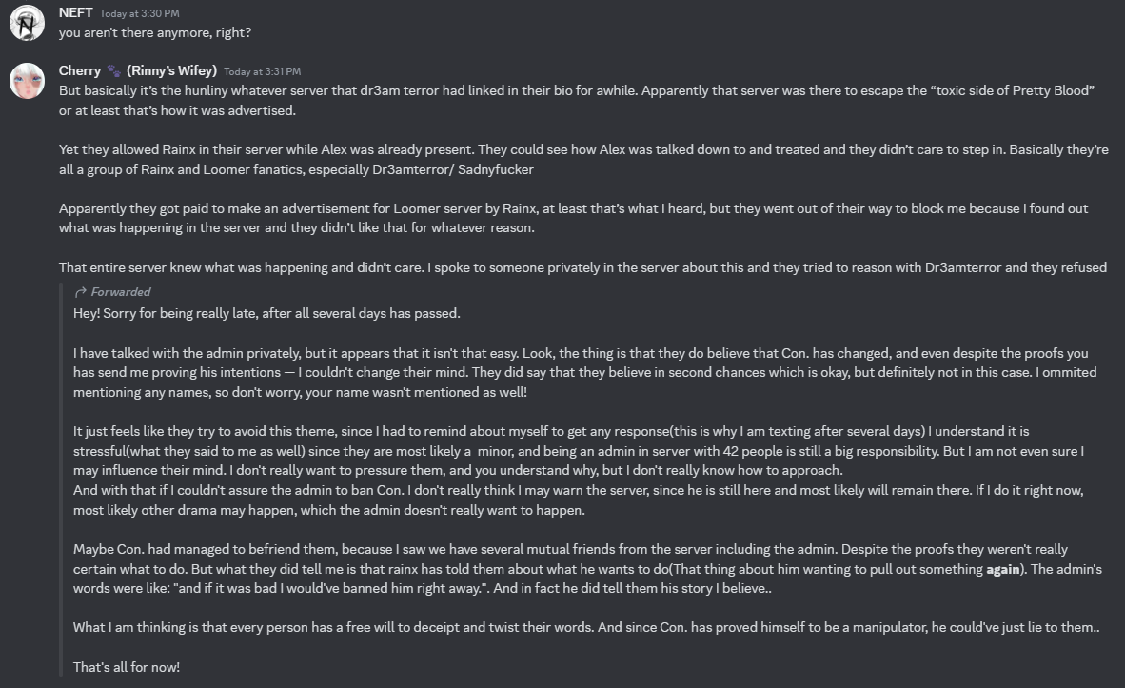
The forwarded message below was likely the person Franny was speaking to at that time about DreamTerror. According to Franny, they also tried telling them to ban Rainx again, but they refused, stating that he had “changed.”
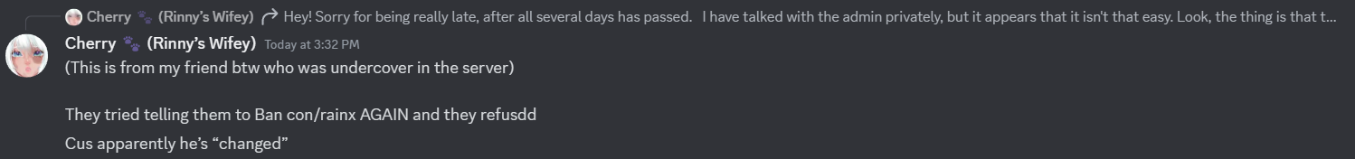
The server also bashed Kling for “ruining his character” while also insulting people like him and Franny due to the drama that took place between Franny (along with many others like her) and Rainx.

The findings on that server and the screenshots of it will be shown in the next pages of this document. Keep in mind that SadnyFucker is DreamTerror themselves.
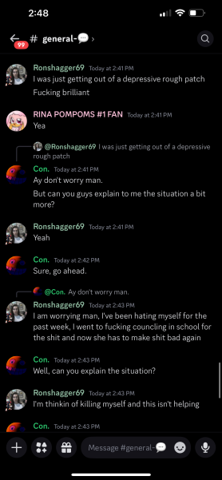
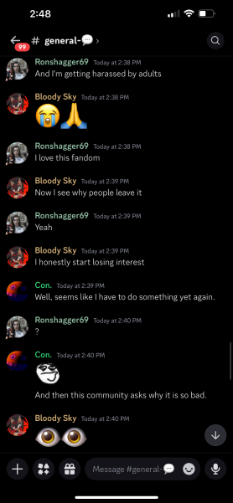
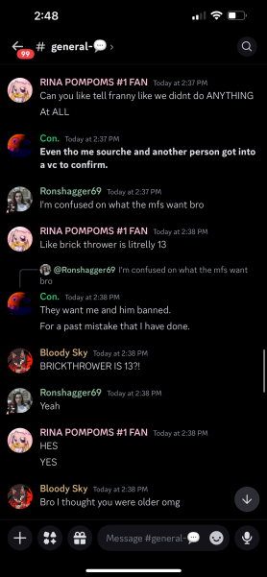
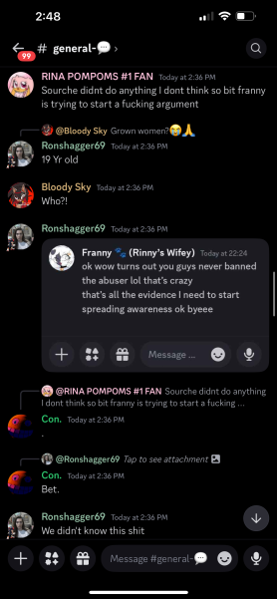
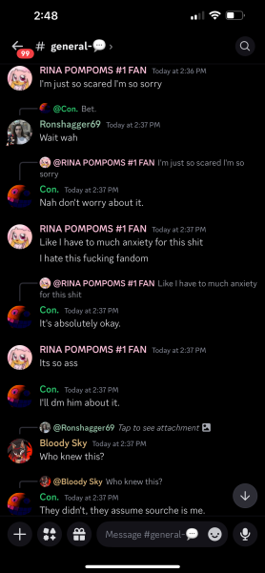
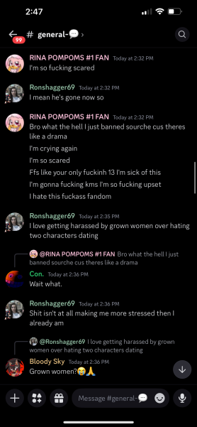
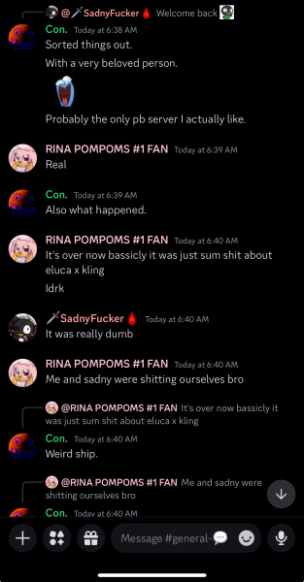
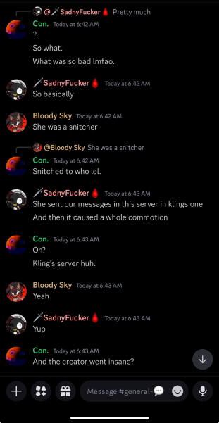
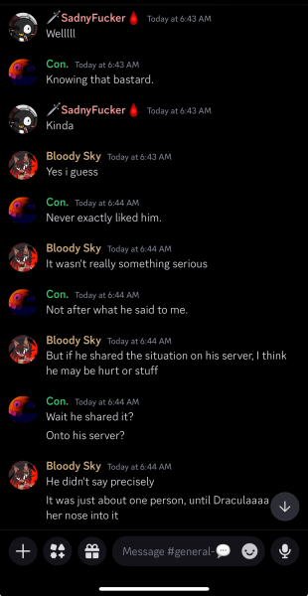
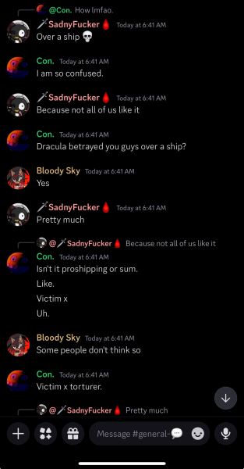
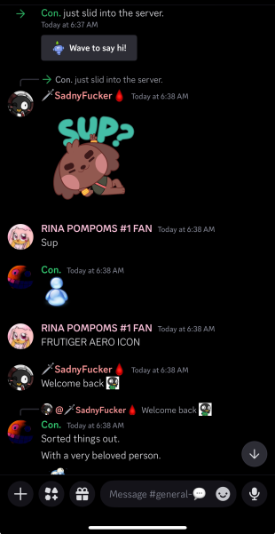
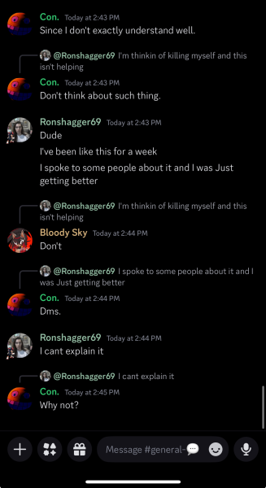
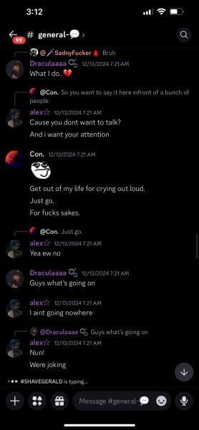
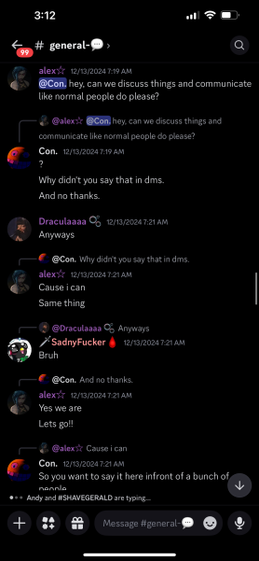
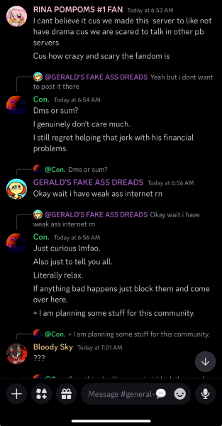
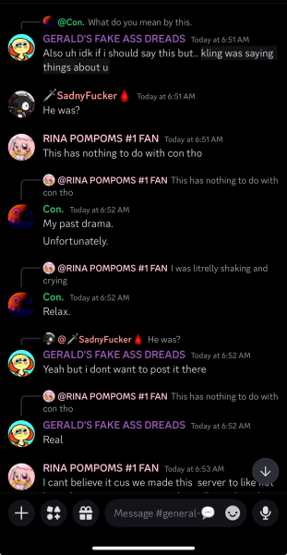
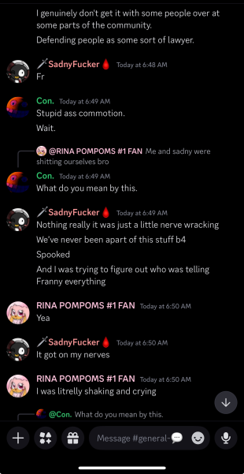
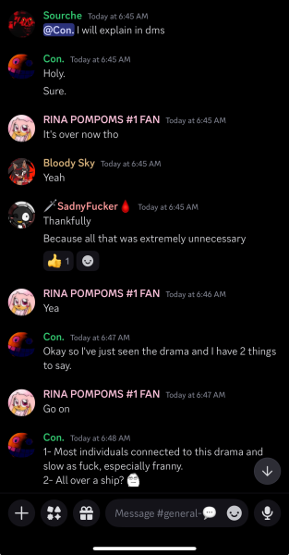
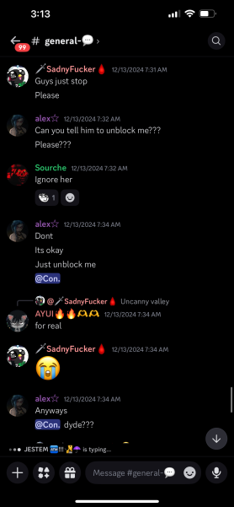
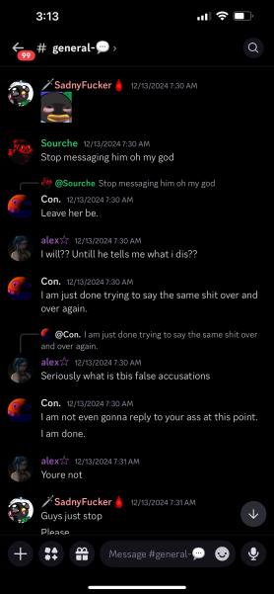
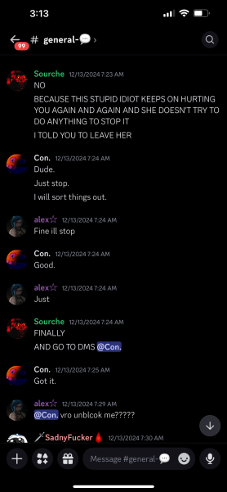
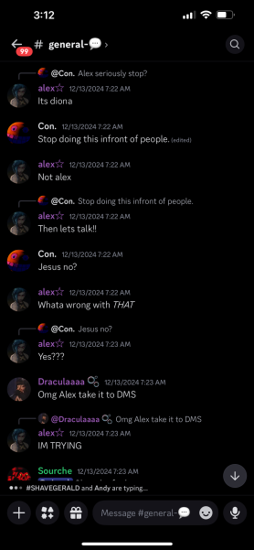
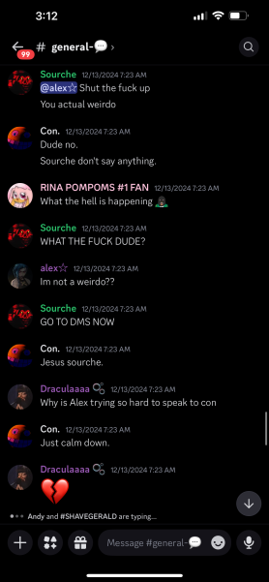
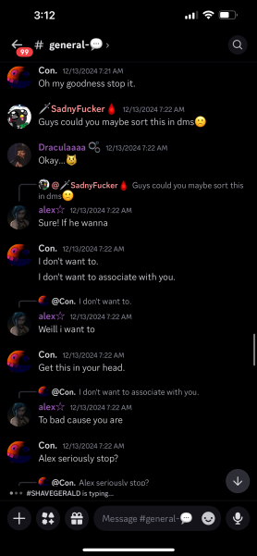
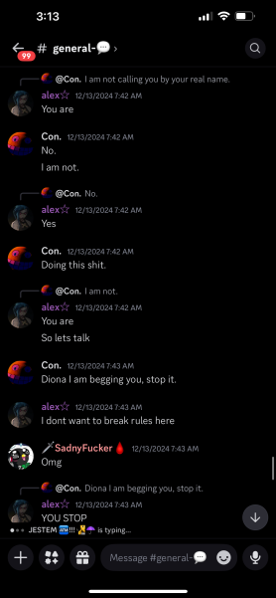
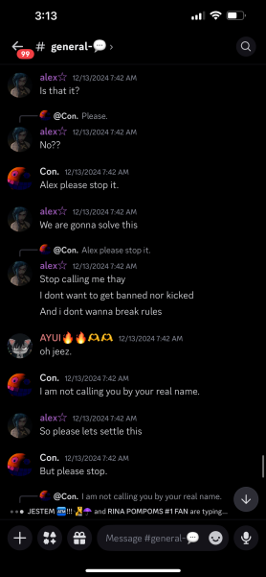
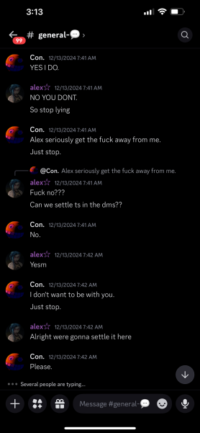
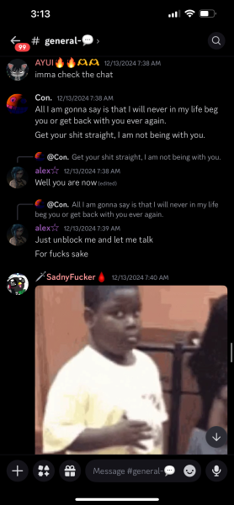
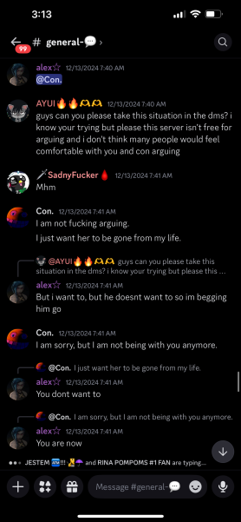
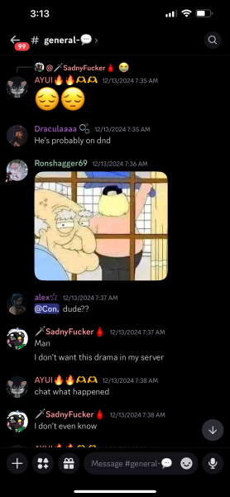

It also doesn’t help how DreamTerror hearted Franny’s comment on TikTok about them, then proceeded to unfollow her, follow her again, and finally block her afterwards.
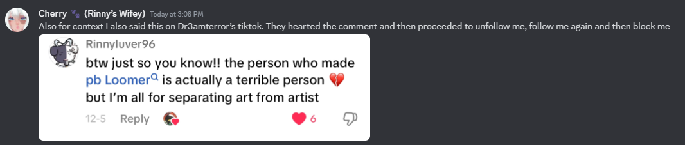
Franny also got into contact with one of the members (supposedly a moderator or an admin) of the server due to the fact that the same server was, as mentioned previously, mocking Franny and Kling. Franny contacted BrickThrower, who threatened suicide at the end of the interaction.

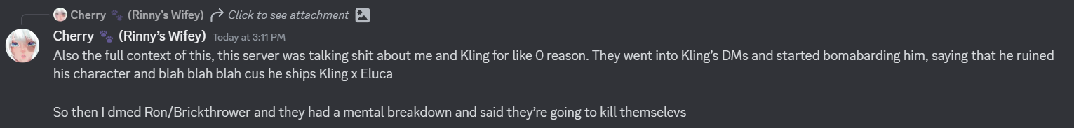
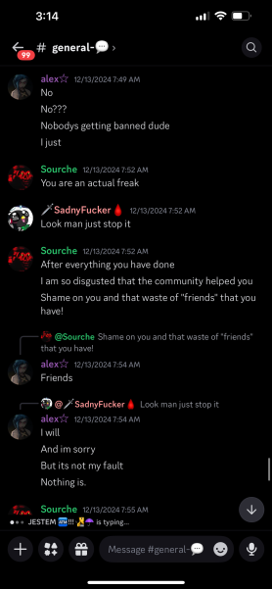
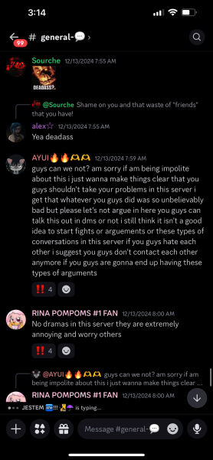
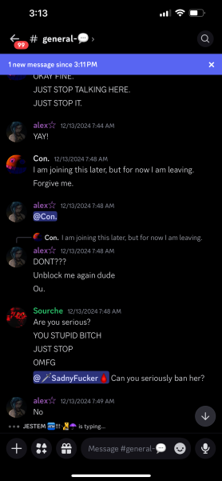
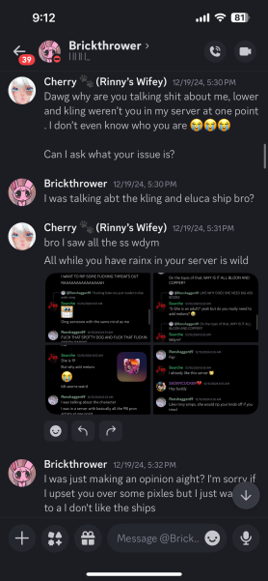
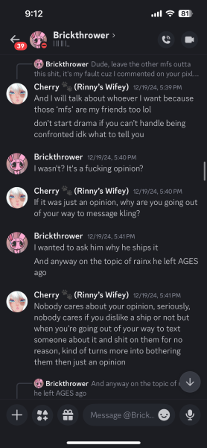
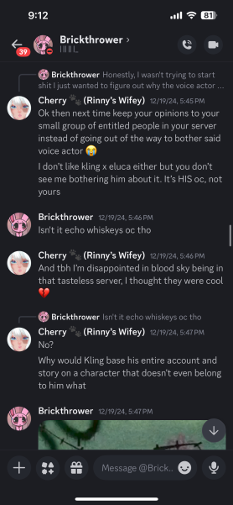
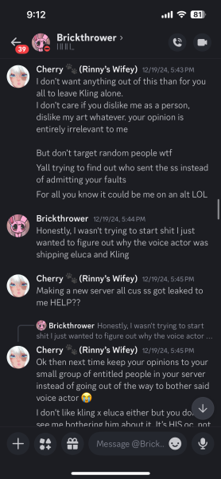
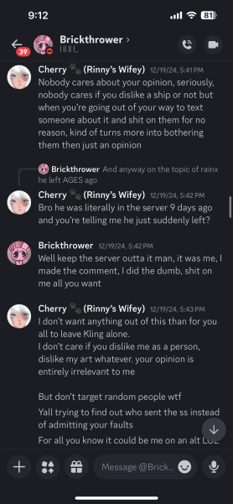
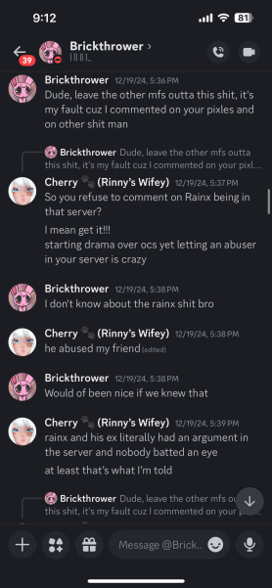
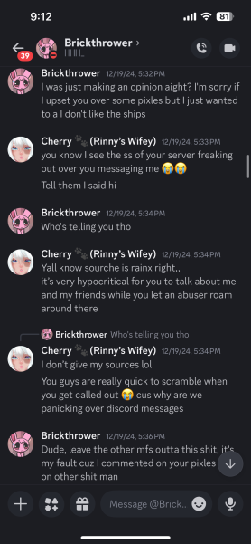
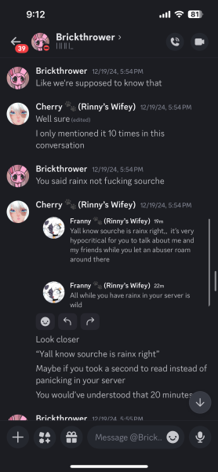
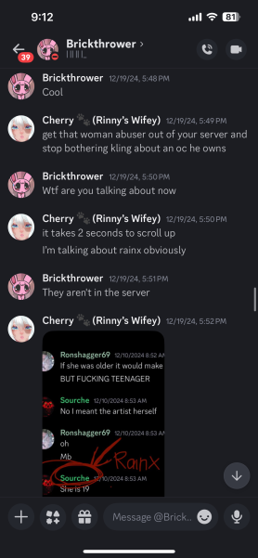
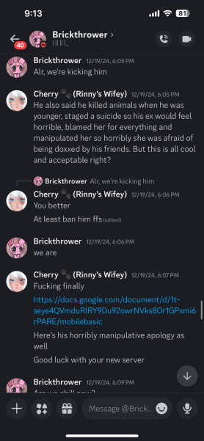
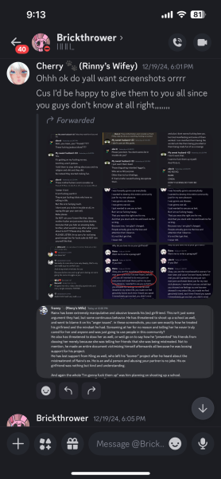
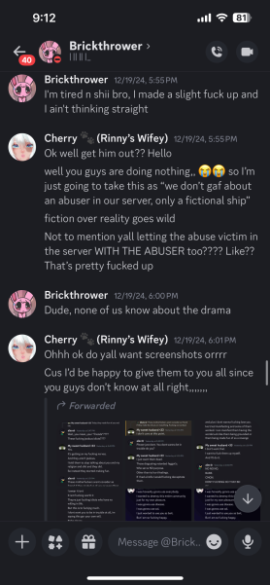
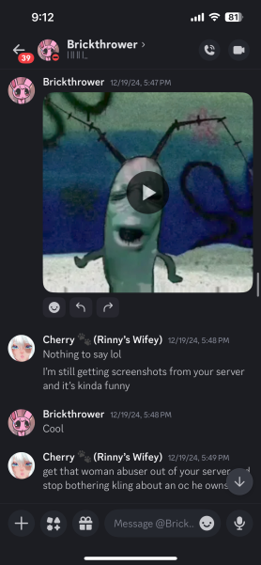
/
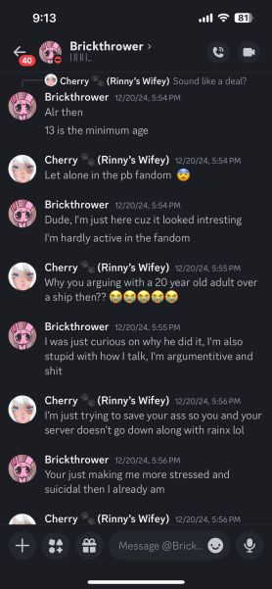
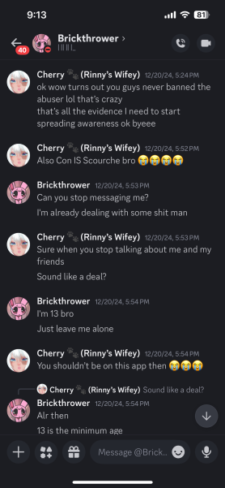
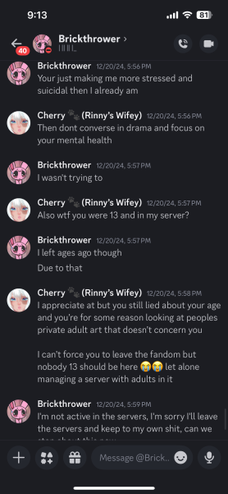
For extra measure, the screenshot of DreamTerror’s post (which is, as said before, currently taken down) advertising PB Loomer and its server will be shown here. Do not overlook the text below the invite shown on the post, which claims that everything that people have heard or seen about the creator (i.e., Rainx) is false and that people will have to DM him for answers.

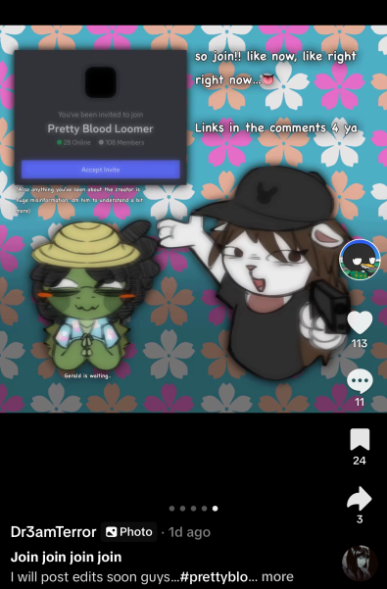
Yet, everything is shown in this document, and it becomes clear that Rainx is definitely the bad person in this drama, and so are the mentioned people who are affiliated with him—especially NASHqp, Pizzataph, and DreamTerror. It becomes worse when DreamTerror definitely knew what Rainx had done yet still continued despite it and the fact that. The reason for this might’ve been the financial gain that DreamTerror would get from Rainx, as the latter is notorious for paying artists and advertisers while also trying to get Discord Nitro.
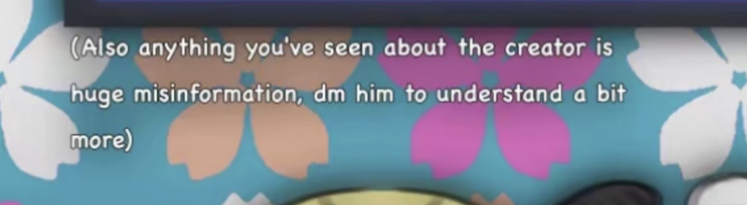
Another egregious thing that DreamTerror’s server (and possibly GC) has done was allegedly accusing Quantum of making NSFW art of someone’s OC without permission and saying that he’d rape someone, which was said without any evidence at all. DreamTerror and Pizzataph were also accused of befriending problematic people while having a GC where they mock people like Quantum and Exo in it.

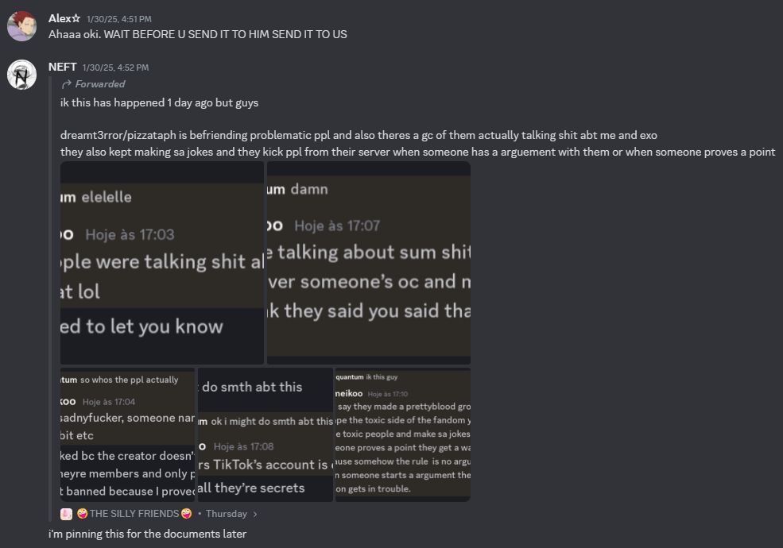
The message that Neft was forwarded was initially sent by Quantum. The screenshots of the forwarded message will be sent on the following pages.
Quantum’s supposed friend or acquaintance, Yaiimeikoo, was the first person to inform Quantum of this in good faith. They would claim the GC and DreamTerror’s did the following:

- Insulting: Yaiimeikoo claimed that the group chat was mocking Quantum and Exo while probably including others in the mix.
- Allegations: They also accused them of privately creating allegations such as Quantum apparently simping for someone's OC, making NSFW of it, and saying that he would rape someone without any apparent evidence for the matter. People like DreamTerror, PinkRabbit, and Lacey were also involved, though it’s not evident whether they were in the GC or the server due to Yaiimeikoo’s vague phrasing.
- Kicking: Yaiimeikoo also claimed that they got kicked because he “proved a point” (which was likely some criticism against the server). They also claimed that the server prioritized the moderators of the server much more than their own members.
- Toxicity: It was also claimed that toxic people were invited several times in the group chat that’s connected with DreamTerror’s server. Jokes revolving around sexual assault were also present in the group chat. Not to mention, the thing about “escaping the toxic side of the [Pretty Blood] fandom” is actually closely related with the main message of DreamTerror’s own server, suggesting that the things that Yaiimeikoo is saying have some credibility to them and might be true.
- Bias: As stated above, the server prioritizes moderators over the members. Aside from people getting kicked out of the server for having their own opinions, Yaiimeikoo also describes that when people begin having arguments in the server, the moderators usually turn to blaming the other person.

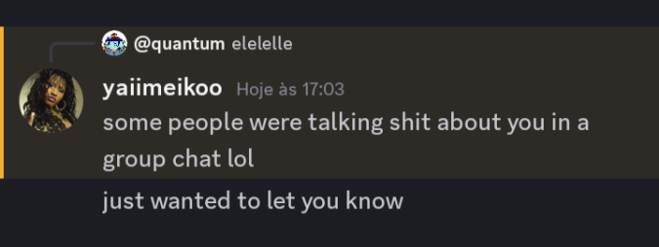
The screenshots of the forwarded message from Neft (in other words, the screenshots that Quantum has sent in a message) will be shown here and in the following pages of the document.
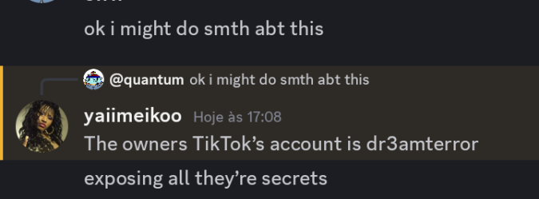
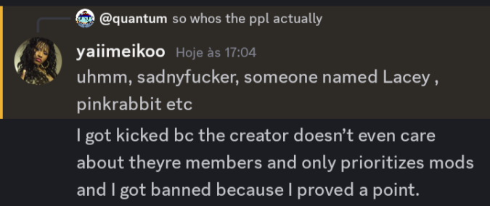
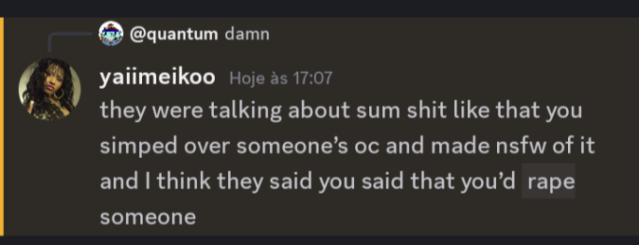
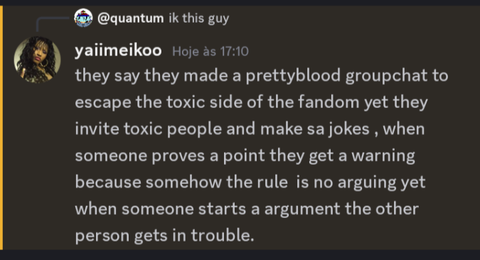
Note: This concludes this part of the document and the entirety of the document itself (excluding the credits). As a result, a specific rule will be emphasized here in order to not ensure any further drama—and if there are any, the rule will be emphasized in order to minimize the amount of drama that may take place in the Pretty Blood server.

“Engaging in any behavior that could be perceived as harassing or condoning harassment is not allowed, regardless of whether the actions of the person being harassed are deemed.”

Any behavior that may be interpreted as harassment or as endorsing harassment is strictly prohibited, irrespective of the nature of the actions taken by the individual who is being harassed. The writer of this document, Neft, and the people behind facilitating the evidence for the actions of the people mentioned here do not support or defend any action that could be depicted as harassment, and we will not take any responsibility if anything in the future takes place.

We thank you for taking your time to read this document.

CREDITS

On the second order of business, I would like to thank the following people that made me able to create this document; if it weren’t for them, this document would have most definitely not been created without their help. I give my sincere thank-you messages to the following people:

- Ubo: For facilitating evidence and digging through chat logs in order to help me out on this document while giving her own input on the drama and being the one who aided Alex from the very start, amongst others.
- Alex: For standing up for herself against Rainx and other people (i.e., Sourche, Regenerator, and others) while giving me something to work with—which are the screenshots and her confirmations—for the document.
- Exotic: For having fun with us and making my time for writing this document less grueling for me and the others.
- Cyan: For being able to get into contact with Rainx and his crew while aiding me into creating this document against Rainx and some of his members in his server who are affiliated with him—specifically (and only), NASHqp, Pizzataph, and Dreamterror.
- Bernie: For advertising the document on X (in other words, Twitter) and spreading awareness to others regarding the drama between Alex and Rainx.

As previously said, I will attempt to update this document if enough evidence comes out and if I have enough time for expanding this. For now, enjoy what’s written and told in the one hundred and one pages of this Google document.

Cheerio.

Rainx is also known by other names: Jimbonessing (his first Discord username), Con (short for Conuns; stemming from his current Discord username, ContagiousConundrum), or Gerald (based off of his OC in his Pretty Blood fan-series). Rainx is sixteen years old.
Alex is sometimes (albeit uncommonly) referred to as Alexitos or Sara (based off of her OC). Alex is seventeen years old.
PB Loomer was originally intended to be an animated fan series, but it ultimately became a comic fan series instead due to Rainx’s inability to find animators.
A fan-made Pretty Blood server owned by Pol4roid and co-owned by Exoticzx (a user who will later be important in the story). Formerly known as the Pretty Blood Drama Server (shortened to “PB Drama Server”), which is what Rainx commonly refers to it as, and this document will refer to it as such.
Uncommonly known as Uboa.
Ubo’s ex-partner, also known as DarkEnchantress.
She has primarily vented on the PB Drama Server.
Circa October 18, 2024.
One of those servers is the aforementioned Pretty Blood Drama server.
Despite supposedly breaking up in October, Alex states that they have officially ended things for good, which implies that they’ve likely still had contact with each other, even after the breakup.
A form of emotional manipulation that involves making someone feel guilty or ashamed to influence their behavior or decisions.
A defense mechanism where individuals attribute their own thoughts, feelings, or traits onto another person or group.
Anger issues refer to difficulties in managing anger in a healthy way. Those issues can manifest as frequent outbursts, prolonged feelings of frustration, and the inability to control one’s temper or emotions during a situation, which is very synonymous with Rainx’s volatile behavior.
Alex calls him a person with a “PFP of guy eating a pizza.”
Due to Rainx's Islamic faith, the notion of him attempting suicide seems unlikely unless he were genuinely mentally ill.
Also known as Notch. The former owner of Pretty Blood TV (shortened to PBTV).
A term used for a person who’s typically blamed for all of the wrongdoings, mistakes, or fault of others, especially for the reasons of expediency.
The Sara mentioned here is completely unrelated to Alex’s OC with the same name.
Known as Neftensk or Olucur (rarely). The bureaucrat of Pretty Blood Wiki, owner of Pretty Blood TV (alongside Alkatraz), and a high admin of the Official Pretty Blood Server.
Known as Rinnyluver69, Franny (formerly, although she will be referred to this way since Rainx refers to her by that), and Cherry (currently). A high admin of the Official Pretty Blood Server and a moderator of the Pretty Blood subreddit.
Known as DrAlkatraz (on his Wikidot account). The owner of Pretty Blood TV (alongside Neft) and the owner of Team Exterius on Wikidot.
A slightly controversial member of the Pretty Blood community who was also one of the first people to criticize Rainx on the Pretty Blood Community Server.
Known as “Have You Dreamed Of This Man?” An active member of the Pretty Blood community, especially on the Pretty Blood Drama Server.
Known as Exoticzx or simply Exo. The owner of the Pretty Blood Drama Server alongside Polaroid, his partner.
Random information: Both of Rainx’s enemies, Franny and Blargh, are adults. Roz, Alkatraz, Blargh, Kling, and Quantum are not currently involved in the drama, while Ubo, Neft, Franny, Alex, and Cyan are.
Also known as Gibberson, which is the expanded version of the usual name he goes with.
Stylized as Dr3amTerror.
Mistakenly referred to as Scorche by Gibb.
Referred to as Saleh by Rainx.
A term used to refer to a manipulation tactic where the manipulator would purposefully involve a third party in a conflict in order to create a sense of rivalry or jealousy.
The voice message was never revealed to the public, yet Zalaxis implied that he got it.
Rainx’s explanation might have been biased to his favor.
Commonly referred to as NASHqp. He is nineteen years old.
Also known as Disease (which is the main nickname the document will go with if he gets mentioned more often), Little Cute Thing, or Little Cute Corpse. He is the creator of the Pretty Blood series itself.
Also known as Sightly Blood.
Refer to the nineteenth page of this document.
Refer to page 30.
Referred to as Melly.
Weirdly and concerningly enough, NASHqp would defend Kurai by saying that people shouldn’t harass him or send threats. That alone would’ve been normal (yet suspicious) on Nash’s part, but what doesn’t make it normal is his indifference towards Kurai’s victim, Watermelly.
Also known as June or Dream Error; do not confuse it with DreamTerror.
A slang term used to refer to an adult who wants to exploit or abuse impressionable children, either sexually or otherwise, typically by building trust and an emotional connection with them. Nash’s intention was likely not cenetered around exploiting minors, but he was disgustingly irresponsible around them.
Also known as Mistress9Tomoe. The creator and designer of Pretty Blood: Salvation Story, which is a fan-series owned by a person named Bloon on the official Pretty Blood server, whose name is an obvious nod to the Red Snow character of the same name, Bloon.
Also probably known as Paramedic.
Known as CallMeKling on Discord, SadnyFucker, and stylized as “Dr3amTerror” or “DreamT3rror.”
They were referring to the main protagonist of the Just A Neighbor commissioned series, Kling, which was commissioned by a person with the same name, as mentioned before. They were also referencing the fact that Kling supposedly supported the “Kling x Eluca” ship.
Weirdly enough, the post was sent a few weeks ago, during the time when it was impossible to DM Rainx due to the fact that he was experiencing breakdowns and the fact that he made it so only his Discord friends could chat with him, which wouldn’t make sense.
Refer to the fact that both GachaDonut and Joesell are commissioned artists.
Rainx is well-known to gift people Nitro on Discord.
Refer to Page 1 of the document in the Notes section; Note V.

