Sinnohz'/Emi's/n64disks' explanation thread archi…

Introduction

This doc was made to specifically archive my explanation threads just incase anything bad happens to my Twitter account, leaving me unable to bring them up when needed.

Just note that everything has already been resolved.
The expose doc that my friend pupuwu has made on me a while back has been deleted/privated due to the drama already being resolved and due to the doc being misused with malicious intent.

Most stuff will be dated to;
2022-2023: Stuff from the doc.
2019-2024: Newly surfaced stuff + loli explanation. (DECEMBER 2024)

If you only care about the new stuff, go here.

Thread explaining the expose doc:

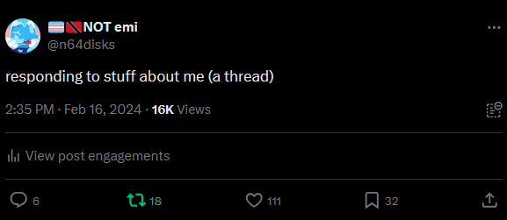
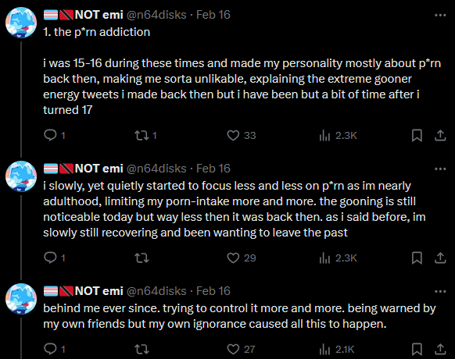
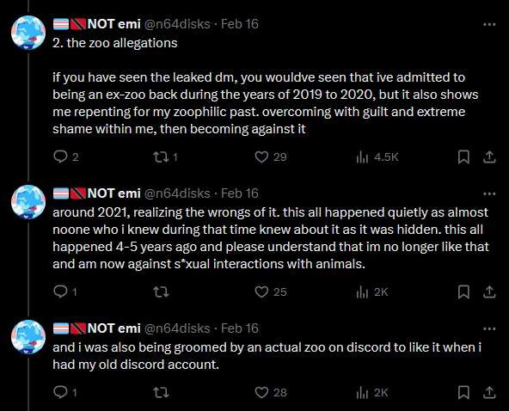
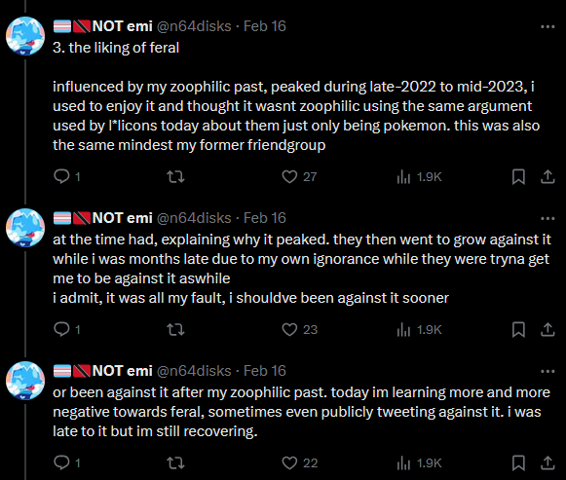
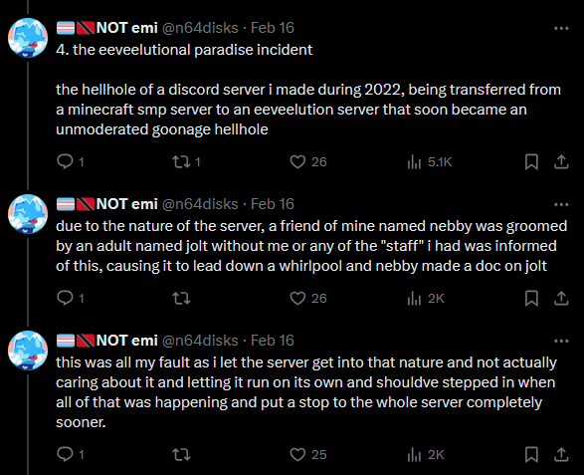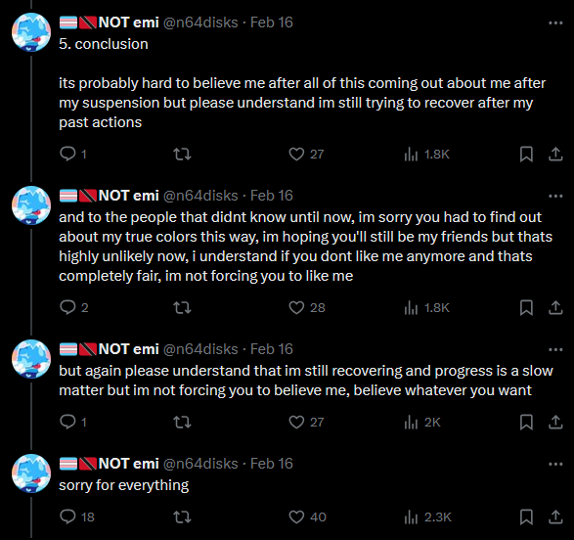

(UPDATE) Newly surfaced stuff thread.
- Loli explanation

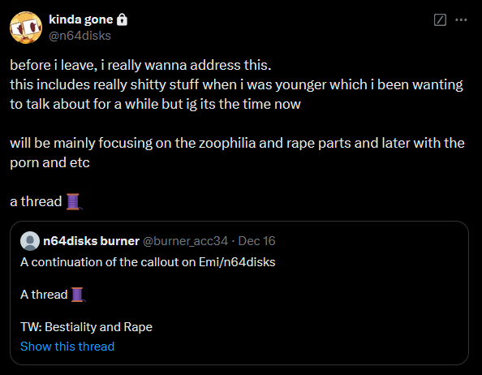

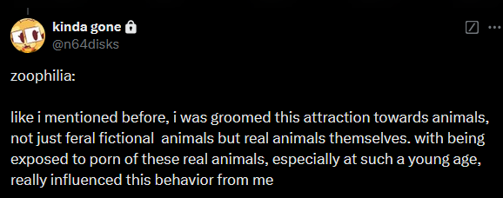

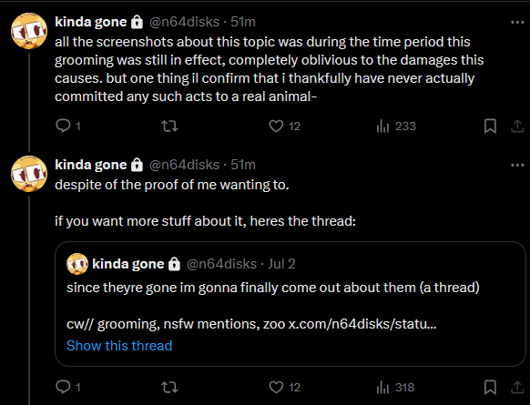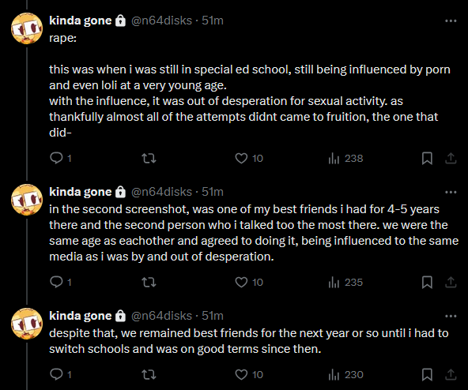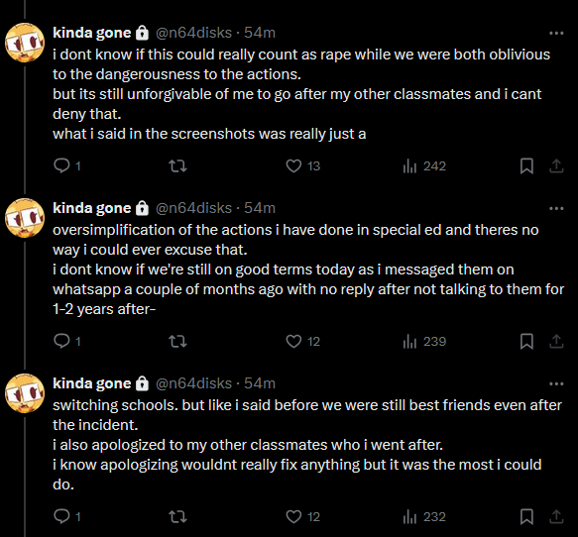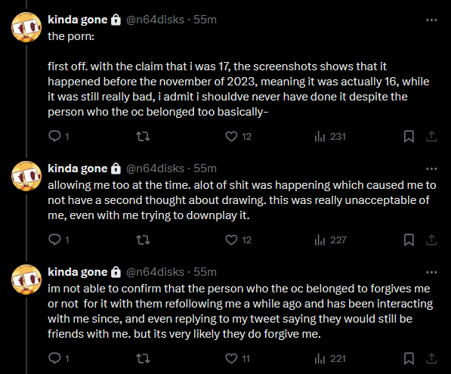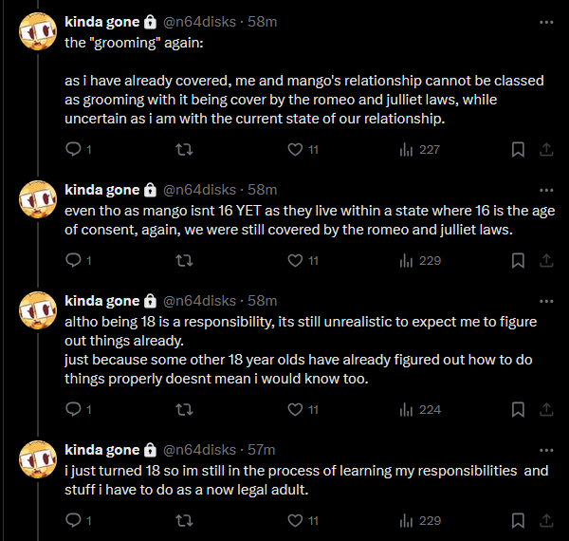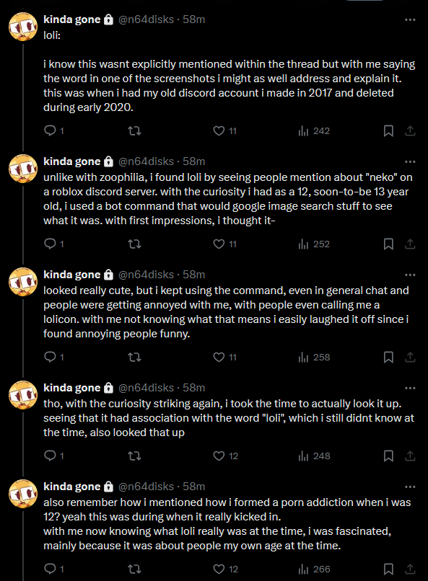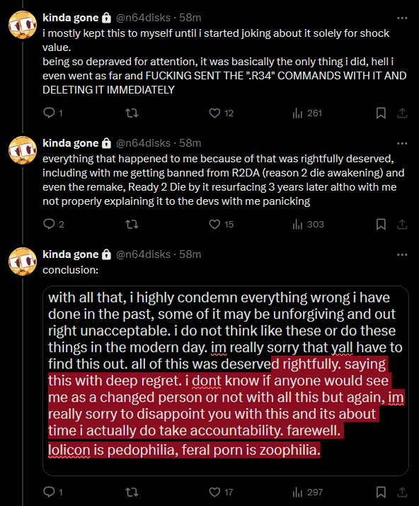

Conclusion (of the threads):

Again, as of writing this, this has been resolved for months.
This was only made to archive these very important threads and to prevent people from twisting the truth in their favor whenever these threads are unavailable and other malicious intents.

Bonus 1: Debunking a lie.

During the time when the expose doc was public, a person who’s Twitter handle went by the name “@_colon_three_” and their friends attempted to spread a falsehood about me liking cub rape porn of Pokemon.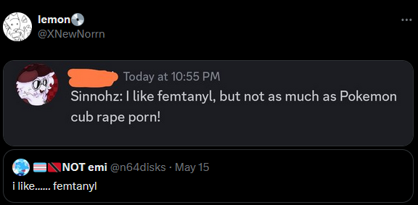
Immediately this claim wasn’t backed up with any proper evidence, and when they tried to “provide” evidence they only linked the doc and not showing where it actually said anything about cub rape porn.
That’s because it didn’t had anything claiming about cub rape porn within the doc.
I stated that this falsehood was harassment and they deflected it by saying things like “It isn’t harassment” since to them it didn’t follow the definition of harassment because it wasn’t “aggressive”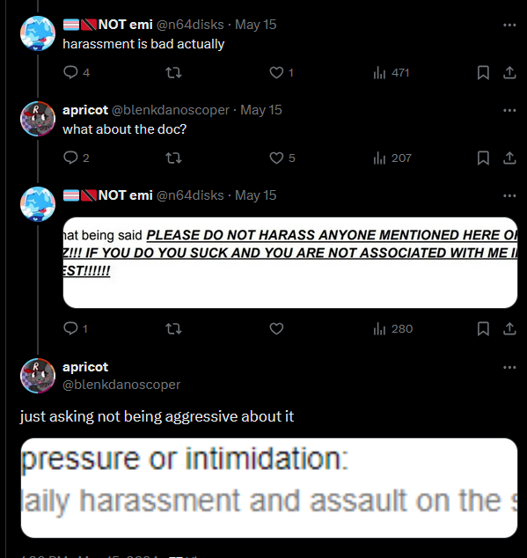
And mind you, within the doc it suggests the idea of NOT harassing anyone;
And one willingly believing the lie because of the sole existence of the doc.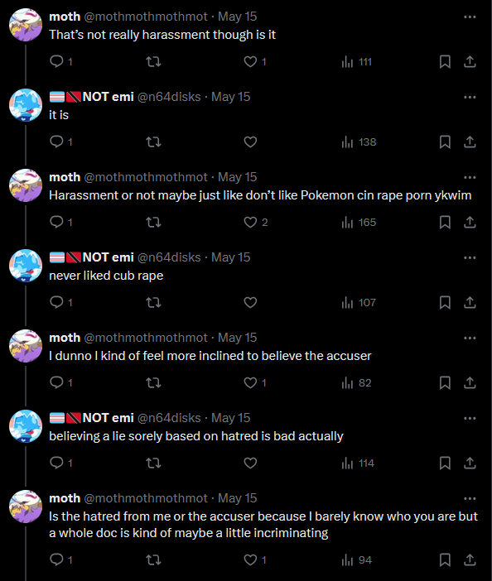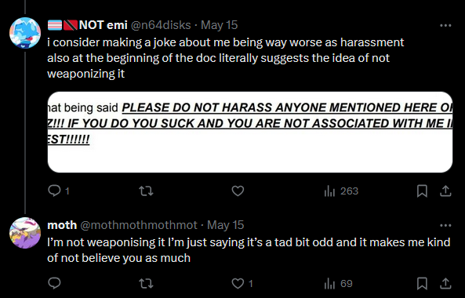

Pupuwu, the person who made the doc even said the claims were bullshit.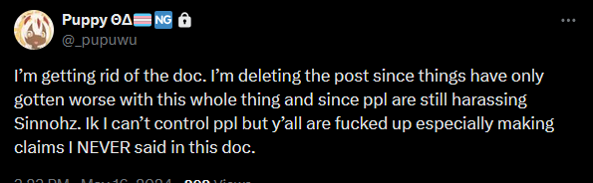

Bonus 2: Refusing to listen to the actual victim.

Going back to this part of my doc explanation thread;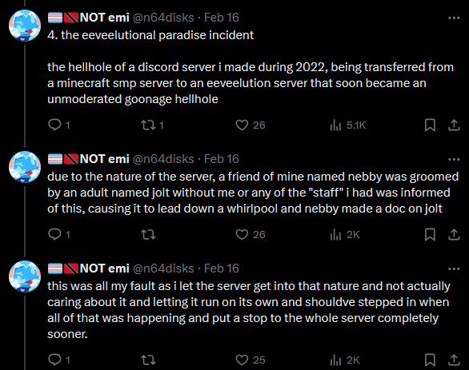
As of today as of writing this, a few people have been trying to twist the truth about what actually happened during the incident.
And when my girlfriend, Nebby, the actual victim of the grooming spoke out about it, they blatantly refused to even listen to her and insisted on twisting her own story to use against me.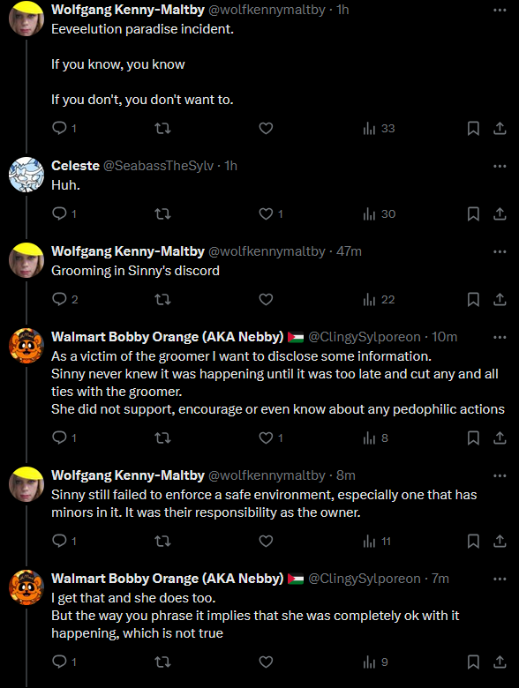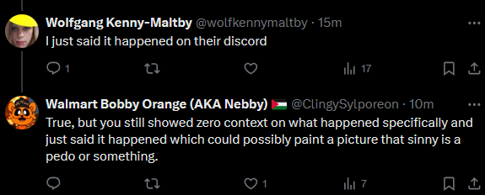

If you wanna see her full story, the link is here.

There was also a time where a former friend of mine kept on claiming there were over 14 victims of the grooming rather than just one.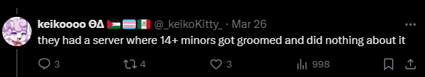
I talked to a friend on why I thought the claim that there was more than one victim to be bullshit;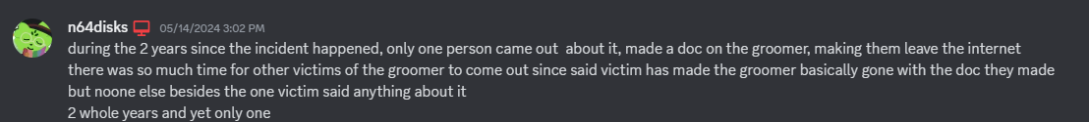

Conclusion (actually):

Like I said in the first conclusion, this was made to prevent the twisting of the truth and other malicious intents.
As much as I do not like these people (the ones in bonus 1, 2), please do NOT send any harassment their way.
However I do suggest keeping a distance away from them, but that’s your choice overall.

Thank you for reading this.

