PREAMBLE, 10/23/25
This is a document from last month that was written before an emotional episode that caused me to private it. It’s mostly a look at the situation through my own lens as opposed to an unbiased retelling of events. My mental state during and after was pretty shot, and I’m not sure how much I stand by any of this now.

Rather than getting rid of it forever, I decided I’d keep it around. I don’t want to erase something when I could learn from it. Don’t take this as an expose document on a couple of people you might not like; take it as a point of view I held.

Regardless of how correct it is or who all agrees with the document below, it was still written from a place of emotion and anger rather than out of wanting to get the story completely and utterly on a timeline. Despite this, I still had the best in mind; I didn’t want to slander anyone.

Keep that in mind if you want to use this for your own little hitpiece. I don’t know. I’m tired of this shit.

BEGINNING OF DOCUMENT
If anyone is reading this, it likely means this situation has escalated a little too far.

You’re about to learn what our good pal SitrusNetwork (and his weirdly older bootlicker sidekick Bernie) hasn’t been telling you. This has become spreading rumors about others this whole time while avoiding an actual conversation with people he should really be considering talking to.

This has gone on long enough. For those who have no idea about this controversy and the things that go on in the Pretty Blood community, you’re going to read something that will probably piss you off by the end of it. For those who do, it’ll likely be worse.

Either way, this document intends to be the truth and nothing but the truth.

This is going to be a long one. Read thoroughly. Misunderstanding this document and contributing to the telephone game drama in this community is only going to make things worse.

This document will assume you have *some* knowledge of who SitrusZ/SitrusNetwork/SitrusJigglypuff and Bernie Burner is. It will also assume you know of his Sitrus’ NSFW account, SitrusPuffy.

It will also assume that you have any knowledge of the situations regarding NashQP or Rainx. There is *some* important context within, but not enough for me to bloat the document with it. If you’d like to read it, it will be linked here.

Extra Context about NashQP and Rainx

GOOD OLD FOX 3
FIRST RESPONSE 8
NONRESPONSE 17
FURTHER NONRESPONSE 22
DISMISSAL 36
SUMMARY 41
AN ACTUAL APOLOGY 44
CONCLUSION 46

GOOD OLD FOX
Good Old Fox is a community member that I met in the main server a while back, during the peak of the NashQP drama. He had believed in what I had said; that Nash was not a pedophile but, in fact, just a mentally unstable creep.

Originally, he was the one who alerted me to a strange fact about Sitrus; he has drawn porn as a minor before and self-posted onto Rule 34.
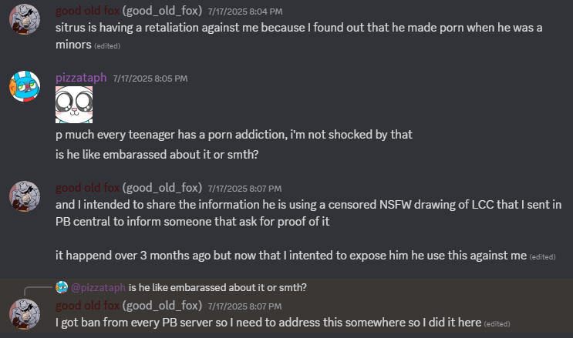
After looking at the situation myself, I learned that this did, in fact, happen.
In fact, Sitrus’ NSFW account on Rule34 was created years before he was 18.
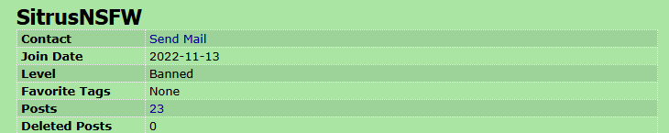
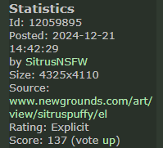
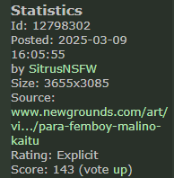
He had made several posts before his 18th birthday on May 16th, 2025.
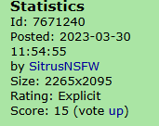

This also led to finding out that he had a secondary account, Mono_777, that was posting his old pornography from when he was younger. It had also posted exclusive art from Sitrus that hadn’t been seen anywhere else.
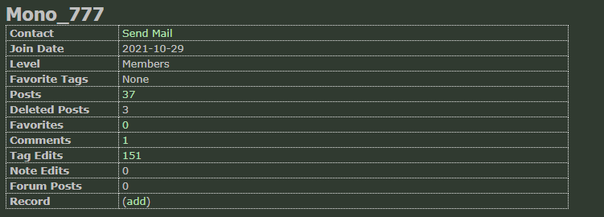
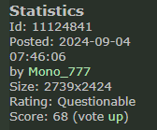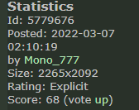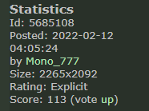

30 minutes after Fox told me about this, Bernie, a friend of Sitrus’, decided to randomly friend request me. It was about Fox.

Bernie did not have good things to say.
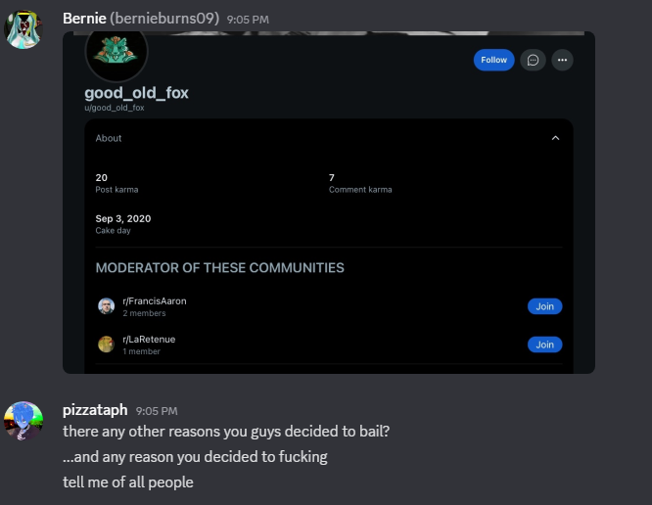
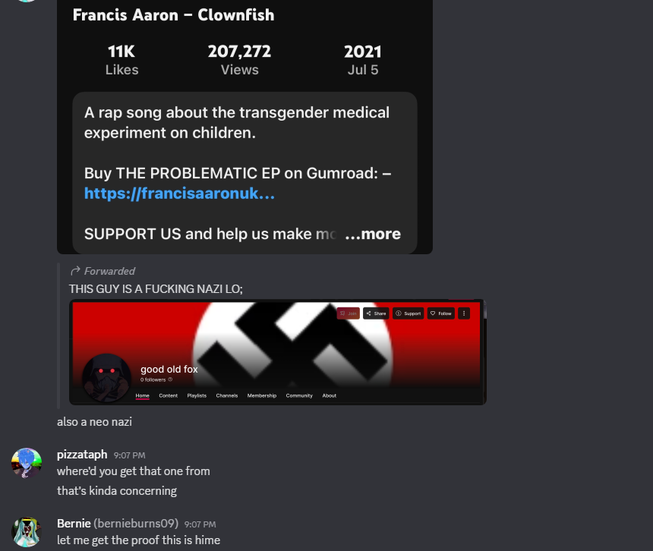
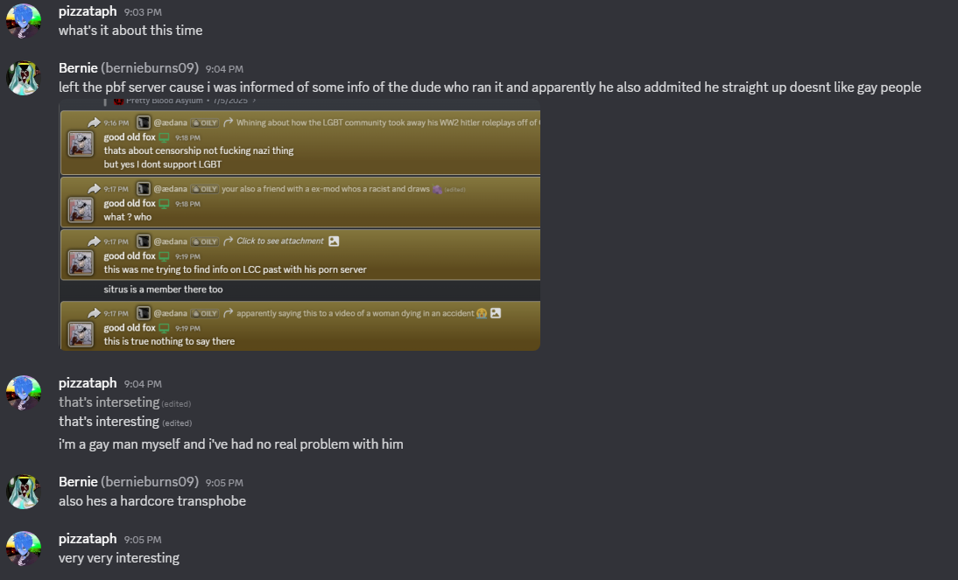

This was, of course, alarming. Even if the account was made in 2022, that’s still not something I really agree with. I even said as much.

However, this didn’t stop me from noticing that the images that Fox told me about was being deleted off of the site it was hosted on, the tags and the credit for the artist being removed.

And, it was from Sitrus’ Rule 34 account.

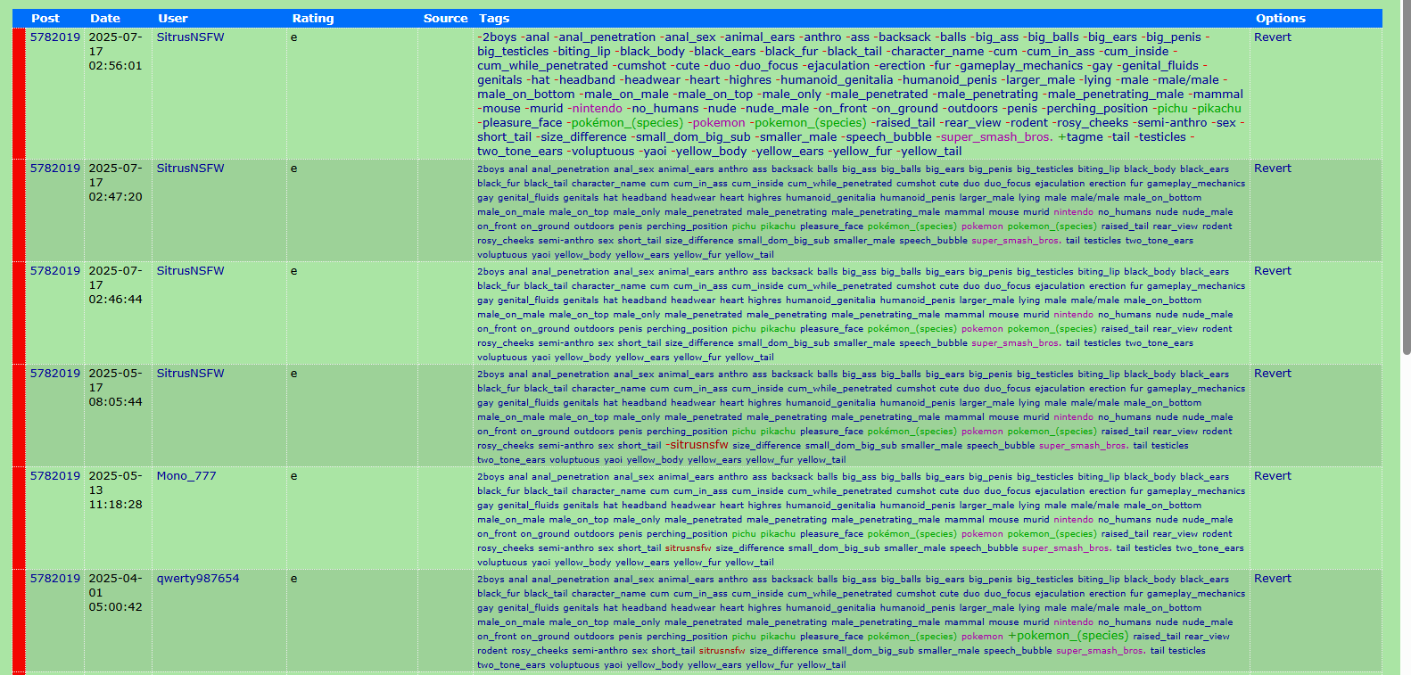
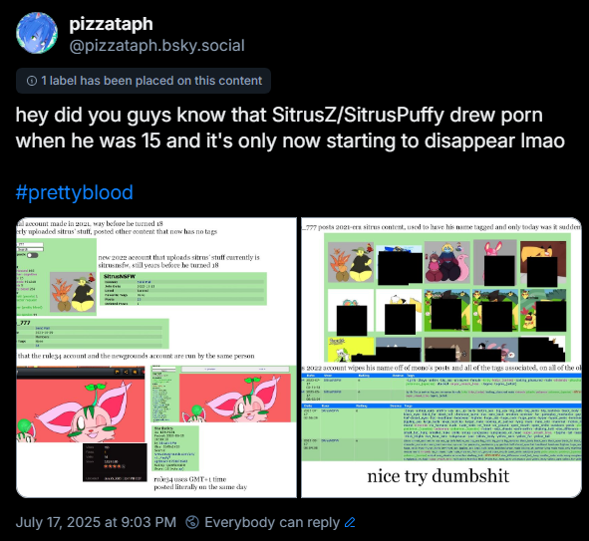

It’s uncommon to bring personal beliefs into a document like this, but they are what caused me to try and shed light on the situation; I don’t enjoy removal of the past. History is something I try to keep. Of course, this would end up coming off as incredibly rude because of how I worded the images within a bsky tweet I had posted publicly on the matter.

Of course, knowing that Fox had been thoroughly chewed out by the time he found out, I figured I would have a pretty big fire lit because I had my own share of drama in this community.

The reaction was less than subtle.

FIRST RESPONSE
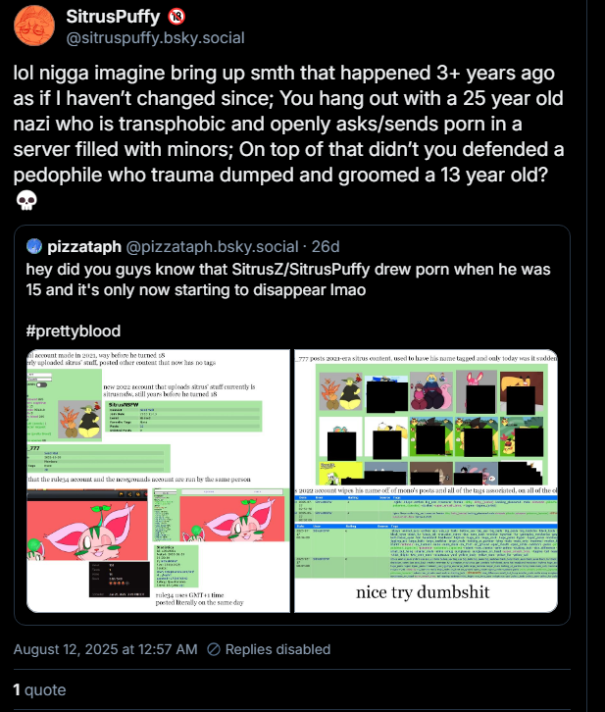
This is at best a blatant misunderstanding. At worst, it’s a knowing attack on my character.

I’m going to dissect this piece by piece in this document, far more than I did in my kneejerk reaction tweet.

“Imagine bring up smth that happened 3+ years ago”
This would be true if Sitrus had not drawn porn right up until he turned 18. Further information in FURTHER NONRESPONSE, page 22.

The original tweet wasn’t meant to cancel or do anything to the guy. It was just meant to tell people it happened. Would have been a more fair point if he didn’t bring up Fox, as well.

“You hang out with a 25 year old nazi who is transphobic and openly asks/sends porn in a server full of minors”
This one’s a long one.

Fox is not 25. There is no evidence even suggesting that he is 25. There is no reason for me to believe he is 25. I asked him, and he confirmed that he is, in fact, not 25. As for how old he is, I have enough respect to keep that private, as he doesn’t want people knowing his age in general.

The Odysee account that Fox had, which has since had its banner changed, is also 3 years old, In fact, it’s likely older than the porn that was posted onto Rule34. This makes this fact of him being a “nazi” just as old as, if not older than, Sitrus’ NSFW posting was.

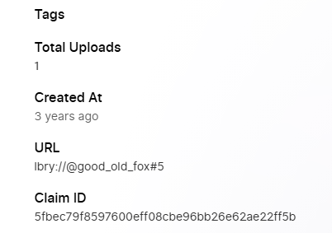
Transphobia is something I cannot confirm or deny. It’s simply a product of a different political opinion. I can believe it, as he has stated he is not an ally of the LGBTQ. Personally, I can take a bit of discrimination. I’m gay myself, and was questioning my gender when I met him, going by the name June.

He and I have never had a problem with each other besides the Odysee account.
Even if he is genuinely hateful, I have not been discriminated against by him in any way, and would not do the same just because I know of him.

As for openly asking and sending porn, this is just a blatant misrepresentation of events. Fox was not openly asking for porn in PB Central, nor was he asking for porn at all. Someone *specifically* asked him about a specific artwork that the creator of Pretty Blood, Disease/LCC, drew.

When purged and banned by Sitrus, Bernie was understanding of the whole thing and, only now, is using it against Fox.

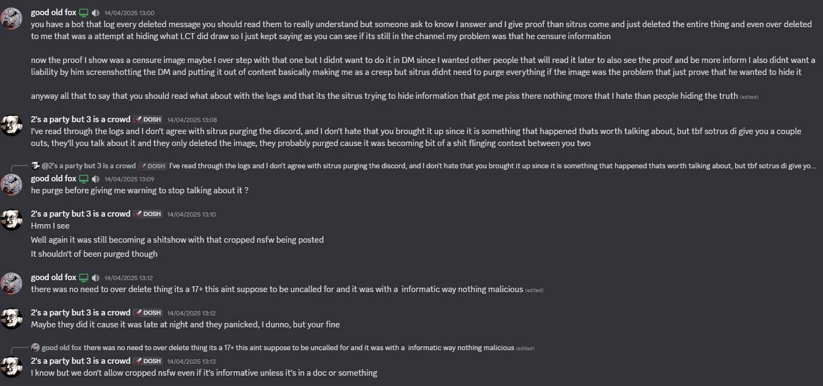

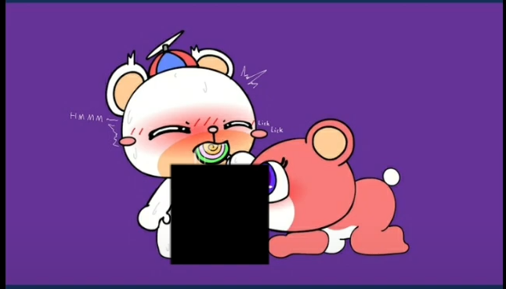
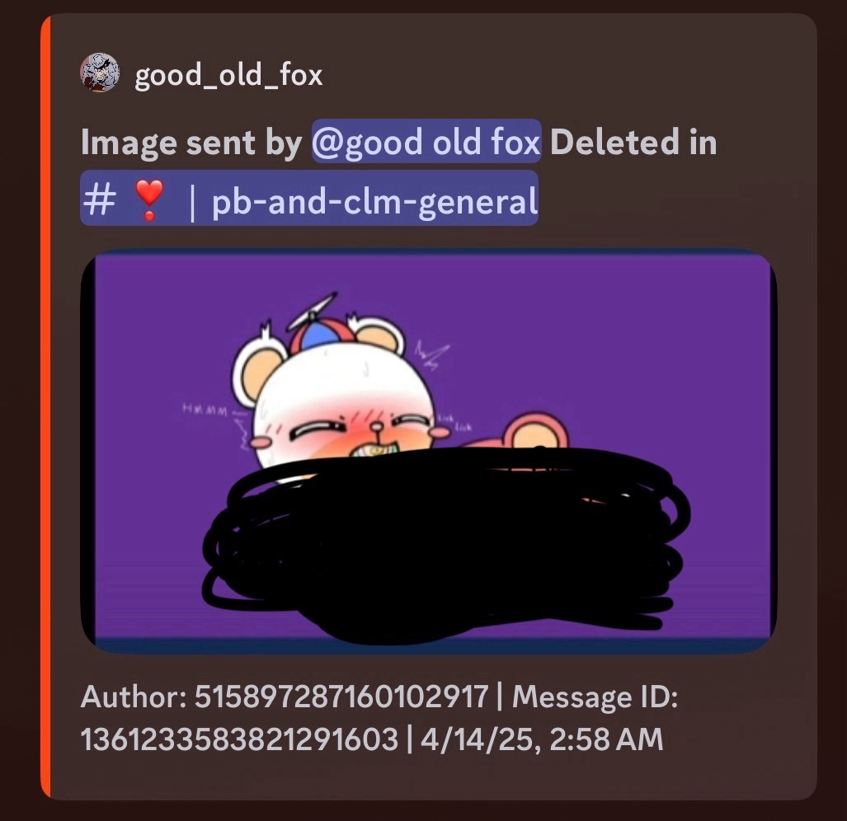
Not only was this meant to be informative as opposed to being a repost of the whole image; Sitrus tried to seem make it *worse* than what it was.

Original Sitrus’ SC

The problem is that this artwork was of two underaged malino characters performing sexual acts. People, including Sitrus, have tried to claim this is ageplay. The original inkbunny page had “cub” listed as a tag, and it is currently under the “young” tag on e621, so this claim is unfounded.

For proof this art was drawn by LCT and that Trash of this Galaxy was his InkBunny account where he posted it, see here.

They are essentially defending Disease for drawing (albeit, fictional, but still) CP. In fact, Fox was only talking about this because he learned it from a video, linked here and on a wiki that was then raided and deleted after Fox pointed it out.. Sitrus was involved.
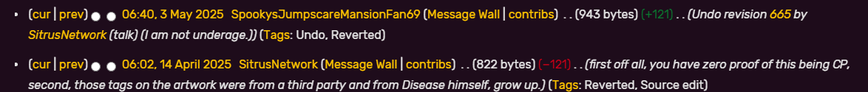
Before 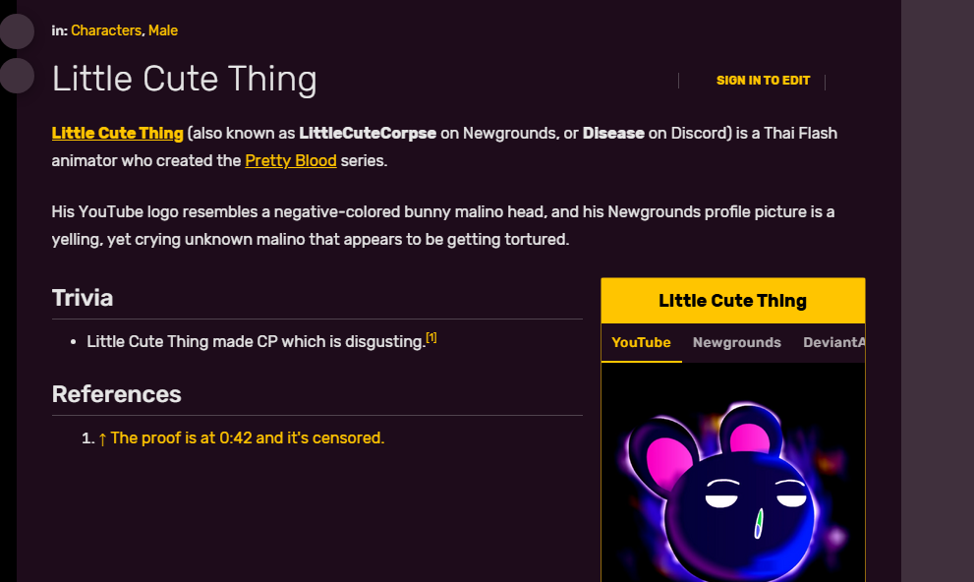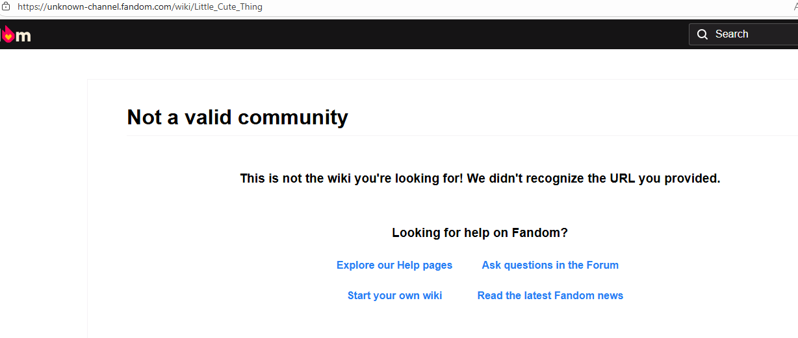 After

This is incredibly sketchy. Why would Sitrus essentially nuke an entire page about LCC just because of one youtube video? Why not just let them be ignorant? It’s very likely he was intentionally nuking the page (and, likely, the wiki) to hide this video from more people. The video only has around 5.8k views, so it wouldn’t have been a totally useless endeavour for him to do this.

So we can surmise now that Fox was banned for talking about porn and telling someone about a very disturbing image that LCC drew, essentially banned for NSFW topics. Talking about Disease drawing, what is essentially, CP in a PB server? PB’s fanbase is mostly minors, so it wouldn’t be a bad idea.

Well…

The problem with this is the server in question was 17+, where you had to be one year off from being an adult. Most 17 year olds wouldn’t bat an eye at these subjects.
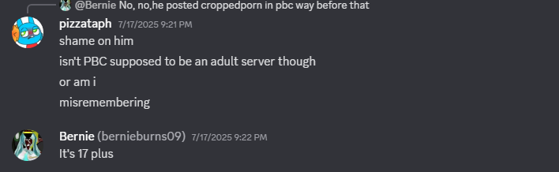
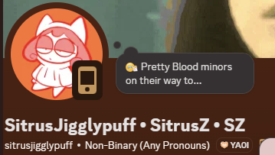
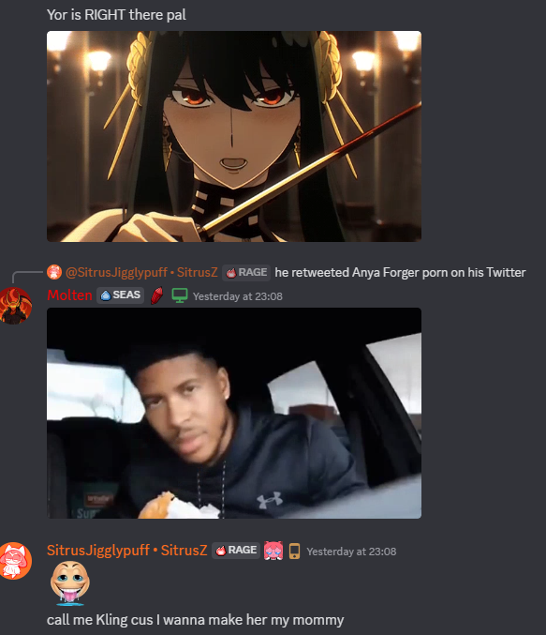
Add on top of this, that people, including Sitrus, openly talk about NSFW topics within the server and Sitrus posts suggestive artwork to it all of the time. Reminder that he’s co-owner; he partially made the rules as well.

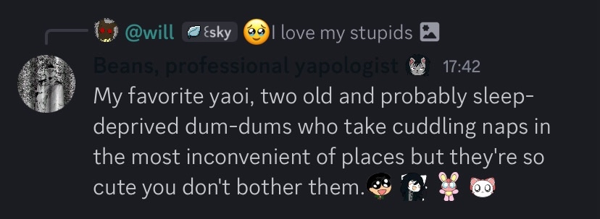
For proof that this isn’t just
simple anthropomorphism,
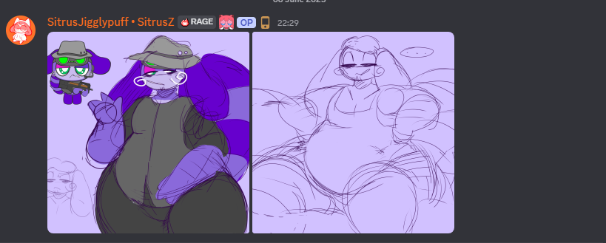
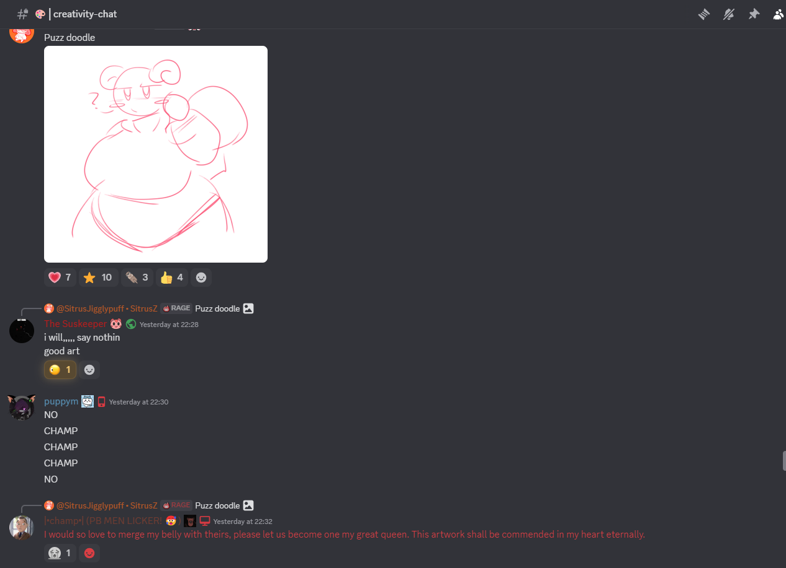
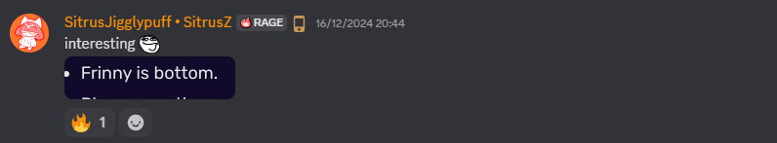
see here.
To add to Fox’s ban, his “asking for porn” was not something most people would recognize; he was asking people about a server that Disease owned/still owns named the “evil server”, where Disease, Sitrus, and others draw and share Pretty Blood porn inside. This was not something that most people would know about. This was something Sitrus specifically chose to silence Fox on.
(Note how the “anthro” artstyle is the same as his NSFW artstyle.)
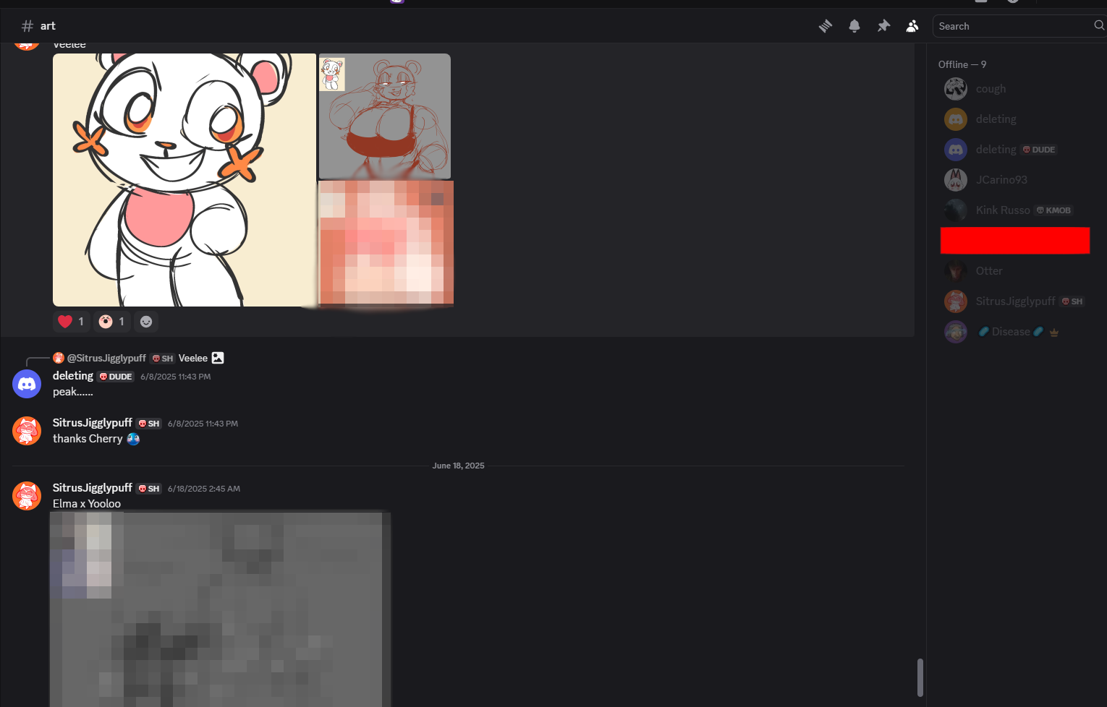

2 minors were confirmed to be in this server: Lower (likely when he lied about his age because of Bearsalot) and Franny/Cherry (before she turned 18, they knew)

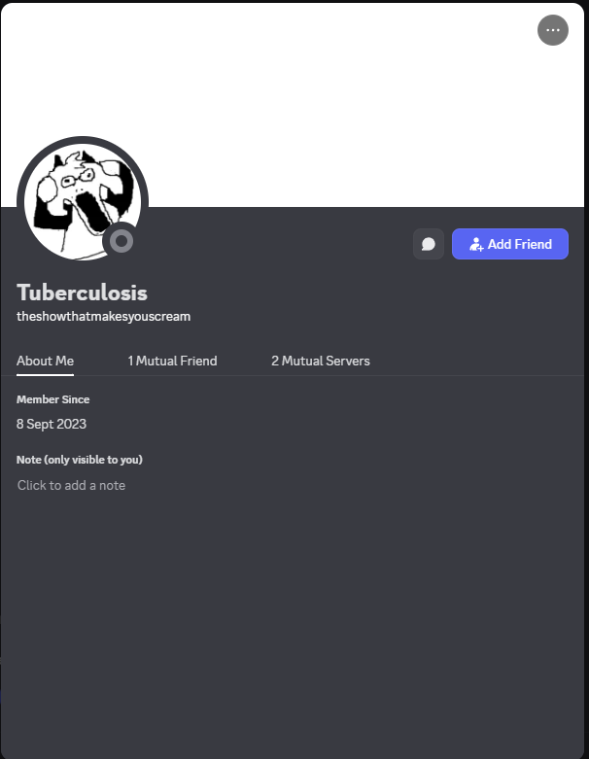
Fun fact; the member on top was actually a staff member in the official Pretty Blood Discord while it was active.

It’s a little funny how the staff can talk about mature topics while the members can’t, despite everyone being 17+ by rule.

“On top of that, didn’t you defended a pedophile”

This is only half-true. If you had read the extra context regarding NashQP, he’s talking about him. I once blindly defended him against the whole thing (terrible), before shifting to only defending him against the pedophilia (still bad), before shifting to just saying he’s extremely likely to not be a pedophile and leaving it at that (debatable).

NashQP is not a mentally stable person. He’s not a saint and he creeped on a girl he had a strange crush on. He is *not* explicitly proven to be a pedophile or groomer and I’m frankly disturbed how many people believed all of this when they saw “13-year-old” without any explicit proof of Nash sexually exploiting him.

That being said, it was an intuitive thought process to believe that Nash was a groomer. Bringing up his troubled past to a teenager, Streaming NSFW to everyone in a server full of minors, creeping on Franny; all bad things to do.

Again, him being a pedophile is not explicitly proven and is only supported through anecdotal evidence like how the 13 year old worded a message or how he kept saying Nash was groomer after being pressured. If you want more on that, read the extra context document at the top of this one.

After I had responded to this, pretty thoroughly going through Sitrus’ reply (though wording it poorly), Bernie decided to show up and argue with me about Nash in the replies of the post.
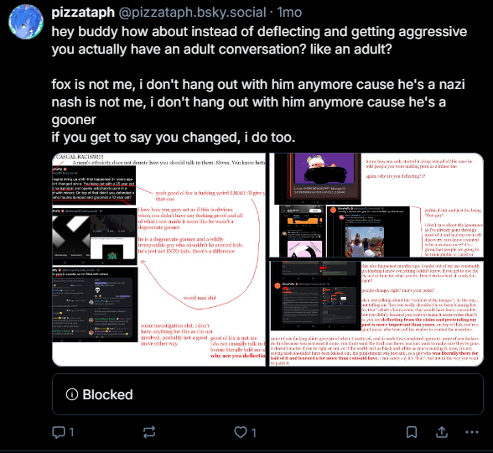
Note the “blocked” message at the bottom of the post. That’s Bernie. He has blocked me on BSky, so this conversation cannot be properly archived without a tedious back and forth between accounts. Most messages did not have media, so it would be incredibly annoying to get all of it.

At this point, Sitrus was out of the conversation. He walked off and let Bernie do all of the heavy lifting. The entire conversation had been derailed to talking about Nash instead of talking about what I had said originally, completely stomping out any conversation about Sitrus’ past.

This was not a good sign of things to come. Needless to say, I was incredibly disappointed. Anyone who tries this hard not to talk about something they did 3 years ago was likely to do a lot more of this kind of thing, so my disappointment only rose further when Sitrus refused to actually talk about any of this.

NONRESPONSE
After the BSky shitstorm, I never heard from Sitrus again. What I did hear was that the official Pretty Blood Discord went down due to staff incompetence and some complacency with a few problematic subjects.

I also heard that Sitrus called me a pedophile and misrepresented PBO in his own post about them.

Safe to say, I’m not a pedophile and this is also blatantly incorrect. They *DID* take action against active problematic users. I was permanently banned for my involvement in Nash’s drama. Nash was permanently banned for being a creep. Kurai was permanently banned for being a pedophile.

People were banned for even talking about Nash. People were banned for talking about me. They did, in fact, “do shit”.

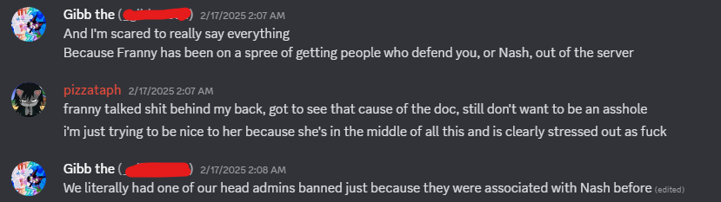

As for the rest of the PBO drama, I have nothing to say about it. I wasn’t part of it when it happened and I don’t have any more info. I haven’t looked into it enough to make heads or tails of it and I’m not sure I will, as it’s not that important to me.

When Cyan, a contributor on Rainx’s doc, heard about this, he wanted to patch things between us and act as a mediator for a conversation about the event. He attempted to contact Sitrus multiple times, also to no avail.
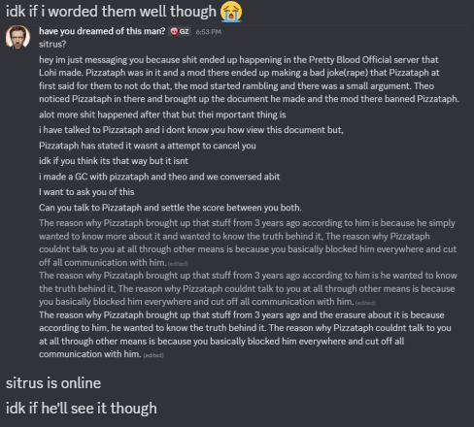
Sitrus ignored this message.
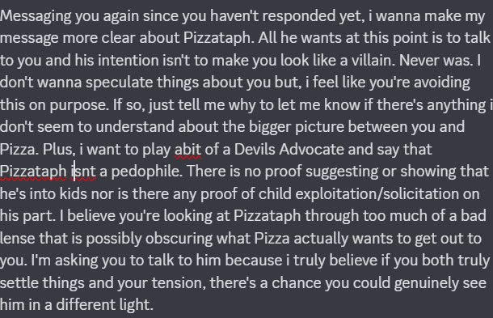
He ignored this one as well.
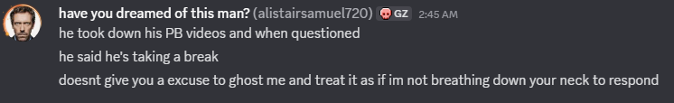
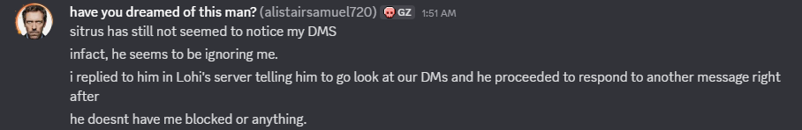
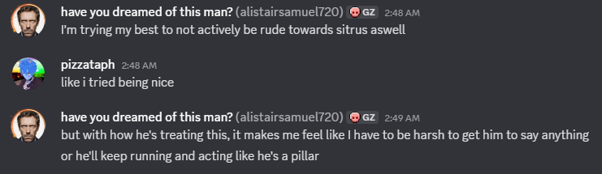
Of course, it was only a matter of time until he finally did respond when another server owner questioned him about it.

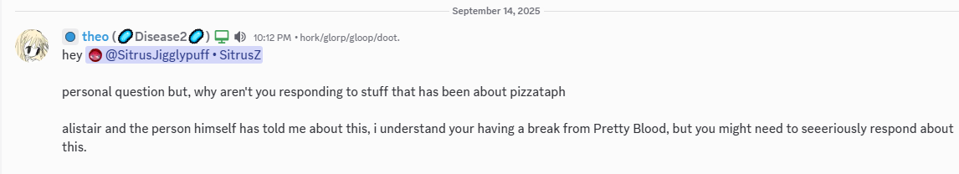
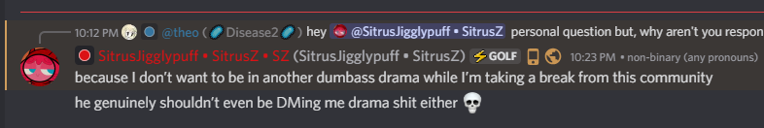

Quite the response. Considering the document, while incredibly crude, had a fair amount of effort put into it, I’d say it would have been a pretty good move to just talk.

Though, he didn’t. Instead, he doubled down.

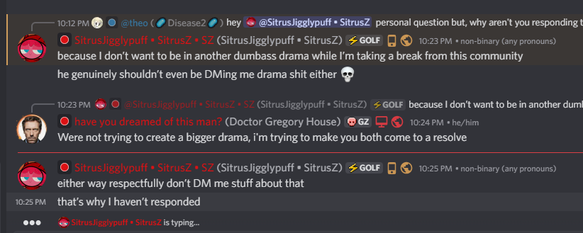
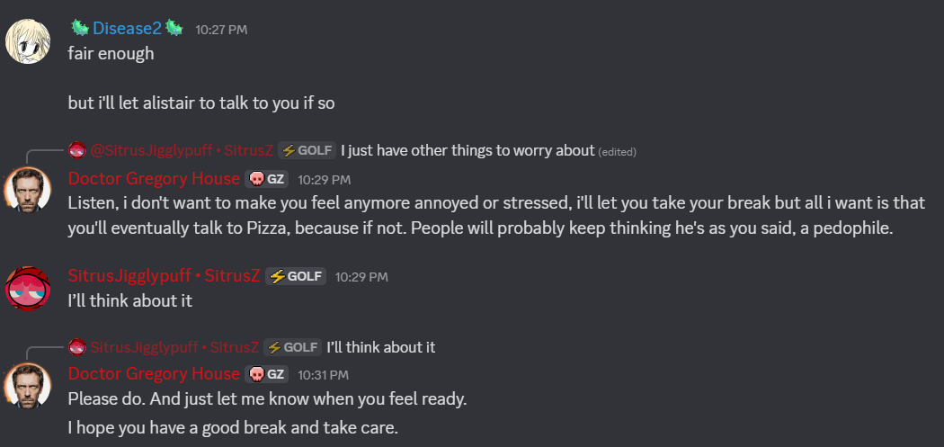
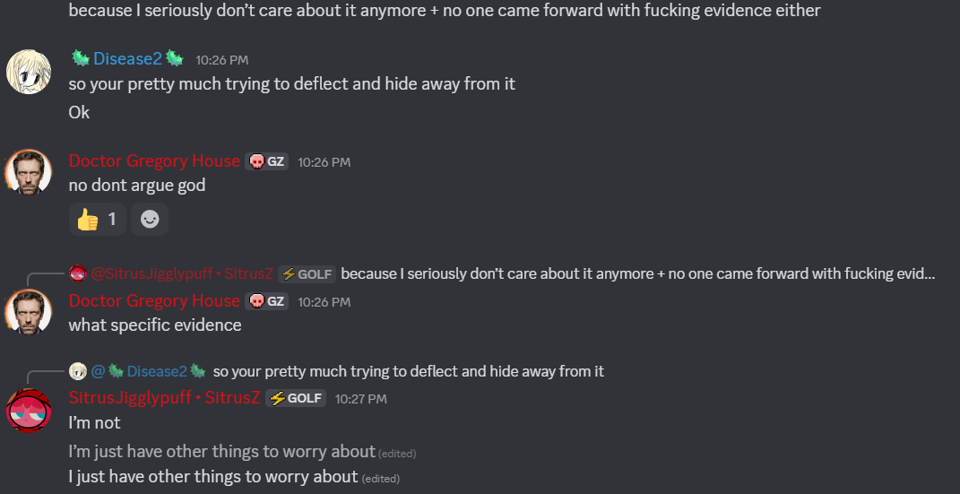

Granted, I don’t have a personal look into Sitrus’ life. We know nothing about his personal life nor what goes on in it. We don’t have a clue what he’s dealing with currently or what he’s busy with. What I do know is that I wasn’t optimistic about him talking it out, especially after his first response.

We decided to give him a week to think about talking. This was more than enough time for Sitrus to form a good argument and come into the conversation ready to explain himself and state his case so that we could move past this.

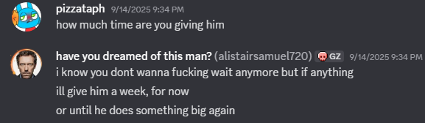

We were waiting patiently. He said he was taking a break and he was going to think about it. I didn’t want to push it, as I wanted him to be at least somewhat ready to actually talk; whether it be in bad faith or good. I didn’t mind waiting, contrary to Cyan’s comment here.

However, I did mind when Bernie tried to discredit me further almost immediately after the week was up. More on that here.

FURTHER NONRESPONSE
Almost like any other, the week passed by. No words from Sitrus and pure shittalk from Bernie. As expected, the week began in nothing and ended in nothing.

So, it’s clear they don’t want to have a civil discussion. Again, more suspicious behavior. Why having an actual conversation about things and trying to hash things out wasn’t part of the plan is beyond me.

It’s almost like someone is trying to hide something.

Turns out, he was. Bernie had previously denounced minors making/accessing porn before.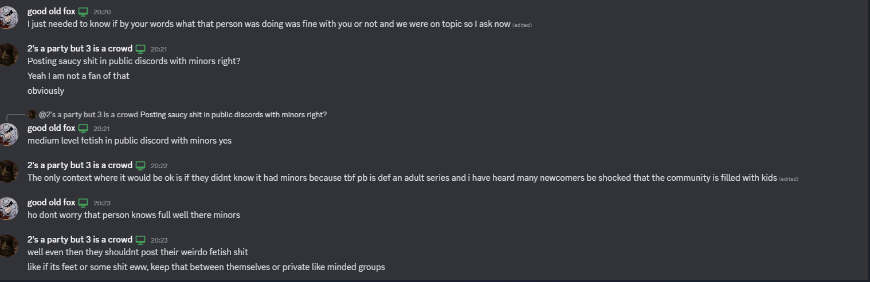
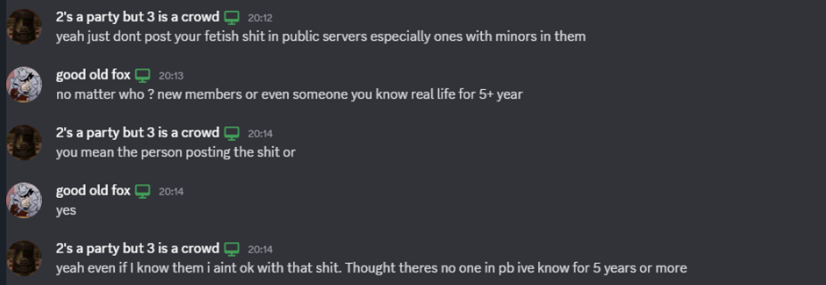
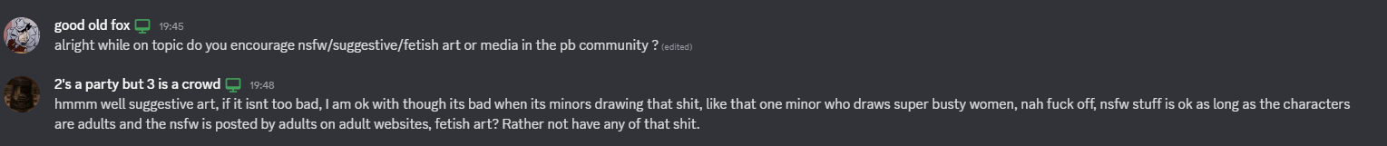

This is a pretty common take to have. Minors should not be accessing porn or drawing it. Simple as that. Turns out, Sitrus did not only draw porn as a minor just “3 years ago”. He was doing it the entire time.

Remember that Sitrus’ 18th birthday was in May.

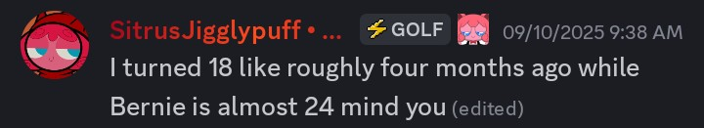
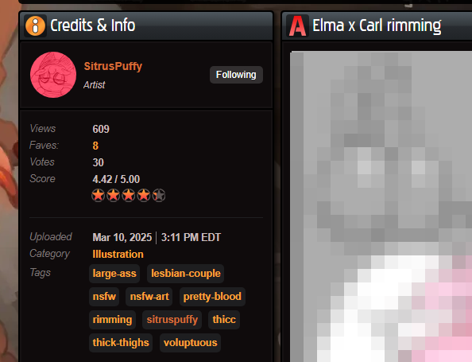
NSFW content was posted onto his Newgrounds alt months before he turned 18.
In fact, the Elma x Carl image was posted earlier in December 2024, on Rule 34. The source of the image was even updated to point to the Newgrounds post.
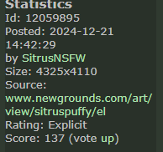

Instead of facing this fact?
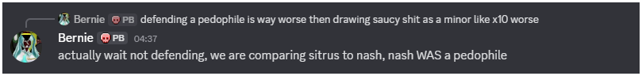
He deflected and continued trying to spout his points without considering anyone else’s. This is a common pattern with Bernie. This is not the first time he’s deflected from criticism. This has happened multiple times and will likely continue happening.

This is a nearly 24 year old man who’s doing this, by the way. Yet again, not a good sign.

What baffles me further is that he holds this standpoint that drawing porn as a minor is not a good thing yet, Franny has also done this under the moniker of rinnyluver69. (including some of her OC despite having qualms about it when others do it, but I don’t think that’s anything too unusual. It’s meant to represent her, so these are likely fantasy drawings anyhow.)

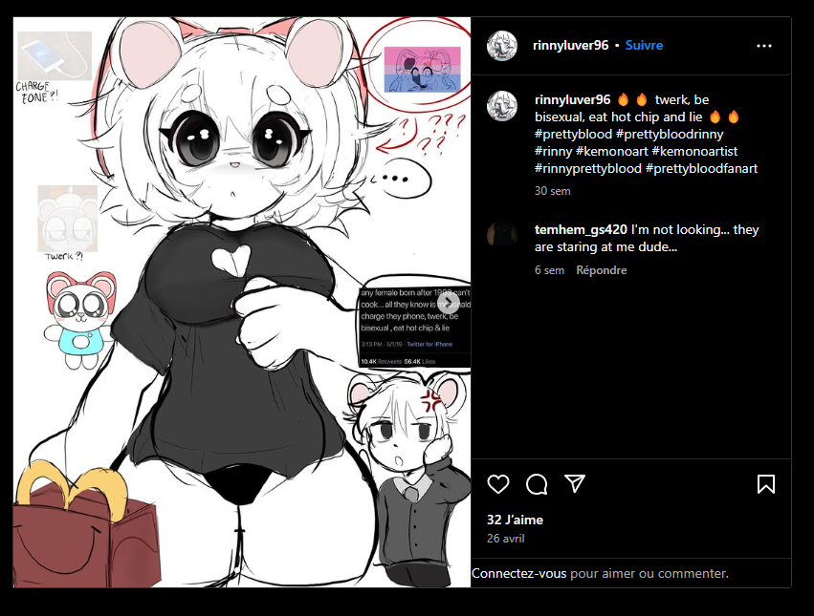

Despite Bernie denouncing this behavior, it seems it didn’t stop him from actively playing GMod with her (and likely buying it for her)
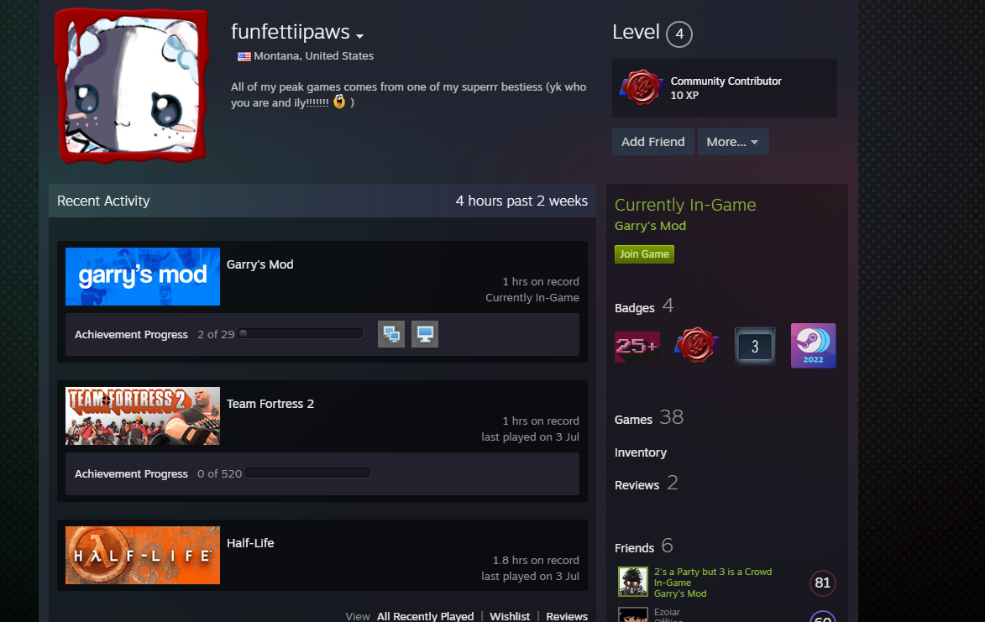
Now we have *two* instances of a minor drawing porn that Bernie is okay with.

You can sit here and argue about the circumstances of either drawing NSFW as a kid or about the age differences or the fact they’re all in the same friend group… and we’d be here all day. The main thing is that he’s actively going against the thing that he said he believed in.

So, essentially, he lied and deflected that lie once caught.

Another discrepancy I’d like to point out is this image.
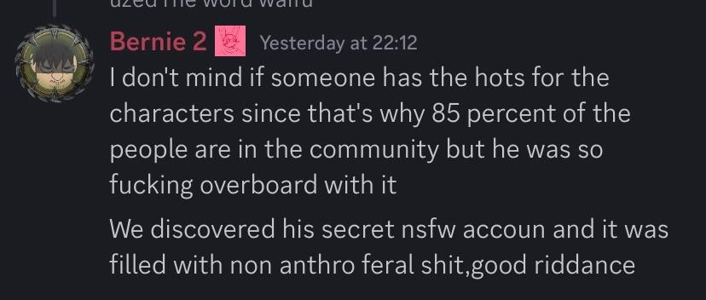
Do you remember the very start of this? When we found Sitrus’ old porn?

You do realize that the majority of that was Pokemon porn, right? Like, not even anthro Pokemon. Just Pokemon in general.

Here’s a post from March 2023. It’s literally just a Jigglypuff (not anthropomorphic at all) with a huge dick.

Here’s another from March 2022 of a barely changed Pikachu with a huge ass.

Now, I suppose you could say this isn’t recent. That’s true. It’s clearly from years ago and Sitrus probably grew out of it. That’s a fair statement to make, and clearly, since Sitrus doesn’t draw this kind of stuff anymore, we’ve reached a changing point.

The difference is that when bringing this stuff up, Bernie does not bring attention to this. He doesn’t tell people Sitrus isn’t like that, he just says it’s “old”. He does not *care* about the content of it despite him denouncing it time and time again. On top of that: If anyone else did this, they’d be getting shit from Bernie fully.

When I point out that he’s bringing up things from my past that are from nearly a year ago, he dismisses it as “you shouldn’t have done it.” Why does this *not apply to other people*? Why only the people he doesn’t like? How come my past gets to be spotlighted, but no one else’s? How come I don’t get to say I changed?

Simple answer? He’s a hypocrite.

Long answer? He’s likely only popular because Sitrus is, and doesn’t want that to disappear. These double standards are because he can’t go after his friends without going after himself.

The more interesting part is that Bernie seemed to have come to understand my viewpoint on Nash just a month prior.
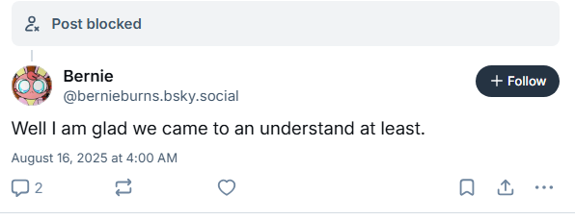
Now that it seems that he wants to get rid of me, his “understanding” has simply vanished. The evidence has not changed. He is still using the same screenshots he’s had for months now. What did he understand? The exaggerations don’t stop at just me or Fox, either.
Gibb, another prominent community figure, had agreed with my points at first and was with me on most of it. Most of the information on it, they had gotten from me. Not a good idea to be listening to a blind defense of a creep, but… you know, it was a different time. I was trying so hard to find excuses to defend a “friend” and Gibb was just listening in, trying to be a good friend.

This didn’t stop Bernie from immediately transplanting my ideas onto Gibb as if it were their idea. This didn’t exclude just saying they were defending a creep. That’d be too loose, obviously. So, instead, Bernie decides to call them a pedophile. The problem is; Gibb’s a minor! How can he do that?
By calling them a future pedophile instead.
Main video, At 36:50
Important Clip, 19 seconds long
This is incredibly petty and a clear exaggeration.

Bernie is essentially claiming that Gibb thought of Nash being clean all by themself without having any influence from me. Oh no, they’re definitely a future pedophile and I didn’t just lead them down a rabbit hole that led them to believe something that was based on half-baked thoughts and utter bullshit.

You claim we shouldn’t be leaving Gibb with minors in the future like this is fucking Minority Report. You’re literally just throwing shade at random children. You’re a 23 year old man. Get your shit together.

Not the last time he’d throw shade at people before they did anything, either.
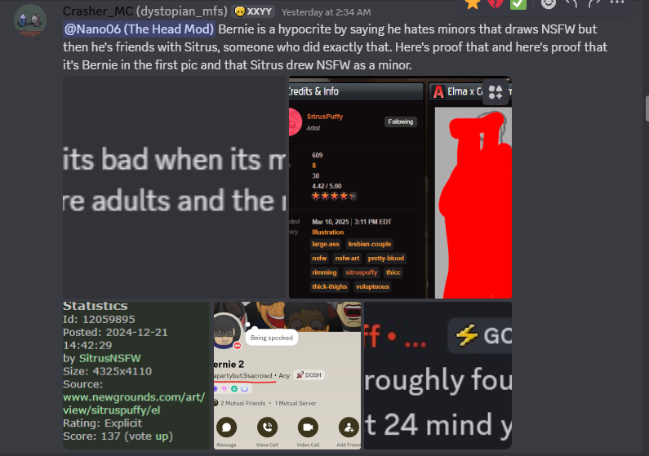
Crasher, upon realizing a few of the things I’ve already talked about, decided to start spreading them to other servers. This would draw Bernie’s ire, and so… he would be banned from the Pretty Blood subreddit.

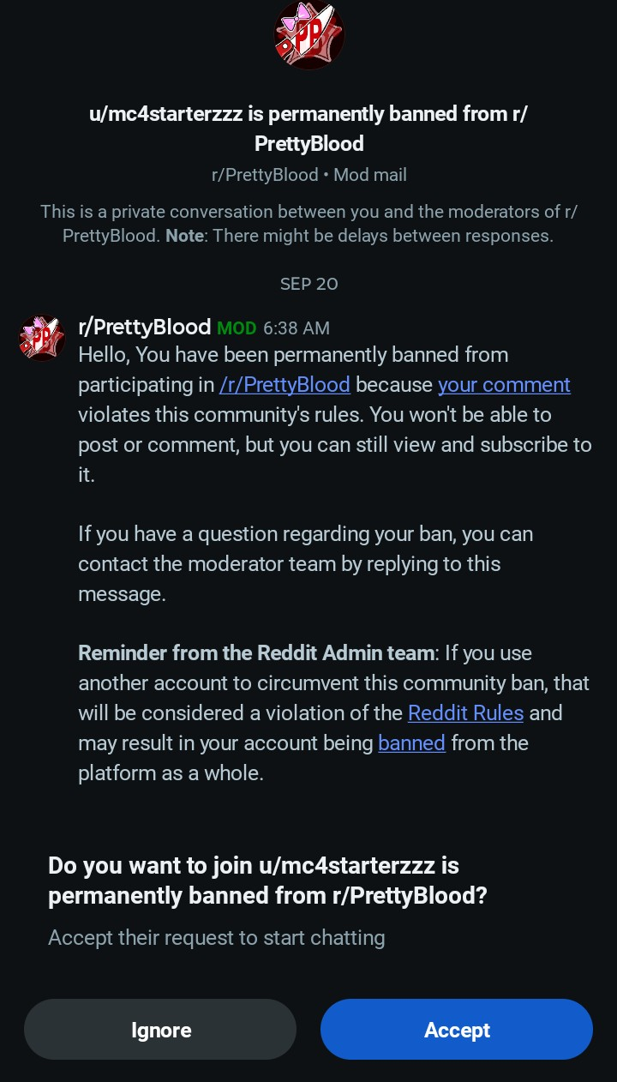
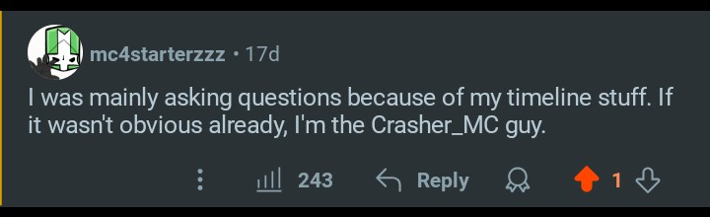
Bernie did not take the time to explain the discrepancies. Bernie did not even try to deflect onto me and make it about me. Instead, he simply banned Crasher (and is likely trying to get him blacklisted from everywhere like everyone else he’s done this to) in mere minutes for pointing out a very, very obvious double standard.
Bernie is not afraid to just toss *anyone* under the bus, even if he can’t get a decent grip on what they’ve actually done. He’ll use hindsight and sleight of hand to get rid of anyone who dares talk about him or his friends.

This is, very clearly, the sort of hypocrisy I’ve come to expect in my time researching this subject. My meetings with Bernie are few and far between, and they’ve all been somewhat like this. What little points he actually has are buried underneath double standards and exaggerations.

I predict he’ll start calling Crasher a pedophile as well, before this document is finished.

This also happened to someone who associates with Good Old Fox. This is another example of the petty throwing of shade at random minors. (ALE is 17.)

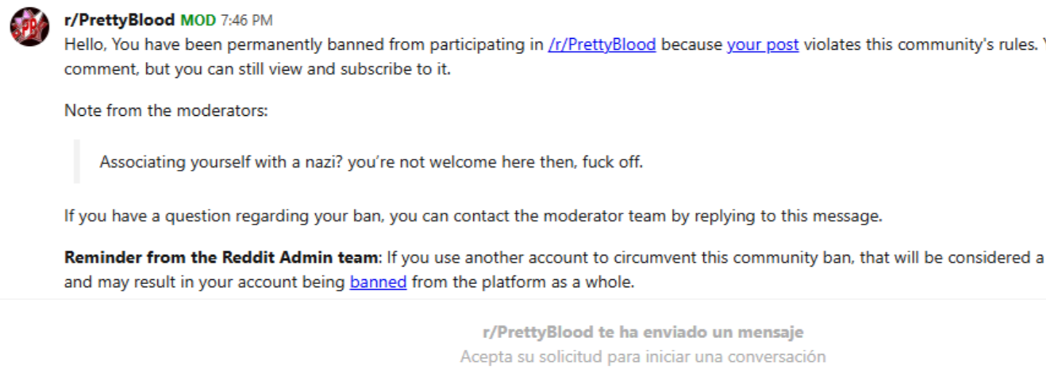
We’ve gone over why they believe he’s a nazi (despite not going after the homosexual who talks to him) so we’ll skip on that part.

ALE was able to get unbanned… only to get banned again.
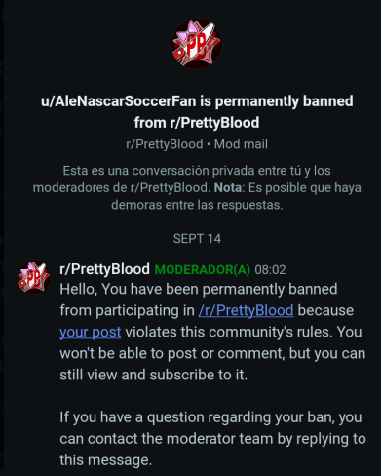

Of course, this was resolved as well. The problem is, ALE was still being censored, even without the bans. His posts were being deleted.
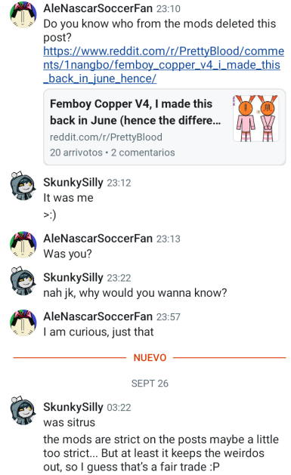

To no one’s surprise, Sitrus was banning ALE and deleting his posts; all because he was friends with a guy who knew about the porn Sitrus drew as a minor.
This is a pretty common thing with people who actually have something to say about Sitrus or Bernie; they disappear. They’re not allowed to talk for one reason or another, because they’re this or that, and no one should listen to them.

This is a symptom of a community that simply listens to whoever has the loudest voice. Whatever bad is exaggerated and is talked about as if it was mere minutes ago, being told you “shouldn’t have done it” no matter what it is. Whatever good is brushed under the rug unless you’re friends with the guy.

Quite the toxic behavior for someone who seems so popular. With these words, I don’t intend to remove him from his position. I don’t care what happens; I just care if people finally see what’s behind the mask and see what we’ve been dealing with the entire time.

DISMISSAL
The problem lies in not only Bernie’s overindulgence in trying to act morally superior and clean, but Sitrus’ enabling of this behavior. Bernie is a 23, almost 24 year old man who hinges his entire internet fame on some random 18 year old he doesn’t even know in real life. Think about that for a moment. Doesn’t that sound weird to you?

24 year old man, relying on an 18 year old to stay afloat.

Sounds terrible when you put it that way, to be honest.

You might argue that Bernie’s carved his own path and, to be honest, I doubt that. You don’t see Bernie without Sitrus. He does not operate alone. He’s never operated alone. He has always been with Sitrus the entire time. Hell, he’ll take over an argument if it means Sitrus doesn’t have to lift a finger, evidenced by the BSky argument I had with him.

In fact, it’s strange how little Sitrus seems to care about this situation besides the one outlier that was the BSky response, and even that was justifiable due to the tone of my own tweet in the beginning. Every subsequent interaction I’ve had with the two has always been with Bernie. I’d say Bernie is a mouthpiece… but Sitrus isn’t afraid to speak for himself. It almost feels like Bernie is whiteknighting.
If Sitrus wasn’t popular, Bernie would have never been influential in the first place. Really, should he be? In a sense, he’s been misusing the influence to put down anyone who has anything to say about him and protect people who he himself would have problems with otherwise. In any other situation,

No one can say anything about him, Sitrus, or any of his other friends. None of them can be talked about negatively, otherwise they become targets, too. It doesn’t matter how recent your drama is, whether it be years or months. It doesn’t even matter if you *DO* have drama or not. You will still be made to be an example. This, in itself, is pretty clear ego-trip behavior.

Someone like this, in my personal opinion, should not have this much influence.
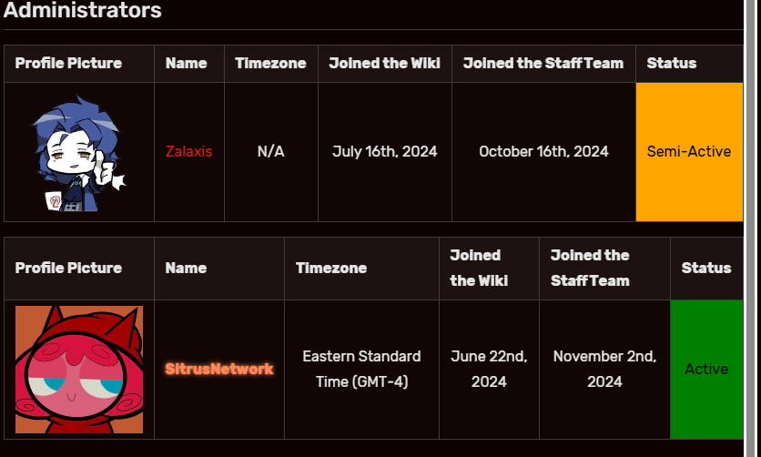
It doesn’t help that Sitrus is a moderator of quite a few popular Pretty Blood-related spaces. Even if Bernie isn’t admin, he can just ask his buddy to ban anyone and he likely will, since we’ve seen Crasher get banned for pointing out the least offensive inconsistency.

Essentially, no one is safe to speak on anything negative about Bernie or Sitrus. No one can criticize them. No one can say a word that they don’t like or make a comment they don’t agree with.

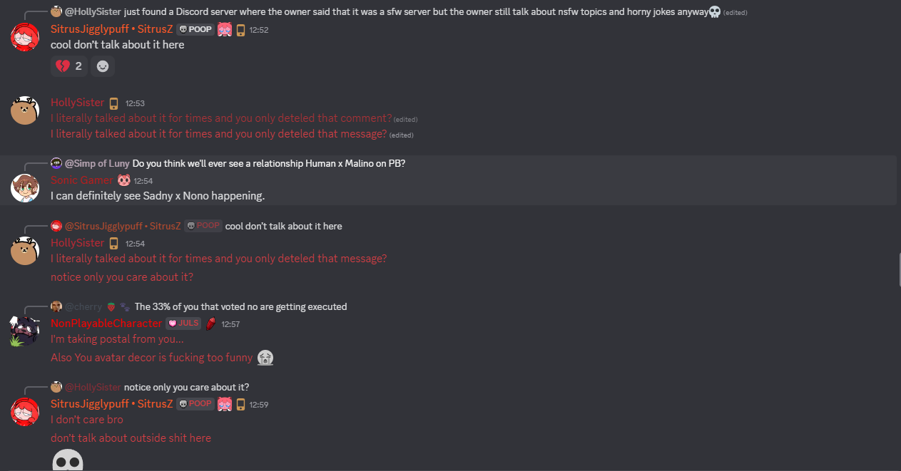
Sometimes, it’s not even that. Sometimes, they’ll get into conflicts with just about anyone.

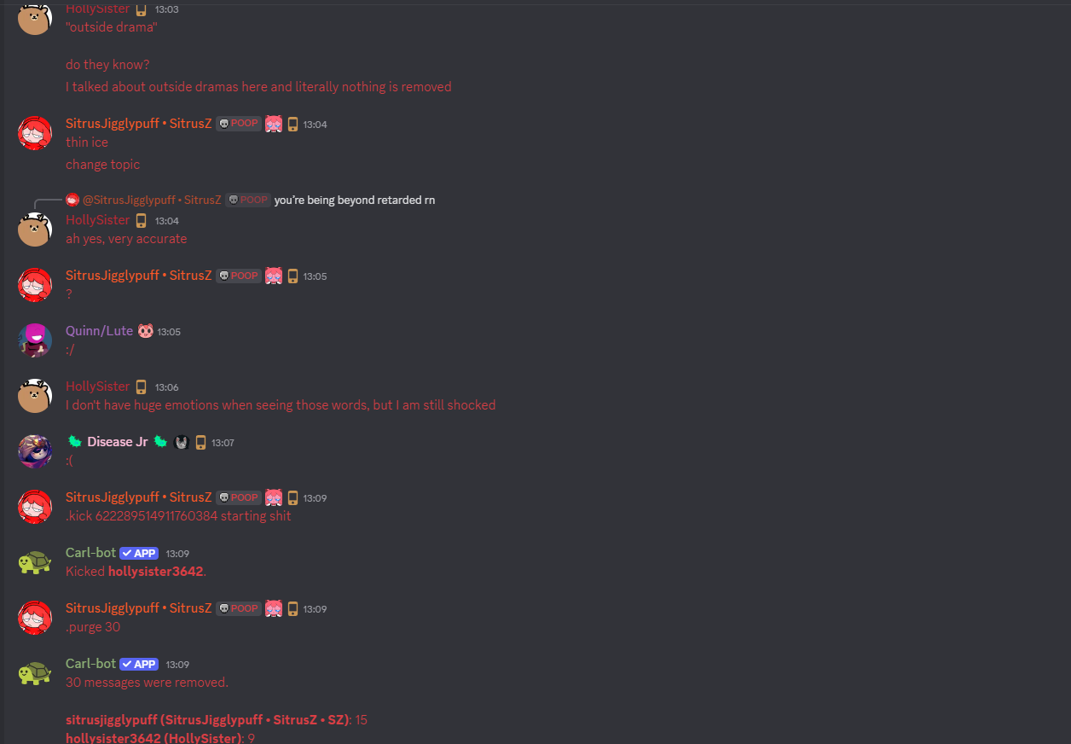
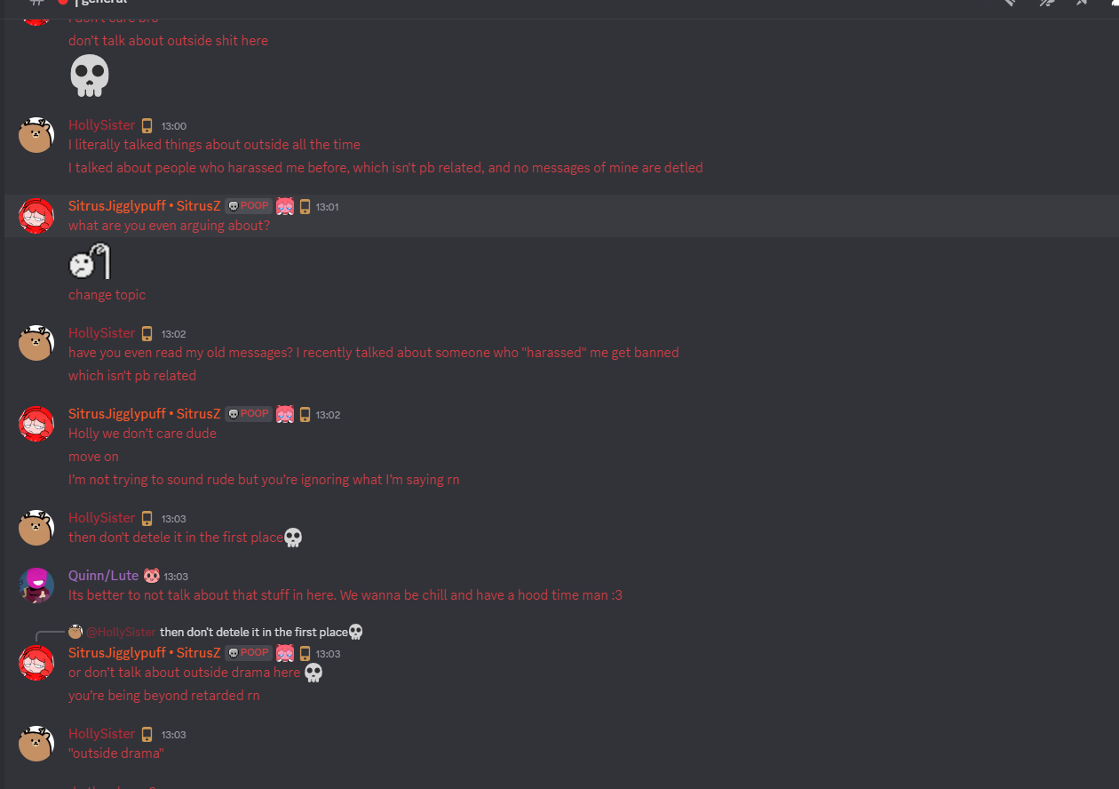
You’re not even allowed to criticize or provide feedback on art that Sitrus likes/makes, either.
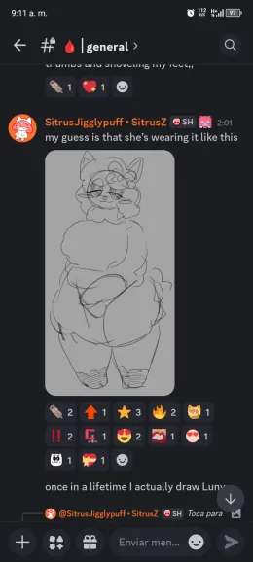
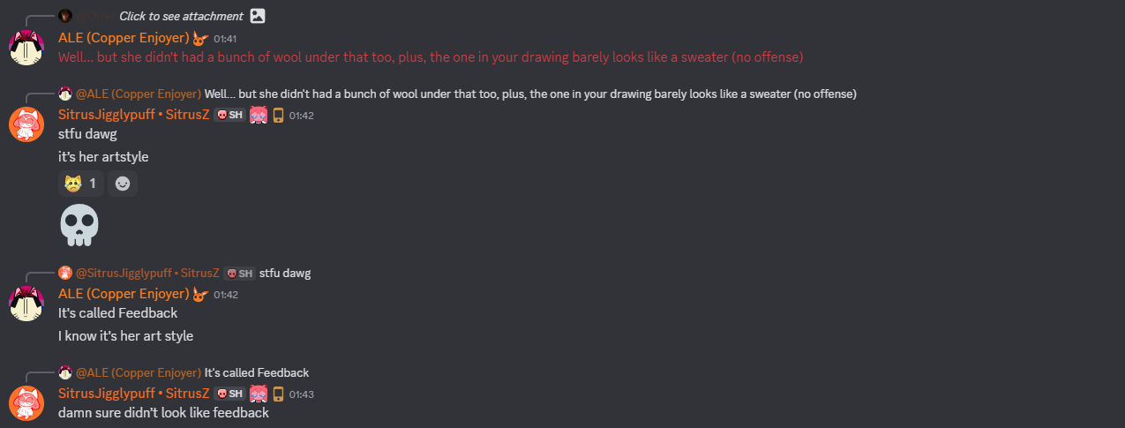

You are not safe from anything when you talk about these people, or the people they’re associated with, or the things they like.

They do not have your best interests in mind. They do not want to get to the bottom of things when things go wrong. They do not want to resolve things when shitstorms flare up. They want to protect themselves and their egos. That is all they want.

If you still think that’s worth having them be so prominent, all I can do is disagree.

SUMMARY
It’s a mess. It’s all a mess. We have a couple hypocrites who run pretty much everything Pretty Blood related. Everyone who says anything they don’t like is instantly swept under the rug, whether they’ve actually done anything or not.

The thing that makes it worse is how simple-minded this community is.

People are literally *too young* to understand what is happening. This community has far too many children in it, most of which listen to these two without argument. They won’t search anything, they won’t try to figure things out themselves; they’ll simply be spoonfed and move on.

This is why most of their claims in the dramas they help expose seem so concrete. Nobody will listen to a rebuttal because *they are the loudest ones talking*. They are the ones with the most influence. It doesn’t matter about any other factor when you’ve disrespected the Church of Bernie-Sitrus Saints.

You can’t argue back. You can’t make any points. You lie down and take the beating. There is no redemption. You are going to be ostracized no matter what you say or do.

As of writing, there’s really nothing you can do to prevent yourself from getting shit if you say something negative about them publicly because these people are some of the most influential in the community. You will be swept up and burned like the rest.

It doesn’t matter how old it is. It doesn’t matter how far you’ve come since. It doesn’t matter how serious it was. Hell, now that they’ve called Gibb a pedophile, it doesn’t even matter how old you are anymore.

They will find something you did.
They will paint it as if it’s present-day.
They will stretch and exaggerate everything until you’re fully antagonized.
Then, you’ll be gone, too.

When that happens, there’s not much you can really do.

If you bring up that Sitrus drew porn as a minor, or that Bernie is a hypocrite who lets his friends do things he wouldn’t let anyone do, you are going to be sent through the wringer. No matter how bad of a person you really are, they will always find a way to make you seem worse.

The Pretty Blood community is full of minors. Far too many. There are dramas about pedophiles all of the time. It’s not even fun to make fun of them anymore. We have reached a point in this community where being in it is mentally exhausting and not even worth being in.

Not even for Sitrus. Finding Pretty Blood enjoyable is harder and harder for everyone.
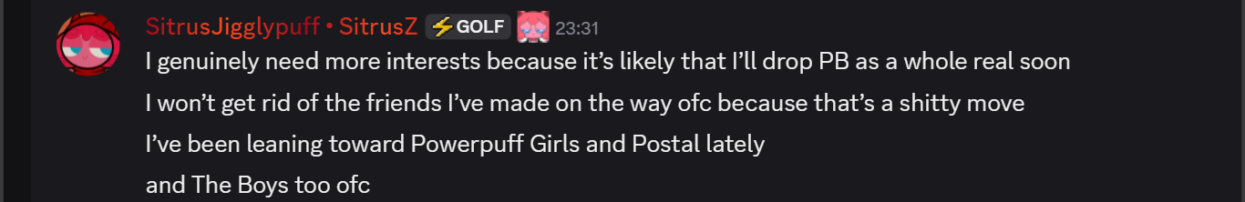
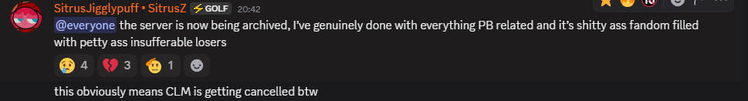
We’ve reached a breaking point. We’re all tired, we’re all pissed, and no one is being honest with each other. We can’t even be nice to one another. The vitriol and spite simmers within the community like a plague. We don’t even want to be here.

So why can’t we just extend a few olive branches here and there? Why is petty bullshit hitting everyone like a tidal wave? Why can’t we make it easier for each other? We’re all trying to just work with something that’s subpar and make something out of it that we can enjoy more and we can’t even do that anymore.

I’ve fucked up a thousand times. I got up, dusted myself off, and tried to learn.
Learning is not even a concept to these people. Anyone bad is bad forever. End of story. Even if you’re not a pedophile or a nazi, you’re still stuck in the shit pit if you say anything negative.

The spite and pettiness crushed everyone’s spirits. This is why no one wants to be here. Everyone hates it in the community because every other day, we hear the same thing we’ve heard a thousand times; someone fucked up. Someone’s done this, or that, or the third. It’s nonstop.

When we stopped just exposing pedophiles and manipulators and started banning people for not having nice things to talk about or being somewhat morally gray, we regressed pretty far as people. Even if you try to distance yourself, whether by rabid fans or detractors, you’ll be dragged back.

Don’t think I’m saying I don’t deserve any of the flak I get; I do. I’m not writing this out because I’m some innocent little flower. I’ve let people down all the time. I’ve made terrible decisions and fallen in with the worst people imaginable. I’m not a good guy as of late and, even if I plan on changing, it’ll take a lot longer than just a few months.

But, I don’t understand what makes someone repeat “you shouldn’t have done that” to someone who is already saying they shouldn’t have done that, like a parrot. I don’t understand what makes people completely ignore the progress and focus on the results. I don’t get what makes people so adamant on one’s failures, applying them like personality traits.

It hit me when I started researching all of this.

There are people who are a lot more subtle about how shitty they really are.
And you’re all listening to them, blindly ignoring all of the evidence that gets thrown out there.

That behavior reminds me a lot of myself about 6 months ago.

AN ACTUAL APOLOGY
Bernie’s only right about a couple things, like how a broken clock is right twice a day. I’ve still fucked over and put down people I shouldn’t have, no matter how exaggerated it gets. I’ve still done terrible things. The difference is that I’m willing to be truthful about it.

So, in this section, I’m going to list a few grievances people have with me, and apologize.

This is not a comprehensive list by any means. I’m sure I forgot something.
Whether you choose to accept this or not, it’s still here.

I am sorry for misleading everyone at first, saying that Nash was totally and completely innocent. I was talking out of my ass and was just trying desperately not to believe (who I thought was) my friend was being a sick fuck. I’m sorry for anyone who’s ever believed this, even partially. I was wrong in the beginning and I’m probably still wrong in the end.

I’m sorry for misleading Gibb. They didn’t deserve to be dragged into this bullshit, even if I didn’t really mean to put them in harm’s way. They didn’t earn any of this. They were just a kid.

I’m sorry to Franny for blaming you for what Nash did to you. You didn’t deserve any of it. No one does, no matter what bad they’ve done in their life. Wherever you are, it’s better than this.

I’m sorry to Nash. Not because I genuinely sympathize with you. I’m just sorry I even entertained you. You’re still a fucking freak and I don’t want anything to do with you.

I’m sorry to Shadz/Sev for being a dick and mistrusting you about someone you knew more about than I did. I’m also sorry for the studio thing. It was a meaningless act of aggression that did nothing but set us apart. I know you said you forgave me on that one, but I still don’t feel right about it.

I’m sorry to Bernie for getting needlessly aggressive. It doesn’t help anyone to flare up like that, and it wasn’t necessary. I don’t care how much you’ve said about me, this is something I need to deal with better than a simple lashing out. Despite all of the exaggeration and hypocrisy, you still have a few points that are actually pretty fair, so I’m sorry for acting like everything you’ve said was bullshit.

I’m sorry for Sitrus for acting like your past was your future. Don’t get me wrong, I still think you should have been truthful about it, but I should have at least tried speaking to you about it first instead of coming off on BSky with something that was pretty angry and expository in nature, even if I didn’t fully mean it to come off that way. I should have handled it better and I’m sorry for throwing you out there like that.

I’m sorry for anyone else I’ve dragged into this shit by association. None of you needed to be involved. This could have been fixed if I just hadn’t said anything at all. A radical belief like this didn’t need to be spread. I could have just held my tongue and learned I was wrong later, no matter how headstrong I was in the beginning about it.

I’m sorry for even trusting Lower; that guy knew what he was doing and won't change. He didn’t deserve the time of the day, and I still gave it to him anyway. He just got worse with each passing day and I should have listened to Sev about him.

Some of these people used to be my friends before this whole thing. I didn’t want to lose what little friends I actually had, so I got desperate. Terrible excuse, I know, but that was my reasoning at the time. Bad thing to do; these people suck. These people are not good people. I’m sorry for even humoring them, let alone sticking around as long as I did. It wasn’t worth any of the time wasted on these fucking freaks.

Again, I’m not expecting forgiveness, much less any instant forgiveness. I just figured this would be better than just bringing it up and doing nothing with the information. All I ask is that you at least take into consideration what I’ve had to say this whole time.

CONCLUSION
An understanding must be gained before peace can be formed. We fail to understand each other on a daily basis, which is why docs like these are made in the first place. We either don’t know or refuse to learn about people and their actions and I’ve been in both camps myself.

Regardless of your opinion at the end, I want to completely hammer in one point; the truth is invaluable. Getting everything out there is the thing that *should* happen. We should know about these things, no matter who it’s coming from, as soon as they happen. We shouldn’t be holding back information until it’s useful or ignoring the information we should really be using.

We shouldn’t embellish it or downplay it. We shouldn’t try to hide from it. The whole unfiltered truth is what’s important. This was something I learned far too late and it continues to burn me to this day.

If we’re honest about everything, we have nothing to hide and nothing to fear. If we stop hiding all of our mistakes, we can rise above them. This isn’t just something selfish that I want to do for my own gain; this is something all of us could be doing. This is something that could be applied to everyone.

If someone’s doing something? Say something. Explanations come, whether they’re shitty excuses or actual justifications. It leads to the truth, eventually.

If you skimmed this entire document, please for the love of god actually read it. Misunderstanding this doc and spreading misinformation will make you no better than the people who exaggerate everyone’s worst traits and actions, or the people who actively rush in and desperately defend a terrible person.

Just because you don’t think anyone else will actually read it doesn’t mean you can’t help regardless.

Give it a try. For the rest of the people in this community.

Please.

