I wanna clear some things before starting
I migrated to BlueSky when I deleted my stuff on Twitter. It was terrible looking at art that I thought was going to make me improve. It’s best to say I won’t use that anymore for a shitton of reasons.
Austin is not real
I faked my death because of numerous purposes regarding fear and an escape to at least try and heal myself. I haven’t acted on being dependent. I had a hard time turning apps off, even acting like my usual calm self.
I do not have the help I need, even after getting discharged from a mental health facility. I wanted to not exist because I myself had no control or precaution on what kinds of unwell and unhealthy decisions; the imbroglio that became of me. I did not want to be remembered because I’ve set selfish and childish examples towards what I truly am, that and the simplest things I couldn’t resolve.
I am afraid. What I do is not enough. Even that doesn’t help prove that I’m disciplining myself to improve my art or my identity.
Before my departure I wanted to release something in secret. I wanted to leave things alone one last time. I failed at recognizing what truly came forward from my decisions, I took several breaks but nothing helped let go.
Complicated things regarding personal and online stuff have driven me insane a lot. Discord has never made me better and it has gotten harder to even feel free & enjoy anything.
I am not dead. I’m alive. Here’s what I have to say:
Like I said I faked my death because it really felt overwhelming to even continue taking something that drove me in a path so insanely unhealthy and distracting. It made me sadder and unhappier. I've stolen art plenty of times, I am more nervous now than having to cope with all my shyness and confidence before I went intrepid with a hellspawn of ideas.
I’ve lied multiple times. I’ve been unreliable and useless with some sort of accomplishment to myself and even being considered trustworthy. Lots of times I’ve been inside somewhere in my mind that never made me say “I am you, you need to be this person right now at this moment than talking to yourself.”
It felt like I was stuck in a room where all I could do was try to help myself after all the conundrums that overtook what came to me.
I apologize for faking my death, for stealing art that I hadn’t made, for wigging out and being selfish, and having no sense of decency. I always am unsure of things honestly because the help I want always makes me feel like I’m scared of telling the truth, or even trying to draw, even keeping up with work. It resolves to me just being quiet and away from the world.
I also would like to apologize to a friend of mine for being manipulative, jealous, irresponsible, rash and insincere. When Discord came along it felt really quick. Through the years it became obsessive and overtime REALLY effective and uneasy to control. I got so many ideas from it and also an introduction to many servers early on became regretful to even control apart from it and schoolwork.
I’m sorry for craziest things I take to heart that for me became a misguided journey to have a future for myself. I apologize for also using one of your characters for the fake statement as well as the scrapped drawings.
Knowing this won’t excuse any of my actions, I want the support I need. I really need something to help me get back on my feet rather than being alone. I like being quiet and at least have somebody on my side to support me rather than me going insane and afraid of saying no. I already despise being myself and also living where I’m at; it just makes me sadder to even live where my future knows it’s heading.
Final Thoughts
It’s odd writing this now knowing in my head things will never be the same, but I don’t really know if I even want to continue on the path where I’m going. NO SHIT LOL I’m an arrogant piece of crap because of being misinformed by other people because of Discord. I wanted somewhere that I could relate my art ideas and try speaking with friends (in my pov). It’s honestly scary now too to even have an artstyle I’m comfortable pursuing along with it.
I’ve spoken to another friend too about this and the reason why I stole and copied Inky’s style.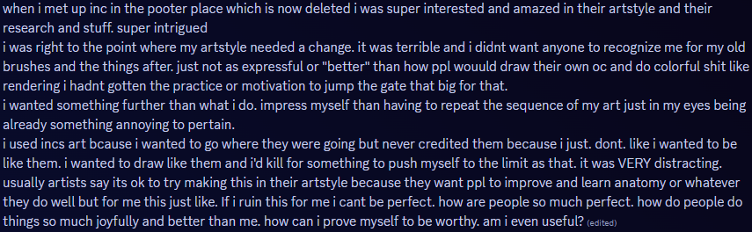
Overall, I apologize for being incoherent, unwise, a liar with too many things to handle everything in the end, a manipulator, jealous of things I’ve yet to improve myself on as well, forcing, and angry at things that should’ve been dealt the right way instead of irrefutable.
One last thing.
I’d like to apologize to the people I was, were, and am friends with on Discord for a bit long or longer than that. I apologize for my actions and selfishness. I ignored everything without knowing the warning and having a chance to be truthful rather than to hide a long burden from myself. I was dishonest, I was easily frightened and unprepared, and I was trying to leave everything from myself for an obvious purpose but was too afraid to vent at all. I was a liar, I was unhealthy and I was worried it’ll stay like → (what I mean is: without support, careless or unenthused.)
I’m afraid of taking a path where I want things for me to be. I suck in a lot of ways. I’m very sorry for the way I acted before and how it kept me unwell after all these (one and a half(?)(maybe more?)) years.

